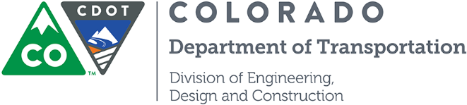
[PROJECT TITLE]
Project No. [PROJECT NUMBER]
[PROJECT SUBACCOUNT NUMBER]

Design-Build Project Team
Confidentiality and Non-Disclosure Agreement

[All members of the CDOT team that participate in the development of the procurement and contract documents and the procurement process should sign the Confidentiality and Non-Disclosure Agreement]

I, _________________________, as a participant in the preparation and/or review of the Request for Qualifications, Request for Proposals, and all related documents for the CDOT Design-Build Project procurement process, hereby agree that, except as otherwise provided by law:

I will maintain the confidentiality of all Confidential Information that I gain access to as a result of my participation in the design-build procurement process, including the preparation of the Request for Qualifications, evaluation of Statements of Qualifications, preparation of the Request for Proposals, evaluation of Proposals, and Contractor selection. This includes proprietary information provided by the Submitters/Proposers and information designated confidential by the Submitters/Proposers or by the CDOT Design-Build Team, drafts of documents, information from any of the Proposers submitting Alternative Configuration Concepts (ACCs) and or Alternative Technical Concepts (ATCs) for review and including all evaluation supporting materials (from sureties, banks, etc.).

I will maintain security and control over all documents containing such Confidential Information in my custody during the design-build procurement process. The Project Director (or his designee) is the only person who can make copies of any documents containing Confidential Information. If requested, I will return all documents to the Project Director when my work with the documents is completed.

I will not divulge any Confidential Information regarding the design-build procurement process to any representative of any construction firms, consultants, the media, any member of the public, or any person who is not a member of the CDOT Design-Build Team or a Task Group created by the CDOT Design-Build Team during the design-build procurement process. Internal Confidential Information exchange shall be conducted only as necessary to conduct the procurement process. I will promptly report in writing any attempts to access such information by construction firms, consultants, the media, or any other person or company not involved in the procurement process to the Project Director.

By: ___________________________ Date: ___________________

Title: _________________________

