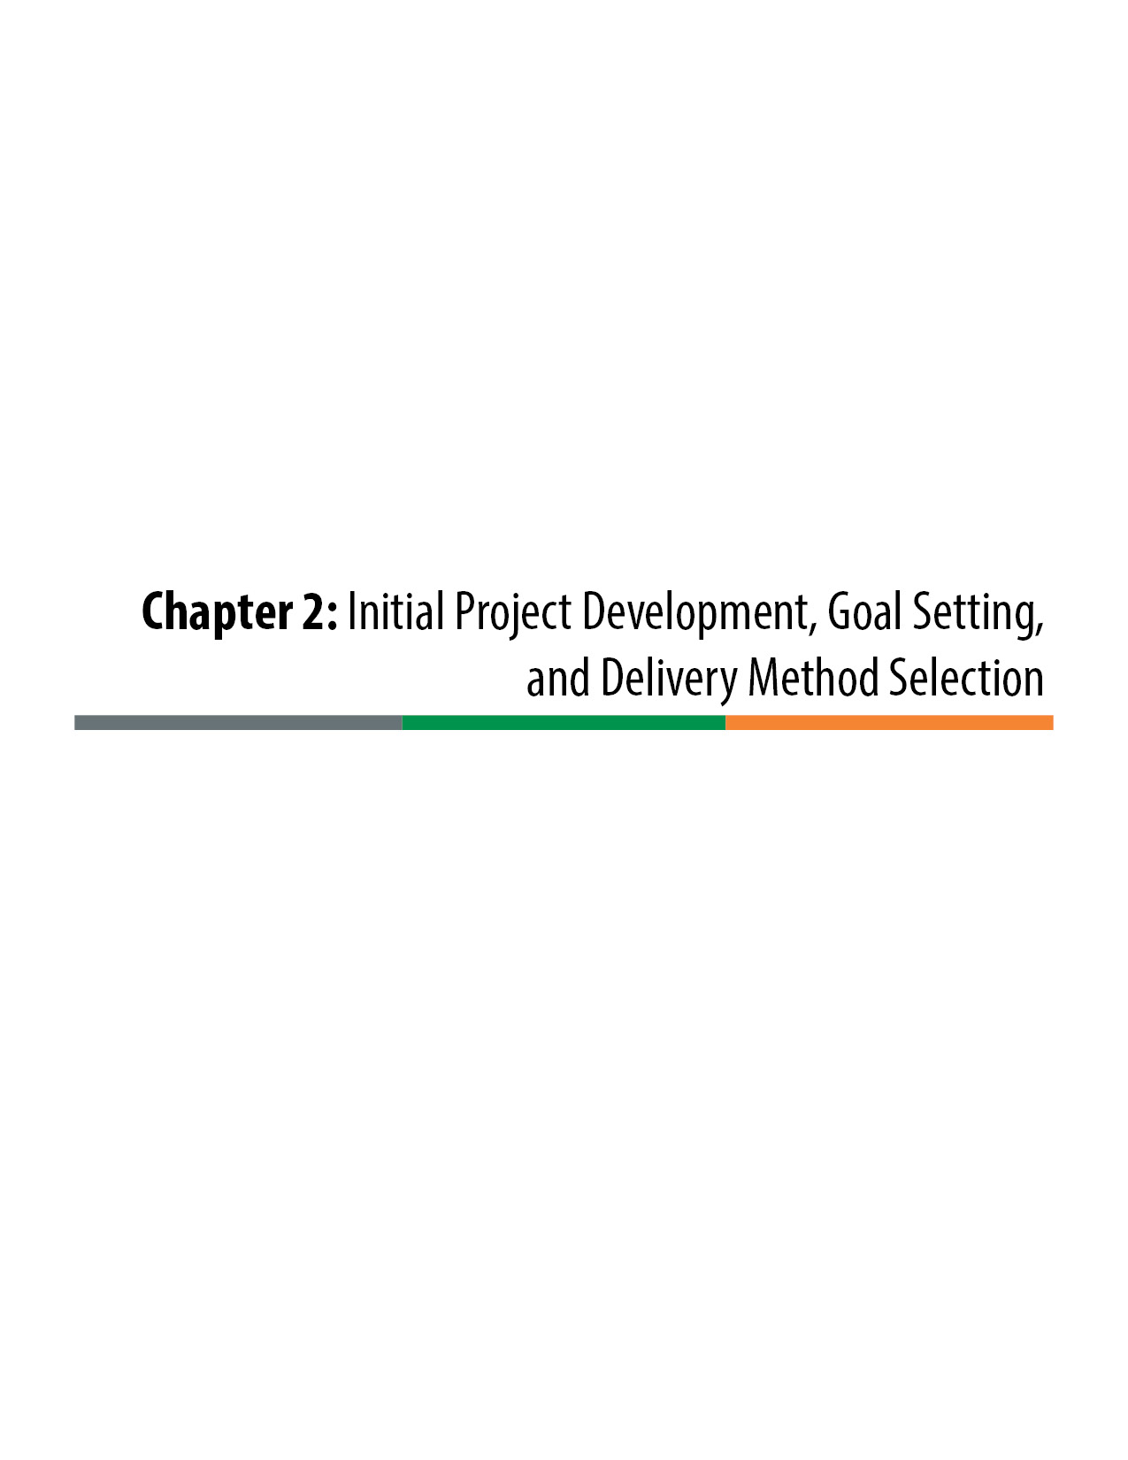

Initial Project Development, Goal Setting, and Delivery Method Selection
Not all projects can and should be delivered with the Design-Build project delivery method. With the time and resource investment required to properly execute a Design-Build procurement process, each project needs to be carefully scoped and scheduled, its project goals set, its staff and resource requirements considered, and an initial project risk assessment completed before the method of delivery is selected for the project.
Colorado Department of Transportation’s (CDOT’s) formal Project Delivery Selection Matrix (PDSM) should be employed as a best practice to identify the appropriate method of delivery for the project. Several of the characteristics of Design-Build delivery noted by the PDSM follow:
- Design-Build can expedite the overall project delivery schedule or the construction schedule.
- Design-Build can obtain aggressive project pricing with a process of innovation focused on cost-efficient solutions.
- Design-Build is most effective when funding available for design and construction of the basic project is known and set.
- Design-Build requires that the project scope of work and the desired performance be fully defined through a preliminary project design development and detailed Technical Requirements.
- Design-Build requires the project team to have the resources (usually including potential consultant support) to preliminarily advance the design and execute a formalized and extensive procurement process.
- After the procurement phase, the project team (often including consultant support) must have the resources to oversee the implementation (design and construction) of the project, including possible co-location requirements.
- To be most effective, the project risks should be well understood and definable and properly allocated between the owner and the Design-Builder.
Using the PDSM methodology, these factors and more are considered in conjunction with other characteristics of traditional Design-Bid-Build (D-B-B) and Construction Manager/General Contractor (CMGC) to identify the best method of delivery for the project.
The initial process of project development, goal setting, and delivery method selection is shown on the flowchart diagram in Figure 2-1.

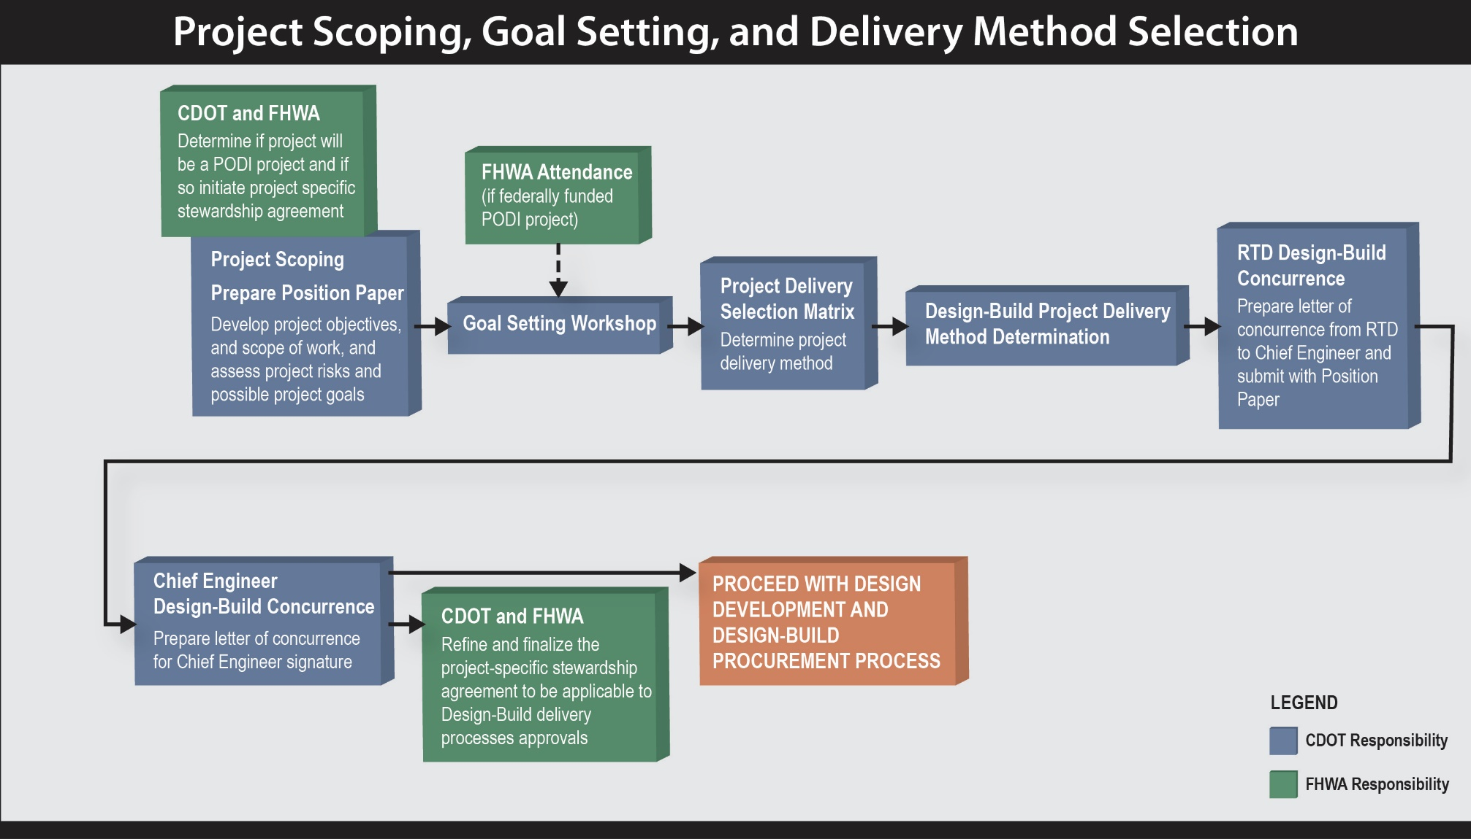

Figure 2-1. Project Scoping, Goal Setting, and Delivery Method Selection
  - Initial Project Development
    - Identification of Funding and Schedule
CDOT prioritizes projects through the development and ongoing maintenance of the Statewide Transportation Improvement Program (STIP) as required by federal regulations. The STIP is managed by the Office of Financial Management and Budget (OFMB).
In order to be included in the STIP, a project must be scoped and a total project estimate must be prepared. The resident engineer creates a draft baseline schedule that identifies key project milestones and related activities, which is then reviewed by the CDOT specialty unit managers and subsequently approved by the Region management team.
CDOT’s project scoping and development is further described in the 2013 CDOT Project Development Manual. The current manual (revised March 28, 2016) can be found at:
https://www.codot.gov/business/designsupport/bulletins_manuals/project-development-manual/revs-to-project-manual/2013-project-development-manual.pdf/view.
The project team should review the established project schedule and funding source(s) along with any associated requirements, as these may affect the project delivery method and the decision to use Design-Build.
    - Scoping a Design-Build Project
The scoping of a project should begin with the development and review of the project’s goals and risks. The identified goals and risks can then be used to prepare the PDSM and determine the best project delivery method. There are three steps in selecting a delivery method:
- Establish project-specific goals.
- Perform an initial project risk assessment.
- Complete a PDSM.
When initially scoping a project for possible Design-Build project delivery, the project team should consider the project schedule and resources available to manage the process. Design-Build projects place a unique demand on project team members in both the development and execution of the procurement process and in the oversight of the project implementation (design and construction). The project team must become knowledgeable in Design-Build delivery and have the commitment of resources necessary to perform its processes. If the project team members do not have prior experience implementing Design-Build delivery for a project of similar nature, then they should attend training sessions. CDOT has developed a Design-Build training program that includes an executive summary session and sessions in RFP development and contract administration.
The project team should review the project for elements that can be favorably addressed by the Design-Build project delivery method. These may include:
- the capability to provide a best value process that evaluates the technical merit, cost, and schedule in the selection of a Design-Builder for the project, with a focus on meeting and exceeding the project goals;
- the capability to expedite the overall delivery schedule of the project, particularly for large, complex projects;
- the capability to minimize the construction durations and construction impacts of the project;
- the promotion of innovation to provide an equal or better product that more efficiently utilizes project budget; and
- an effective means of addressing project risks by allocating them to the parties that are best able to manage them.
A unique benefit of Design-Build delivery is the Alternative Technical Concept (ATC) process that is used as part of the best value procurement process. Through confidential one-on-one meetings between the owner and contractor, the contractor is allowed to propose ATCs that specifically revise the Technical Requirements of the project. If the owner determines that an ATC provides an equal or better product, the owner may approve the ATC proprietarily and confidentially for the contractor who proposed it.
ATCs provide a powerful incentive for proposers to provide a best value project, both in terms of its technical merit and its price and schedule. Oftentimes, the selection of the Design-Build delivery method is driven by the proposers’ approved ATCs. The ATC process is one of the most significant ways in which Design-Build delivery provides a best value project that is very responsive to the project goals.
    - Risk Identification and Analysis
A “risk” is defined as an uncertain event or condition that, if it occurs, has a negative or positive effect on a project’s goals and objectives. Understanding which risks can and must be controlled by CDOT and which risks can and should be shared with the contractor results in an efficient and effective bid package, a competitive bidding environment, and overall lower costs.
Risk management is discussed in more detail in Chapter 3, however a basic understanding of the risk characteristics relative to the different methods of project delivery is important in initial project scoping, goal setting, and selection of the appropriate delivery method.
Traditional D-B-B delivery uses prescriptive provisions and fully completed designs that effectively assign most of the risk to CDOT. A primary benefit of alternative delivery methods such as Design-Build and CMGC is the ability to contractually allocate specific risks to the party best able to manage that risk. When project risks can be well defined, an advantage of the Design-Build delivery method is that those risks can be properly assigned in the Technical Requirements. When there is a high potential of unknown risks or poorly understood risks, the CMGC delivery method can be beneficial because it provides a forum to communicate and discuss risk in the design phase and to collaboratively address and reduce risk with the owner, contractor, and design consultant.
Risk assessment should be a continual process throughout the project development. An initial assessment of project risks needs to be performed by the project team at the time of the initial project scoping to assist with the selection of the appropriate delivery method. Project risks also need to be continually reviewed throughout the development of the RFP, the design development phase, and the construction phase of the project. The risk analysis and management process generally includes these five steps:
1. Identify the risk.
2. Assess and analyze the risk.
3. Mitigate and plan for the risk.
4. Allocate the risk.
5. Monitor and control the risk.
Design investigations and design development by the owner in Design-Build delivery is focused on minimizing and managing project risks. Elements of the design are advanced not blindly to an arbitrary level of completion but as necessary to manage their risks. Low-risk areas of the project may need to be advanced to only a very low level of development to adequately address the risks associated with the scope of work, however high-risk areas of the project may need to be developed to a more significant level to address the risks and properly allocate them. The identification of risk and preparation of a risk management plan leads to the development of a Risk Register for the project, which is further explained in Chapter 3 of this manual.
  - Project Goal Setting
You must define your goals in order to define what you value. When you know what you value, you can determine best value based upon objective criteria.
An understanding of project goals is essential to the selection of an appropriate method of delivery. The goals influence the project development, procurement, implementation, and administration of the contract. The goals communicate what CDOT values for the project and become distinguishing factors between proposers when determining which Proposal provides the best value to CDOT. These goals should strongly influence contractors, consultants, and others in assembling their teams, in preparing Proposals for the project, and in guiding the project throughout the design and construction phases.
Project goals should reflect the project’s need, objectives, and benefits. A position paper should be developed for the project to specifically define the project needs and objectives, its specific scope of work, the project goals, and ultimately the benefits of the selected method of delivery.
It is the project goals that unify the owner (CDOT), designer, and contractor into a collaborative Design-Build team. The project goals also become the basis of the partnering charter; rather than each party guarding its own interests, any potential disputes are filtered through the lens of the project goals and decisions are made based on what best meets the project goals.
Following are some generic examples of transportation project goals. The goals for transportation projects are generally similar. Nevertheless, the project goals must be considered specifically for each project and remain consistent over the life of the project.
Typical Generic Project Goals:
Schedule
- Minimize the project delivery time.
- Complete the project before a specified date.
- Make the project fully operational prior to a specified date.
- Accelerate the start of project revenue.
Cost
- Minimize the project cost.
- Maximize the project budget.
- Complete the project on budget.
- Maximize the project scope and improvements within the project budget.
Quality
- Meet and exceed the project requirements.
- Provide a design and construction that minimizes project risks.
- Provide the most highly qualified organization to perform the Work.
- Provide a high-quality design and construction.
- Provide a high-quality design and construction that best addresses the complexity of the project.
- Provide an aesthetically pleasing project.
Functional
- Maximize the life cycle performance of the project.
- Maximize capacity and mobility improvements.
- Provide innovative solutions to the complex project problems.
- Minimize inconvenience to the traveling public during construction.
- Maximize safety of workers and the traveling public during construction.
Significant transportation projects should include a goal setting workshop early in the project development, prior to selection of the delivery method. The workshop can be conducted by the project team or can be facilitated by an outside expert. Facilitated goal setting workshops preferably include expertise in both goal setting for transportation projects and innovative contracting.
Oftentimes, transportation projects include significant stakeholder interests beyond the department of transportation (DOT) project teams. In these cases, it is advantageous to include stakeholders in goal setting. This is best accomplished by including the stakeholders in the goal setting workshop or by soliciting their input in one-on-one meetings prior to the workshop if their participation in the workshop is not feasible. In projects with multiple funding sources, it is particularly important to solicit input from funding partners in the development of the project goals.
Representation to consider in assembling the goal setting team includes the following:
- Regional program engineer
- Regional resident engineer or Project Manager
- Consultant Project Manager and key staff
- Specialty project staff (major contributors)
- Lead agency representation (Federal Highway Administration [FHWA], Federal Transit Administration [FTA], Federal Railroad Administration [FRA], Regional Transportation District [RTD])
- Entity funding partners (local government)
- Facilitator
- Other stakeholders
It is important for CDOT executive management to support the project goals. Their support is usually attained through the approval of the project goals by the project Executive Oversight Committee. An example worksheet for the development of the initial project definition and goals is provided in Figure 2-2. When the worksheet is completed and the project goals are determined, it can provide the basis of a position paper that summarizes the initial project definition and goal setting.
Initial Project Definition and Goal Setting Worksheet
Basic Project Characteristics
Project description:

Why is the project necessary?

What will the project accomplish?

Project Goals
What are key project objectives?

Identify potential prioritized goals:

Potential Project procurement criteria for the ITP
What types of measurable Best Value Criteria will maximize the project goals?

Technical Requirements and Risk Allocation
Key Technical Requirement Risk Allocation Consideration
1.
2.
3.
4.
5.
6.
7.

Refine

Figure 2-2. Initial Project Definition and Goal Setting Worksheet
  - Selecting the Project Delivery Method
The project delivery method is the process by which a project is comprehensively designed, procured, and constructed. The delivery method generally begins with the development of a project design and continues through the administration of the construction. The choice of delivery method influences many aspects of the project at different stages, including the:
- project scope definition;
- organization of contractors, designers, and various consultants;
- sequencing of design and construction operations;
- execution of design and construction;
- environmental approvals;
- testing, inspection, and Acceptance; and
- start-up and close-out procedures.
The different project delivery methods are distinguished by the manner in which contracts between the owner, designers, and builders are formed and the technical relationships that evolve between each party as described in the contracts. The key contractual relationships of the primary methods of delivery are described below:
D-B-B is the traditional project delivery method in which the owner completes its own designs, or retains a designer to furnish complete design services, and then advertises and awards a separate construction contract based on the designer’s completed construction documents.
With this delivery method, the agency owner is responsible for the details of design during construction; as a result, in D-B-B the owner is responsible for the cost of any errors or omissions encountered in construction.
Design-Build is a project delivery method in which the owner procures both design and construction services in the same contract from a single, legal entity referred to as the Design-Builder, or simply the Contractor. The method typically uses a two-phase selection process that includes Statements of Qualifications, short-listing, Proposals and a final selection of the Design-Builder. The Design-Builder controls the details of design and the critical path for the project delivery life cycle and is responsible for the cost of any errors or omissions encountered in construction.
CMGC is a project delivery method in which the owner contracts separately with a designer and a construction manager. The owner can either perform the design itself or contract with an engineering firm to provide the design. The owner selects a construction manager to provide input into the design phase of the project. A defining characteristic of this delivery method is a sole source negotiated contract between the owner and the construction manager to perform the construction. CMGC brings the contractor into the design process early in its development.
    - The Project Delivery Selection Matrix
The evolution of innovative contracting methods of project delivery such as Design-Build and CMGC has made it important to evaluate projects early in their development to determine the most beneficial method of delivery. CDOT, the transportation industry, FHWA, and the University of Colorado have jointly developed the PDSM tool for assessing traditional D-B-B, Design-Build, and CMGC delivery for a given project in order to select the delivery method most suitable for a project. Use of the PDSM is expanding throughout the transportation industry and is increasingly being used by other state DOTs.
The PDSM is available on the Innovative Contracting website at:
https://www.codot.gov/business/designsupport/innovative-contracting-and-design-build.
The PDSM manual provides the detailed methodology and worksheets to use for the delivery selection process, which is summarized in the narrative of this manual.
The PDSM is a formal, documented approach for CDOT highway project delivery selection. The manual provides generic forms for use by CDOT staff and project team members. By using these forms, a brief project delivery selection report can be generated for each individual project. The primary objectives of this document are to:
- present a structured approach to assist CDOT in making project delivery decisions;
- assist CDOT in determining if there is a prevailing or an obvious choice of a project delivery method; and
- provide documentation of the project delivery decision in a Project Delivery Decision Report.
The PDSM should not be used to justify a predetermined decision of delivery method. Though often the project team will begin the PDSM process with an initial bias toward a method of delivery, it is vital that the team is committed to use the PDSM to aid in an objective assessment of delivery methods for the project.
The PDSM and Design-Build Delivery:
There are eight factors to consider when using the PDSM approach to selecting the method of delivery. The PDSM process starts by evaluating four primary factors, followed by a risk assessment, which essentially constitutes a fifth primary factor. Usually, an assessment of the five primary factors determines the most advantageous method of delivery. The primary factors, as they are related to Design-Build, are:
- Delivery Schedule
Design-Build can get a project under construction before completing design. The parallel process of design and construction can accelerate the project delivery schedule; however, procurement time can be lengthy due to the time necessary to develop the design, prepare an adequate RFP, evaluate Proposals, and provide for a fair and transparent selection process.

- Complexity and Innovation
Design-Build incorporates Design-Builder input into the preliminary design process through best value selection and contractor-proposed ATCs—which results in a cost-oriented approach to providing complex and innovative designs. For this approach to be effective Design-Build requires that desired solutions and outcomes to complex projects be well defined through contract requirements and, in particular, the Technical Requirements.
- Level of Design
In Design-Build, the project design is advanced to the level necessary to precisely define contract requirements and properly allocate risk. The level of design is most commonly 30 percent or less but can vary by discipline as is necessary to define the scope and manage the risk.

- Project Cost
Designer-Builder collaboration and ATCs can provide a very cost-efficient response to project goals. Costs are determined with Design-Build Proposals, early in the design process. Design-Build can allow a variable scope bid to match a fixed budget.

- Project Risk Assessment
Design-Build provides an opportunity to properly allocate risks to the parties best able to manage them, but it requires risks allocated to the Design-Builder to be well defined to minimize contractor contingency pricing of risks.

Three secondary factors are then assessed, primarily on a pass/fail basis to ensure that they do not adversely impact the actual project delivery selection. The secondary factors are:

- Owner Staff Experience and Availability
Technical and management resources and expertise are necessary in Design-Build to develop the RFQ and RFP and to administrate the procurement. Then there is a concurrent need for both design and construction resources to oversee the implementation phase of the project. Experience and availability of the owner are viewed by a Design-Builder as risks and can influence the innovation a Design-Builder pursues during the Proposal period, either positively or negatively.

- Level of Oversight and Control
Oversight and control of the design are exercised in a much different manor in Design-Build (design requirements, criteria, and desires must be written into the RFP contract requirements). In construction, oversight and control are most often provided through auditing the Quality Assurance program that is provided by the Design-Builder.

- Competition and Contractor Experience
Design-Build allows for a balance of price and non-price factors in the selection process. The delivery method is mature enough in Colorado to routinely expect qualified and experienced Design-Builders to competitively respond to Design-Build procurements.
Table 2-1 provides a summary comparison of the first four primary factors for CMGC, Design-Build, and D-B-B. Table 2-2 provides a summary comparison of the fifth factor: the project risks for these delivery methods.
The PDSM is typically prepared during a four-hour workshop with a delivery selection panel that should consist of the following members:
- A facilitator that is neutral toward the delivery method
- The Project Management Team
- An individual with innovative contracting experience, especially with CMGC and Design-Build experience for complex projects
- Representatives from key specialty groups
- Environmental Specialty Group representation (for most projects with environmental clearances)
- Other stakeholders (local agencies, FHWA, RTD, etc.)

Table 2-1. Comparison of Primary Evaluation Factors for Delivery Methods
Factor | D-B-B | Design-Build | CMGC
Delivery Schedule | - Requires time to perform sequential design and procurement  - If design time is available, has the shortest procurement time after the design is complete | - Can get a project phase under construction before completing total design for the project  - Parallel process of design and construction can accelerate project delivery schedule  - Procurement time can be lengthy due to the time necessary to develop an adequate RFP, evaluate Proposals, and provide for a fair, transparent selection process | - Quickly gets contractor under contract  - Can expedite initial construction packages  - Parallel process of development of contract requirements, clearances, design, procurements, and construction can accelerate project schedule  - Schedule delay can result from coordinating design between the construction manager and the designer  - Schedule delay can result from cost negotiations
Complexity and Innovation | - Allows the owner to fully resolve complex design issues and qualitatively evaluate designs before construction bidding  - Innovation provided by CDOT/consultant expertise and through traditional owner-directed processes such as value engineering (VE) studies and contractor bid alternatives | - Incorporates Design-Builder input into the design process through:  - best value selection  - contractor-proposed ATCs  - ATCs focus on innovative, cost-efficient solutions to complex problems  - Requires that desired outcomes to complex projects be well defined through contract requirements | - Allows independent selection of designer and contractor based on qualifications, experience, and project approach  - Effectively addresses complex and innovative designs through three-party collaboration by the owner, designer, and contractor  - Focuses on a qualitative design approach
Level of Design | - 100% design by owner, with owner having complete control over the design | - Design advanced by owner to the level necessary to precisely define contract requirements and properly allocate risk (typically 30% or less) | - Can utilize a low level of design prior to procurement of the CMGC contractor  - Allows joint collaboration of CDOT, the designer, and the CMGC in the further development of the design  - Iterative nature of design process risks extending the project schedule
Project Cost | - Competitive bidding provides a low-cost construction for a fully defined scope of work  - More cost change orders due to contractor having no design responsibility | - Designer-Builder collaboration and ATC process can provide a cost-efficient project  - Can allow a variable scope bid to match a fixed budget  - Poor risk allocation can reduce cost efficiency or can jeopardize the success of the procurement | - Owner, designer, and contractor collaboration to reduce risk pricing can provide a cost-efficient project  - Noncompetitive negotiated construction agreed price (CAP) introduces price risk  - Allows flexibility to design to a budget
Table 2-2. Comparison of Project Risks for Delivery Methods
Project Risk | D-B-B | Design-Build | CMGC
General Characteristics | - Requires that most design-related risks and third-party risks be resolved prior to procurement to avoid costly contractor contingency pricing and change orders and claims | - Provides opportunity to properly allocate well-defined and known risks to the parties best able to manage them  - Risks allocated to Design-Builder must be well defined to minimize contractor contingency pricing of risks | - Provides opportunity for the owner, designer, and contractor to collectively identify and minimize project risks and either allocate risk to the appropriate party or share risk  - Has potential to minimize risks associated with innovative and complex design and construction
Site Conditions and Investigations | - Site condition risks are generally best identified and mitigated during the design process prior to procurement to minimize the potential for change orders and claims | - Certain site condition risks can be allocated to the Design-Builder provided they are well defined and associated third-party approval processes are well defined  - Unreasonable allocation of site condition risk results in high pricing due to risk  - Site investigations by owner should include but are not limited to:  - basic design surveys  - hazardous materials  - geotechnical investigations  - utilities investigations | - CDOT, the designer, and the contractor can collectively assess site condition risks, identify the need to perform site investigations in order to reduce risks, and properly allocate or share risk prior to CAP
Utilities | - Utilities risks are best allocated to the owner and are mostly addressed prior to bid to minimize potential for claims | - Utilities responsibilities need to be clearly defined in the contract requirements and appropriately balanced between Design-Builder and owner  Private utilities: Need to define coordination and schedule risks as they are difficult for Design-Builder to price. Best to have utilities agreements before procurement. Note: By Colorado regulation, private utilities have schedule liability in Design-Build projects, but they need to be made aware of their responsibilities  Public Utilities: Design and construction risks can be allocated to the Design-Builder, if properly incorporated into the contract requirements | - Can utilize a lower level of design prior to contracting and joint collaboration of CDOT, the designer, and the contractor in the further development of the design
Table 2-2. Comparison of Project Risks for Delivery Methods (continued)
Project Risk | D-B-B | Design-Build | CMGC
Environmental | - Risk is best mitigated by obtaining all environmental clearances prior to bid | - Certain environmental approvals and processes that can be fully defined can be allocated to the Design-Builder. Agreements or memorandums of understanding (MOUs) with approval agencies prior to procurement are best to minimize risks | - Environmental risks and responsibilities can be collectively identified, minimized, and allocated by the owner, the designer, and the contractor prior to the negotiation of the construction agreed price (CAP)
Right-of-Way (ROW) | - ROW clearances are best obtained before bid | - ROW clearance commitments can be defined to allow Design-Build before completing all acquisition  - ROW acquisition responsibilities and risks can be shared if well defined | - ROW risks and responsibilities can be collectively identified, minimized, and allocated by the owner, the designer, and the contractor prior to the CAP
Drainage and Water Quality | - Drainage and Permanent Water Quality (PWQ) systems are designed prior to bid | - Generally, the owner is in the best position to manage the risks associated with third-party approvals regarding compatibility with off-site systems and should pursue agreements to define requirements for the Design-Builder | - The owner, the designer, and the contractor can collectively assess drainage risks and coordination and approval requirements, minimize and define requirements, and allocate risks prior to the CAP
Third-Party Involvement  (FHWA, railroads, Public Utilities Commission [PUC], funding partners, adjacent jurisdictions, etc.) | - Third-party risk is best mitigated through the design process prior to bid to minimize potential for change orders and claims | - Third-party approvals and processes that can be fully defined can be allocated to the Design-Builder  - Agreements or MOUs with approval agencies prior to procurement should be obtained to minimize risks | - Third-party approvals can be resolved collaboratively by the owner, designer, and contractor

    - Approval for Design-Build Delivery Method Use
Once a region has completed a PDSM and written the PDSM Report outlining why Design-Build has been found to be appropriate or most appropriate for the project, the resident engineer or the Project Manager must prepare one letter of concurrence from the RTD to the Chief Engineer, which should be supported by a project position paper. Templates for these documents can be found in the online Appendix on the CDOT Innovative Contracting web page or by contacting CDOT Innovative Contracting.
    - Training
As is discussed throughout this manual, Design-Build delivery is a much different process than traditional D-B-B delivery. For this reason, CDOT has established a best practice of providing training to the CDOT project teams for all major Design-Build projects. Even when many members of the CDOT project team have previously worked on Design-Build projects it is valuable to undergo the training again to refresh the project team’s understanding of the delivery method. The training is provided in four modules. PowerPoint presentations for each of the modules can be found in the online Appendix on the CDOT Innovative Contracting web page or by contacting CDOT Innovative Contracting. But review of those presentations should not be considered as a substitute to the actual training. The training modules are:
Module 1: Executive Summary
Module 2: RFP Development
Module 3: PTT (Project Technical Team) Kickoff
Module 4: Contract Administration

