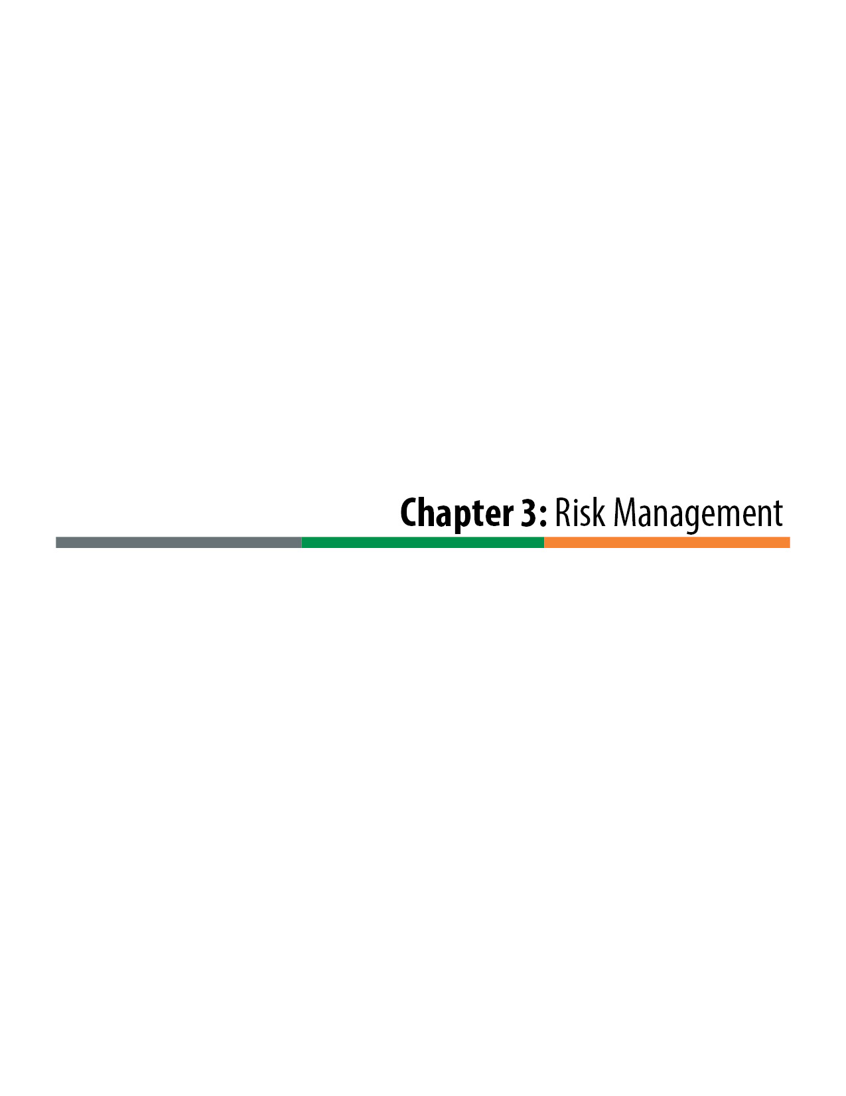

Risk Management

Risk Management Processes
Risk Definition
A project risk is an uncertain event or condition that, if it occurs, has a negative or positive effect on a project’s goals and objectives. A risk may have one or more causes and, if it occurs, one or more impacts.
This chapter provides a summary of risk management and the tools that the Colorado Department of Transportation (CDOT) has developed to assist with project risk management, with a focus on risk management for Design-Build delivery. For a detailed discussion of risk management of transportation projects the reader is referred to National Cooperative Highway Research Program (NCHRP) Report 658, Guidebook on Risk Analysis Tools and Management Practices to Control Transportation Project Costs (available at http://onlinepubs.trb.org/onlinepubs/nchrp/nchrp_rpt_658.pdf).
Risk management is the identification, analysis, planning, allocation, and control of project risks. It is a central concept to Design-Build project delivery. The ability of Design-Build delivery to properly allocate risks to the parties that are best able to manage them is a key attribute of the delivery method. Through Design-Build delivery, risks that would otherwise reside with the owner in traditional Design-Bid-Build (D-B-B) instead can be assigned to the Design-Builder.
Not all risks should be passed on to the Design-Builder, as certain risks can best be managed by the owner. When risks that are best managed by the owner are passed through to the Design-Builder, often the result is an increase in contingency (risk) pricing for the project, or an unnecessary increase in the schedule for the project, or both. Improperly allocated risk can potentially jeopardize the success of the project by increasing exposure to claims and litigation. The advantages that Design-Build offers in managing risk can be recognized only through the proper allocation of risk.
The risk analysis and management process generally includes the following five steps:
1. Identify and discuss project risk.
2. Assess and analyze the risk.
- What is the probability of the risk (high, medium, or low)?
- What are the consequences of the risk?
3. Mitigate and minimize the risk.
4. Allocate the risk.
5. Monitor and manage the risk.
As shown in Figure 3-1, risk management is a continual and iterative process.

Figure 3-1. Risk Management Process
Risk management should start in the planning phase of a project and continue through to the completion of the project. The five steps are detailed below.
1. Identify and Discuss Project Risk
Generally, project risks are first identified during CDOT’s Project Delivery Selection Matrix (PDSM) process, which is summarized in Chapter 2 of this manual. Risk assessment is a primary consideration in determining the appropriate method of delivery.
The project risk assessment in the PDSM provides a starting point for the development of the initial project Risk Register. Additional project risks are then identified and addressed and added to the Risk Register throughout the design development process.
2. Assess and Analyze the Risk
Though risk management should be a continuous process through the life of the project, there needs to be an especially strong emphasis on it during the initial design development and Request for Proposal (RFP) development phase of the project. Risk management should in fact drive much of those processes. Risk is identified, assigned, and then mitigated through the development of both the project design and the RFP Technical Requirements. Because of its importance, CDOT’s specialty groups should be involved early on in the project risk discussions.
Risk mitigation plans may include additional investigations, additional design, and stakeholder coordination activities that are performed by the project team during the development of the RFP.
Assessment of risk should include an examination of both the probability of the risk and the consequences of the occurrence. Figure 3-2 depicts a process for risk assessment.
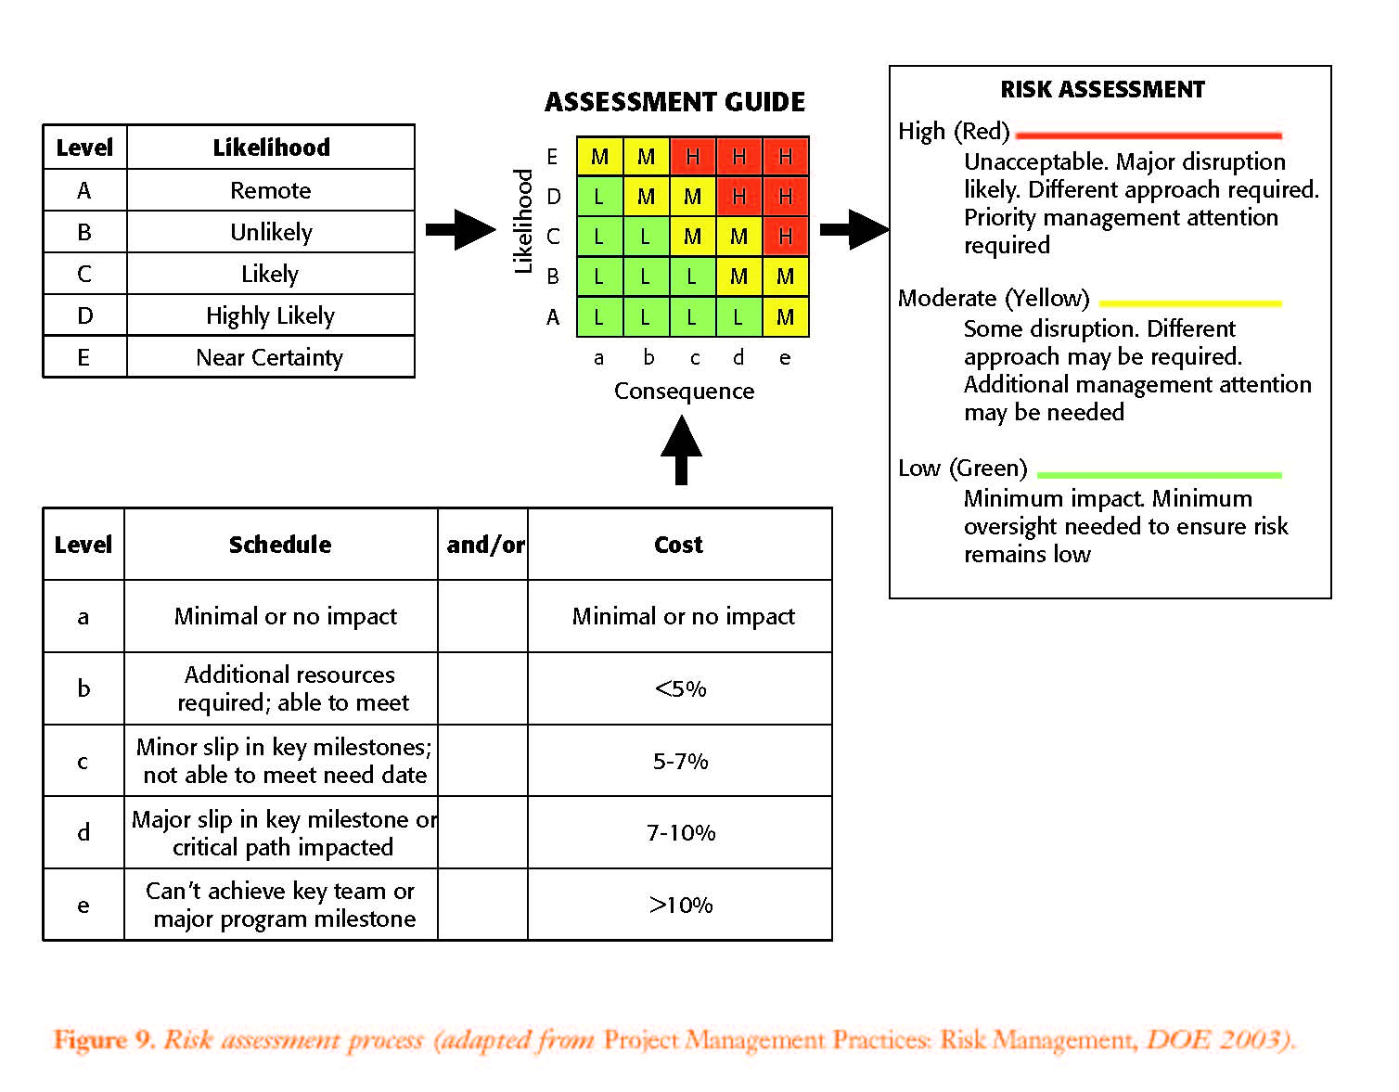
Figure 3-2. Risk Assessment Process (adapted from Federal Highway Administration, Guide to Risk Assessment and Allocation for Highway Construction Management, October 2006)
3. Mitigate and Minimize the Risk
Though generally design development by the owner should be limited to allow the most design flexibility for the Design-Builder, the design needs to be advanced to the extent necessary to ensure project risks can be identified and properly managed and allocated. The owner’s design must ensure that the project is well defined, is buildable, and facilitates strong Proposal designs with manageable risks. To meet these objectives, every discipline of the design needs be individually assessed, which results in differing levels of design development. Some elements of the project may only require a low level of design effort, whereas other elements of the design may require much higher levels of development to define the work and minimize risk.

Table 3-1. Example of Design-Build Project Risk Allocation Matrix
 | Design-Bid-Build |  | Design-Build
Risk | Agency | Contractor | Agency | Contractor
Design Issues
Project scope definition | X |  | X
Design criteria | X |  | X
Geotech investigation – Initial borings on preliminary design | X |  | X
Geotech investigation – Initial borings on Proposal | X |  |  | X
Plan conformance with regulation/guide/RFP | X |  |  | X
Environmental
NEPA/SEPA | X |  | X
Environmental Mitigation Commitments¹ | X |  | X | X
Final Design Environmental Approvals¹ | X |  | X | X
Permitting | X |  | X | X²
Right-of-Way
Establishing right-of-way limits | X |  | X
Acquire right-of-way | X |  | X
Local Agency
Identification of initial local agency impacts | X |  | X
Establish final/actual local agency impacts | X |  |  | X
Modifications to existing local agency permits | X |  |  | X
Utility
Establish initial utility locations/conditions | X |  | X
Relocation of utilities under agreement during contract |  | X |  | X
Modified agreement with private utility based on final design | X |  |  | X
Railroads (RR)
Obtain initial RR agreement based on preliminary design | X |  | X
Coordination with RR under agreement | X |  |  | X
Public Relations
Community relations | X |  | X
Public safety |  | X |  | X
Construction
Initial performance requirements | X |  | X
Final construction/materials QA/QC Plan | X |  |  | X
Material quality |  | X |  | X
Construction quality and safety |  | X |  | X
Force Majeure
Natural hazard (tornado, earthquake, etc.) | X |  | X
Change in law | X |  | X
Differing Site Conditions
Changed and differing site conditions | X |  | X
Warranty
Long-term ownership/final responsibility | X |  | X
Insurance |  | X |  | X

Source: K.D. Molenaar, D. Gransberg, S. Scott, D. Downs, and R. Ellis, Recommended AASHTO Design-Build Procurement Guide: Final Report, Project No. 20-7/TASK 172, National Cooperative Highway Research Program, Source continued: Transportation Research Board, National Research Council (Aug. 2005): 36. http://onlinepubs.trb.org/onlinepubs/archive/NotesDocs/NCHRP20-07%28172%29_FR.pdf.
¹ Line added by authors of this manual to reflect CDOT methodologies.
² Added by authors of this manual to reflect CDOT methodologies.

4. Allocate the Risk
Once a risk has been identified and analyzed, it should be assigned to either CDOT or to the contractor. The goal is to assign the risk to the party who is best able to mitigate the risk. Risks can be allocated solely to the contractor or CDOT, or they can be shared. However, because shared risks can lead to disputes, they should be avoided if at all possible. In situations where it seems that shared risk may be appropriate, the project team should first consider a more detailed assessment of the sub-factors that drive the risk and to try to assign each risk associated with the sub-factors solely to the best party who is best able to mitigate it.
Table 3-1 provides a risk allocation matrix with guidance on how transportation project risks are typically allocated in traditional D-B-B and in Design-Build delivery projects.
During the Design-Build procurement phase, project risks are specifically addressed through the development of the Technical Requirements of the RFP. The Technical Requirements specify the Design-Builder’s responsibilities for managing and resolving the elements of the design and construction of the project and should clearly identify and allocate risk. When risks are shared between CDOT and the Design-Builder, the Technical Requirements should also clearly define the risk sharing and the collaborative processes that are required to jointly address the risk.
5. Monitor and Manage the Risk
An important advantage of Design-Build is the collaborative environment that it fosters between the owner and the Design-Builder during the implementation phase of the project. Truly successful Design-Build projects are dependent on collaboration and partnership in risk management. Through strong collaboration the project risks can be effectively managed to the benefit of the Design-Builder, the owner, and the project as a whole. To facilitate such a process, it is valuable to maintain a Risk Register through the construction of the project and schedule regular management meetings to review the status of risk resolution.

Risk Register
The Risk Register is a tool used to guide and document the risk management process. The purpose of the Risk Register is to define the risks, document the risks, identify cost and schedule impacts associated with the risks, and produce mitigation plans for the risks. The project team should develop a Risk Register and refine it throughout the design development, procurement, and implementation of the project. Ideally, the initial Risk Register is developed as a part the project delivery selection, and it progressively evolves as the project is advanced through all of its stages to completion
The Risk Register is not intended to identify all of the project risks, as that can require an extensive and potentially counterproductive effort. The purpose of the Risk Register is to assist the project team in the efficient management and allocation of risks. To that end, the Risk Register focuses on key risks that can significantly impact the project goals, costs, schedule, and performance.

The outline and CDOT template for a typical Risk Register includes the following:
Risk Tracking Number and Description
Status of the Risk (active or resolved)
Potential Impacts of the Risk
Oftentimes the risk impacts are described in terms of schedule and cost, but they can also include stakeholders, product quality and other elements.
Risk Level
A subjective assessment of the importance of resolving the risk
Strategy
A general identification of the approach to address the risk such as:
Define—to advance investigations and designs provide a better definition of the risk and associated responsibilities to minimize threats
Mitigate—to take specific action to minimize or eliminate threats
Response Actions
A detailed description of the specific actions to execute to manage the risk
Risk Owner
Identification of the party(ies) to whom the risk is allocated
An example of a Risk Register is provided in Table 3-2. The example shows a typical Risk Register in the early design phases of a project. As the project design becomes more advanced, the Risk Register becomes more detailed, assigning specific costs and schedule impacts to risks, to both help inform mitigation decisions and to determine contingency pricing needs for the project.

Table 3-2. A Sample Risk Register
RISK REGISTER Project Name: Example Project Name |  |  |  |  | Project Number: XX-XXXX
Risk Identification |  |  | Risk Assessment |  |  | Risk Response |  | Allocation
ID # | Status | Identified Risk | Potential Impact (cost, schedule, etc.) |  | Risk Level | Strategy | Response Actions | Risk Owner | Updated
10 | Active | Potential contaminated soils within the project limits | If undefined and unmitigated in advance, encountering the materials during construction could have significant cost and schedule impact and could result in potential contractor claims |  | High | Define and Partially Mitigate | • CDOT performs physical investigation prior to Notice to Proceed (NTP) to characterize and perform some mitigation in advance if possible  • CDOT accepts cost responsibility through force account and Contractor accepts schedule responsibility | CDOT and Contractor | 10/12/2014
11 | Active | Bridge crossing at Noname Creek | • A detailed hydraulic floodplain analysis is required to identify bridge crossing geometry creating Federal Emergency Management Agency (FEMA) approval schedule risk and structure cost risk for proposers if they are unable to perform detailed analyses prior to submittal of Proposals  • A 404 permit is needed if working in the creek and a stream crossing plan are necessary |  | Medium | Define | • CDOT performs initial floodplain survey and analysis to provide a default structure opening requirement that proposers can rely on  • CDOT encourages Alternative Technical Concepts (ATCs) for more innovative design  • CDOT initiates discussion with floodplain administrator to define FEMA approval process for Contractor | CDOT (bridge) Contractor (permit and plan) | 11/23/2014
12 | Resolved | Delay of Right-of-Way (ROW) acquisition | ROW acquisition is behind schedule and will not be completed at the planned NTP date of the project, jeopardizing project start-up date |  | Medium | Define | • CDOT and Design Consultant to determine likely ROW acquisition dates and provide a schedule of parcel acquisition dates in the Technical Requirements that Contractor is entitled to rely on  • Consider ATCs for Contractor to assume acquisition responsibilities | CDOT | 9/13/2014
13 | Active | Potential contaminated groundwater | Contaminated groundwater may need to be treated or removed for the construction of drilled caissons |  | Med | Define | Require Contractor to develop a Hazardous Waste Management Plan (HWMP) to address how contaminated groundwater will be mitigated and allocate cost and schedule risk to the Contractor | Contractor | 10/20/2014
13 | Resolved | Permanent Water Quality (PWQ) system | The current Municipal Separate Storm Sewer System (MS4) permit is vague and ambiguous, creating risk that contractor-proposed Water Quality designs will not be approved by CDOT |  | High | Define | • Develop a Technical Requirement that defines a default system (and/or acceptable details) that the Contractor can rely on (CDOT essentially accepts CDPHE risk)  • Consider Contractor ATC for innovation if Contractor accepts approval risks | CDOT | 12/2/2014
14 | Active | Dry utility relocation delays | Project has a number of telecommunication lines that are running the full length of the roadway that will have to be relocated by private utility company, which could substantially impact the project schedule |  | High | Mitigate | • Work with private utilities up front to develop utilities agreements that include relocation schedule commitments  • Remind utility agencies of their regulatory schedule responsibilities (C.R.S. § 43-1-1412) | CDOT | 11/24/2014
15 | Resolved | Nesting birds | Nesting birds, protected under the Migratory Bird Treaty Act, may delay construction during the nesting season |  | Medium | Mitigate | Identify conditions that contractor can implement to prevent birds from nesting, including Senate Bill 40 permitting to remove trees | CONTRACTOR | 11/4/2014

Typical Design-Build Risks on Transportation Projects
Though each project has unique risks, the risks that follow are present on most transportation projects.
Site Conditions and Investigations:
Certain site condition responsibilities can be allocated to the Design-Builder provided they and any associated third-party approval processes are well defined. However, an unreasonable allocation of site condition risk results in high contingency pricing by the contractor. At a minimum, site investigations should be performed by the owner to minimize overall project risk and to provide the necessary base information for proposers to complete their pursuit designs without redundant investigations being performed by each proposer. These investigations typically include the following:
- Basic design surveys—as necessary for the proposers to complete their Proposal design
- Contaminated materials and groundwater investigation—at a minimum to characterize the general nature of mitigation requirements
- Geotechnical investigations—as necessary for proposers to advance the design of structures foundations, retaining walls, and pavements as required for their Proposals
- Utilities investigation—physical determination of horizontal and vertical locations at critical locations of potential conflicts
Utilities:
Utilities responsibilities need to be clearly defined in the contract requirements and appropriately allocated to either the Design-Builder or to CDOT:
Private utilities: The owner needs to define coordination and schedule risks as they are difficult for the Design-Builder to price. It is preferable to have utilities agreements executed with each private utility before the completion of the procurement. The agreements should define the scope of anticipated relocations, relocation responsibilities (both construction and design), and the schedule for the relocations. Note: By state regulation (C.R.S. § 43-1-1412) private utilities have schedule liability in Design-Build projects, but they need to be made aware of their responsibilities.
Public Utilities: Design and construction risks can be allocated to the Design-Builder, if the work and approval processes are fully defined in the Technical Requirements.
Environmental Permitting:
Typically, environmental permitting can be more effectively managed by the owner because the owner has stronger working relationships with the permitting agencies and a better understanding of the processes. However, certain environmental approvals and processes that can be well defined can be allocated to the Design-Builder. Agreements or memorandums of understanding (MOUs) with permitting agencies that define approval requirements and processes can significantly reduce risks to the Design-Builder. In situations where permitting can be clearly defined and allocated to the contractor, scheduling benefits can be recognized.
Right-of-Way:
In the majority of Design-Build projects, the owner acquires the Right-of-Way (ROW) necessary to construct the project. When all of the ROW is not acquired by the owner prior to the start of construction, a ROW clearance schedule should be provided in the Technical Requirements to define and minimize schedule risk for the Design-Builder. This schedule becomes part of the contract and provides an assurance to the proposers that the risk is recognized and allocated to the owner. ROW acquisition responsibilities and risk can be transferred to the Design-Builder, with potential schedule benefits, but because the state agency needs to become involved in any condemnation process, ROW acquisition responsibilities then become a shared risk that must be carefully defined in the Technical Requirements. To avoid the shared risk, preferably the owner performs all of the ROW acquisition.
Railroads:
The railroad companies are a particularly challenging third party to manage in Design-Build projects. They often require very advanced designs before executing construction and maintenance agreements, which constitute their formal approval of grade separation structures over their facilities. Their processes introduce a high level of risk to proposers needing to include the costs and schedules for work that interfaces with the railroad in their Proposals. Typically, the risks can be best minimized and managed by the owner advancing the designs as much as possible in advance of the Design-Build procurement phase.
Drainage and Water Quality:
Often project drainage facilities receive flows from outside the project limits and/or release flows to outside the project limits. When the project design is likely to change historic flow patterns or release volumes, it is necessary to negotiate with adjacent owner agencies for the revised conditions. In this situation the owner is usually in a better position to manage the risk. Ideally, MOUs or intergovernmental agreements should be developed to define off-site drainage requirements for the Design-Builder.
Permanent Water Quality (PWQ) requirements are continually evolving and are frequently difficult to define and assess. As a result, PWQ is often a high-risk item for the Design-Builder. CDOT has ultimate responsibility for any water that is treated from their ROW, therefore, a prescriptive approach to water quality Technical Requirements that the Design-Builder can rely on minimizes contingency pricing by the Design-Builder. Design-Build delivery then allows the Design-Builder to propose more maintenance-efficient and effective alternative systems.
Third-Party Involvement:
In general, third-party involvement can be most effectively managed by the owner. Railroad companies, the Federal Highway Administration, public utilities commissions, adjacent jurisdictions, funding partners, and other third parties often have established relationships with the owner that the owner can benefit from. In particular, third-party agencies that have contributed funding to the project usually participate in the owner’s project management organization and decision-making process. In cases where the owner can clearly define processes and approval requirements, it can be beneficial to allocate some third-party risks to the Design-Builder, who is in a better position to incorporate those well-defined processes into its design and project schedule.

