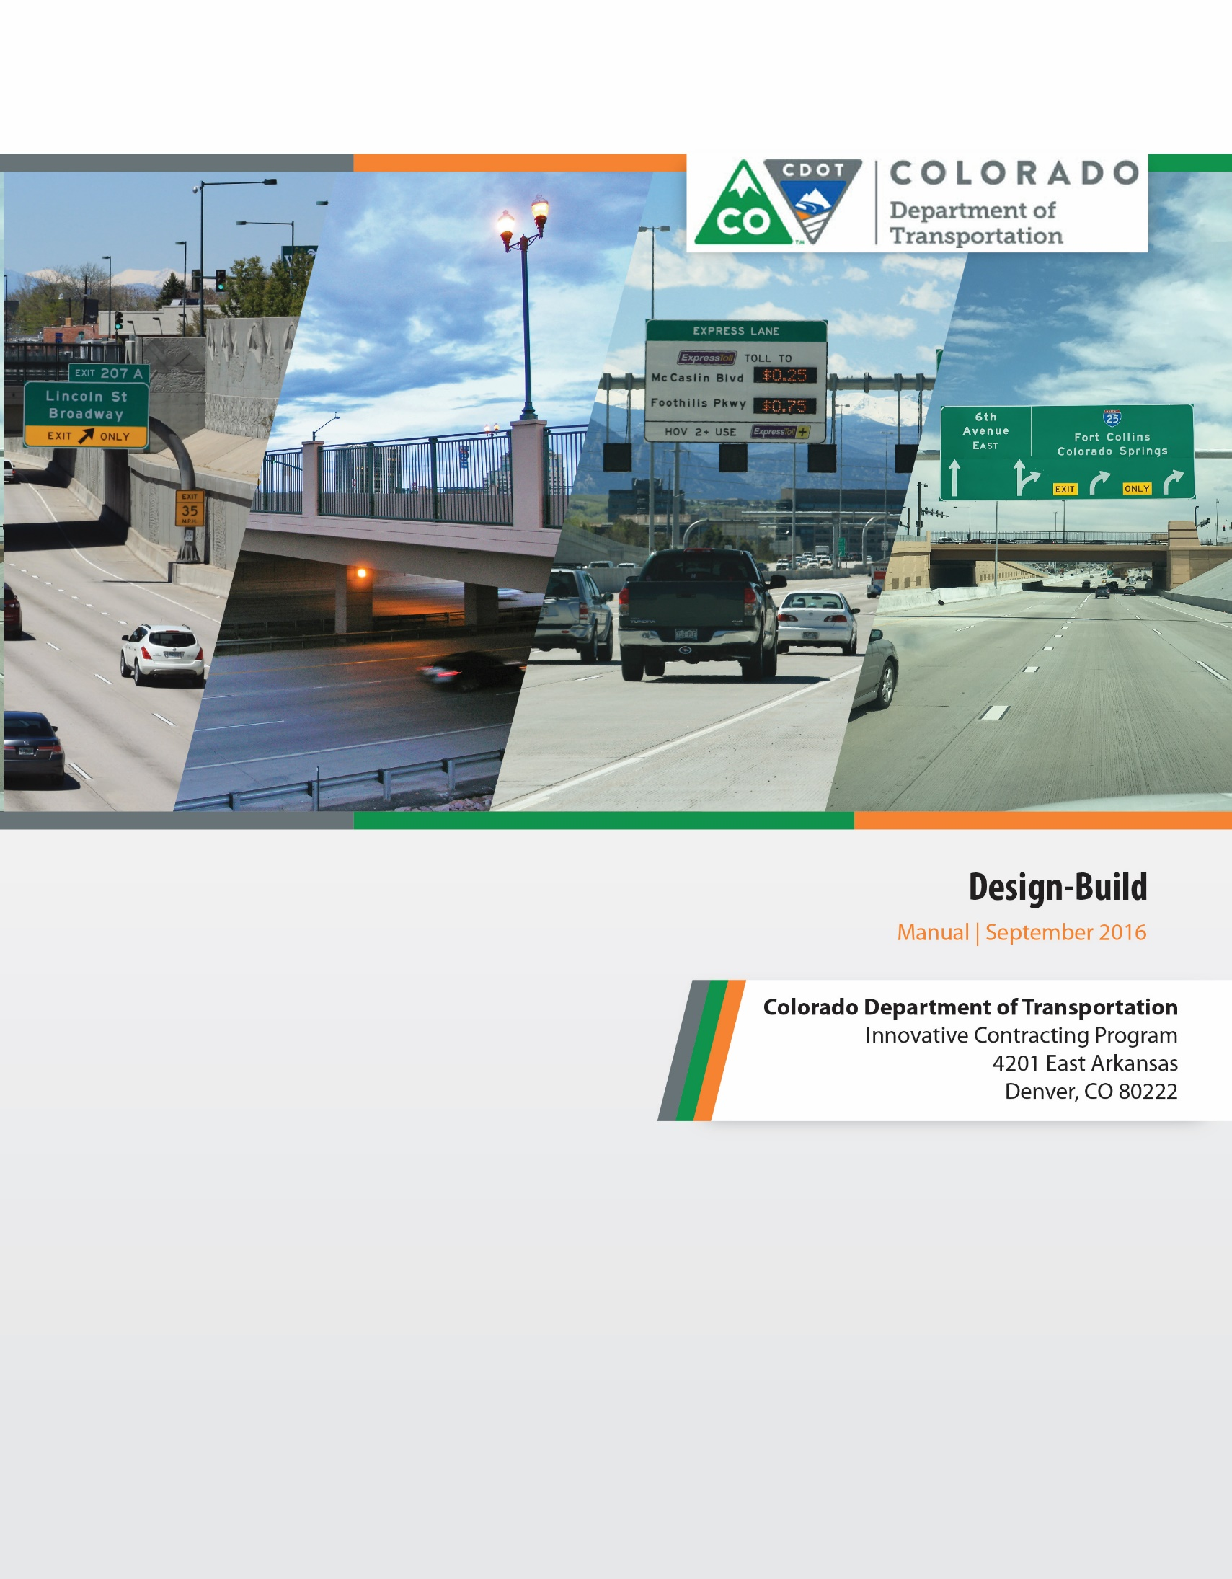

Acknowledgments
Design-Build Manual Development Committee
Nabil F. Haddad, PE, CDOT Innovative Contracting Program Manager
Neil J. Lacey, PE, CDOT Project Development Branch Manager
Jay Hendrickson, PE, CDOT Program Engineer
Matthew D. Pacheco, PE, CDOT Resident Engineer
David M. Watt, PE, CDOT Resident Engineer
David L. Kosmiski, PE, CDOT Professional Engineer
Marci Gray, CDOT Award Officer
Mark M. Scholfield, PE, Wilson & Company, Inc., Engineers & Architects

Manual Contributions and Review
CDOT Design-Build Environmental Subcommittee
Jordan Rudel, CDOT
Scott Epstein, Pinyon Environmental
Jay E. Goldbaum, PE, CDOT Pavement Design Program Manager
Randy Jensen, FHWA Colorado Division
Monica C. Pavlik, PE, FHWA Colorado Division
Melinda Urban, PE, FHWA Colorado Division
Gregory Doyle, FHWA Technical Programs Manager
Jeff Lewis, FHWA Office of Technical Services/Resource Center
Wendy Schlosberg, Wilson & Company, Inc., Engineers & Architects (Editor)

Colorado Department of Transportation
Innovative Contracting Program
4201 East Arkansas
Denver, CO 80222

Table of Contents
List of Figures v
List of Tables vi
Online Appendix vii
Chapter 1: Introduction and State of the Practice 1-1
1.1 Introduction 1-1
1.2 Description of Innovative Project Delivery Methods 1-1
1.2.1 Design-Bid-Build 1-2
1.2.2 Design-Build 1-2
1.2.3 CMGC 1-3
1.2.4 Comparison of Project Delivery Methods Schedules 1-3
1.3 Current Design-Build Practice 1-4
1.4 CDOT Design-Build Projects 1-4
1.5 Federal Laws, State Legislation, and Design-Build Regulations 1-5
1.5.1 Federal Transportation Acts and Design-Build 1-5
1.5.2 Federal Design-Build Law 1-5
1.5.3 Federal Regulations and the NEPA Process 1-6
1.5.4 State Legislation and the Code of Colorado Regulations 1-8
1.5.5 State Legislation regarding Design-Build Utility Relocations 1-9
1.5.6 Colorado Department of Transportation Design-Build Requirements 1-10
1.6 Design-Build Acronyms and Definitions 1-10
Chapter 2: Initial Project Development, Goal Setting, and Delivery Method Selection 2-1
2.1 Initial Project Development 2-3
2.1.1 Identification of Funding and Schedule 2-3
2.1.2 Scoping a Design-Build Project 2-3
2.1.3 Risk Identification and Analysis 2-4
2.2 Project Goal Setting 2-5
2.3 Selecting the Project Delivery Method 2-8
2.3.1 The Project Delivery Selection Matrix 2-8
2.3.2 Approval for Design-Build Delivery Method Use 2-14
2.3.3 Training 2-14
Chapter 3: Risk Management 3-1
3.1 Risk Management Processes 3-1
3.2 Risk Register 3-5
3.3 Typical Design-Build Risks on Transportation Projects 3-8
Chapter 4: Project Organizational Structure and Design Development 4-1
4.1 Project Organizational Structure 4-1
4.2 Confidentiality and Conflict of Interest 4-2
4.3 Procuring a Design Consultant 4-4
4.4 Design Development 4-5
4.4.1 Organization of Design Documents 4-6
4.4.2 The Basic Configuration 4-8
4.4.3 Preliminary Investigations 4-10
4.4.4 Design Development of the Reference Documents 4-10
4.4.5 Right-of-Way Acquisitions 4-12
4.4.6 Design Development of the Technical Requirements (Book 2) 4-13
4.4.7 Cost Estimating 4-13
Chapter 5: Design-Build Procurement Process 5-1
5.1 Request for Letters of Interest 5-4
5.2 Phase 1—Request for Qualifications, Statements of Qualifications, and Short-Listing 5-9
5.2.1 Development and Structure of the Request for Qualifications 5-9
5.2.2 SOQ Evaluation and Short-Listing 5-12
5.3 Phase 2—Request for Proposals, Pursuit Design, Proposals and Selection 5-13
5.3.1 The Draft RFP and Industry Review 5-14
5.3.2 The Final RFP Process 5-16
5.3.3 Instructions to Proposers 5-16
5.3.4 Alternative Configuration Concept / Alternative Technical Concept Process 5-22
5.3.5 Requests for Clarification and Addendums 5-24
5.3.6 Document Control and Data Management 5-25
5.3.7 Public Opening 5-25
5.3.8 Best and Final Offers 5-25
5.3.9 Stipends 5-26
5.3.10 Protest Procedures 5-26
5.4 Design-Build Delivery Interface with Other Processes 5-27
5.4.1 Environmental Processes 5-27
5.4.2 FHWA Processes 5-30
Chapter 6: Evaluation of Statements of Qualifications and Proposals 6-1
Chapter 7: Structure and Content of the Request for Proposal 7-1
7.1 Book 1 – Contract 7-1
7.1.1 Book 1, Section 4.2: Notices to Proceed 7-1
7.1.2 Book 1, Section 6.2: Utilities 7-3
7.1.3 Book 1, Section 7.2: Disadvantaged Business Enterprises 7-3
7.1.4 Book 1, Section 7.9: Key Personnel 7-3
7.1.5 Book 1, Section 9.0: Insurance 7-3
7.1.6 Book 1, Section 11.0: Payment 7-3
7.1.7 Book 1, Section 12.0: Value Engineering and Negotiated Changes and Section 13.0: Changes in the Work 7-3
7.1.8 Book 1, Section 17.0: Damages 7-3
7.1.9 Book 1, Section 20: Acceptance of Project 7-3
7.1.10 Book 1, Exhibit A: Acronyms and Definitions 7-4
7.1.11 Book 1, Exhibit B: Completion Deadlines 7-4
7.1.12 Book 1, Exhibit D: Key Personnel 7-4
7.2 Book 2 – Technical Requirements 7-5
7.2.1 Book 2, Section 1: General 7-5
7.2.2 Book 2, Section 2: Project Management 7-6
7.2.3 Book 2, Section 3: Quality Management 7-8
7.2.4 Book 2, Section 4: Public Information 7-12
7.2.5 Book 2, Section 5: Environmental 7-13
7.2.6 Book 2, Section 6: Third-Party Agreements 7-16
7.2.7 Book 2, Section 7: Utilities 7-18
7.2.8 Book 2, Section 8: Right-of-Way 7-20
7.2.9 Book 2, Section 9: Survey 7-23
7.2.10 Book 2, Section 10: Geotechnical and Roadway Pavements 7-24
7.2.11 Book 2, Section 11: Earthwork 7-27
7.2.12 Book 2, Section 12: Drainage 7-28
7.2.13 Book 2, Section 13: Roadways 7-30
7.2.14 Book 2, Section 14: Signing, Pavement Markings, Signalization, Lighting 7-32
7.2.15 Book 2, Section 15: Structures 7-33
7.2.16 Book 2, Section 16: Transportation Management Plan 7-34
7.2.17 Book 2, Section 17: Landscaping 7-36
7.2.18 Book 2, Section 18: Maintenance During Construction 7-37
7.2.19 Book 2, Section 19: Intelligent Transportation Systems (ITS) 7-38
7.2.20 Book 2, Section 20: Modifications to Standard Specifications 7-40
7.3 Book 3 – Applicable Standards, Data and Reports 7-40
7.4 Book 4 – Contract Drawings 7-41
Chapter 8: Implementation 8-1
8.1 Project Organization 8-1
8.2 Contract Award and Project Start-up 8-3
8.2.1 Partnering 8-3
8.2.2 Co-Location and Design Development 8-4
8.3 Design Development 8-5
8.3.1 Task Forces and Over-the-Shoulder Reviews 8-5
8.3.2 Formal Milestone Packages and Reviews. 8-6
8.3.3 Design Quality Processes 8-7
8.4 Construction Processes 8-7
8.4.1 Testing, Inspection, and Acceptance Quality Processes 8-7
8.4.2 CDOT Auditing Processes and Nonconforming Work 8-8
8.5 Change Management 8-12
8.6 Project Acceptance and Closeout 8-14
Chapter 9: Streamlined Design-Build 9-1
9.1 Procurement 9-1
9.2 RFP and Contract Documents 9-2

List of Figures
Figure 1-1. Project Delivery Methods Contractual Relationships 1-2
Figure 1-2. Project Delivery Methods Schedule 1-3
Figure 2-1. Project Scoping, Goal Setting, and Delivery Method Selection 2-2
Figure 2-2: Initial Project Definition and Goal Setting Worksheet 2-7
Figure 3-1. Risk Management Process 3-2
Figure 3-2. Risk Assessment Process (adapted from Federal Highway Administration, Guide to Risk Assessment and Allocation for Highway Construction Management, October 2006) 3-3
Figure 4-1. Typical Design-Build Project Organization 4-3
Figure 4-2. Design Development 4-5
Figure 4-3. Basic Configuration Example 4-9
Figure 5-1. Design-Build Procurement Process Overview 5-2
Figure 5-2. The Two-Phase Design-Build Procurement Process 5-3
Figure 5-3. Typical Design-Build Procurement Schedule 5-6
Figure 5-4. Example Request for Letters of Interest (LOIs) 5-7
Figure 5-5. RFQ Elements 5-9
Figure 5-6. Design Development 5-13
Figure 5-7. ITP Elements 5-16
Figure 5-8. Developing Evaluation Procedure 5-17
Figure 5-9 Environmental Interface with Design-Build Process 5-29
Figure 5-10. FHWA Interface with Design-Build Process 5-32
Figure 5-11. FHWA Design-Build processes for Major Projects 5-33
Figure 6-1. The SOQ and Proposal Evaluation Procedures 6-1
Figure 7-1. Development of Technical Requirements Workflow 7-5
Figure 7-2. CDOT’s Quality Assurance Plan 7-10
Figure 8-1. Design-Build Implementation Phase Project Organization 8-2
Figure 8-2. Design Development during Implementation 8-5
Figure 8-3 Requirements Database Example 8-9
Figure 8-4 Auditing Report Workflow and Levels of Nonconformance 8-10
Figure 8-5 Example Auditing Report 8-11
Figure 8-6. Change Order Procedure 8-13
Figure 8-7: Final Submittal Check List Example 8-15

List of Tables
Table 2-1. Comparison of Primary Evaluation Factors for Delivery Methods 2-11
Table 2-2. Comparison of Project Risks for Delivery Methods 2-12
Table 3-1. Example of Design-Build Project Risk Allocation Matrix 3-4
Table 3-2. A Sample Risk Register 3-7
Table 4-1. Design-Build Documents 4-7
Table 5-1. CDOT Design-Build Alternative Algorithms to Determine Total Evaluation Score 5-19
Table 5-2. Relating Project Goals and Values to Best Value Scoring Parameters 5-20
Table 6-1. Adjectival Evaluation and Scoring Guide 6-7
Table 7-1. Design-Build Documents (same as Table 4-1 in Chapter 4) 7-2
Table 7-2. Comparison of Construction Acceptance System Approaches 7-11
Table 7-3. ITS and ETC Equipment 7-39

Online Appendix
The following source documents are resources being made available to assist Design-Build teams in executing Design-Build programs. They are available by contacting CDOT Innovative Contracting or at the CDOT Innovative Contracting (Design-Build, and CMGC) web page at:
https://www.codot.gov/business/designsupport/innovative-contracting-and-design-build.

Resource Document Source File Chapter Reference
State and Federal Design-Build Regulations pdf 1
Design-Build Selection Letter of Concurrence
from the Chief Engineer Word 2
Design-Build Training Presentations Power Point 2
Basic Configuration Examples pdf 4
Typical Design-Build Procurement Schedule MSProject 5
Confidentiality and Nondisclosure templates Word 4, 5, 6
Request for Letters of Interest (LOI) template Word 5
Request for Statements of Qualifications (RFQ) Word 5
Instructions to Proposers template (ITP) Word 5
Proposal Evaluation Plan template Word 5, 6
Typical FHWA Oversight Roles and
Responsibilities Word 5
RFP Book 1 template Word 7
Selective Design-Build RFP Book 2
Technical Requirements templates Word 7
Streamlined Design-Build ITP template Word 9
Streamlined Design-Build
Book 2 Section 1 template Word 9

