

5615 Wills Blvd.

Pueblo, CO 81008-2349

Duran Rodeo Ranch

15801 SH 239

Trinidad, Co

81082

Ref: CDOT Project FBR 200-267 MP 9.8

The Colorado Department of Transportation is requesting permission to enter your property along SH 350.

We are planning a topographical survey near Mile Post 9.8 to gather data for a design project that will replace a bridge in this area and to improve the safety of the public roads.

Our hope is to access your property to do these investigations and help improve any future road hazards at this location.

Please sign and return the enclosed form #730.

You can contact me by phone if you would like to talk in more detail.

Respectfully,

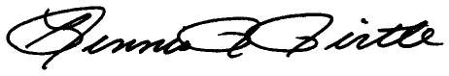

Dennis R Pirtle

Region 2 Survey Coordinator

[Dennis.Pirtle@state.co.us](mailto:Dennis.Pirtle@state.co.us)

719-546-5746