

5615 Wills Blvd.

Pueblo, CO 81008-2349

Samuel & Babette Fief

P.O Box 257

La Junta, CO 81050

Ref: CDOT Project FBR 200-267 MP 69.82

The Colorado Department of Transportation is requesting permission to enter your property along SH 350.

We are planning a topographical survey near Mile Post 69.82 to gather data for a design project that will replace a bridge in this area and to improve the safety of the public roads.

Our hope is to access your property to do these investigations and help improve any future road hazards at this location.

Please sign and return the enclosed form #730.

You can contact me by phone if you would like to talk in more detail.

Respectfully,

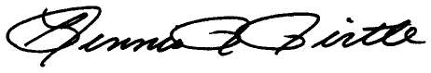

Dennis R Pirtle

Region 2 Survey Coordinator

[Dennis.Pirtle@state.co.us](mailto:Dennis.Pirtle@state.co.us)

719-546-5746