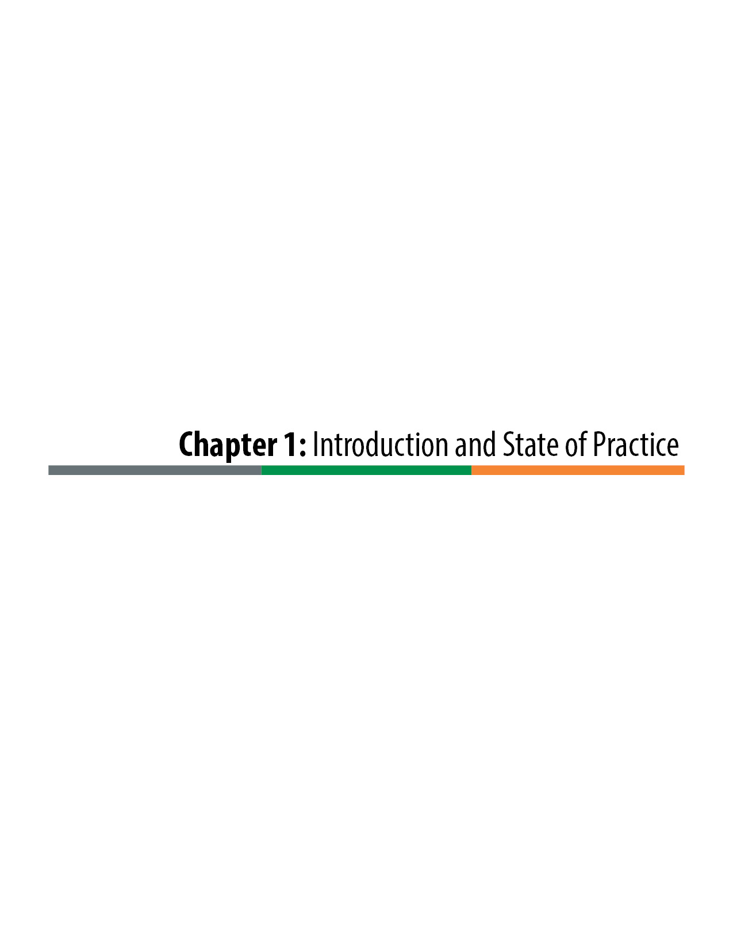

Introduction and State of the Practice

Introduction
Transportation facilities directly relate to a community’s economic health and quality of life. The demands on transportation facilities in the state of Colorado continually grow, along with the competition for available funding and expectations of increased quality and higher Levels of Service. To ensure timely, efficient, and effective responses to these demands, approved projects may be delivered using alternative contracting methods, including the Design-Build contracting process.
The Colorado Department of Transportation (CDOT) has been using the Design-Build project delivery method since the late 1990s. In 1997 CDOT developed the first Design-Build guidelines, and in 2006 CDOT issued its first Design-Build procedural manual. Since that time, CDOT and the Design-Build industry have continued to learn valuable lessons and have further developed more effective and efficient Design-Build processes. This manual represents a major update to the CDOT Design-Build Manual and includes CDOT’s most recent Design-Build practices and procedures.
The Design-Build process offers potential benefits not achievable with the traditional Design-Bid-Build (D-B-B) delivery method. A comparison of process sequencing shows how the phases of design, advertisement, award, and construction with Design-Build delivery can offer significant savings in time over the D-B-B method. In addition to Design-Build’s potential time-saving benefits, the delivery method promotes innovation and potentially saves cost and administrative burden; improves quality without sacrificing schedule and budget; and reduces project risks.
Design-Build is an alternative contracting method where design and construction services are included in a single contract. Using the Design-Build approach, CDOT provides conceptual and preliminary designs and required performance results. The Design-Build delivery method then requires construction firms to team with consultant design firms to work together to design and construct the improvements.
The shift to Design-Build from D-B-B allocates responsibility and risk to the parties who can best manage the processes and outcomes. It allows for innovation in design, construction techniques, construction phasing, sequencing, risk management, traffic management, Public Information, and cooperative communication.
Design-Build procedures continue to advance and evolve with each use. This manual encompasses the lessons learned from Design-Build projects in Colorado and throughout the United States. The manual focuses on the initial project design development, followed by a two-phase selection process, which then transitions to a Design-Build implementation phase. This manual provides procedures, guidelines, information, resources, and insights for the user to successfully develop and implement a Design-Build contracting strategy that is unique yet in compliance with federal regulations, state legislation, and CDOT policy.

Description of Innovative Project Delivery Methods
For all but the largest of projects, CDOT primarily employs three types of project delivery methods: (1) traditional D-B-B, (2) Design-Build, and (3) Construction Manager/General Contractor (CMGC). The delivery methods differ in the contractual relationship between CDOT, the contractor, and the designer as represented in Figure 1-1.
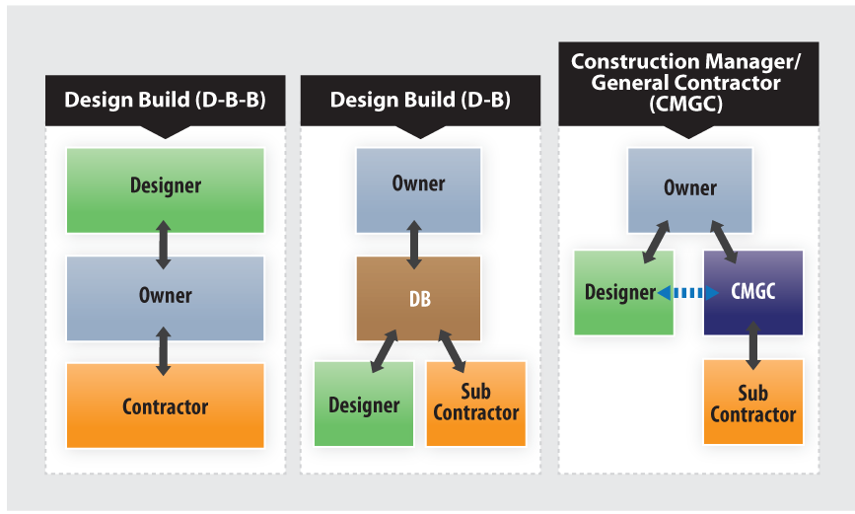
Figure 1-1. Project Delivery Methods Contractual Relationships

Design-Bid-Build
D-B-B has been the most utilized project delivery method and continues to be the method most used by CDOT. The linear nature of the planning, preconstruction, and construction phases is well known and practiced. In this delivery method, CDOT staff or consultant staff design a project, and when construction plans are complete, the project is let for bids to the construction industry. Typically, the lowest bidder wins the project and then construction occurs under CDOT oversight. Using this delivery method, CDOT allocates the majority of the responsibility for risk to itself.

Design-Build
Design-Build is a common alternative project delivery method that began in the 1990s at CDOT and has since become a frequently used delivery method by CDOT. In Design-Build, the owner procures a Design-Build team (a paired contractor and design consultant) with a best-value procurement process. The selected Design-Build team takes over the preliminary design from the owner and develops the final design for the project. When construction packages are ready, the contractor builds the packages until the project is complete.
During this delivery method, the majority of the responsibility and risk for the design and construction is allocated to the selected Design-Build team. The Design-Builder is responsible for the budget, schedule, and quality control. However, for this method to be effective, the owner needs to recognize that there are certain responsibilities and associated risks that the owner is better able to manage. A key to successful Design-Build is to properly allocate the project risks to the parties that are best able to manage them. The CDOT project team should spend significant efforts during the procurement phase to research project risks and develop the Technical Requirements to properly allocate risk and focus the Design-Build team toward achievement of the project goals.

CMGC
In CMGC, the owner is the primary Project Manager much like in D-B-B. However, with this method, the owner takes on new roles while managing separate contracts with a selected CMGC services contractor and its design consultant team. The owner must act as a facilitator, negotiator, decision maker, collaborator, and manager and must be an active participant in every step of the preconstruction and construction phases. CMGC Project Managers make the final decisions on budget, design, and construction methods and must be able to make risk-based decisions on short timelines to meet project deadlines. The CMGC contractor is actively involved during the preconstruction phase, working collaboratively with the owner and designer to provide suggestions and methods to improve the design for constructability, add innovative value engineering solutions, maximize scope, and optimize schedule and cost. As the design nears completion, the contractor provides the owner with construction pricing that is negotiated to reach an agreed construction price.
Once a construction contract is executed, the contractor’s role changes to that of a general contractor (GC) during construction. This is a very traditional role and is similar to the responsibilities of a GC on a D-B-B. The contractor also manages its own risk that it assumed responsibility for or is sharing with the owner.

Comparison of Project Delivery Methods Schedules
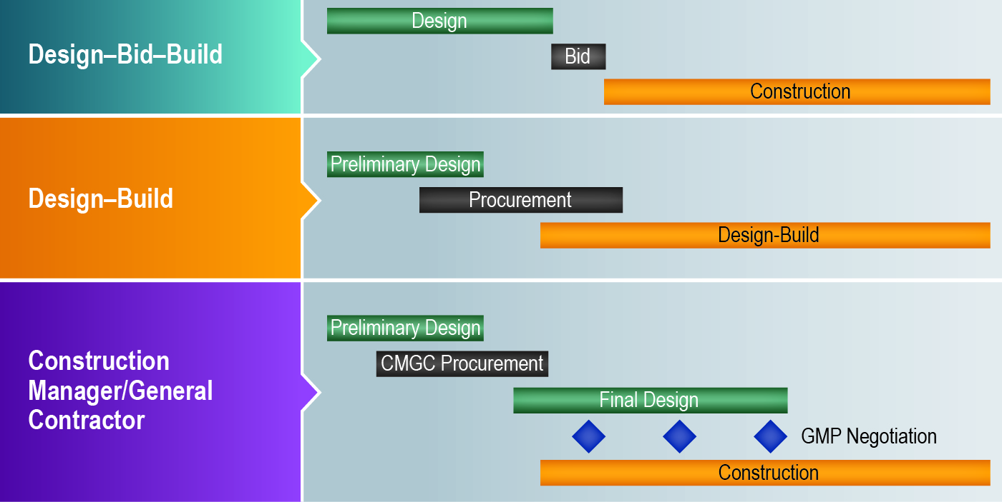
The delivery methods differ in the timing of the design, procurement, and construction phases of a project as represented in Figure 1-2.
Figure 1-2. Project Delivery Methods Schedule
D-B-B and CMGC are often used to advance the construction phase of a project or accelerate the total project delivery schedule. Although project schedules are still controlled by items such as Right-of-Way (ROW) acquisition, permitting, and funding availability, both Design-Build and CMGC offer opportunities to accelerate the project delivery time. This is accomplished by having overlapping design, procurement, and construction phases. The contractor also has greater control over project phasing and construction methods that can accelerate the project schedule. The designer and contractor collaborate to develop the design, construction methods, and phasing in support of an efficient construction schedule. Schedule and budget certainty is also obtained sooner in Design-Build, as the Design-Builder commits to a construction schedule earlier in the procurement process.

Current Design-Build Practice
Design-Build is a highly utilized project delivery method by state departments of transportation (DOTs) across the country. Transportation is the fastest growing Design-Build sector in the United States, with transportation Design-Build projects substantially increasing since 2010, both in quantity and value of projects. As of March 2015, there are only 6 states that do not have Design-Build authority in the transportation sector, whereas the remaining 44 states and the District of Columbia all authorize Design-Build for transportation to some degree.
In 2009, the Federal Highway Administration (FHWA) launched the Every Day Counts (EDC) initiative in cooperation with the American Association of State and Highway and Transportation Officials (AASHTO) to speed up the delivery of highway projects and to address the challenges presented by limited budgets. The EDC campaign is the FHWA’s focused effort to advance a culture of innovation in the highway community in partnership with the states. Through this collaborative, state-based effort, FHWA coordinates rapid deployment of proven, market-ready strategies and technologies to shorten the project delivery. The EDC-1 Innovations, introduced and promoted during 2011 and 2012, further encouraged the use of Design-Build.

CDOT Design-Build Projects
CDOT awarded its first Design-Build contract in 1997 for the design and reconstruction for approximately 12 miles of I-70 from Airport Road to Bennett, Colorado. In 2001, CDOT in partnership with the Regional Transportation District (RTD) entered into a Design-Build contract for the Transportation Expansion Project (T-REX) project, the largest multimodal transportation project in the history of Colorado. Following the success of T-REX, in 2005 CDOT used the Design-Build method to expand I-25 through Colorado Springs for the $150 million Colorado Springs Metro Interstate Expansion (COSMIX) project. As of 2014, CDOT used Design-Build to deliver over 14 projects worth more than $3 billion.
Projects that have been identified by CDOT for possible Design-Build delivery are submitted by the regions and listed on the Innovative Contracting web page at: https://www.codot.gov/business/designsupport/innovative-contracting-and-design-build.
A project delivery selection matrix report and a contact person are included for each project.

Federal Laws, State Legislation, and Design-Build Regulations
Federal and state legislation continue to evolve in the support of Design-Build project delivery for publicly funded transportation projects. The following section summarizes the existing federal laws and Colorado state legislation that allow for Design-Build and the regulations that govern Design-Build. Refer to the online Appendix on the CDOT Innovative Contracting web page or contact CDOT Innovative Contracting for full versions of the federal laws and Colorado Revised Statutes (C.R.S) § 24-93-101, Integrated Project Delivery Method for Public Projects Act.

Federal Transportation Acts and Design-Build
The last three federal surface transportation funding acts included provisions in the support of Design-Build, which led to the creation and reforms of the FHWA statutory requirements for Design-Build.
On December 10, 2002, in response to Section 1307 of the Transportation Equity Act for the 21st Century (TEA-21), the FHWA published the Final Rule that established regulations for Design-Build contracting in the Code of Federal Regulations (CFR) as Title 23 CFR Part 636. Subsequent modifications required by Section 1503 of the Safe, Accountable, Flexible, Efficient Transportation Equity Act: A Legacy for Users (SAFETEA-LU) resulted in revisions published in a final rulemaking on August 14, 2007. Among the revisions made by SAFETEA-LU were the elimination of the dollar thresholds for qualified projects and permission to release a Request for Proposal (RFP) or award a Design-Build contract prior to completion of the National Environmental Policy Act of 1969 (NEPA) process. Design-Build procurement processes that deviate from the requirements of 23 CFR Part 636 may still require a Special Experimental Project No. 14 (SEP-14) work plan and approval.
The federal surface transportation bill Moving Ahead for Progress in the 21st Century Act (MAP-21) was signed into law on July 6, 2012, and it further defined regulations for using Design-Build to deliver federal-aid projects. MAP-21 made provisions to streamline the environmental review process and broadened the ability for states to acquire or preserve ROW for a transportation facility prior to completion of the review process required under NEPA. MAP-21 also increased funding for the Transportation Infrastructure Finance and Innovation Act (TIFIA) and expanded the types of projects eligible for the program. This increased the states’ abilities to engage in public-private partnerships (P3s).

Federal Design-Build Law
Statutory Requirements:
Title 23 of the United States Code (U.S.C.), Part 112(b)(3) provides the FHWA’s statutory requirements for the Design-Build project delivery method. It includes the following:
- A state transportation department or local transportation agency may award a Design-Build contract for qualified projects using any procurement process permitted by applicable state and local law.
- Design-Build contract means an agreement that provides for design and construction of a project by a contractor, regardless of whether the agreement is in the form of a Design-Build contract, a franchise agreement, or any other form of contract approved by the Secretary.
Regulatory Requirements:
Title 23 CFR Part 636 provides the FHWA's regulatory policy for the Design-Build project delivery method and is broken into five subparts: Subpart A—General; Subpart B—Selection Procedures, Award Criteria; Subpart C—Proposal Evaluation Factors; Subpart D—Exchanges; and Subpart E—Discussions, Proposal Revisions and Source Selections.
Qualified projects are defined as projects meeting all requirements of Title 23 CFR Part 636.

Federal Regulations and the NEPA Process
Within 23 CFR Part 636, FHWA has put into effect its Design-Build Contracting regulations that establish the parameters by which state transportation departments (STDs) may deliver projects using Design­ Build. The section that pertains to how far an STD can take a procurement process prior to the conclusion of the NEPA process follows:
§ 636.109 How does the NEPA process relate to the design-build procurement process?
The purpose of this section is to ensure that there is an objective NEPA process, that public officials and citizens have the necessary environmental impact information for federally funded actions before actions are taken, and that design-build proposers do not assume an unnecessary amount of risk in the event the NEPA process results in a significant change in the proposal, and that the amount payable by the contracting agency to the design-builder does not include significant contingency as the result of risk placed on the design-builder associated with significant changes in the project definition arising out of the NEPA process.
Therefore, with respect to the design-build procurement process:
(a) The contracting agency may:
(1) Issue an RFQ prior to the conclusion of the NEPA process as long as the RFQ informs proposers of the general status of NEPA review;
(2) Issue an RFP after the conclusion of the NEPA process;
(3) Issue an RFP prior to the conclusion of the NEPA process as long as the RFP informs proposers of the general status of the NEPA process and that no commitment will be made as to any alternative under evaluation in the NEPA process, including the no-build alternative;
(4) Proceed with the award of a design-build contract prior to the conclusion of the NEPA process;
(5) Issue notice to proceed with preliminary design pursuant to a design-build contract that has been awarded prior to the completion of the NEPA process; and
(6) Allow a design-builder to proceed with final design and construction for any projects, or portions thereof, for which the NEPA process has been completed.
(b) If the contracting agency proceeds to award a design-build contract prior to the conclusion of the NEPA process, then:
(1) The contracting agency may permit the design-builder to proceed with preliminary design;
(2) The contracting agency may permit any design and engineering activities to be undertaken for the purposes of defining the project alternatives and completing the NEPA alternatives analysis and review process; complying with other related environmental laws and regulations; supporting agency coordination, public involvement, permit applications, or development of mitigation plans; or developing the design of the preferred alternative to a higher level of detail when the lead agencies agree that it is warranted in accordance with 23 U.S.C. 139(f)(4)(D);
(3) The design-build contract must include appropriate provisions preventing the design-builder from proceeding with final design activities and physical construction prior to the completion of the NEPA process (contract hold points or another method of issuing multi-step approvals must be used);
(4) The design-build contract must include appropriate provisions ensuring that no commitments are made to any alternative being evaluated in the NEPA process and that the comparative merits of all alternatives presented in the NEPA document, including the no-build alternative, will be evaluated and fairly considered;
(5) The design-build contract must include appropriate provisions ensuring that all environmental and mitigation measures identified in the NEPA document will be implemented;
(6) The design-builder must not prepare the NEPA document or have any decision making responsibility with respect to the NEPA process;
(7) Any consultants who prepare the NEPA document must be selected by and subject to the exclusive direction and control of the contracting agency;
(8) The design-builder may be requested to provide information about the project and possible mitigation actions, and its work product may be considered in the NEPA analysis and included in the record; and
(9) The design-build contract must include termination provisions in the event that the no-build alternative is selected.
(c) The contracting agency must receive prior FHWA concurrence before issuing the RFP, awarding a design-build contract and proceeding with preliminary design work under the design-build contract. Should the contracting agency proceed with any of the activities specified in this section before the completion of the NEPA process (with the exception of preliminary design, as provided in paragraph (d) of this section), the FHWA’s concurrence merely constitutes the FHWA approval that any such activities complies with Federal requirements and does not constitute project authorization or obligate Federal funds.
(d) The FHWA’s authorization and obligation of preliminary engineering and other preconstruction funds prior to the completion of the NEPA process is limited to preliminary design and such additional activities as may be necessary to complete the NEPA process. After the completion of the NEPA process, the FHWA may issue an authorization to proceed with final design and construction and obligate Federal funds for such purposes.

State Legislation and the Code of Colorado Regulations
The use of Design-Build contracting in Colorado is provided for in C.R.S. § 43-1-1401, et seq. The Colorado Revised Statutes authorizes the Code of Colorado Regulations (CCR), which provides the rules and regulations for Design-Build.
The legislation authorizes CDOT to enter into Design-Build contracts and to use an adjusted score Design-Build selection and procurement process. It allows Design-Build contracting to be used regardless of the minimum or maximum cost. Use of Design-Build contracting must be based on the individual needs and merits of the project, and it is subject to approval by the Transportation Commission.
Specific Information on C.R.S. § 43-1-1401, et seq., Design-Build Contracts may be found at:
http://www.lexisnexis.com/hottopics/colorado?source=COLO;CODE&tocpath=1OIUQBI82FNSS0KVX,2QM4VQK3Q08E4JP43,31MTP04ZDHROAKHVS&shortheader=no.
The legislation also requires the creation of the CCR for the implementation and use of Design-Build contracting.
Created to comply with legislation, 2 CCR 601-15 establishes policy and procedure requirements for CDOT to procure Design-Build contracts for transportation projects. It consists of 22 sections. Awareness of, understanding, and, above all, compliance with each section are required.
Section 3 - Policy 2 of 2 CCR 601-15 provides that:
- CDOT may use a Design-Build contract process when the Chief Engineer determines such use is appropriate and in the best interest of the public.
- Based on individual need and merit of the project CDOT may use:
  - the Adjusted Score Design-Build (i.e., the Two Phase Design-Build) Contract process,
  - the Low Bid Design-Build Contract process, or
  - any other process the Chief Engineer determines appropriate.
Also included in Policy 2 of CCR 601-15 are Design-Build contract rules outlined in the following sections:
- Section 4 – Definitions: Defines Design-Build terms, which should not be altered or redefined.
- Section 5 – Subcontracting: States the need to identify goals and participation of subcontractors, including Disadvantaged Business Enterprises (DBEs) and Emerging Small Businesses (ESBs).
- Section 6 – General Requirements for Design-Build Firms: Identifies the Firm’s responsibility or liability to legal status and compliance with all applicable requirements.
- Section 7 – Conflict of Interest: Identifies not only Firm objectivity but also consultant conflict.
- Section 8 – Scope of Work: Specifies the need to provide adequate detail and identify applicable standards and specifications in the Invitation for Bid (IFB) or the Request for Qualifications (RFQ).
- Section 10 – Award and Contract: Identifies Best Value, Two Phase, Low Bid, and Fixed Price bases for awarding contracts.
Requirements for Procurement by the Colorado Department of Transportation of Design-Build Contracts for Transportation Projects, 2 CCR 601-15 may be found at the following link: https://www.sos.state.co.us/CCR/GenerateRulePdf.do?ruleVersionId=162.

State Legislation regarding Design-Build Utility Relocations
C.R.S. § 43-1-1411 (2013) provides legislation regarding the process for utility relocations under Design-Build. These processes differ from the utility relocations procedures for D-B-B. C.R.S. § 43-1-1411(3)(a), created for the Design-Build process, allows the Design-Build contractor to perform utility work when the utility owner is unable or unwilling to do so.
In relation to Project-Specific Utility Relocation Agreements (PSURAs), the C.R.S. allows CDOT to pay for the performance of the design work to relocate a utility company's facilities that are affected by the scope of the Design-Build transportation project; advance funds for the performance of the construction work to relocate a utility company's facilities affected by the scope of the Design-Build transportation project; and perform any utility relocation work through the contractor for the Design-Build transportation project in accordance with the utility company's specifications for the relocation work and subject to the utility company's prior review and written approval.
The intent of the legislation is to authorize CDOT to work with the utility company to come to a mutually satisfactory agreement so that the Design-Build transportation project may proceed to be constructed in an efficient manner without causing interruption of utility services.
For any utility company that chooses not to enter into a PSURA with CDOT for the performance of utility relocation work, C.R.S. § 43-1-1411(3) states the following:
(a) The department may direct the utility company to perform or allow the performance of the utility relocation work within the performance schedule for the design-build transportation project.
(b) The utility company shall pay for damages caused by the company's delay in the performance of the utility relocation work or interference with the performance of the design-build transportation project by other contractors, including, but not limited to, payments made by the department to any third party based on a claim that performance of the design-build transportation project was delayed or interfered with as a direct result of the utility company's failure to timely perform the utility relocation work; except that damages resulting from delays in the performance of the utility relocation work caused by a force majeure shall not be charged to the utility company.
(c) The department may withhold issuance of a permit for the location or installation of other facilities to a utility company until the company pays the department damages caused by the company's delay in the performance of the relocation work or interference with the performance of the design-build transportation project by any other contractor. Any person aggrieved by an action of the department in denying a permit may apply to a court of competent jurisdiction for appropriate relief pursuant to the Colorado rules of civil procedure or section 24-4-106, C.R.S.
The legislation also provides CDOT with the following authority:
(4) The department shall provide written notice to any utility company of a design-build transportation project that will require the relocation of the company's facilities as soon as practicable following the environmental clearance for the project. The notice shall include all available and relevant information concerning the project, including the performance schedule for the project within which the utility relocation work must be completed in order to coordinate with and avoid delay in the performance of the project.
(5) When feasible, the department shall provide a replacement easement for a utility company whose facilities are to be relocated from an easement owned by the utility company to accommodate a design-build transportation project, and the department shall condemn the replacement easement when necessary. If no replacement easement is provided, the department shall fund the initial relocation of the easement owner's facilities and shall also fund all future relocations of those utility companies whose facilities occupy the easement at the time of the design-build transportation project at the department's sole expense in lieu of compensating the utility companies for the loss of the easement. The utility company shall quitclaim to the department that portion of the easement that is replaced or extinguished. (C.R.S. § 43-1-1411)

Colorado Department of Transportation Design-Build Requirements
All Design-Build contracting shall follow the processes and methods presented in the CDOT Design-Build Manual. Procedures identified in the manual are based on, and comply with, federal regulation, state legislation, Colorado court rules, and Colorado Department of Transportation policy directives.

Design-Build Acronyms and Definitions
The following lists of acronyms and definitions are generally taken from the lists of acronyms and definitions that are a part of CDOT’s standard Book 1 Contract for Design-Build projects. Those lists have been reduced here to include just the terms that are most directly relevant to this manual. Some definitions have been revised to provide direct definitions in lieu of references to sections of an RFP Document. Some terms that relate directly to this manual have been added but are not part of the standard Book 1 list of acronyms and definitions.
For the definitive list of acronyms and definitions included in Design-Build contracts, refer to the Book 1 template provided in the online Appendix on the CDOT Innovative Contracting web page or contact CDOT Innovative Contracting.

ACRONYMS
AADT | Annual Average Daily Traffic
AASHTO | American Association of State Highway & Transportation Officials
ABC | Aggregate Base Course
ACC | Alternative Configuration Concept
ADT | Average Daily Traffic
ALPR | Automatic License Plate Recognition
ARE | Additional Requested Element
ATC | Alternative Technical Concept
ATR | Automatic Traffic Recorder
AVI | Automatic Vehicle Identification
BAFO | Best and Final Offer
BMP | Best Management Practices
BNSF | Burlington Northern Santa Fe Railway
CAP | Construction Agreed Price
CatEx or CE | Categorical Exclusion
CCR | Code of Colorado Regulations
CCTV | Closed Circuit Television
CDOT | Colorado Department of Transportation
CDPHE | Colorado Department of Public Health & Environment
CER | Cost Estimate Review
CERCLA | Comprehensive Environmental Response, Compensation, and Liability Act, 42 U.S.C. §§ 9601, et seq.
CFR | Code of Federal Regulations
CIP | Cost in Place
CLOMR | Conditional Letter of Map Revision
CM | Construction Manual (CDOT)
CMCG | Construction Manager/General Contractor
COE or USACE | Corps of Engineers (United States Army)
COC | Certificate of Compliance
COSMIX | Colorado Springs Metro Interstate Expansion
CPM | Critical Path Method
CPW | Colorado Parks and Wildlife
CQMP | Construction Quality Management Plan
C.R.S. | Colorado Revised Statutes
CTMC | Colorado Traffic Management Center
D-B | Design-Build
D-B-B | Design-Bid-Build
DBE | Disadvantaged Business Enterprise
DBIA | Design-Build Institute of America
DCS | Document Control System
DOTs | Departments of Transportation
DRB | Dispute Review Board
DTM | Digital Terrain Model
DQMP | Design Quality Management Plan
EA | Environmental Assessment
ECM | Environmental Compliance Manager
EDC | Every Day Counts (FHWA)
EEO | Equal Employment Opportunity
EIS | Environmental Impact Statement
EMT | Executive Management Team
EOC | Executive Oversight Committee
EPA | Environmental Protection Agency (U.S.)
ESB | Emerging Small Business
ETC | Electronic Toll Collector
FDC | Field Design Change
FEMA | Federal Emergency Management Agency
FHWA | Federal Highway Administration
FIPIs | Findings in the Public Interest
FIR | Field Inspection Review
FONSI | Finding of No Significant Impact
FP | Finance Plan
FRA | Federal Railroad Administration
FTA | Federal Transit Administration
FTP | File Transfer Protocol
GC | General Contractor
GMP | Guaranteed Maximum Price
HASP | Health and Safety Plan
HWMP | Hazardous Waste Management Plan
IA | Independent Assurance
IAR | Interstate Access Request
ICE | Independent Cost Estimator
ICQC | Independent Construction Quality Control
IDQC | Independent Design Quality Control
IFB | Invitation for Bid
IGA | Intergovernmental Agreement
IMP | Incident Management Plan
ISA | Initial Site Assessment
ITP | Instructions to Proposers
ITS | Intelligent Transportation Systems
LCCA | Life Cycle Cost Analysis
LOIs | Letters of Interest
LOS | Level of Service
LRT | Light Rail Transit
MAP-21 | Moving Ahead for Progress in the 21st Century Act
MHT | Method for Handling Traffic
MMP | Materials Management Plan
MOT | Maintenance of Traffic
MOU | Memorandum of Understanding
MS4 | Municipal Separate Storm Sewer System
MTIP | Materials Testing and Inspection Plan
MUTCD | Manual on Uniform Traffic Control Devices
MVRD | Microwave Vehicle Radar Detector
NC | Nonconformance
NC-1, NC-2, NC-3 | Nonconformance Level 1, Nonconformance Level 2, Nonconformance Level 3
NCHRP | National Cooperative Highway Research Program
NCR | Nonconformance Report
NDC | Notice of Design Change
NEPA | National Environmental Policy Act
NICET | National Institute for Certification in Engineering Technologies
NPDES | National Pollutant Discharge Elimination System
NTP | Notice to Proceed
NTP1 | First Notice to Proceed
NTP2 | Second Notice to Proceed
NWN | Nonconforming Work Notice
OA | Owner Acceptance
OCIP | Owner Controlled Insurance Program
OFMB | Office of Financial Management and Budget
OSHA | Occupational Safety & Health Administration
OVT | Owner Verification Testing
P3 | Public-Private Partnership
PCO | Potential Change Order
PCP | Product Control Plan
PDSM | Project Delivery Selection Matrix
PDT | Project Delivery Team (FHWA)
PE | Professional Engineer, or, in the context of ROW, PE shall mean Permanent Easements
PET | Price Evaluation Team
PI | Public Involvement or Public Information
PIM | Public Information Manager
PIP | Public Information Plan
PLS | Professional Land Surveyor
PLT | Project Leadership Team
PMP | Project Management Plan
PMT | Project Management Team
PoDI | Project of Division Interest
POTW | Publicly Owned Treatment Works
PSQF | Permanent Stormwater Quality Facility
PSURA | Project-Specific Utility Relocation Agreement
PTT | Project Technical Team
PUC | Public Utilities Commission
PWQ | Permanent Water Quality
QA | Quality Assurance
QAP | Quality Assurance Plan
QC | Quality Control
QMP | Quality Management Plan
RCO | Request for Change Order
RCP | Request for Change Proposal; Reinforced Concrete Pipe
RE | Resident Engineer
RFC | Released for Construction; Request for Clarification
RFI | Request for Information
RFP | Request for Proposal
RFQ | Request for Qualifications (CDOT)
RHMs | Recognized Hazardous Materials
RMS | Ramp Meter Station
ROD | Record of Decision
ROM | Rough Order of Magnitude
ROW | Right-of-Way
RSAR | Roadway Surface Accomplishment Report
RTD | Regional Transportation District
RWIS | Road Weather Information System
SAFETEA-LU | Safe, Accountable, Flexible, Efficient Transportation Equity Act: A Legacy for Users
SB | Senate Bill
SDB | Streamlined Design-Build
SEP-# | Special Experimental Project No. #
SHPO | State Historic Preservation Officer
SOI | Statement of Interest
SOQ | Statement of Qualifications
STDs | State Transportation Departments
STIP | Statewide Transportation Improvement Program
SWMP | Stormwater Management Plan
TCP | Traffic Control Plan
TDM | Transportation Demand Management
TE | Temporary Easement
TEA-21 | Transportation Equity Act for the 21st Century
TECS | Transportation Erosion Control Supervisor
TIFIA | Transportation Infrastructure Finance and Innovation Act
TMP | Transportation Management Plan
TOC | Traffic Operations Center (CDOT)
TR | Technical Requirements
TRB | Transportation Research Board (National Research Council)
T-REX | Transportation Expansion Project
TTI | Travel Time Indicators
UCP | Unified Certification Program
UE | Utility Easement
UIS | Utility Information Sheet
UNCC | Utility Notification Center of Colorado
UPRR | Union Pacific Railroad
URA | Utility Relocation Agreement
U.S.C. | United States Code
USDOT | United States Department of Transportation
USFWS | U.S. Fish and Wildlife Service
VE | Value Engineering
VECP | Value Engineering Change Proposal
VMS | Variable Message Sign
WBS | Work Breakdown Structure

DEFINITIONS
Accept or Acceptance | Formal conditional determination in writing by the CDOT Project Manager that a particular matter or item appears to meet the requirements of the Contract Documents.
Additional Requested Elements (AREs) | Elements of the project that may be incorporated into the Basic Configuration as a part of the Contractor’s Proposal.
Alternative Configuration Concept (ACC) | Changes to the Basic Configuration that are proposed by the Contractor and Approved by CDOT. ACCs will be Approved by CDOT that are equal or better in quality or effect to the original Basic Configuration (as determined by CDOT in its sole discretion). ACCs that provide less than equal quality and/or effect with the intent of saving project cost for other undefined uses will not be Approved.
Alternative Technical Concept (ATC) | Changes to the Technical Requirements that are proposed by the Contractor and Approved by CDOT. ATCs will be Approved by CDOT that are equal or better in quality or effect to the Technical Requirements which they replace (as determined by CDOT in its sole discretion). ATCs that provide less than equal quality and, or effect with the intent of saving project cost for other undefined uses will not be Approved.
Alternative Technical Concept (ATC) Conditions | Conditions that CDOT identified during the ATC process that are necessary for Approval of the ATC.
Approve or Approval | Formal conditional determination in writing by the CDOT Project Manager that a particular matter or item is good or satisfactory for the project. Such determination may be based on requirements beyond those set forth in the Contract Documents without payment of additional compensation or a time extension and may reflect preferences of CDOT.
As-Built Documents | All plans reflecting Released for Construction Documents, including any revisions to Released for Construction Documents reflecting the as-built conditions, and supporting documentation.
Baseline Schedule | The Contractor’s plan for the project from NTP1 through Final Acceptance. It shall be a detailed Critical Path Method (CPM) Schedule with Work Activities and Completion Deadlines included for the full term of the project.
Basic Configuration | Work within the existing or new ROW that is required to construct the elements of the project as defined in the Contract.
Book 1 | The Contract.
Book 2 | The Technical Requirements.
Book 3 | Applicable Standards, Data and Reports.
Book 4 | Contract Drawings.
Calendar Day | Each and every day shown on the calendar, beginning and ending at midnight.
CDOT | The Colorado Department of Transportation.
Change Order | A written amendment to the terms and conditions of the Contract Documents.
Claim | A separate demand by the Contractor for: (i) a time extension, which is disputed by CDOT, or (ii) payment of money for damages arising from work done by or on behalf of the Contractor in connection with the Contract, which is disputed by CDOT.
Completion Deadline | Any or all Contract deadlines as defined in Contract Documents.
Construction Acceptance Testing | Testing performed in accordance with defined CDOT procedures to be used by CDOT to determine if constructed elements are acceptable for the project.
Construction Process Control | The system used by the Contractor to monitor, assess, and adjust production or placement processes to ensure that the final product meets the specified level of quality. Construction Process Control includes sampling, testing, inspection, and corrective action (where required) to maintain continuous control of a production or placement process.
Contract | Depending on the context: (i) the Design-Build Contract, or (ii) collectively, the Contract Documents, which establish the rights and obligations of CDOT and the Contractor.
Contract Deadlines | Completion Deadlines identified in the Contract.
Contract Documents | Documents that collectively establish the rights and obligations of CDOT and the Contractor, which are identified as such in the Contract.
Contract Drawings | The drawings included in Book 4, including the ROW Plans.
Contract Price | The price provided in the Contract as full compensation for the Work and all other obligations to be performed by the Contractor under the Contract Documents.
Contract Schedule | A practical plan to complete the Work within the Completion Deadlines and convey the intent in the manner of the prosecution and progress of the Work.
Contractor | The individual, firm, or corporation contracting with the State of Colorado through CDOT for performance of prescribed work.
Contractor’s Engineer | A professional engineer registered in the state of Colorado who is responsible for engineering and administrative supervision of the project on behalf of the Contractor and who is either an employee of the Contractor or a consulting engineer under contract to the Contractor.
Critical Path | The precedence of activities with total Float less than or equal to zero on each applicable Contract Schedule.
Day | One Calendar Day.
Department | The Colorado Department of Transportation.
Design-Build Contract | That certain Design-Build Contract (Project Name) executed by CDOT and the Contractor.
Design Process Control | Frontline QC activities consisting of “self-checks” by the design production staff responsible for development of the design documents. This includes QC checking of design calculations, plans, studies, reports and software validation.
Differing Site Conditions | "Differing Site Conditions" shall mean (a) subsurface or latent conditions encountered at the exact boring holes identified in the geotechnical reports that are part of the Contract and which differ materially from those conditions indicated in the geotechnical reports for such boring holes, or (b) physical conditions of an unusual nature, differing materially from those ordinarily encountered in the area and generally recognized as inherent in the type of work provided for in the Contract. The term shall specifically exclude all such conditions of which the Contractor had actual or constructive knowledge as of the Proposal Due Date. The foregoing definition specifically excludes Utility facilities, hazardous substances, and any conditions that constitute or are caused by a Force Majeure event.
Disadvantaged Business Enterprise (DBE) | A Colorado-certified Disadvantaged Business Enterprise listed on the Colorado Unified Certification Program (UCP) DBE Directory at www.coloradodbe.org.
Draft RFP | The initial RFP issue for industry review prior issuance of the final RFP.
Environmental Approvals | All local, state, and federal environmental requirements, including, but not limited to decision documents, COE Section 404 Permit, COE Section 401 Certificate, CDOT Municipal Separate Storm Sewer System (MS4) Colorado Discharge Permit System (CDPS) Permit, and SB 40 Certification.
Environmental Compliance Work Plan | A plan required to be developed by the Contractor and Approved by CDOT that specifically identifies all environmental compliance requirements for the project and the Contractor’s approach for obtaining compliance.
Federal Requirements | All Legal Requirements applicable to work financed with federal funds and the provisions required to be included in FHWA-assisted contracts, including the provisions set forth in Book 1, Exhibit C.
Final Acceptance | Final CDOT acceptance of the project from the Contractor after all of the requirements of the Contract Documents have be met.
Final Design Documents | The total plan and specification documents that define the entire design of the project. They consolidate the RFC, NDC, and FDC Documents into one coherent package and are subject to CDOT Acceptance.
Fixed Price/Best Design Approach | The best value selection method set forth in 23 CFR, Part 627, et seq.
Guaranteed Maximum Price (GMP) | A specified upper limit or the costs submitted on Form J of the Instructions to Proposers if the Form J costs are lower than the specified upper limit.
Independent Assurance (IA) | An unbiased and independent evaluation of all the sampling and testing (or inspection) procedures used in the Quality Assurance program. IA provides an independent verification of the reliability of the acceptance (or verification) data obtained by the agency and the data obtained by the contractor. The results of IA testing or inspection are not to be used as a basis of acceptance. IA provides information for quality system management.
Independent Assurance (IA) Testing | The sampling and testing (or inspection) procedures used in the Quality Assurance program. IA provides an independent verification of the reliability of the Acceptance (or verification) data obtained by the agency and the data obtained by the Contractor. The results of IA testing or inspection are not to be used as a basis of Acceptance. IA provides information for quality system management.
Independent Contractor Quality Control (ICQC) | Formal QC activities performed by a separate Construction QC team that is independent from the production staff. This involves formal QC sampling, testing, and inspection to provide timely data to monitor and guide each production and placement process and to ensure the product conforms with the Contract requirements. Secondarily, this QC data may be included in CDOT’s Acceptance determination.
Independent Design Quality Control (IDQC) | Formal QC activities performed by a Design QC team independent of the design production staff. This includes independent technical reviews at key milestones in the design process and audits intended to confirm that the design process is functioning effectively.
Instructions to Proposers (ITP) | The RFP Document that defines the procurement process and Proposal submittal requirements.
Key Personnel | The persons listed on Contract Exhibit D, subject to revision in accordance with the Contract Documents.
Municipal Separate Storm Sewer System (MS4) | A conveyance or system of conveyances (including roads with drainage systems, municipal streets, catch basins, curbs, gutters, ditches, man-made channels, and storm drains):  a. owned or operated by a state, city, town, borough, county, parish, district, association, or other public body (created by or pursuant to state law) having jurisdiction over disposal of sewage, industrial wastes, stormwater, or other wastes, including special districts under state law such as a sewer district, flood control district, drainage district, or similar entity; an Indian tribe or an authorized Indian tribal organization; or a designated and approved management agency under section 208 of the CWA that discharges to waters of the United States;  b. designed or used for collecting or conveying stormwater;  c. that is not a combined sewer; and  d. that is not part of a Publicly Owned Treatment Works (POTW). See 5 CCR 1002-61.2(62).
Nonconformance Report (NCR) | The report described in Book 2, Section 3.
Nonconforming Work | Work performed that does not meet the requirements of the Contract Documents.
Notice to Proceed (NTP) | The notice provided to the Contractor so that Work can begin.
NTP1 Payment Cap | The maximum amount the Owner may pay to the Contractor prior to NTP2.
Owner Acceptance (OA) | All activities performed by CDOT to evaluate the degree of compliance with contract requirements and to determine the corresponding value for a given product. Design Acceptance activities by CDOT include reviews of plans, specifications, and other documents prepared by the Design-Builder. Construction Acceptance activities include Acceptance sampling, testing, and inspection of the work by CDOT.
Owner Verification Testing (OVT) | OVT is the Acceptance testing performed by CDOT on projects where ICQC testing data is included in CDOT’s Final Acceptance determination. OVT is typically performed at a lower frequency than full Acceptance testing.
Permanent Water Quality (PWQ) | The meaning and requirements as set forth in CDOT’s MS4 permit.
Private Utility | A Utility that is owned by a Private Utility Owner.
Private Utility Owner | Any owner or operator of a Utility that is not a Public Utility Owner. However, a private property owner who merely owns one or more service lines is not considered a Private Utility Owner as a result of such ownership.
Project Manager | The person designated by the Contractor to supervise the project persons performing Work and to receive delivery of notices to the Contractor per Book 1, Section 24.9.1.
Project Operationally Complete | Interchanges, ramps, and bridges fully operational and in the final configuration. Final Basic Configuration, roadway lighting, pavement, signals, signage, and striping complete in place.
Proposal or Proposal Documents | Those documents constituting the Contractor’s Proposal in response to the RFP, including any best and final offers or supplements to Proposals as may have been requested by CDOT.
Proposal Due Date | The date the Proposal is due as specified in the Instructions to Proposers.
Proposer | An individual, firm, partnership, corporation, joint venture, or combination thereof that was short-listed under CDOT's Request for Qualifications and that submits a Proposal in response to the RFP.
Proposer’s Price | The price included by the proposer in Form J of the Instructions to Proposers.
Public Information Plan (PIP) | The plan provided by the Contractor and Approved by CDOT as described in Book 2, Section 4 (or, prior to such Approval, the draft Public Information Plan included with the Proposal Documents).
Public Utility | A Utility that is owned by a Public Utility Owner.
Public Utility Owner | Any owner or operator of a Utility that is entitled to reimbursement of its relocation costs pursuant to C.R.S. § 43-1-225, provided, however, that in the event of any inconsistency between the foregoing definition and the designation of a Utility Owner as either “public” or “private” in the Reference Documents – Utilities, the designation set forth in the Reference Documents – Utilities shall control.
Punch List | The list of Work items, with respect to the project, that remain to be completed after achievement of each milestone completion, each segment completion, or the project completion, limited to incidental items of Work necessary to correct imperfections that have no adverse effect on the safety or operability of the project.
Quality Assurance (QA) | All those planned and systematic actions necessary to provide confidence that a product or facility will perform satisfactorily in service. Quality Assurance is an “umbrella” term that includes Quality Control (QC) activities by the Design-Builder and Acceptance activities by CDOT for both design and construction.
Quality Control (QC) | The system used by the Design-Builder (design consultant, sub-consultants, prime contractor, subcontractors, producers, fabricators, manufacturers) to monitor, assess and adjust their processes to ensure that a product will meet the specified level of quality. The Design-Builder is responsible for implementing a Design QC system and a Construction QC system. There are two tiers of Quality Control: Frontline QC (herein called “Process Control”) and Formal QC (herein called “Independent Quality Control”).
Quality Control Administrator  (QC Administrator) | Designated by the Design-Builder, the person responsible for managing and coordinating all formal QC procedures and activities performed in accordance with the Project Quality Management Plan.
Quality Control Plan  (QC Plan) | Prepared by the Design-Builder, a project-specific document that identifies all construction QC personnel and procedures that will be used to maintain all production and placement processes “in control” and meet the specification requirements for an individual construction Work item.
Quality Management Plan (QMP) | A written document that describes the overall QC operating procedures of the Design-Builder and all Design-Build contractor parties (i.e., design consultant, sub-consultants, prime contractor, subcontractors, producers, fabricators, manufacturers) to ensure the quality of the project design and construction.
Reasonable Accuracy | The utility horizontal location to within 10 feet, size to within 12 inches, and no depth accuracy.
Recognized Hazardous Materials (RHMs) | The meaning set forth in Book 2, Section 5.
Record Set | A reproduction of a drawing or set of drawings, design calculations, or other record of engineering work required to be performed by the Contractor’s Engineer in accordance with the Rules of Procedures of the State Board of Registration for Professional Engineers and Land Surveyors.
Reference Documents | Documents that are provided by CDOT to the Contractor that contain information relevant to the project. Reference documents should not be considered contract requirements except to the extent they are invoked through the Contract Documents. The Contractor is not entitled to rely on any information contained in the Reference Documents.
Released for Construction (RFC) Documents | The drawings (including plans, elevations, sections, details, and diagrams), specifications, shop drawings, drawings, samples, reports, calculations, and approximate quantities approved by the Contractor for construction as required by Book 2, Section 3.
Remediation Work | After determination by the Contractor that a hazardous substance(s) exists, sampling, treatment, and/or off-site disposal of hazardous substances and materials containing hazardous substances, as Approved by CDOT and in accordance with Book 2, Section 5.
Request for Proposals (RFP) or RFP Documents | The documents issued by CDOT that govern both the procurement process and the design and construction of the project.
Right-of-Way (ROW) | The real property and property interests provided by CDOT, local municipalities and/or Utility Owners (through agreements with CDOT) necessary for ownership and operation of the project.
Risk | An uncertain event or condition that, if it occurs, has a negative or positive effect on a project’s goals and objectives.
Risk Register | A document that identifies specific project risks, the likelihood of their occurrence, and approaches to mitigate their effects.
ROW Plans | Plans that define the limits and conditions of the property owned by CDOT as a part of Book 4 Contract Drawings.
Second Notice to Proceed (NTP2) | A written notice issued by CDOT to the Contractor to proceed with the remainder of the Work on the date specified therein.
Shop Drawings | A general term that includes drawings, diagrams, illustrations, samples, schedules, calculations, and other data, which provide details of the construction of the Work and details to be used by the engineer for inspection.
Standard Specifications | Colorado Department of Transportation Standard Specifications for Road and Bridge Construction (current edition).
Stormwater Construction Permit | The meaning set forth in Book 2, section 5 and 12.
Stormwater Management Plan | The plan required when a Stormwater Construction Permit is obtained from the Colorado Department of Public Health & Environment (CDPHE).
Technical Criteria | The criteria described in Book 2 that establishes the minimum acceptable standards of quality, materials, and performance for the Work, which will be used as a basis for reviews and Final Acceptance.
Test | The procedure and method of acquiring and recording physical data, comparing it with set standards, and submitting a statement to such conditions or operations that leads to the Acceptance or rejection (deficiency, defective condition, nonconformance) of the item.
Test-Based Acceptance | Acceptance based on each Test meeting minimum requirements.
Traffic Control Plans (TCPs) | Plans that define the control of traffic through the project during construction.
Utility or utility | (i) A privately, publicly, or cooperatively owned line, facility, and/or system for producing, transmitting, or distributing communications, power, cable television, electricity, light, heat, gas, oil, crude products, water, steam, waste, signal systems, and other products that directly or indirectly serve the public; (ii) a privately owned irrigation facility. The necessary appurtenances to each utility facility shall be considered part of such utility. Without limitation, any service line connecting directly to a utility shall be considered an appurtenance to that utility, regardless of the ownership of such service line. The term “Utility” is sometimes also used to refer to the owner or operator of any such line, facility, and/or system (a “Utility Owner”). The term “Utility” shall specifically exclude existing storm water facilities, traffic signals, street lights, and proposed utility services for the Park-n-Rides and light rail transit (LRT) substations, without regard to whether or not such items are included in the definition of “Utility” in the Project-Specific Utility Relocation Agreements (PSURAs).
Utility Owner | The owner or operator of any Utility (including both Public Utility Owners and Private Utility Owners).
Utility Relocation Agreement (URA) | An agreement made between CDOT and a Utility Owner that provides a general framework for addressing Utility conflicts associated with the project and that is included in Appendix A (for Public Utility Owners) or Appendix B (for Private Utility Owners) to Book 2, Section 7.0.
Utility Relocation Plans | The design plans for relocation of a Utility impacted by the project to be prepared by the Contractor or the Utility Owner, as determined pursuant to Book 2, Section 7.
Utility Removal Work | Work necessary to remove any Utilities (whether or not in use as of the date of NTP1 or NTP2) for which leaving the Utilities in place is not feasible or not permitted, or which the Contractor otherwise proposes to be removed in order to accommodate or permit construction of the project, regardless of whether or not replacements for such Utilities are being installed in other locations.
Value Engineering Change Proposal (VECP) | The meaning set forth in the Book 1, Section 12.
Verification/Verify | The act of testing or inspecting performed by qualified testing or inspecting personnel employed by CDOT or its designated agent to independently establish conformity to the Contract.
Warranty | Any warranty made by the Contractor in Book 1, Section 21.
Work | All duties and services to be furnished and provided by Contractor as required by the Contract Documents, including the administrative, design, engineering, Quality Control, relocation, procurement, legal, professional, manufacturing, supply, installation, construction, supervision, management, QC inspection and testing, labor, materials, equipment, documentation, and other efforts necessary or appropriate to achieve Final Acceptance except for those efforts that the Contract Documents specify are to be performed by CDOT or other persons. In certain cases, the term is also used to mean the products of the Work.
Work Breakdown Structure | The meaning set forth in Book 2, Section 2.
Working Day | Any Calendar Day other than Saturday, Sunday, or a holiday.

Design-Build Institute of America (DBIA), Design-Build Transportation Fact Sheet (March 2015), retrieved from http://www.dbia.org/news/Documents/transport_fact_sheet_150209.pdf.

