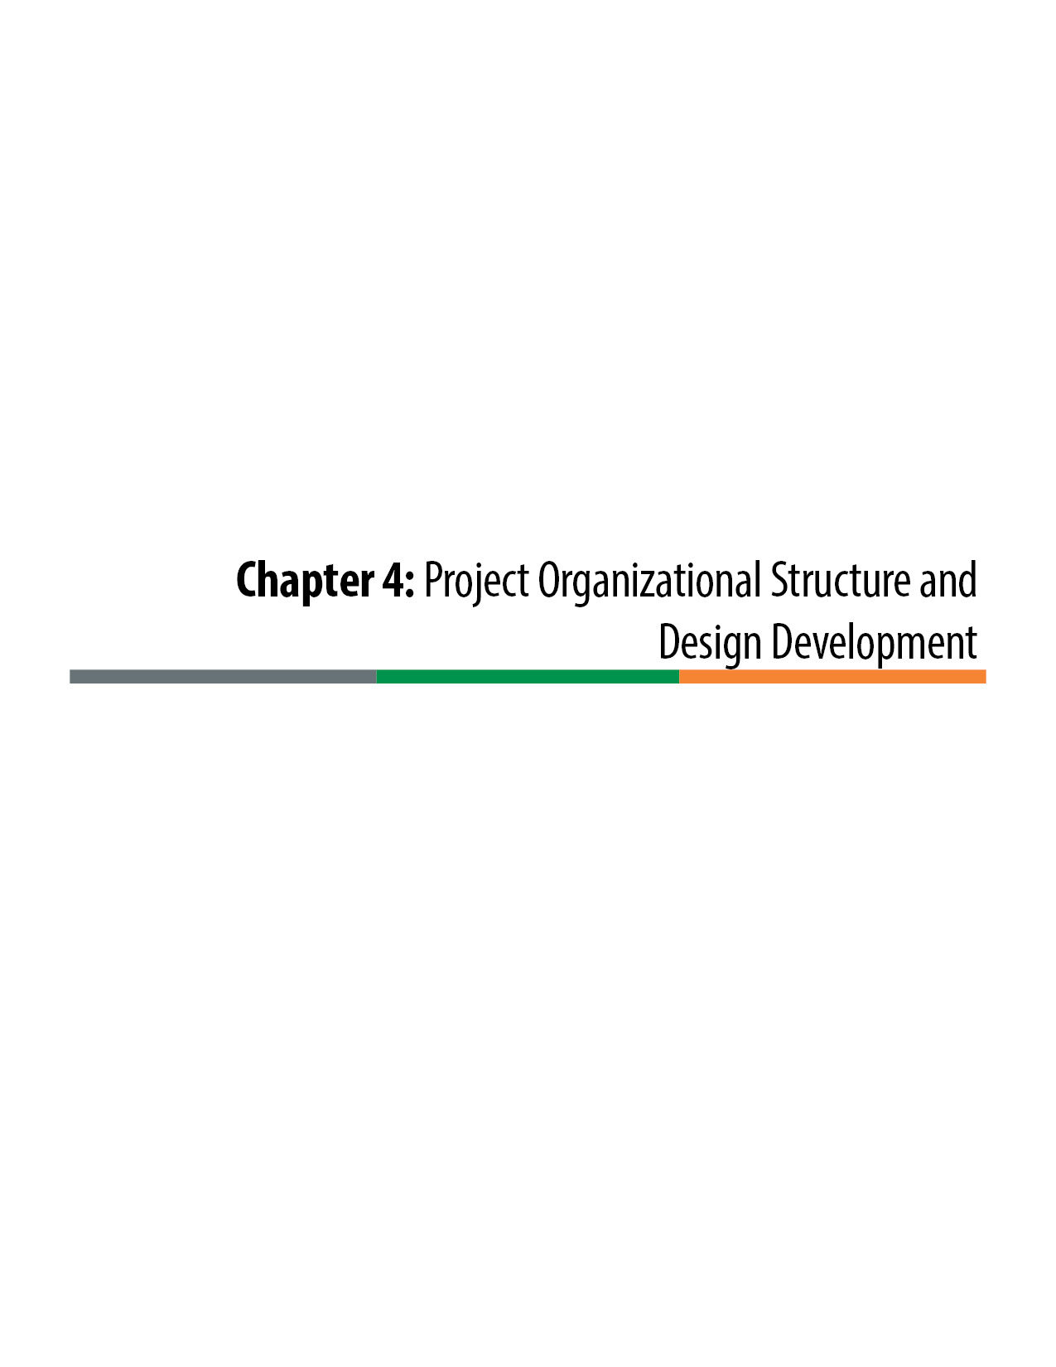

Project Organizational Structure and Design Development

Project Organizational Structure
Design-Build projects are typically large projects that involve multiple agencies and stakeholders and require large project teams. For the projects to be executed efficiently it is important to set up a formalized organizational structure that defines roles, responsibilities, and decision-making authority. The specific organization for a given project may vary but the general structure is usually consistent with the structure shown in the diagram. The roles of the key individuals and groups are:
Project Director: The Project Director is the single point of authority responsible for the administration and implementation of the project. The Project Director is typically a Colorado Department of Transportation (CDOT) resident or program engineer and usually leads both the Project Management Team (PMT) and the Project Leadership Team (PLT). The Project Director is CDOT’s sole contact person and addressee for receiving all communication regarding the project. The Project Director is the only person on the project team that has approval authority, and all approvals by the Project Director should be documented in writing. The Project Director provides guidance from a programmatic level and is a liaison to the Executive Oversight Committee (EOC). The Project Director has the authority to remove any team member for failure to comply with the confidentiality requirements of the project.
Project Manager: The Project Manager role is often provided on large projects. The Project Manager directly supports the Project Director in leading the project and assumes specific leadership responsibilities at the direction of the Project Director. Often the Project Manager leads the development of the design and the Request for Proposal (RFP) development and is involved in more of the intimate details of the project. As the project moves into construction, the Project Manager often leads the design and construction oversight activities, and the Project Director becomes more involved in the administration of the Design-Build contract.
Executive Oversight Committee: The EOC provides overall policy guidance for the project and the Design-Build procurement process. The EOC comprises executive level staff with representation from the CDOT Region, CDOT Headquarters, and the Federal Highway Administration (FHWA). Local governments that participate in funding the project or are within the project limits should be considered for membership on the EOC. The EOC is the project representative of and reports directly to the CDOT Chief Engineer. It is important to recognize that the EOC is empowered to make decisions on behalf of the Chief Engineer, which provides a responsiveness at the project level that is necessary to promote and support project innovation.
The EOC:
- confirms the project goals;
- confirms the release of the Letters of Interest (LOIs);
- confirms the release of the Request for Qualifications (RFQ);
- confirms the Statement of Qualifications (SOQ) Evaluation Plan;
- confirms the short-listed firms;
- confirms the Proposal Evaluation Plan;
- approves the release of the RFP; and
- presents the recommended apparent successful proposer to the Chief Engineer, who will ultimately make the final selection.
Project Management Team: The PMT provides an upper level of management on large projects. It includes key members from the PLT and is supplemented by representatives of key stakeholders, FHWA, and critical technical disciplines. The PMT should also include the CDOT NEPA Manager and CDOT legal counsel on complex projects. PMT representatives of stakeholders and local jurisdictions ensure their organization’s interests are fully considered in the development of the procurement documents. The PMT provides recommendations to the EOC.
Project Leadership Team: The PLT is responsible for the day-to-day management, coordination, and development of the project and the Design-Build procurement process. The PLT comprises members of CDOT, the consultant team, local agency funding partners, and public involvement representatives. On large projects, it is often valuable to have on the team a Design-Build procurement specialist that is provided by the CDOT Region, CDOT Headquarters, or consultant team. If the project is a FHWA Project of Division Interest (PoDI), then the FHWA should be invited to provide representation on the PLT.
The PLT has final decision-making authority over the project’s daily management and coordination activities. The PLT is responsible for the delivery and the development of the procurement documents, including but not limited to: LOIs, RFQs, short-list selection criteria, evaluation of SOQs (“short-listing”), RFP Documents (Books 1–4 and Reference Documents), Proposal evaluation criteria, Proposal evaluations, recommendation to the EOC naming the apparent selected proposer, and debriefs of unsuccessful proposers.
The PLT oversees and directs the activities of the technical teams and incorporates their work products into the procurement documents. The PLT is responsible to ensure all parties involved in the project are aware of and have signed confidentiality agreements. The PLT reports directly to the PMT.
Project Technical Team (PTT): The PTT comprises discipline leads that may be staff from CDOT or its consultant, depending on the availability of CDOT technical staff. The discipline leads direct, prepare, and/or assist in designing, developing, and writing the Book 2 Technical Requirements, supporting Reference Documents, standards, details, and specifications required for the RFP. Members of the PTT may serve on an evaluation board to assist in determining short-listed firms and/or the apparent successful proposer. The PTT reports to the PLT.
Figure 4-1 on the following page shows a typical organization for a Design-Build project.

Confidentiality and Conflict of Interest
During the procurement process, the project team must adhere to strict requirements that apply to all communications with submitters and third parties who are not a part of the project team. Each project team member must sign a pledge to maintain the confidential status of the RFP and any information relating to Proposals or selection of proposers. The exception is FHWA team members who are not allowed to sign confidentiality agreements. Confidentiality agreements are essential to maintain fairness and impartiality during the procurement process. The RFP development, its content, and most importantly the selection process must not be discussed outside of the project team. Additionally, all confidential documents must be kept in a secure location that is not accessible to potential proposers. It is especially important during the selection process that confidential documents are secured at a central location, and they are not to be taken from that location.

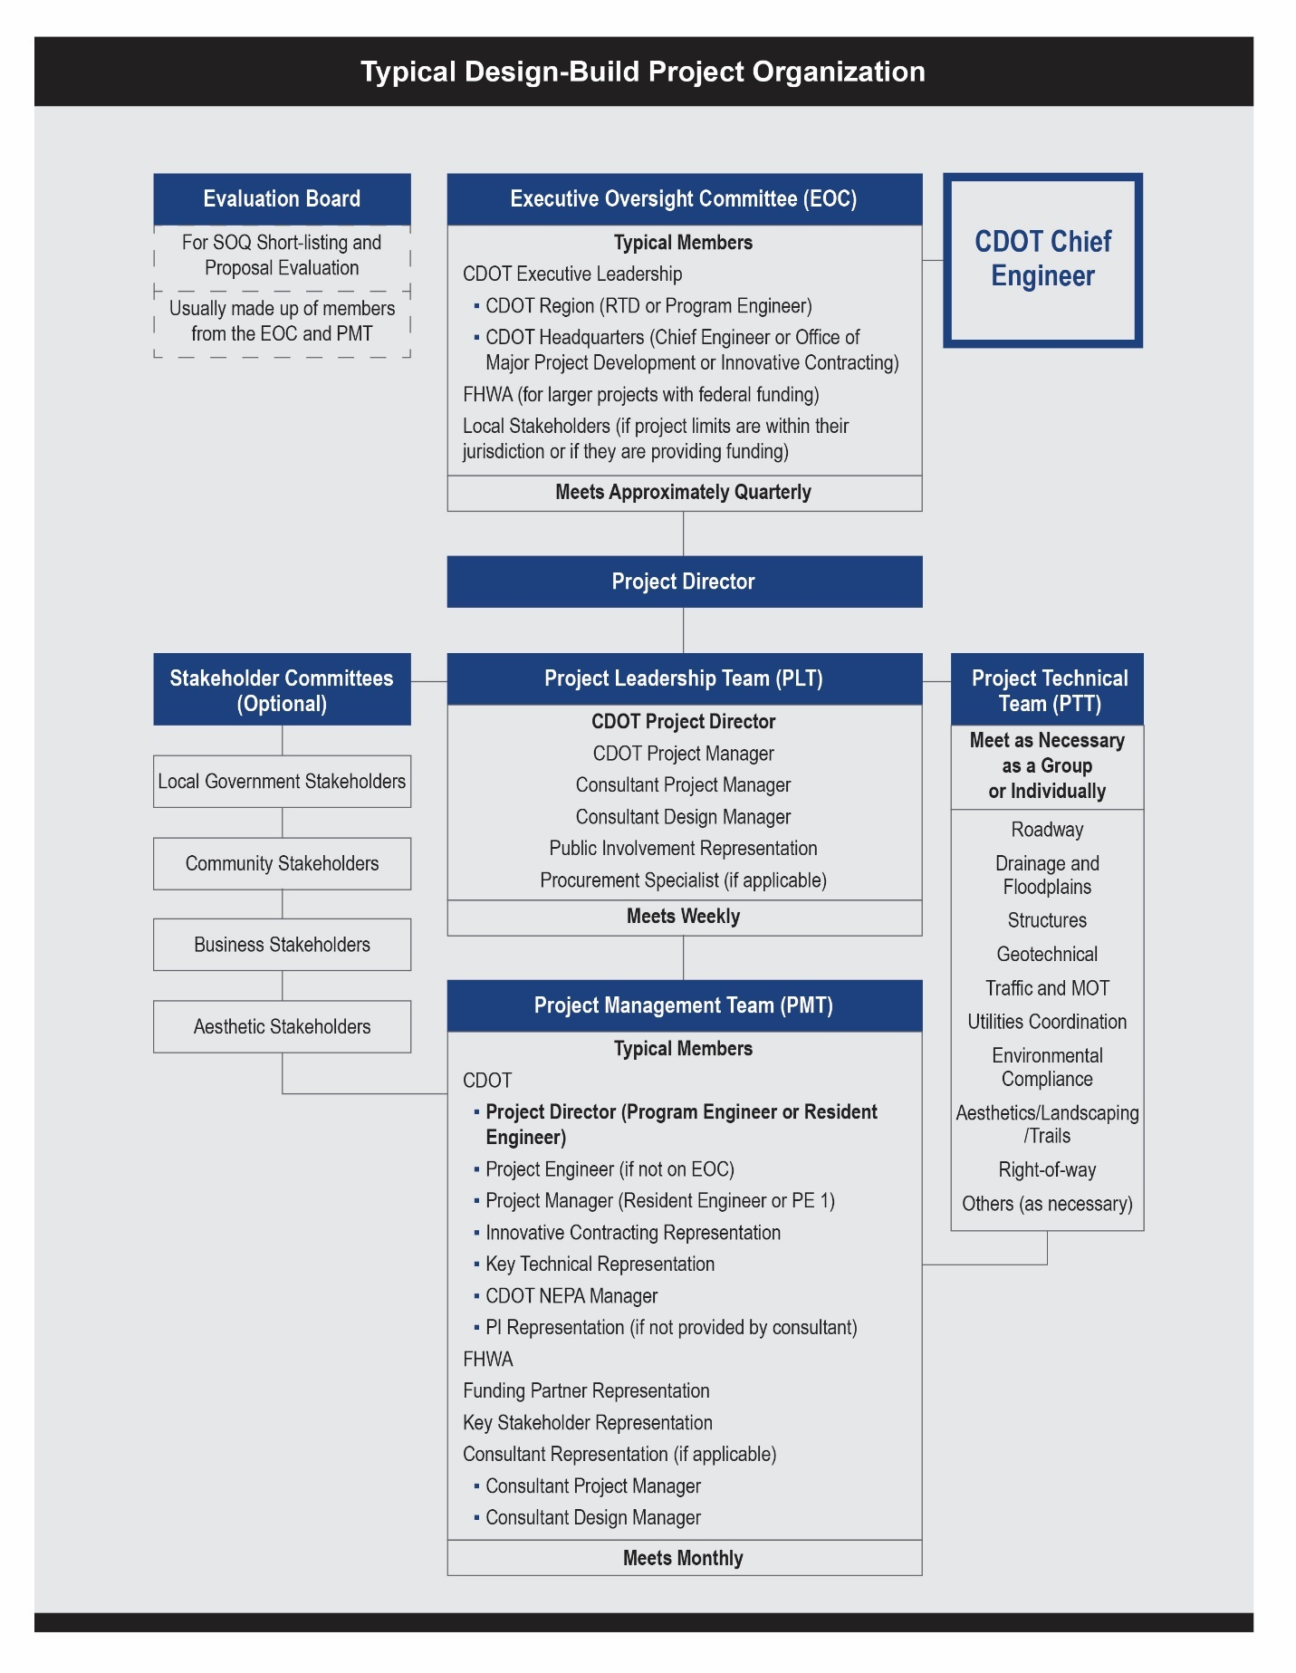
Figure 4-1. Typical Design-Build Project Organization

In order to ensure the integrity of the Proposal process, confidential information regarding the procurement process must not be divulged to any representative of any construction firm, any consultant, any member of the media, any member of the public, and any person who is not a member of the project team. Internal confidential information exchange shall be conducted only as necessary to conduct the procurement process. When information is released to proposers, it is important that the information is released to each competing proposer simultaneously and uniformly, thus ensuring that no one proposer gains a competitive advantage over another.

Procuring a Design Consultant
Given the level of effort that is required of the owner’s team, both in the procurement phase and the implementation phase of the project, CDOT often procures the services of a program management consultant team. The consultant team can provide expert support in the following activities:
- Project goal setting
- Project Delivery Selection Matrix (PDSM) facilitation
- Design development
- Development of RFQ, RFP, and Contract Documents
- Supporting the procurement phase of the project
- Supporting the implementation (construction) phase of the project
Consultants can be procured either separately for the procurement and implementation phases of the project or under a single contract that issues separate consecutive task orders for the procurement and implementation phases of the project.
Care should be exercised to ensure there is no conflict of interest with any members of the consultant’s team. The state Design-Build regulations specifically prohibit consultants participating on both the owner’s team and the Design-Builder’s team. Per 2 CCR 601-15, Section 7, members of the Design-Build team are prohibited from having any involvement in the development of:
- the scope of work of the project,
- the RFQ or RFP for the project, and
- more than 20 percent of the preliminary design of the project.
If there is any question of potential conflict of interest, then the consultant should formally petition CDOT for a determination prior to pursuing a role on the project. If it is determined to use a program management consultant on the CDOT team, then it is in the best interest of both CDOT and the industry to procure the consultant early in the process to minimize potential conflicts of interest and provide consultants that are not selected for the role the best opportunities to pursue positions on Design-Build teams.

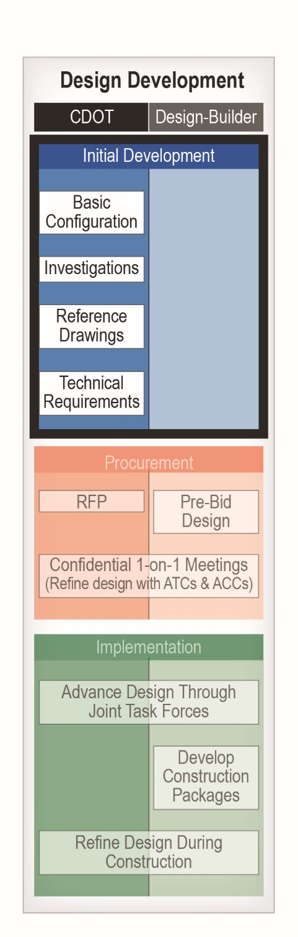
Design Development
Design development for Design-Build projects is a distinctly different process than for Design-Bid-Build (D-B-B) or Construction Manager/General Contractor (CMGC) projects. In D-B-B and CMGC, the designer is working directly for the owner, whereas in Design-Build the designer works directly for the contractor. It is important to recognize that not having a direct contractual relationship with the designer does not exclude the owner from the design process in Design-Build projects. In fact, in the most successful Design-Build projects, the owner is intimately involved in the design development from the initial development of the project, through the procurement phase of the project, and throughout the implementation phase of the project to its completion.
Figure 4-2 illustrates the design development process.
Initial Development: The development is initiated by the owner, who defines the scope of the project with the Basic Configuration. The owner also undertakes on-site investigations to gather information needed to define project requirements and allocate risk. These usually include utility and geotechnical investigations, examining existing drainage and maintenance problems, and so forth. The design then advances to the preliminary design stage during which Reference Documents (including the preliminary plans) and Technical Requirements are developed. The focus of this phase of the design development is to:
- ensure the project scope and requirements are well defined and reflect the project goals;
- ensure the project is constructible within the identified budget;
- provide necessary data, investigations, and analyses to proposers; and
- advance the design as necessary to properly identify, manage, and allocate risks, such as Right-of-Way (ROW), environmental compliance, and so forth.
Figure 4-2. Design Development
The NEPA process needs to be carefully addressed in the initial project development phase. The project team needs to understand and distinguish which elements of NEPA are to be completed by CDOT (and when), and which elements of NEPA are the Design-Builders responsibility. NEPA processes can have a significant impact on the project schedule.
Procurement: The design is then refined by the proposers in the procurement phase. The owner maintains involvement in the design process during this phase through one-on-one meetings with proposers. Often there is a perception that in Design-Build, the procurement phase’s only purpose is to select the Design-Builder for the project. Although that is a primary objective of the process, there is also significant advancement of the design throughout the procurement phase that is critical to setting the direction of the final design that follows selection. The procurement phase of the project needs to be properly structured and allow enough time to foster design development, which leads to innovative designs that benefit the project. This process is elemental to the advantages of Design-Build delivery. The procurement process is described in detail in Chapter 5.
Implementation: After selection of the Design-Build proposer is finalized, the design is further developed through a collaborative process between the owner and the Design-Builder. This is usually accomplished by establishing design task forces through which the Design-Builder and the owner collaborate on project-related specialties such as environmental compliance, drainage, traffic management, public relations, roadway and structure design, and so forth. In the most successful projects, the owner’s involvement in the design during the implementation phase goes beyond design reviews and approvals to working together with the Design-Builder to develop design refinements that benefit both parties. Because the owner maintains Acceptance authority over the design, it is most efficient for the owner to provide immediate feedback and guidance at design task force meetings in order to assure that expectations for design Acceptance are known prior to any official submittal of any contract deliverables. The implementation process is described in Chapter 8.

Organization of Design Documents
The organization of the design documents in Design-Build delivery varies significantly from other methods of delivery such as D-B-B and CMGC. In D-B-B and CMGC, the design is completed to 100 percent by the owner and presented in the design plan drawings and details and the technical specifications (CDOT Standard Specifications, Standard Special Provisions, and Project Special Provisions). In Design-Build there is a need to specify both the design work and the construction work in the RFP, which becomes the contract for the selected Design-Builder. Therefore, the RFP must include all of the binding requirements of both the design and construction processes within its provisions. The RFP also needs to communicate the design development that has been performed in advance by the owner, as it will form the starting point for the Design-Builder’s design development.
After selection of the Design-Builder for the project, the design is advanced to its completion. The design documents that are developed during the implementation phase typically fall into five categories:
- Preliminary design plans, which formalize the preliminary design of the project.
- Released for Construction (RFC) Documents, which direct the construction of the project.
- Notice of Design Changes (NDCs) and Field Design Changes (FDCs), which provide revisions to the RFC Documents as the design is further refined throughout the construction.
- Final Design Documents, which are submitted to obtain CDOT’s formal Acceptance of the project design.
- As-Built Documents, which are submitted to obtain CDOT’s formal Acceptance of the project construction.
Additional discussion of design development in the implementation phase of the project is provided in Chapter 8.
Structure of RFP and Design-Build Contract:
Table 4-1 on the following page summarizes the elements of the RFP and Design-Build contract.

Table 4-1. Design-Build Documents
Book 1 – Contract
Book 1 is the overriding Contract that governs the design and construction of the project. Key elements of the book include:
- Contract Terms  - Defined Terms  - Warranties  - Equal Employment Opportunity/Disadvantaged Business Enterprise  - Bonding  - Insurance  - Payment  - Project Schedule  - Completion and Milestone Dates | - Processes and Procedures  - Dispute Resolution  - Change Management  - Partnering  - Third-Party Cooperation  - Audit and Inspection Rights  - Incentives and Disincentives  - Value Engineering
Book 2 – Technical Requirements
Book 2 provides the project-specific Technical Requirements of the project, including design criteria, methodology, and deliverables; project-specific construction requirements; and operational requirements. Book 2 is divided into 20 sections:
01. General (includes the Basic Configuration)  02. Project Management  03. Quality Management  04. Public Information  05. Environmental  06. Third-Party Agreements  07. Utilities  08. Right-of-Way  09. Survey  10. Geotechnical and Pavements | 11. Earthwork  12. Drainage  13. Roadways  14. Signing, Pavement Marking, Signalization, and Lighting  15. Structures  16. Transportation Management Plan  17. Landscaping  18. Maintenance during Construction  19. Intelligent Transportation System  20. Modification of Standard Specifications
Book 3 – Applicable Standards, Data and Reports | Book 4 – Contract Drawings
Book 3 includes documents such as CDOT design guides, American Association of State Highway & Transportation Officials (AASHTO) design standards, Manual on Uniform Traffic Control Devices (MUTCD), local design standards, CDOT M & S standards, CDOT construction and materials manuals. | Book 4 contains drawings that are considered to be contractually binding. Typical Contract Drawings include ROW Plans, architectural plans and details, geotechnical boring logs, and binding third-party plans and details.
Reference Documents
Reference Documents are nonbinding plans, details, reports, and investigations related to the project. Elements of Reference Documents can become binding to the extent that they are referenced to in the Contract Document. Reference Documents communicate the design development done by the owner. Reference Documents typically include:
- Preliminary Plans and Details  - Preliminary Phasing Scenarios  - Preliminary Drainage Reports | - Surveys (if not in Book 3 or 4)  - Preliminary Geotechnical Recommendations  - NEPA Documents (EA, EIS, FONSI, ROD)

As shown in Table 4-1, the Design-Build documents are organized into four books and Reference Documents. Each of the books is an essential part of the contract, and a requirement occurring in one is as binding as a requirement occurring in all. The books are intended to be complementary, but as they are Contract Documents it is important that there be an order of precedence, as follows:
- Book 1 – Contract, as executed by CDOT and the Contractor
- Book 2 – Technical Requirements
- Book 3 – Applicable Standards, Data and Reports
- Book 4 – Contract Drawings
- Proposal Documents, to the extent they meet or exceed the requirements of the other Contract Documents. In other words, if the Proposal Documents include statements that can be contractually interpreted as commitments to provide higher quality, scope, or value or to perform additional services to the benefit of CDOT, then they are contractually binding.
Reference Documents are provided to support the Contract Documents. They are not binding contractual documents, but they communicate the design development that has been done to date by the owner.

The Basic Configuration
The Basic Configuration defines fundamental parameters of the project, and it is a critical provision in the Contract Documents. The Basic Configuration is described in the RFP in Book 2, Section 1. Unlike the project description, which is furnished to the proposers as information, the Basic Configuration is a contractual obligation to which the Design-Builder must conform. The Basic Configuration describes the scope of the improvements and elements that at a minimum must be included in the Proposal by a Design-Build team. It should provide a concise but complete description of the scope of the construction work of the project. The Basic Configuration is generally a narrative description and not a set of plans, exhibits, or technical documents.
The Basic Configuration combines with the technical provisions of the RFP to fully define the project. Generally, the Basic Configuration describes what is to be built, and the technical provisions describe how it is to be designed and constructed.
The essence of writing the Basic Configuration is finding the appropriate balance between maintaining sufficient control over the basic design and allowing enough room to incorporate innovative ideas from the proposers. The owner should have a good understanding of project goals and risk allocation before developing the Basic Configuration.
The project limits should be defined in the Basic Configuration. The project limits are typically defined by the limits of the owner’s ROW. ROW acquisition is typically best performed by the owner with the goal of developing a footprint in which the Basic Configuration can be constructed. Then the proposers can assess any needs and risks of additional ROW acquisitions to accommodate their specific designs.
The project limits are also important with regard to environmental clearances. The project limits should ensure that the environmental footprint of the construction does not exceed that of the environmental decision document.
Conceptual horizontal and vertical alignments are often provided (or referenced) with the Basic Configuration. The Basic Configuration defines ranges of acceptable alignments to provide flexibility while ensuring that the facility aligns with adjacent facilities, environmental requirements, and long-range corridor plans.
Critical project components, such as interchanges, on- and off-ramps, and number of lanes, often are included in the Basic Configuration.
The Basic Configuration also can be performance based, requiring defined traffic operations and accessibility to certain locations rather than specifying the number of lanes and location of interchanges (e.g., meeting specific Levels of Service, based on the approved 20-year traffic forecast).
However it is defined, the Basic Configuration is the foundation of the project scope of work and its elements may not be omitted, altered, or substituted in a Proposal without approval by the EOC.
The Basic Configuration should be defined in such a way as to give the Design-Build team leeway to make design adjustments that provide cost or schedule advantages while maintaining compliance with project goals, objectives, criteria, and other contract requirements. The "envelope" described by the Basic Configuration provides the Design-Build team the flexibility to modify the preliminary design developed by the owner, which is important in transferring the ownership of the design from the owner to the Design-Build team. In writing the Basic configuration, the owner should avoid imposing unnecessary controls over the design that may lay liability for design defects on the owner and limit the Design-Builder's flexibility for innovation.
An example of a Basic Configuration is provided in Figure 4-3.
1.1 Project Description
The project is located on I-25 in northern Colorado Springs, starting at Pine Creek and proceeding north to the Monument Interchange. The project involves the widening of the I-25 corridor to six (6) through lanes, plus auxiliary lanes, from the Pine Creek Bridges north to the existing concrete pavement, with a twelve (12) foot outside shoulder and a twelve (12) foot inside shoulder and eight (8) foot outside shoulder adjacent to auxiliary lanes. Additional paving will be required north of the existing concrete pavement for the NB lanes.

1.2 Basic Configuration
The Basic Configuration is defined as work within the ROW that is required to conform to the eight (8) lane configuration and six (6) lane configuration of I-25 north of Colorado Springs and typical sections at selected locations, as shown in the Basic Configuration Exhibit. The Basic Configuration is further defined as follows:
- Lane Configuration:
  - From Pine Creek to Interquest Parkway
    - Three 12ft. travel lanes
    - 12-ft. inside shoulder (future HOV lane), 12-ft. outside shoulder without auxiliary lanes
    - Auxiliary lanes with 8-ft. outside shoulder
  - Interquest Parkway to Monument Interchange
    - Three 12ft. travel lanes
    - 12-ft. inside shoulder and 12-ft. outside shoulder
- Any structures constructed shall conform to the eight (8) lane configuration or the six (6) lane configuration as shown in the Reference Documents.
- Improvements to the I-25 / Northgate Interchange on- and off-ramps
  - Eliminate loop ramps
  - Convert to diamond interchange with signalized intersections. The proposed ramps shall be compatible with the proposed action of the I-25 Environmental Assessment (EA)

Figure 4-3. Basic Configuration Example

Preliminary Investigations
Preliminary investigations are important elements of the design. They provide the information to proposers that is necessary for them to perform their Proposal design. Preliminary investigations also reduce project risk for both the owner and the proposers, and as result they support an aggressively priced project. Results of preliminary investigations can be incorporated in Book 3 (Applicable Standards, Data and Reports), Book 4 (Contract Drawings), or the Reference Documents. Because a primary purpose of the investigations is to reduce risk, it is beneficial for the results of the investigations to be put in Book 3 or Book 4, whenever possible, so that the proposers are entitled to rely upon the information; however, if the information must be validated or is specific to the Basic Configuration only, it is more appropriate to put it in the Reference Documents. The need for preliminary investigations should be based on the risk assessment process discussed in Chapter 3. Some common preliminary investigations are:
- Design Surveys: These are necessary to provide a database for the Proposal designs. If design surveys are not performed by CDOT, then the effort will be duplicated by all proposers simultaneously during the procurement period and also may not be completed adequately to support strong and accurate Proposal designs. Design surveys should be supplemented with as-built information on existing facilities.

- Geotechnical Investigations: The basic geotechnical information necessary to design pavements (if applicable), bridges, and retaining walls reflecting the Basic Configuration should be completed and provided to proposers. Geotechnical information need only include the boring logs and test results and should be included in Book 4. If geotechnical recommendations are provided, they should be separated out from the basic data and provided in the Reference Documents for information only.

- Utilities Investigations: Utilities coordination and relocations almost always have the potential to be a major risk on transportation Design-Build projects. A strong investigation program performed by the owner in advance of the procurement significantly reduces risk potential and helps the proposers to give CDOT the best technical and price proposals possible.

- Environmental Investigations: Additional environmental information is often necessary to reduce risks for both the owner and the Design-Builder. In particular, Hazardous Materials Investigations should be conducted to identify the best approach to minimize and/or allocate hazardous materials risk. At a minimum, investigations should be performed to accurately characterize the nature and locations of any hazardous materials. Additional site investigation to accommodate potential project Permanent Water Quality (PWQ) features may also be warranted.

Preliminary investigations are further discussed in Chapter 7, “Structure and Content of the Request for Proposal.”

Design Development of the Reference Documents
CDOT’s design development leading to the procurement process is primarily presented in the Reference Documents. The Reference Documents typically include preliminary plans and design reports. It is important to understand that the Reference Documents are for information only and do not dictate design requirements to the Design-Builder. Similarly, the Design-Builder is not entitled to rely on any designs that are provided in the Reference Documents.
The reason for segregating the owner’s advance design effort in this manner is to clearly define the legal design responsibilities for the project. Design-Build delivery seeks to allocate the primary design responsibility solely to the Design-Builder. Wherever the design responsibility is shared, the professional liability associated with that design (and any errors and omissions) can be difficult to assign. For example, if the owner requires a specific horizontal or vertical alignment that is out of compliance with design criteria, or that requires the design of an associated element of the project to be out of compliance, then the owner shares the professional liability associated that substandard product.
Though they are nonbinding, the Reference Documents serve important purposes. They communicate the intent and expectations of the owner with regard to the project design, and as such they provide valuable insights to the proposers, whose designs are in turn evaluated by the owner as a part of their Proposals. The Reference Documents also provide the proposers with a starting point for their further advancement of the design during the Proposal phase of the project, significantly reducing the need to duplicate the design development performed by the owner prior to the Proposal phase of the project.
Sometimes it is valuable to invoke certain elements of the Reference Documents into the project contract through Book 2 – Technical Requirements. A common example is to incorporate roadway typical sections shown in the Reference Documents into the Contract Documents. Another example is invoking certain elements of the NEPA documents (when they are included in the Reference Documents instead of Book 3). When elements of the Reference Documents are invoked into the contract by reference they are as binding as the section of the contract in which they were referenced. Rather than citing the Reference Documents, the preferred way of incorporating elements of the Reference Documents into the Contract Documents is by creating separate exhibits that are included in the relevant sections of Book 2. That approach avoids confusion over which elements of the Reference Documents are binding.
To maximize the efficiency and effectiveness of the procurement process, it is important to release as much of the information generated during the initial design development phase of the procurement process as possible through the Reference Documents. There may be rare exceptions of confidential documents related to politically sensitive issues or third-party considerations, but for the most part the more information that is provided to the proposers the better they can develop designs and Proposals that maximize their ability to fulfill CDOT’s goals for the project. The proposers are not entitled to rely on the Reference Documents and have the responsibility for validating the information, which enables the approach of full disclosure.
The level to which the design development should be advanced is very dependent upon the specific nature of the project and the associated risk. The owner must provide enough of the preliminary design for the project to ensure that the project scope is sufficiently characterized (through the Basic Configuration), to ensure constructability, and to minimize risks for proposers and for the project as whole. Although it may seem logical to advance the entire preliminary design to a set percentage of design (such as 30 percent), such an approach does not respond to the objectives of pre-procurement design development in Design-Build delivery. Each element of the project must be examined to determine how much design needs to be completed to convey the scope while not placing undue risk on the Design-Builder for design. The best RFPs contain elements with varying levels of design as necessary to define the scope of work and manage the risk. The goal is to convey the project's scope to the proposer with a minimum level of design so that the proposer may create an innovative design and be fully responsible for any errors and omissions in the end product.
The Design-Build Institute of America (DBIA) addresses the level of design development:
Procurement documents need to address line and grade development in a manner that allows flexibility with ROW, environmental, storm water facilities, utility impacts and other project characteristics without advancing the design to a level that stifles innovation and best value. Utilizing this approach can stimulate the benefits of competitive design creativity which drives design-build delivery. A defined set of line and grade documents will provide sufficient detail to define the project footprint, horizontal and vertical alignment, proposed bridge and retaining structures, required environmental mitigation, ROW and utility impacts while still allowing for best-value procurement that achieves maximum benefit from the use of design-build delivery.
The level of design development required prior to issuing the project RFP should flow out of a risk assessment and the initial completion of the Risk Register, as described in Chapter 3. Some common design elements that often need to be advanced are:
- Utilities coordination and agreements: These are based on the Basic Configuration to minimize the significant risks associated with utilities relocation schedules and costs.
- Third-party designs and requirements: CDOT is typically in a better position to manage third-party risks and to advance third-party coordination to provide definitive requirements in the RFP (i.e., intergovernmental agreements and/or third-party review commitments and protocols).
- Railroad designs and agreements: Railroad approvals and agreements are often subject to a high degree of uncertainty and risk. CDOT is typically in the best position to advance railroad designs, approvals, and permitting so that railroad-related requirements are not in the critical path of the project schedule. Railroad coordination is most often to some degree a shared risk.
- Pavement type selection: Industry sensitivity to pavement types, life cycle cost analysis, and related processes often make it impractical to allow the Design-Builder to take on pavement design.
- Master drainage report (conceptual), including drainage crossing hydrology and hydraulics: This eliminates the need for proposers to duplicate costly and time-consuming efforts in the procurement phase.
- PWQ: It is often beneficial to address the uncertainty of Municipal Separate Storm Sewer System (MS4) compliance by providing preliminary designs for default systems and facilities.
- Environmental permitting: In some cases, the permitting process can be advanced more effectively by CDOT than by the proposers during the procurement to minimize environmental agency approval risks.
The NEPA process should be considered when advancing the design development. NEPA regulations dissuade developing the overall design of the project to more than 30 percent prior to the completion of the NEPA decision document.

Right-of-Way Acquisitions
In the majority of Design-Build projects, the owner acquires the ROW necessary to construct the project. The design development needs to be advanced as necessary to allow for the preparation of ROW Plans and to complete the subsequent acquisition processes.
The ROW Plans usually provide the contractually binding limits of the projects, and are included in Book 4 – Contract Drawings.

Design Development of the Technical Requirements (Book 2)
As design development for the project advances with the development of the preliminary plans, it becomes important to concurrently begin drafting the Technical Requirements. Both of these key aspects of the owner’s design development need to be well advanced for inclusion in the Draft RFP (refer to Chapter 5). Whereas the preliminary plans are nonbinding inclusions in the Reference Documents, the Technical Requirements are the primary binding documents that tell the Design-Builder how to manage and design the project. As shown in Table 4-1, the Technical Requirements are organized into 20 sections by discipline.
Refer to Chapter 7, “Structure and Content of the Request for Proposal,” in this manual for additional discussion of the Technical Requirements.

Cost Estimating
Cost estimating is an important part of the design development process. Most large Design-Build projects have budgetary constraints, so it is vital to ensure that the Basic Configuration can be constructed within a set budget. In addition, FHWA considers large projects of more than $500 million (year of expenditure) to be “Major Projects” that require a formal Cost Estimate Review (CER).
Many CDOT Design-Build best value Proposal formats include a Guaranteed Maximum Price (GMP) that cannot be exceeded by the proposers, requiring accurate early estimates by CDOT. Best value formats also typically include Additional Requested Elements (AREs) that require accurate estimates by CDOT to properly include in the Proposal scoring formats.
Design-Build projects do not have the luxury of having a 100 percent design completed for developing an engineer’s estimate prior to the bid of the project. As a result, the project team needs to develop the means to accurately estimate the project without reliance on a detailed bid item quantity breakdown.
Parametric estimating is one methodology that is often employed to prepare cost estimates for Design-Build projects during the initial design development stage of the procurement process. This method identifies historical projects of similar character and evaluates costs of various elements of work as a percentage of core item costs for the project. Another procedure to employ is to identify the elements of the project that bear the highest costs and perform detailed estimates for those items. Developing an accurate estimate usually requires the use a combination of approaches and possibly independent review.
The use of an Independent Cost Estimator (ICE) can be a valuable tool to use to validate critical cost estimates. ICE firms perform production-level cost estimates using the same procedures that contractors employ in bidding projects. The methodology can provide a significant improvement in the level of confidence in the accuracy of the cost estimate.

Design-Build Institute of America (DBIA), Design-Build Done Right Transportation Sector Best Design-Build Practices (January 2015), 3, retrieved from http://www.dbia.org/resource-center/Documents/bestpractices_transportation.pdf.

