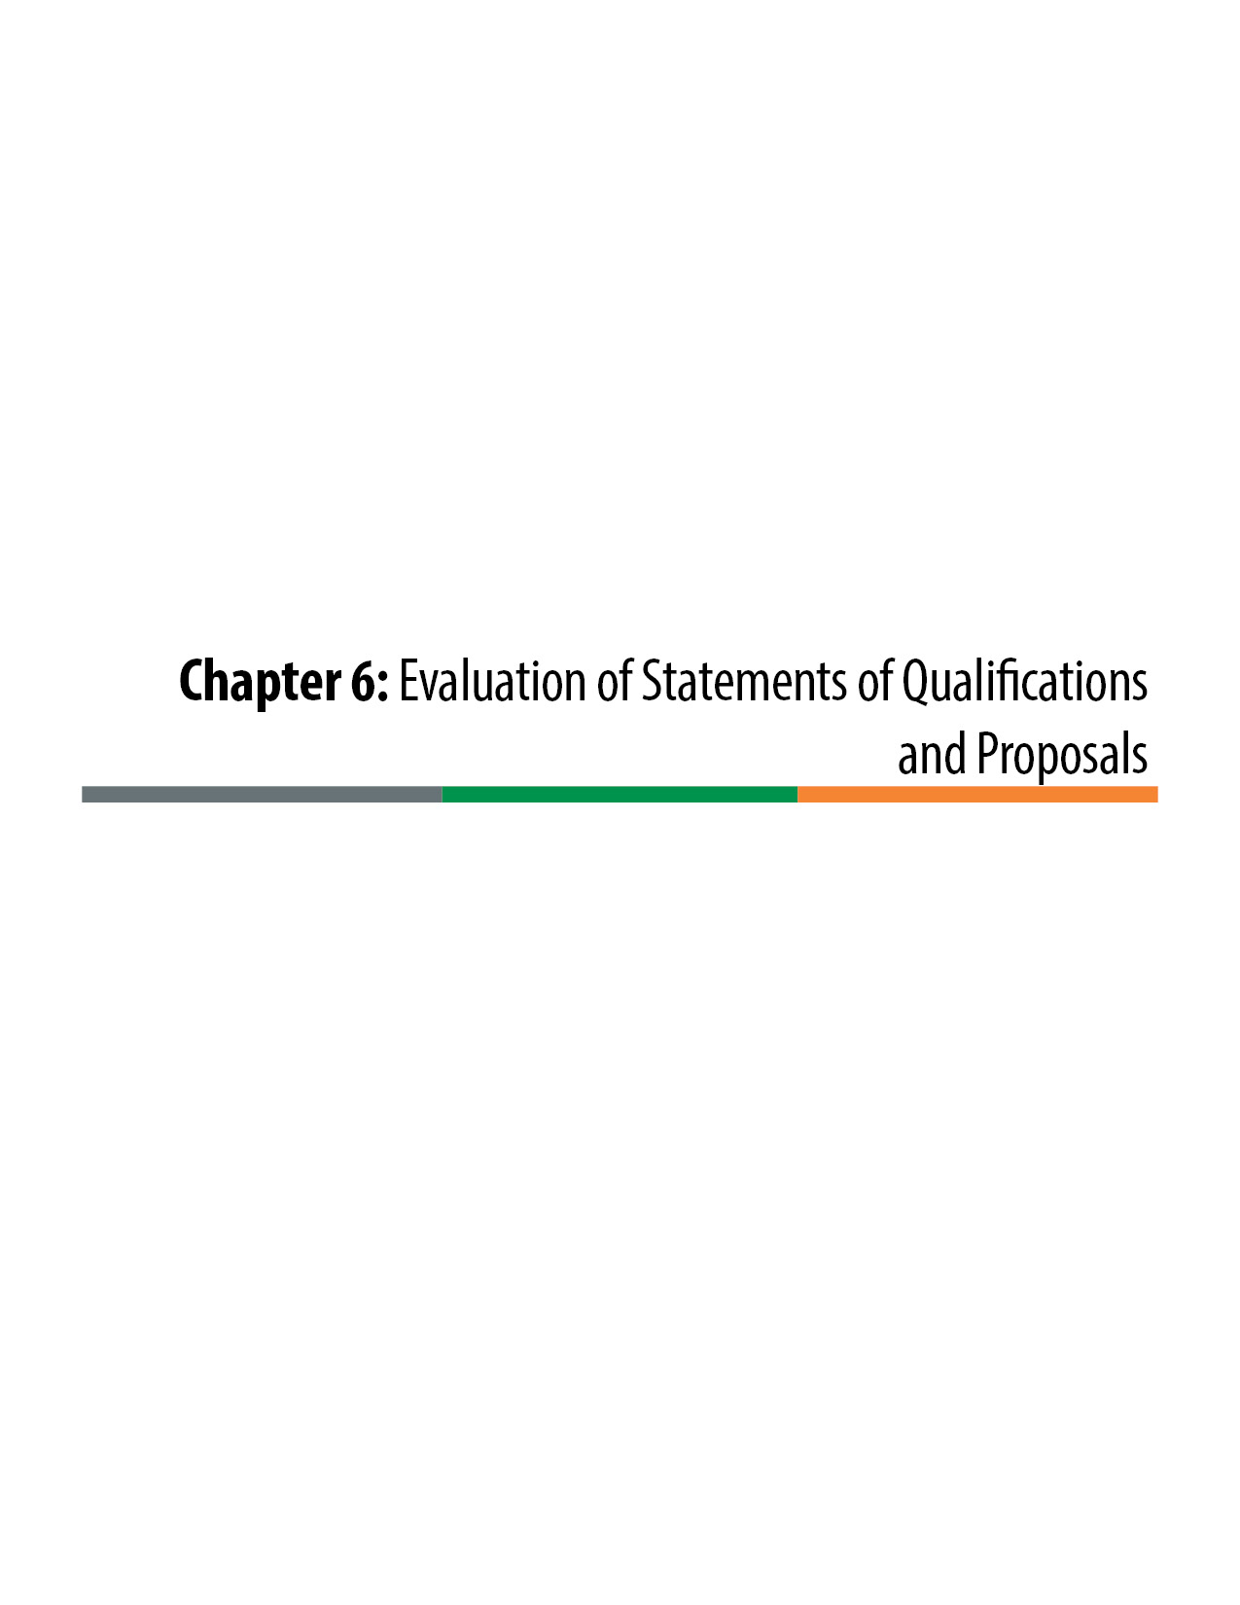

Evaluation of Statements of Qualifications and Proposals
Design-Build procurement evaluation procedures are unique to the delivery method. The extensive nature of the Design-Build procurement process warrants rigorous and defensible processes be executed for both the short-listing of qualified Design-Builders and the ultimate selection of a single Design-Build entity to perform the project. The Statement of Qualifications (SOQ) evaluation procedure and the Proposal evaluation procedure are summarized in Figure 6-1 below. A formal project-specific written evaluation procedure plan is developed for both the SOQ evaluation and the Proposal evaluation. Both plans should be approved by the Executive Oversight Committee (EOC) before the evaluations begin.
SOQ and Proposal evaluation plan templates are provided in the online Appendix on the CDOT Innovative Contracting web page or by contacting CDOT Innovative Contracting. The following discussion provides guidance in the development of project-specific evaluation plans.

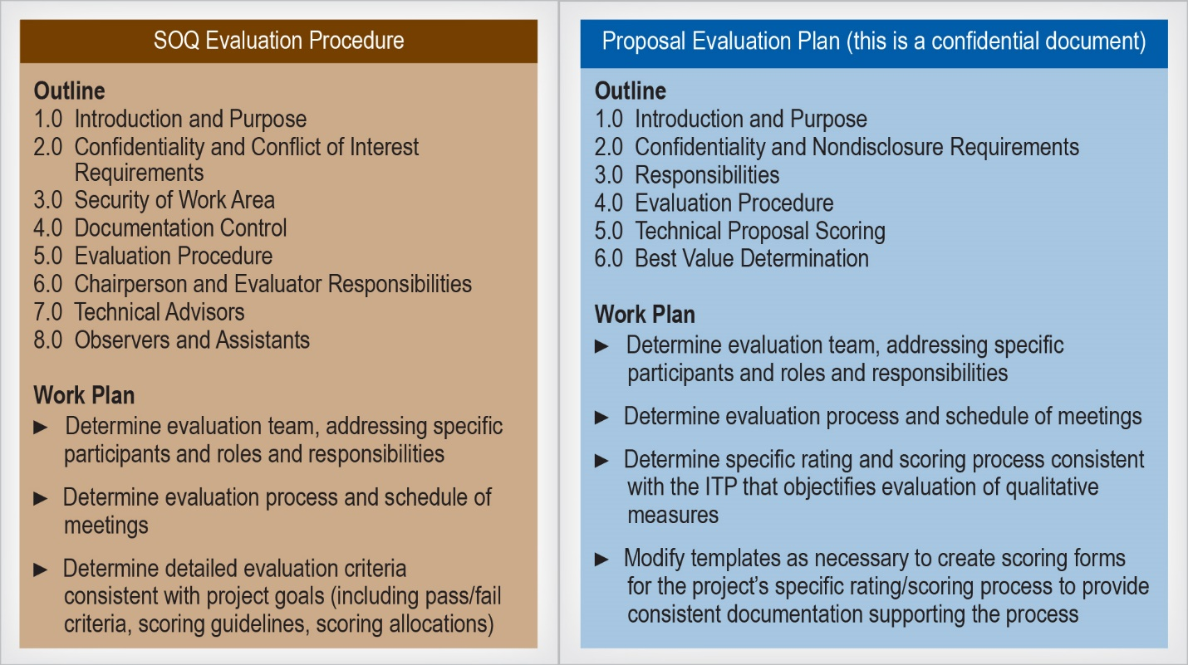

Figure 6-1. The SOQ and Proposal Evaluation Procedures
Evaluation Plan Transparency:
Subjectivity in evaluations: “An essential premise in design-build evaluation planning is that the design is not complete at contract award. Thus, it is always in the owner’s best interest to ask for information regarding the design-builders’ design approaches. The review of design product, in any form, is by definition an exercise in the application of professional judgment.…
A protest of a design-build evaluation plan in Minnesota dealt with the issue of subjectivity in the evaluation process. The plaintiff, a design-build team who had failed to make the shortlist, argued that the process was ‘arbitrary and capricious.’ In its Findings of Fact, the district judge stated: ‘The court recognizes that there is a human element in the evaluation process. It would be impossible to use people in the process and filter out subjective evaluation. However, the court also recognizes that the fact that the process could be improved does not make the process used in this case arbitrary or capricious.’ ⁷
This finding also discussed the fact that the requirements for making the shortlist were published in the RFQ, that the evaluators were professionally competent to make judgments between competing statements of qualifications, and that the evaluation criteria were applied as published. Thus, the protest was denied and the Minnesota Department of Transportation’s evaluation plan was vindicated even though it contained an element of subjectivity, [precisely because it was transparent].”⁸
The American Association of State Highway and Transportation Officials (AASHTO) stresses the importance of transparency in Design-Build evaluation planning in the AASHTO Guide for Design-Build Procurement, which states, “It is imperative for all the parties involved in a design-build project that the evaluation plan be fair, equitable, and transparent.” The evaluation process should clearly indicate what the Colorado Department of Transportation (CDOT) values and show the process by which CDOT determines the short list from the SOQ submittals or, in the case of the Proposal submittals, which proposer provides the best value to CDOT.
In the Proposal phase in particular, evaluation processes that are not transparent or appear to be unfair expose CDOT to potential protests from the unsuccessful proposers. The following list of recommendations, excerpted from AASHTO’s Guide for Design-Build Procurement, should be followed:
- “Clearly state the evaluation criteria and weight given for each item and ensure that the evaluation team uses them.
- Clearly state the requirements of the RFP including what will be considered a non-responsive submittal.
- Do not seek from design-builders the number or dollar amount of changes on past projects constructed by them.
- [In the proposal phase,] give equal opportunity … for each short-listed submitter to converse with representatives of the public [owner’s] evaluation team to clarify their proposal and any of the requirements of the RFP.
- [In the proposal phase] provide candid feedback and a stipend to unsuccessful bidders.”
AASHTO based this list on “several cases where the award was successfully protested because the evaluation plan was unclear and overly subjective. Award protests and their subsequent project delays are avoidable if the agency invests the upfront resources necessary to develop a fair, equitable, and, perhaps most importantly, transparent evaluation system with which to select the best value from among several competing proposals.”9
Scoring Systems:
Public owners use a variety of evaluation scoring methods, ranging from quite simple to very sophisticated. Scoring methods can yield numeric results or be more qualitative in their assessments. All can be categorized into four types of methods:
- Satisficing (acceptable or not acceptable)
- Modified Satisficing (provides some distinction of acceptability)
- Adjectival Rating
- Direct Point Scoring
For descriptions of these types of scoring systems, refer to the AASHTO Guide for Design-Build Procurement.10 Also refer to Chapter 5, Section 5.3.3.2, “Design-Build Best Value Formula,” in this manual for additional discussion of scoring procedures.
CDOT has determined traditionally to use an adjectival rating type of scoring methodology for Design-Build projects and has created a process that is repeatable and very successful. When a project team wishes to use an alternative to the adjectival rating system, it must gain approval from the Chief Engineer before proceeding. The adjectival rating methodology is described later in this section.
Confidentiality and Nondisclosure Agreement:
All evaluation team members, technical advisors, and all other staff that are part of the process (except FHWA participants) should sign a Confidentiality and Nondisclosure Agreement and Conflict of Interest Certificate prior to commencement of the evaluation process. Anyone who fails to sign the Certificate must be excluded from participation in the evaluation. Indications of real, apparent, or possible conflicts of interest should be resolved by the Project Director in accordance with the code of ethics for public employees established by C.R.S. § 24-18-109 (http://www.lexisnexis.com/hottopics/colorado?app=00075&view=full&interface=1&docinfo=off&searchtype=get&search=C.R.S.+24-18-109). If the conflict cannot be resolved, the individual involved should be removed from the evaluation process. Confidentiality and Nondisclosure Agreements and Conflict of Interest Certificates must be retained as part of the evaluation record.
Security of the Work Area:
Each member of the evaluation team should be issued one copy of each submittal. When working with the evaluation materials, members of the evaluation team must keep all of the materials under their direct control and secure them from others not associated with the evaluation team. At all other times, the materials should be locked in a secured storage area/container. To retain confidentiality, the evaluation material should not be shared with any persons outside of the evaluation team.
When using computers, files should not be stored on non-removable hard disks. All computer-generated data should be stored on CDs or removable USB flash drives and secured with the evaluation material.
A private meeting room should be provided for all SOQ/Proposal reviews, evaluations, and discussions pertaining to the evaluation. Only the evaluation team should be authorized admittance to the meeting room when evaluations are taking place.
Document Control:
The evaluation materials and all documentation developed by the evaluation team, and notes taken by evaluators, should be kept confidential. All documentation should be kept secured at the end of each working day and/or at all other times that it is not under the direct control of authorized personnel. At the conclusion of the evaluation process, members of the evaluation team should not be permitted to retain any work papers or any part of the SOQs/Proposals.
Evaluation Team:
A chairperson is appointed to lead the evaluation process. Often the Project Director serves as the evaluation team chairperson. The chairperson is responsible for ensuring the timely progress of the evaluation, coordinating any consensus meeting(s) or reevaluations, and ensuring that appropriate records of the evaluation are maintained. The chairperson serves as a point of contact if an evaluator has questions or encounters problems relative to the evaluations. The chairperson also coordinates and facilitates the participation of technical advisors and observers, as may be necessary during the course of the evaluation process.
Though the chairperson should facilitate the evaluation committee process, he or she cannot participate in the actual evaluation scoring process. This rule is of particular importance if the chairperson is the Project Director because it insulates the Project Director from conflict of interest with the future administration of the project with the selected Design-Build team. If the evaluation team is supported by technical advisory committees, it is often beneficial to allow the Project Director/chairperson to participate as a technical advisor who can offer valuable technical project knowledge in assessing proposers’ strengths and weaknesses. But the chairperson’s advice must not extend to the actual scoring of the Proposals. Though not a scorer, the chairperson’s responsibilities as the primary facilitator of the process requires the chairperson to be intimately familiar with the Proposals.
Each evaluator should review the Request for Qualifications (RFQ) /Request for Proposal (RFP) and SOQ/Proposal evaluation procedure prior to the evaluation kick-off meeting. Any questions that an evaluator may have regarding the evaluation criteria or process should be raised at the SOQ evaluation kick-off meeting.
Each evaluator reviews and assesses individual SOQs/Proposals using the overall criteria set forth in the evaluation manual and records observations using provided evaluation forms. The evaluation forms are completed in a manner that substantiates the basis of each evaluator’s assessment, including the strengths and weaknesses supporting the assigned ratings. Reasoning for strengths and weaknesses should be specific and not rely on generalizations. Well-documented evaluation forms assist in debriefing the unsuccessful submitters and validate the selection process.
The chairperson may request that technical advisors review the SOQs/Proposals and attend the evaluation coordination meeting. The technical advisors provide input to the evaluation committee associated with the evaluations, but they do not score the submittals.
The chairperson may choose to identify observers to view the evaluation process. The observers may review the submittals and evaluation procedures and may attend any evaluation meeting, but they do not provide input to the evaluation committee regarding the evaluation process.
Evaluation Procedures:
Evaluation procedures typically include the following elements:
- The RFQ/RFP, SOQs/Proposals, and evaluation procedures are reviewed with the evaluation committee and technical advisors at the evaluation kick-off meeting.
- Each evaluator determines strengths and weaknesses, if any, of each SOQ/Proposal and records assessments on forms included in the evaluation plan.
- Each evaluator then determines an adjectival rating for each evaluation category using the adjectival evaluation and scoring guide presented in Table 6-1 and records the ratings on a form provided in the evaluation plan.
- Each evaluator determines a numerical score for each category based upon the category adjectival rating. Table 6-1 provides a range of percentages available for each adjectival rating.
- The evaluation committee and technical advisors (and observers, if applicable) meet and discuss the submitted SOQs/Proposals and the evaluation forms developed by the evaluators. The technical advisors support and assist the evaluators on the evaluation committee in connection with their review and scoring of the SOQs/Proposals, but technical advisors do not individually or independently score any SOQ/Proposal.
- The evaluation committee then determines the final score for each proposer.
- CDOT reserves the right to conduct interviews with any or all submitters as a part of its evaluation process but typically provides final evaluation scoring without requiring interviews in Design-Build procurements. Not conducting interviews minimizes the risk of technical leveling and Proposal negotiating, both of which compromise the integrity of the procurement process. If interviews are conducted, in advance the project team should review the federal regulations concerning the process: 23 CFR 636, Subpart E—Discussions, Proposal Revisions and Source Selection (http://www.ecfr.gov/cgi-bin/text-idx?rgn=div5&node=23:1.0.1.7.24#se23.1.636_1209).
- The evaluation committee, led by the chairperson, develops an executive summary of the evaluations. The executive summary is forwarded to the EOC for concurrence of the Proposal scoring.
- In the case of Proposals that include a price proposal, the price proposal is provided in a separately sealed submittal that is provided independently to a Price Evaluation Team (PET). The PET performs a review of the competency of all the legal, bonding, and miscellaneous forms and certificates required for a responsive submittal. The PET also opens the sealed proposers’ price proposals and reviews the competency of the pricing, after completion of the technical evaluations, in accordance with Colorado Design-Build regulations (2 CCR 601-15 Section 11).
To eliminate the need to review Proposals that exceed the Guaranteed Maximum Price (GMP) and to comply with the Colorado Design-Build regulations, the ITP can require proposers to provide a separately sealed certification of whether or not their Proposal price is within the GMP without revealing the actual price.
Adjectival Scoring Process:
The five adjectival ratings available to each evaluator are defined in Table 6-1. The description establishes the basis by which an adjectival rating is assigned. Also, a percentage range of the maximum score is defined for each adjectival rating.
It is important to note that each adjectival rating is defined through the use of strengths and weaknesses to aid evaluation. Evaluators should begin the evaluation by documenting the strengths and weaknesses of each Proposal and then apply the appropriate adjective. For example, a proposer whose Proposal contains weaknesses, even minor ones by definition, cannot be considered excellent.
It is highly recommended that all evaluators be trained in the established evaluation process, once the evaluation plan is finalized and approved by the EOC. This increases the defensibility of the selection and aids in consistent implementation of the evaluation plan.
Typically, Proposals competing for Design-Build projects are submitted by highly qualified companies, and distinguishing between the proposers can prove challenging. A well-thought-out plan and rigid adherence to the process both aid in determining who will best meet the project goals and provide a strong defense against protest.
Table 6-1. Adjectival Evaluation and Scoring Guide
Adjective | Description | Percentage of Max. Score
Excellent (E) | SOQ/Proposal supports an extremely strong expectation of successful project performance if ultimately selected as the contractor. SOQ indicates significant strengths and/or a number of minor strengths and no weaknesses. Submitter provides a consistently outstanding level of quality. | 100-90%
Very Good (VG) | SOQ/Proposal indicates significant strengths and/or a number of minor strengths and no significant weaknesses. Minor weaknesses are offset by strengths. There exists a small possibility that, if ultimately selected as the contractor, the minor weaknesses could slightly adversely affect successful project performance. | 89–75%
Good (G) | SOQ/Proposal indicates significant strengths and/or a number of minor strengths. Minor and significant weaknesses exist that could detract from strengths. While the weaknesses could be improved, minimized, or corrected, it is possible that if ultimately selected as the contractor, the weaknesses could adversely affect successful project performance. | 74–51%
Fair (F) | SOQ/Proposal indicates weaknesses, significant and minor, which are not offset by significant strengths. No significant strengths and few minor strengths exist. It is probable that if ultimately selected as the contractor, the weaknesses would adversely affect successful project performance. | 50–25%
Poor (P) | SOQ/Proposal indicates existence of significant weaknesses and/or minor weaknesses and no strengths. SOQ indicates a strong expectation that successful performance could not be achieved if ultimately selected as the contractor. | 24–0%

Strengths and weaknesses are defined as follows:
- Strengths: That part of the SOQ/Proposal that ultimately represents a benefit to the project and is expected to increase the submitter’s ability to meet or exceed the project’s goals. A minor strength has a slight positive influence on the submitter’s ability to meet or exceed the project’s goals whereas a significant strength has a considerable positive influence on the submitter’s ability to meet or exceed the project’s goals.
- Weaknesses: That part of an SOQ/Proposal that detracts from the submitter’s ability to meet the project’s goals or may result in inefficient or ineffective performance. A minor weakness has a slight negative influence on the submitter’s ability to meet project goals whereas a significant weakness has a considerable negative influence on the submitter’s ability to meet the project’s goals.
Information Release:
No information regarding the contents of the SOQs/Proposals, members of the evaluation committees, deliberations by the evaluation committee or technical advisors, or other information relating to the evaluation process should be released (except to authorized persons) or publicly disclosed without CDOT executive authorization. The evaluation manual is deemed to be sensitive information and will not be publicly disclosed unless otherwise provided for by statute or regulation. It is particularly important that any information designated as “proprietary or confidential” by any proposer be carefully guarded to avoid its inadvertent release.

American Association of State Highway and Transportation Officials (AASHTO), AASHTO Guide for Design-Build Procurement (Washington, DC: AASHTO, 2008), 39. ⁷ Minnesota District Court, (2004). Lunda/Shafer Joint Venture versus Minnesota Department of Transportation, Second Judicial District, Civil Division, Court File No. CO-03-11451, Saint Paul, Minnesota; emphasis added. ⁸AASHTO, Guide for Design-Build Procurement, 40.
9 Ibid., 39–40.
10 Ibid., Chapter 6, “Evaluation Planning and Award.”

