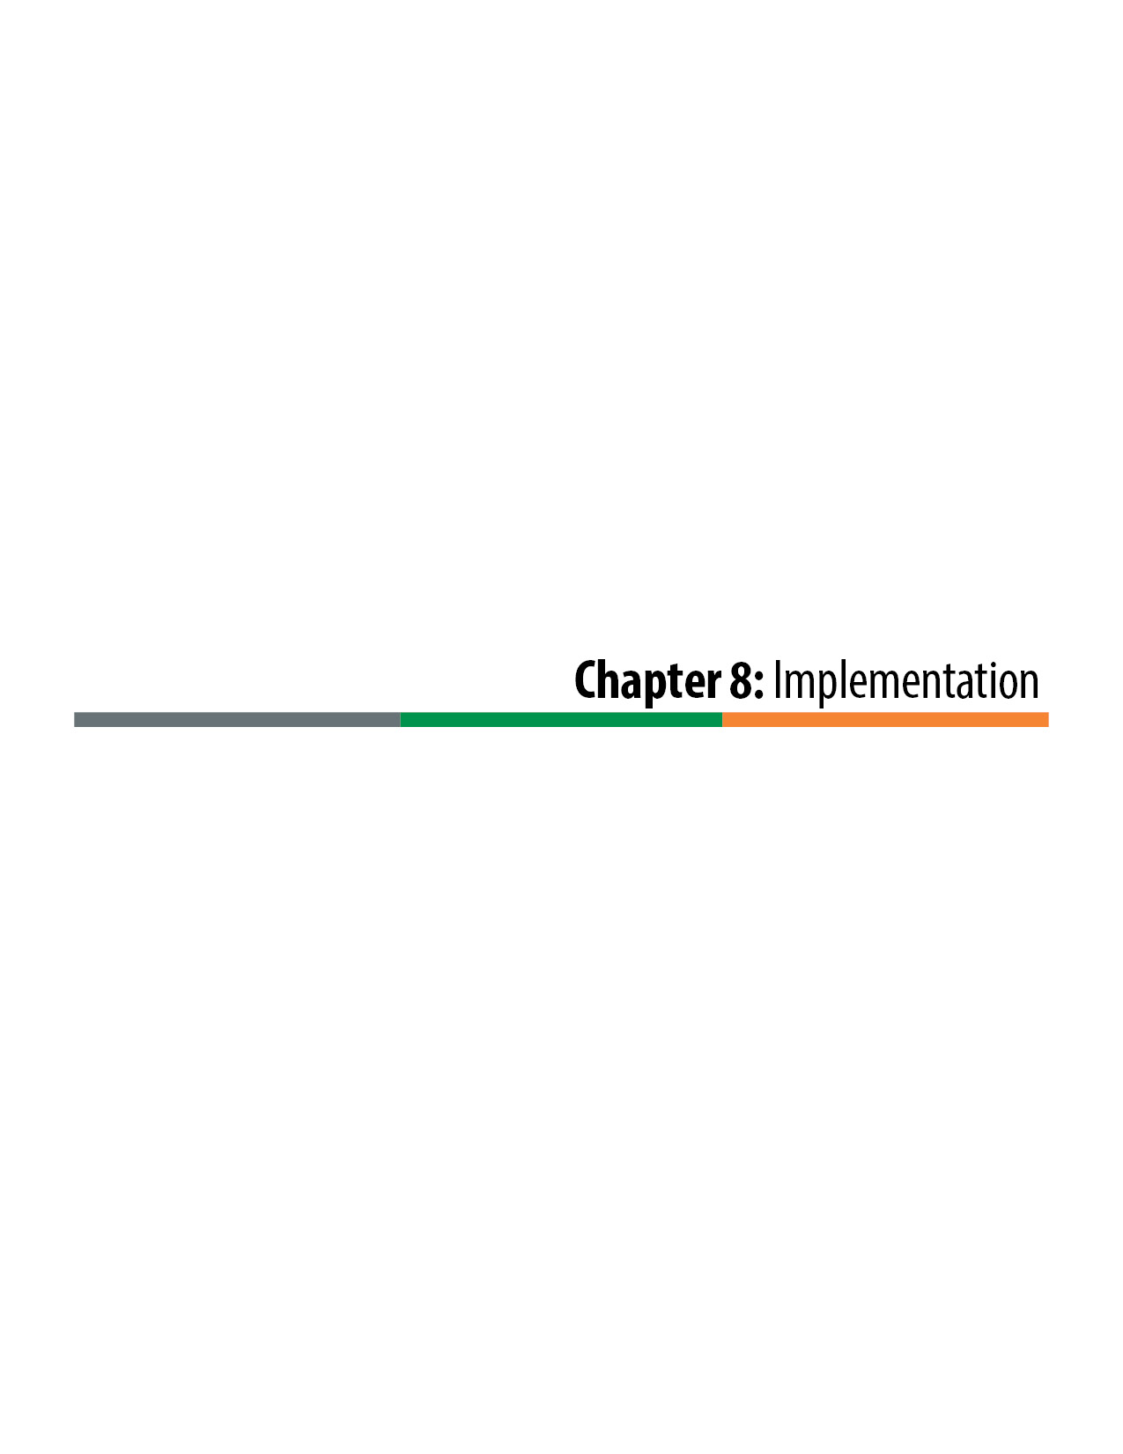

Implementation
After the Contractor is selected in the procurement phase of the project, the project enters into the implementation phase. The term “implementation phase” is used instead of “construction phase” because the phase includes both design and construction elements of the project. These two elements of work are usually performed in parallel (overlapping) schedules, which results in project management processes that are unique to Design-Build delivery.

Project Organization
A typical implementation phase project organization chart is provided in Figure 8-1. As the project transitions from procurement to implementation, the organization transitions from a Colorado Department of Transportation (CDOT) team to a joint CDOT/Contractor team. The key elements of the project organization are:
Executive Oversight Committee (EOC): The EOC in the implementation phase is a continuance of the EOC from the procurement phase. However, because the project focus changes from project development to final design and construction, the makeup of the EOC often changes. The EOC has already overseen most of the major design and procurement decisions in previous phases of the project. During implementation, the project team’s primary responsibility to the EOC is informative, ensuring that most of the key stakeholders of the project are kept aware of its progress and construction impacts to the community. Federal Highway Administration (FHWA) involvement remains to ensure the project contract management is compliant with federal regulations and process. The EOC remains the project representative of and reports directly to the Chief Engineer.
Executive Management Team (EMT): The EMT is a collaborative committee made of executives from both CDOT and the Contractor. The EMT provides upper-level project guidance, oversees the progress and quality of the project, and resolves major issues that have been escalated to them by the CDOT/Contractor management teams. The CDOT Project Director or Project Manager and the Contractor’s Project Manager report directly to the EMT.
CDOT Management Team: The CDOT Management Team is the owner’s representative in the day-to-day management and coordination of the project. The team typically includes the CDOT Project Director and/ or Project Manager, often the consultant Project Manager, a contract manager, a design manager, and a construction manager. Though the team may meet formally only once a week, the individual team members are often full-time dedicated project personnel, and they informally meet more frequently. The Contractor typically has a similar management team, and individuals from both teams interact freely with their counterparts on a well-functioning and well-integrated project team.
Project Controls Team: The project controls team administers the schedule, document control, invoicing, and the Contract. Project control requirements are defined in Section 2 of the project Technical Requirements and are discussed Chapter 7, Section 7.2.2 of this manual.

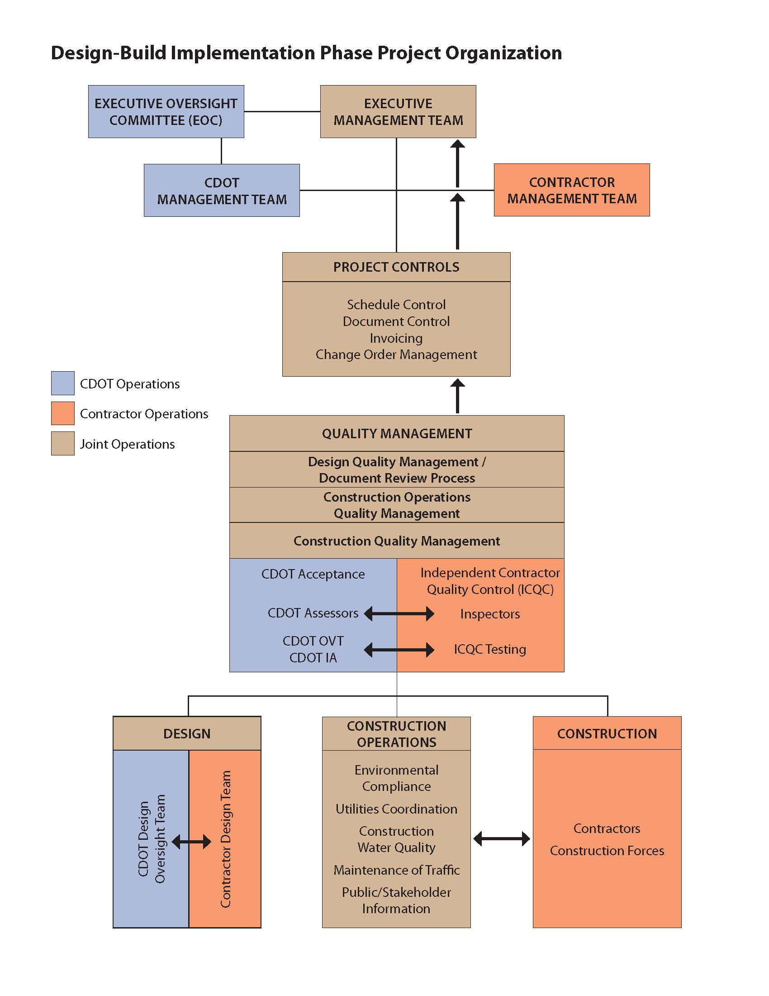

Figure 8-1. Design-Build Implementation Phase Project Organization
Quality Management Team: Quality management team administers the Quality Control (QC) processes, including design quality management, construction quality management (inspection and testing), and construction operations quality management. Quality processes are further discussed below in Sections 8.3 and 8.4 and also in Chapter 7, Section 7.2.3.
Quality management activities are typically joint CDOT/Contractor activities. The quality management team reports directly and independently to the EMT.
Design Team: As the project transitions from procurement to implementation, the primary responsibility for design shifts to the Contractor’s team. The design process is described below in Section 8.3.
Construction Team: In the end, the primary function of the implementation phase of the project is to construct the project in compliance with the Contract requirements. Construction activities are primarily performed and managed by the Contractor’s forces.
Construction Operations Team: Construction operations are those activities that are necessary to support the construction of the project. Construction operations include environmental compliance, utilities coordination, construction water quality management, traffic management, and public and stakeholder information processes. Construction operations are discussed in this manual in Chapter 7 with respect to their applicable Technical Requirements. Generally, construction operations are shared responsibilities between the Contractor and CDOT. Though the Contractor is usually responsible for performing the Work, most often there are third-party considerations that require a high level of CDOT involvement.

Contract Award and Project Start-up
As is noted in Section 7.1 of Chapter 7 of this manual, CDOT Design-Build projects typically have two Notices to Proceed (NTPs). In order to obtain the First Notice to Proceed (NTP1), the Contractor is required to submit a Preliminary Baseline Schedule and a Design Quality Management Plan (DQMP). Following NTP1, the Contractor may begin limited activities related primarily to design, development, and initiation of various operational work plans and the setup of project offices and other infrastructure necessary to support the project. As a result, the time from Award to the Second Notice to Proceed (NTP2) is a crucial initiation period for the overall project team. With all the necessary documents that need to be developed, reviewed, accepted, and approved, it is often a very work-intensive period. Usually these initial activities are performed without the benefit of the project co-location facilities, which are still being activated. Because most of the initial activities of the project require active participation by CDOT, the CDOT team should be assembled, familiarized with the project requirements as delineated in the Contract, and be ready to engage in the project prior to Award.

Partnering
CDOT has established a best practice of having a formal, facilitated partnering meeting at the start of all significant Design-Build projects. As can be seen from the organization chart in Figure 8-1, a Design-Build team is a combination of the owner’s oversight team and the Contractor’s design and construction team. For the project to be successful, it is imperative that these two teams work together to achieve the common goal of successfully completing project. The goal of the partnering session is to foster the development of an integrated and cohesive team, which is essential to the success of any Design-Build exercise. It is important to not overlook or marginalize this step, as a united Design-Build team that is focused on common goals for the project is much more successful than a team that relies on the traditional adversarial roles played by the owner and Contractor. The executive management from both CDOT and the Contractor must participate to show support and solidarity with the newly formed unified Design-Build team. A well-executed partnering process enhances teamwork and helps build the relationships that are essential for an effective project team. Potential items for an initial partnering meeting include the following:
- CDOT executive’s opening remarks
- Contractor executive’s opening remarks
- CDOT and Contractor Project Managers’ expectations
- Project Charter (mission statement)
- Issue resolution process (counterparts, escalation ladder, timelines)
- Continued partnering evaluation, monitoring, and accountability (report cards)
- Key issues discussions and initial action items

Co-Location and Design Development
Co-location is discussed in Chapter 7, Section 7.2.2, with respect to the project management Technical Requirements. As noted in that section, co-location can greatly facilitate Design-Build collaboration between the owner and the Contractor. Co-location provides the owner the best opportunity to jointly develop the project design with the Contractor’s designer. Co-location also provides the owner and the Contractor with an opportunity to take advantage of efficient and expedited decision making by housing all the decision makers in a single facility.
The CDOT project team should make every effort to encourage co-location and collaborative meetings with the Contractor’s designer. Even when co-location facilities are provided (in response to Request for Proposal [RFP] requirements and Proposal commitments), sometimes the Contractor’s design staff are reluctant to leave their home offices and co-locate to the project office. CDOT’s management should make it clear to the Contractor that compliance with co-location commitments is mandatory.

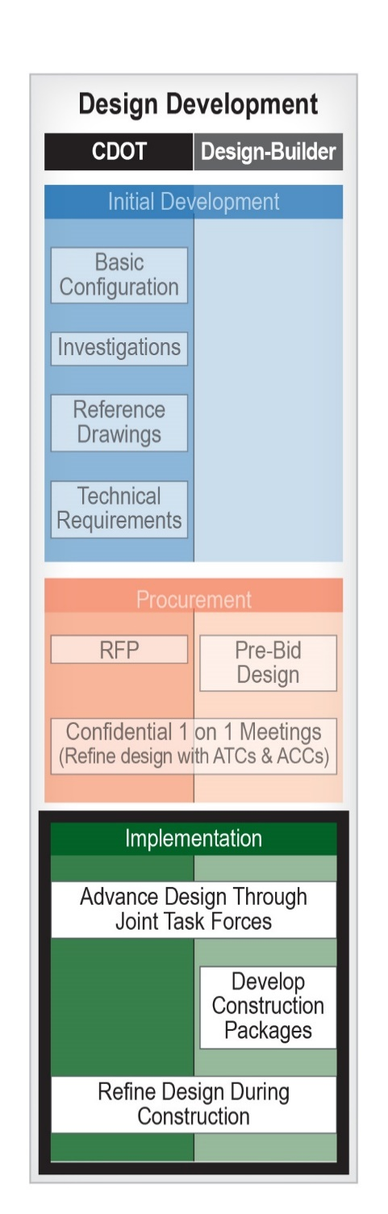
Design Development
As shown in Figure 8-2, the implementation phase is the third and final phase of the design development. The primary design responsibility of the project is transferred to the Contractor’s designer, although the owner remains very involved in the design process through joint task forces, during formal reviews of milestone design submittals, and as the design is further refined during the construction of the project.

Task Forces and Over-the-Shoulder Reviews
In a highly functioning Design-Build team, the design process is a continuous, active collaboration between the Contactor’s and CDOT’s designers. The focal point of the process is the design task forces that meet regularly (generally weekly) throughout the design phase of the project. It is important that the task force meetings be more than just design update meetings. At these meetings, the design task forces should review informal plan submittals as they are developed and make decisions on how the design should proceed. When the task forces are implemented well, the design approval process and progress of the project are efficient and expeditious. The process is significantly enhanced through co-location.
The makeup of each task force varies depending on the size and nature of the project. It may be a single general cross-disciplined design task force or comprise a number of discipline-specific task forces. The intent is to set up a meeting structure that promotes a continuous over-the-shoulder review process whereby the Contractor’s designers frequently brief the owner’s designers on the design status, and the owner’s designers provide input on the progression of the design. The specific approach should be tailored to the project, but at a minimum the meetings should include issuance of advance agendas and documented meeting minutes that track the resolution of design issues. Though documenting meeting minutes is important, CDOT should only review and not Approve the minutes in order to avoid taking responsibility for interim designs. It can be beneficial to distribute status drawings or iterations of reports or deliverables prior to task force meetings, but it should not be a CDOT requirement to do so, as that may result in additional designer procedural work that may slow down the advancement of the design.
Figure 8-2. Design Development during Implementation
When third parties have review, Acceptance, or Approval authority over design elements, they should be encouraged to participate in the appropriate task force meetings. If they are unable to participate in task force meetings, separate third-party interim review meetings should be considered, with the understanding that additional review meetings may prolong the development of the project design.
A simplified and more efficient formal review process results when the task force and over-the-shoulder review processes are well executed. This largely is due to the CDOT reviewers’ familiarity with the progress of the design and their ability to provide comments and feedback on an ongoing basis and not just when milestone submittals are made. Ideally, by the time actual milestone submittals are reviewed CDOT and the Contractor already will have had the opportunity to resolve many design differences and to clarify design ambiguities.

Formal Milestone Packages and Reviews.
Section 3, Quality Management, of the Technical Requirements provides the Contract requirements for formal milestone submittals and CDOT’s review authority. Most typically formal reviews are required for the preliminary plans, Released for Construction (RFC) Documents, Final Design Documents, and As-Built Documents. These are the primary design documents that define the overall project design, though numerous supporting design documents may be required by the discipline-specific Technical Requirements. Document review authority by CDOT can be for Acceptance, Approval, or just review (refer to Section 7.1 in Chapter 7 of this manual for a discussion of the review authority terminology). The milestone design documents are described below:
Preliminary Plans: The preliminary plans are generally considered to be at approximately a 30-percent level of design completion. The plans show how the Contractor’s design complies with the Basic Configuration and Technical Requirements and set an overall design framework for the subsequent development of construction packages. Because the preliminary plans are superseded by the RFC Documents and the Final Design Documents, they are typically submitted to CDOT for review only. Nonetheless, a comprehensive review of the preliminary plans by CDOT is critical to an efficient design process because the preliminary plans set the course of the final design.
RFC Documents: RFC Documents are the primary documents that define the construction of the project. To leverage the Design-Build advantages of a parallel and overlapping design and construction, RFC Documents are usually issued in multiple packages to allow for the early start of construction before the design for the project as a whole is completed. CDOT generally reserves Acceptance authority over RFC Documents but will qualify that authority as not constituting Acceptance of any partial, incomplete designs that are included in the RFC Documents. This puts the risk of continuity and compatibility of subsequent RFC Documents on the Contractor and its designers.
Notice of Design Change (NDC) Documents and Field Design Changes (FDC) Documents: As a result of the interim design nature of many RFC Documents, it is inevitable that some designs that are issued to the field will need to be revised. NDC Documents are revisions to RFC Documents that have been previously issued and that originate from the designers. FDC Documents are also design revisions to the previously issued RFC Documents, but they are a result of encountering unforeseen conditions in the field. Because NDC and FDC Documents are revisions to RFC Documents, they should undergo the same formal review processes as the RFC Documents themselves and are subject to CDOT Acceptance. It is important that the Contractor’s Quality Management Plan (QMP) includes a process to ensure that the latest plan sets are appropriately reviewed and are distributed to the appropriate construction personnel in a timely manner.
Final Design Documents: Final Design Documents are the total plan and specification documents that define the entire design of the project. They consolidate the RFC, NDC, and FDC Documents into one coherent package. Final Design Documents are subject to CDOT Acceptance and should not be Accepted until all design issues have been resolved and incorporated into the project.
As-Built Documents: Similar to traditional Design-Bid-Build (D-B-B) delivery, As-Built Documents reflect adjustments that are made to the construction plans in the field. As-Built Documents are subject to CDOT Acceptance.

Design Quality Processes
The contractual requirements for design quality processes are defined in the Contract Technical Requirements, Book 2, Section 3, Quality Management. The Technical Requirements require that the Contractor prepare a DQMP as a part of the QMP, subject to CDOT Approval.
The DQMP defines Design Quality Control to be performed by the Contractor, including QC checking procedures, independent technical reviews, and auditing of the design quality processes. The DQMP also demonstrates how the owner’s review and Acceptance/Approval process is integrated into the Contractor’s overall design process. All design quality processes and audits must be rigorously defined, executed, and documented.
CDOT’s primary involvement in design quality processes occurs through both the informal over-the-shoulder review process and the formal reviews of milestone submittals. This involvement is documented through the CDOT audit process, which checks specific Contract requirements and the Contractor’s fulfillment of those requirements. Milestone reviews should include documented comment resolution procedures. Ideally, CDOT and third-party reviewers provide written review comments to the Contractor’s designer in advance of review meetings, allowing the designer to be better prepared to address the comments efficiently at the review meeting. Review comments are tracked at the meeting and thereafter until all comments have been resolved to the satisfaction of CDOT and any third-party reviewers. Completed comment resolution forms should be submitted with final RFC Documents as a prerequisite to RFC; Final Design Documents should be submitted as a prerequisite to the final design Acceptance by CDOT.
It is important for CDOT to commit to timely review times in Section 3, Quality Management, of the Technical Requirements. Review time commitments provide the Contractor with firm durations from which the Contractor, in turn, can develop the overall project schedule commitments.

Construction Processes

Testing, Inspection, and Acceptance Quality Processes
Similar to design quality processes, Section 3 of the Technical Requirements requires that the Contractor prepare a Construction Quality Management Plan (CQMP), subject to CDOT Approval. As is discussed in the previous chapter in Section 7.2.3, there are two primary approaches to quality Acceptance in Design-Build delivery: (1) Owner Acceptance (OA) testing and inspection, in which CDOT assumes responsibility for the quality Acceptance process, and (2) Independent Contractor Quality Control (ICQC), in which CDOT assigns responsibility much of the testing and inspection to the Contractor. In both cases CDOT retains the ultimate Acceptance authority (per 23 CFR Part 637). CDOT may, however, elect to use ICQC inspection and testing results in the Acceptance decision provided those results are validated statistically by owner verification auditing and testing results.
The CDOT Field Materials Manual provides guidance on materials testing processes for Design-Build projects and details procedures for both these approaches. In particular, Chapter 17 of the Field Materials Manual discusses the ICQC approach that is often used in Design-Build delivery. Streamlined Design-Build projects, which are typically smaller projects with construction processes more similar to traditional D-B-B delivery, most often use CDOT Acceptance testing, in lieu of ICQC.

CDOT Auditing Processes and Nonconforming Work
In addition to the CDOT Field Materials Manual’s guidance on materials testing processes for Design-Build projects, it is important to recognize that workmanship is as fundamental an element of overall project quality as materials. The quality of workmanship is demonstrated through the Contractor’s process control procedures and QC inspections, and through CDOT’s auditing program. The extent of the CDOT auditing program depends on whether or not an ICQC program is used for the project. If an ICQC program is used, then CDOT’s auditing program consists of Owner Verification audits and Independent Assurance testing. If an ICQC program is not used, then CDOT’s auditing program becomes much more extensive, essentially replicating a CDOT inspection program on a traditional D-B-B project.
CDOT’s program to assess workmanship on Design-Build projects centers on compliance with the specifically stated requirements of the Contract Documents. For the most part, these are the project Technical Requirements and the CDOT Standard Specifications. To be effective in their role, CDOT’s auditors should have an intimate familiarity with the requirements of the Contract Documents and be able to cite specific requirements that are or are not in compliance. A database of auditing requirements can be developed to facilitate the assessment process. An example of a requirements database is provided in Figure 8-3.
Nonconforming Work is work performed that does not meet the requirements of the Contract Documents. Auditors determine Nonconforming Work by identifying objective evidence that the finished product does not conform to a stated Contract requirement. Objective evidence is evidence that directly relates to the Contractor’s fulfillment of a Contract requirement and does not include opinion, commentary, or grievance.
Nonconformances are categorized by their level of severity from NC-3 (least severe) to NC-1 (most severe). Less severe nonconformances are progressively escalated to more severe classifications if they are not resolved in a timely manner by the Contractor. A diagram of the auditing report workflow and levels of nonconformances is provided in Figure 8-4, and an example auditing report is provided in Figure 8-5.
A nonconformance tracking report is usually maintained by CDOT, the Contractor, or both parties, and it is reviewed jointly on a weekly basis by management to ensure that nonconformances are being addressed and resolved.
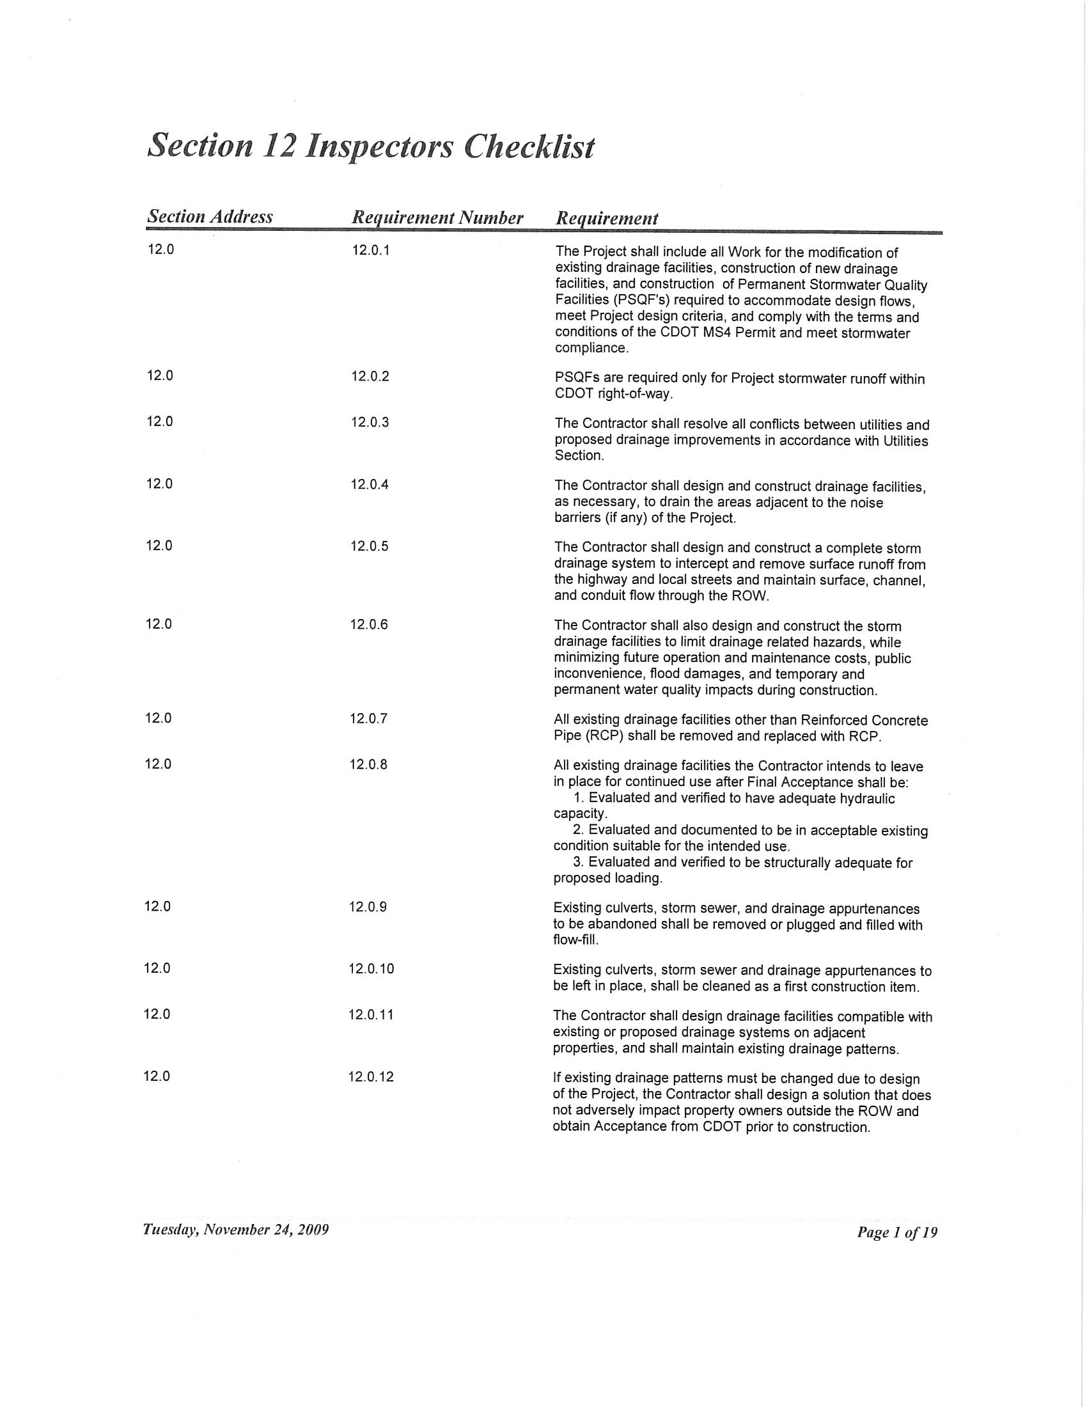
Figure 8-3. Requirements Database Example

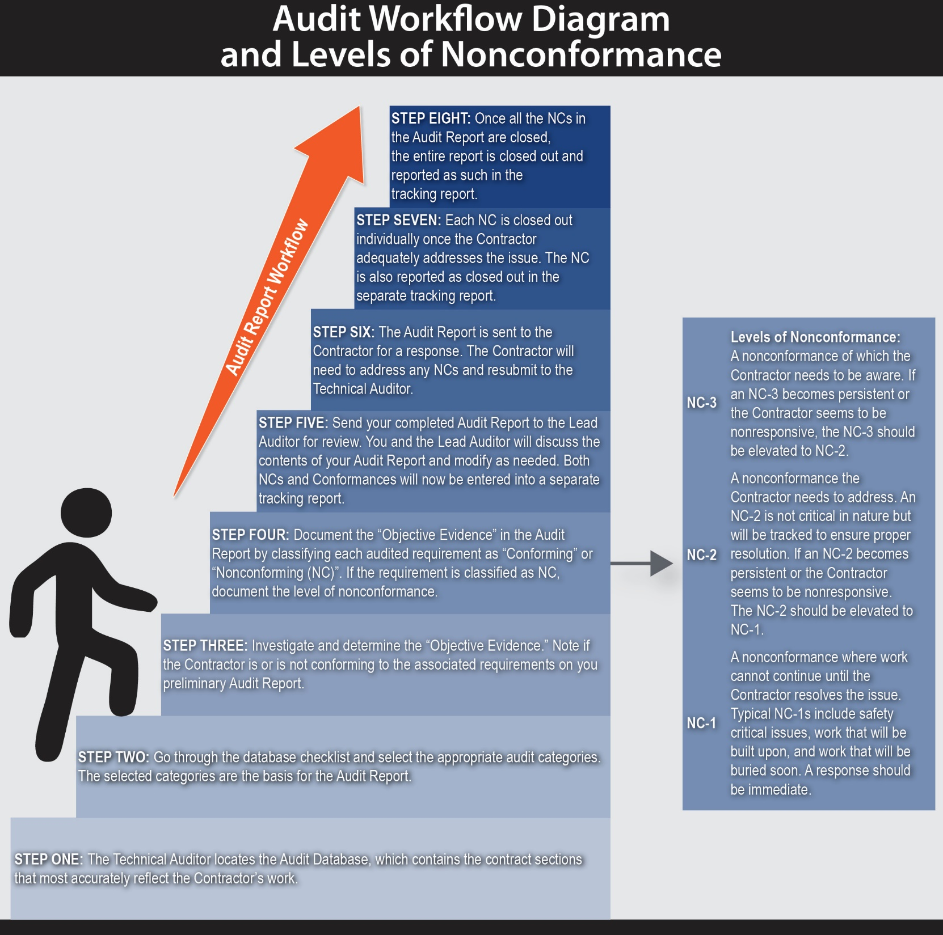
Figure 8-4. Auditing Report Workflow and Levels of Nonconformance
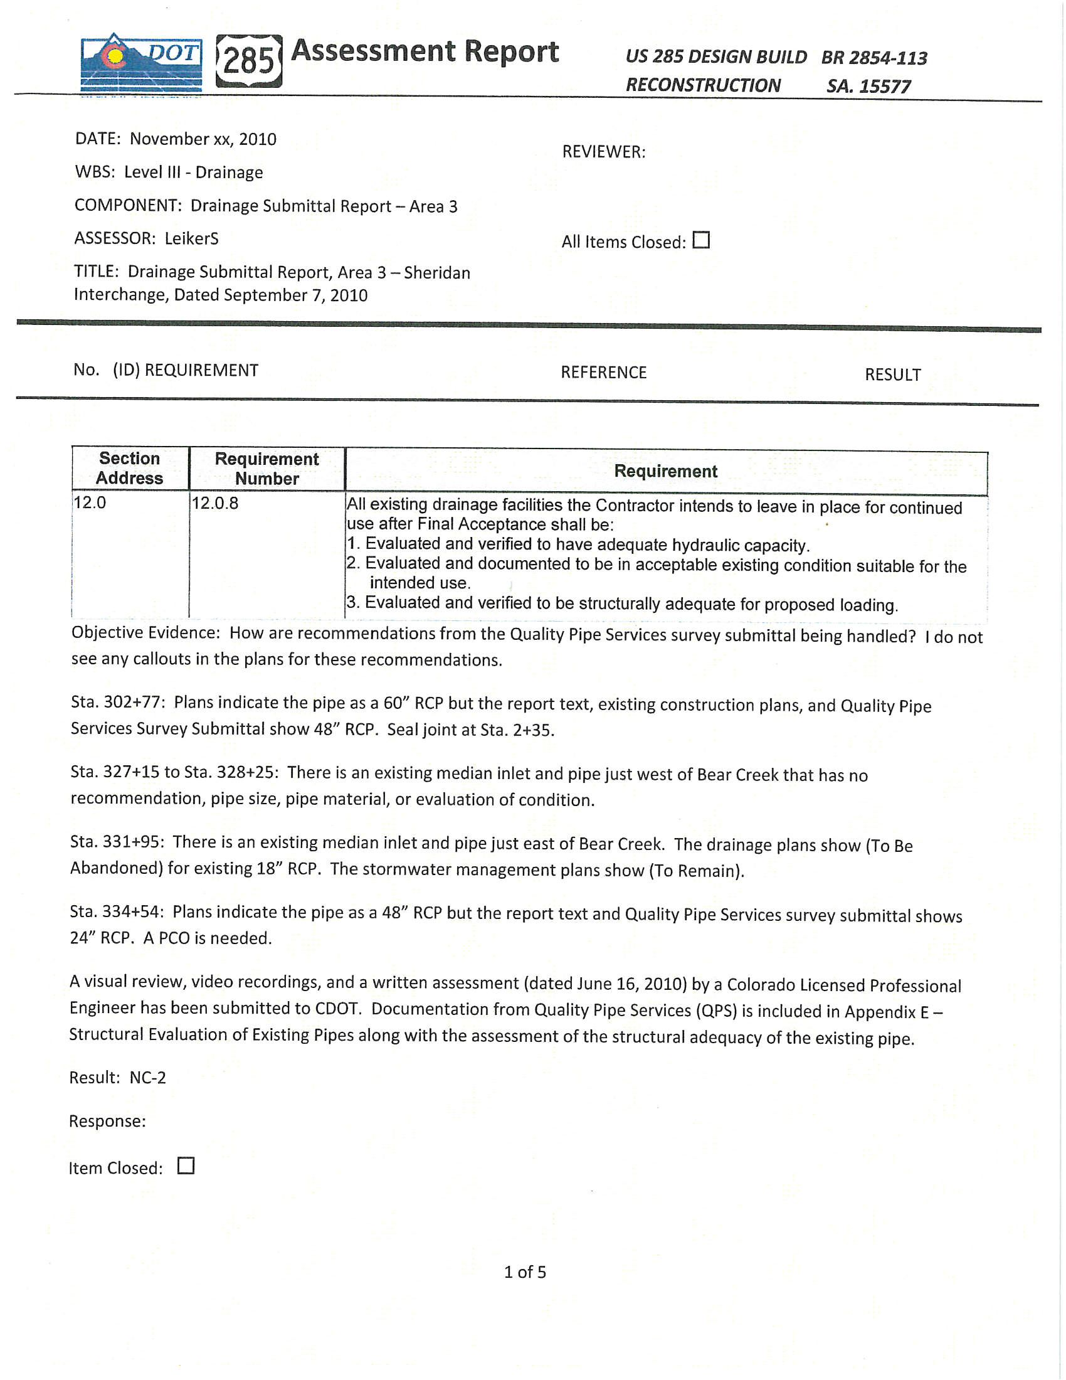

Figure 8-5. Example Auditing Report

Change Management
The change order process in Design-Build delivery differs significantly from that in traditional D-B-B delivery. For the most part Design-Build contracts are lump sum based, and D-B-B contracts are unit price based. Therefore, in Design-Build delivery, instead of relying on contractually set unit pricing, change order costs must be negotiated. The fact that the Contractor performs much of the design work further complicates the change order process. The CDOT project team must be very familiar with these processes to effectively manage the project during implementation. Book 1, Sections 12 and 13 address the change management processes and provide an explicit approach for developing and executing change orders. The change order procedure is shown diagrammatically in Figure 8-6.
As part of contract management it is important that CDOT maintain a conformed Contract that reflects any changes to the Contract Documents as a result of change orders, regardless of which party initiates the changes. Maintaining a conformed Contract ensures all parties are working off of the most updated Contract requirements throughout the implementation of the project. At the end of the project the conformed Contract becomes part of the final record of the project and reflects the administration of the project.

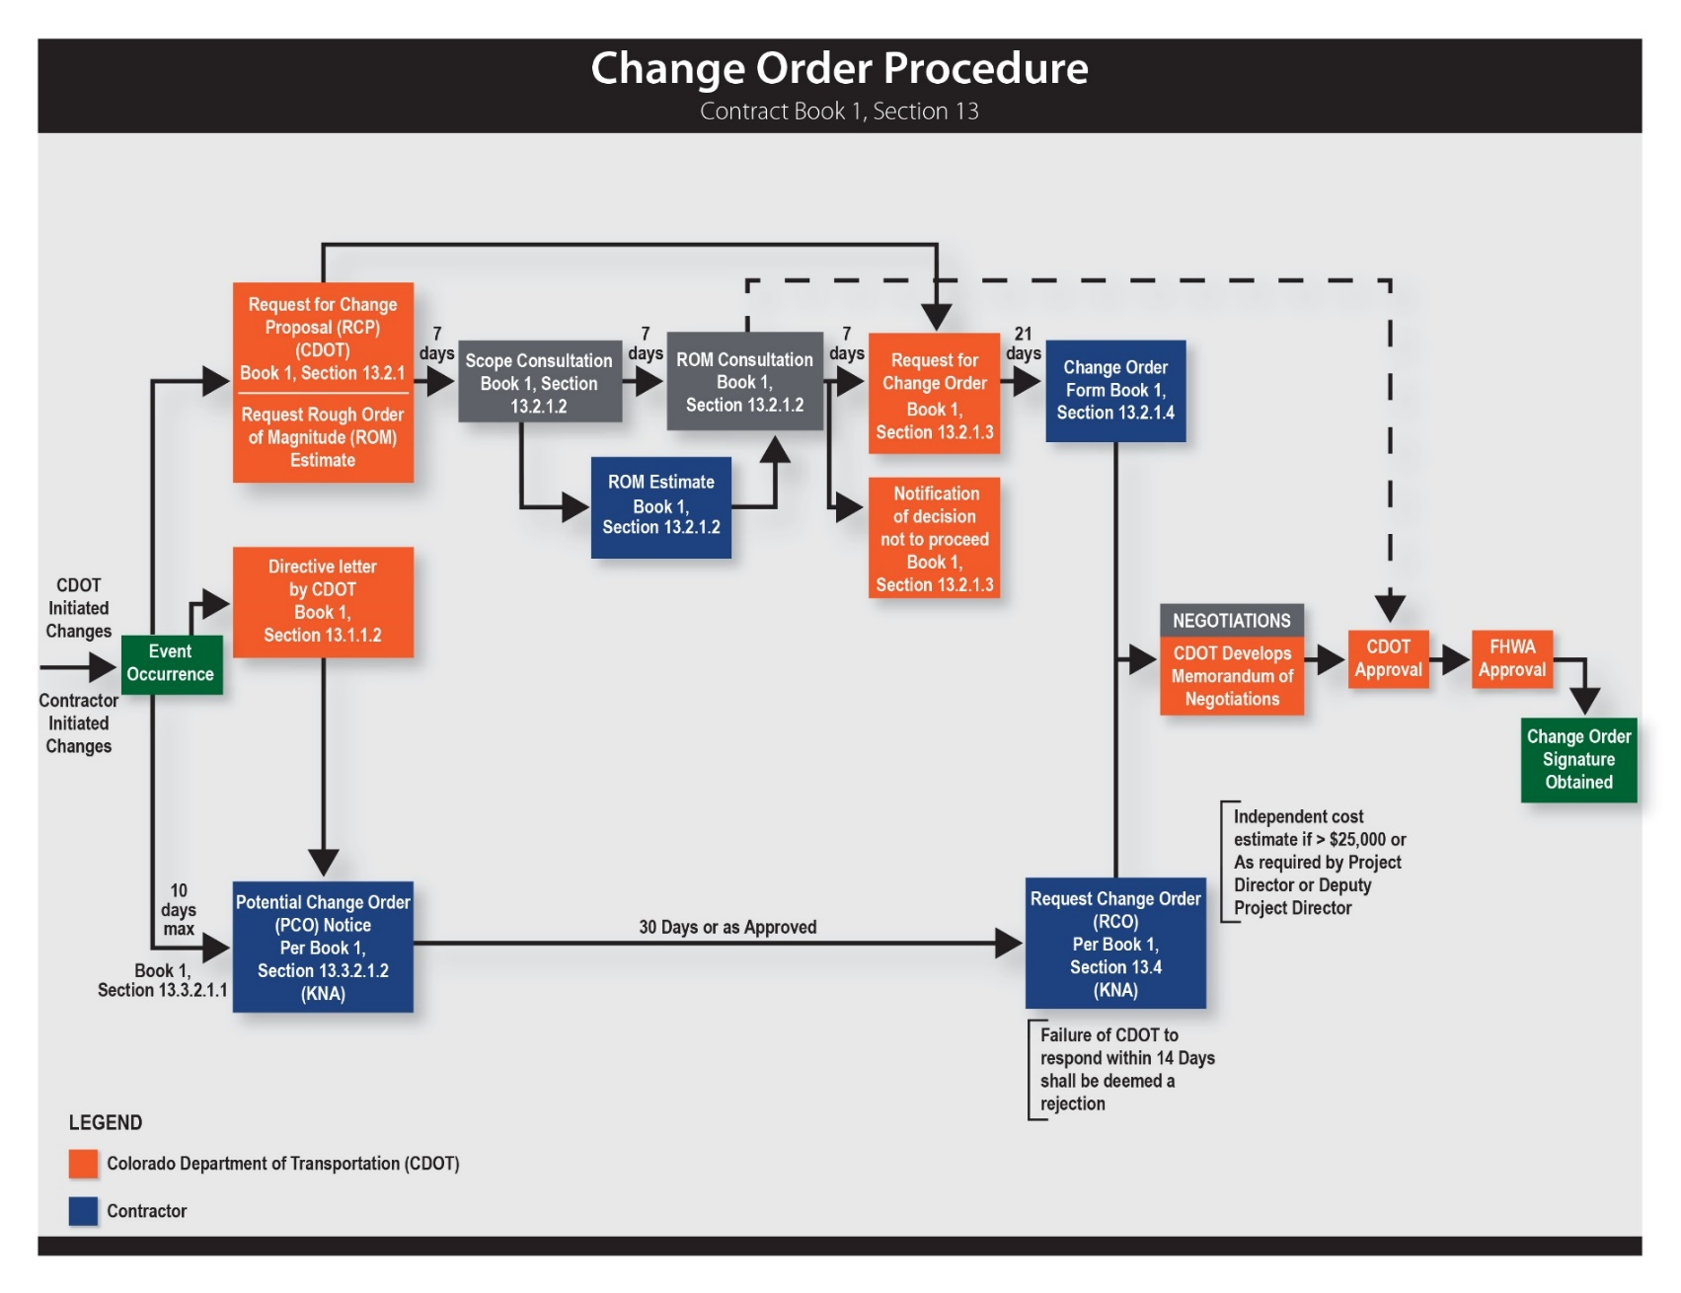
Figure 8-6. Change Order Procedure

Project Acceptance and Closeout
The Contractor is required to develop a process for final project Acceptance and closeout as part of the QMP. The process includes scheduling, accomplishing, and tracking the final inspection process and developing and resolving punch lists in conformance with the requirements of the Contract. Final inspection includes inspection of the Work by the Contractor and the ICQC team (if applicable) and associated Final Design Documents, As-Built Documents, certifications, and Contractor cleanup requirements. The Contractor (or ICQC) performs an independent inspection of all the Work and addresses any outstanding and Nonconforming Work prior to requesting an inspection from CDOT. After the inspection, CDOT and the ICQC team jointly agree upon punch list items and a deadline date to correct those items. CDOT performs a final field audit of the Work with ICQC personnel after the Contractor has resolved the final punch list and the ICQC team has provided its final Acceptance of the Work.
The detailed requirements for the project Acceptance are provided in Book 1, Section 20 of the Design-Build Contract. The CDOT project team completes a Final Submittal Check List to ensure all of the required submittals are provided. An example Final Submittal Check List is provided in Figure 8-7.

Draft (Design-Build) FINAL SUBMITTAL CHECK LIST
PROJECT NO: ______________________________ ID# _____________________
Reference: Section 121 of the Construction Manual.
_____1. Acceptance Letter –Timely submittal is EMPHASIZED. Itemize all documentation still outstanding from Contractor. Be specific. See Construction Manual (CM) 109.9.1 and 120.3.2 for distribution; Appendix B for example.
_____2. CDOT Form 1212 (Final Acceptance Report). Required on ALL projects. RE will print form from SAP, sign & submit.
Pay Documentation
_____3. Field Books (Piling, grade stakes, and survey documentation w/ Professional Land Surveyor stamp, signed Survey control data sheets and/or Monumentation records). QA?
_____4. All Change Orders that have not been previously submitted. (executed)
_____5. Seeding Tickets w/ PLS calculations if not submitted with material documentation.
_____6. CDOT form 105’s (Speed Memo), that affect Contractor payments (i.e. work zone violations, deleted/unused items), if not already submitted.
_____7. "As Constructed" plans completed per CM 121.2.3. (include NDCs, FDCs, RFI, At Risk)
_____8. Pay Invoices/Final As-Built Schedule
Water Quality
_____9. Water Quality Notebook (inspection reports, 1176’s, 1177’s, memos, etc.) turned over to Water Quality Manager on__________________. (hard copy)
Civil Rights
_____10. Checked Payrolls to Region Civil Rights office. (all Federal-Aid Projects and F/A work). (CM 107.1.1.2;121.2.8). Payrolls submitted on _________________________.
_____11. OJT Documentation – copies of CDOT 832’s, 838’s, 1337 & 266/DWR showing payments. (Note: CDOT 382’s 1377, 1418’s should have been submitted monthly to the CRO) Workforce Development Program
_____12. Final DBE Report
Materials
_____13. COCs.
_____14. Copy of CDOT 250 (Materials Documentation Record)
_____15. Copy of CDOT 473 Letter of Certification (Materials)
_____16. RSAR (Roadway Surface Accomplishment Report) form completed online _____________________.
Printed copy included. Form available at http://internal/pavementmgt/RSARdata/RSARform.cfm
Design-Build
_____17. Nonconformance Report Log (NCR Log)
_____18. QMO audit spreadsheet (Log)
_____19. Utility Log
Copy of this checklist with Final electronic files to Finals Engineer on ___________________.
Figure 8-7. Final Submittal Check List Example

