2.01 ROUTE LOCATION APPROVAL AND ENVIRONMENTAL COMPLIANCE

It is the intent of CDOT to comply with the National Environmental Policy Act of 1969 and 23 CFR Part 771, which contains the Federal Highway Administration (FHWA) policies and procedures for implementing the National Environmental Policy Act for transportation projects. The Resident Engineer should check with the Region Planning/ Environmental Manager for the status of current regulations.

In compliance with 23 CFR Part 771, all proposed projects must be assigned an Environmental Category designation of Major, Intermediate, or Minor (Categorical Exclusion projects). The category designation helps determine the appropriate level of environmental studies and public involvement activities required for location approval.

Minor Projects
Most CDOT projects are categorized as Minor projects because they clearly fit one of the Categorical Exclusions as defined by the FHWA. Minor category projects do not individually or cumulatively result in significant environmental impacts and generally do not have a great deal of public controversy. A Form 128, Categorical Exclusion Determination, is prepared for these projects, and it documents the environmental clearances and permits required and completed for the project.

Major Projects
Major projects are those that will have a significant impact on the environment. Draft and Final Environmental Impact Statements are prepared for the project. The result of the Final Environmental Impact Statement is identification of the preferred project alternative that is approved by FHWA in a Record of Decision.

Intermediate Projects
Intermediate projects are those projects for which the significance of the environmental impact is not clear. An Environmental Assessment is prepared. Projects may also be classified as Intermediate if they have public controversy and CDOT believes a document such as an Environmental Assessment will assist in communications with the public and resolution of the appropriate mitigation measures to be incorporated into the project. The result of the Environmental Assessment is either a Finding of No Significant Impact or a requirement to prepare an Environmental Impact Statement if it is determined there are significant impacts associated with the project.

Environmental documents for Major and Intermediate projects are either prepared by the Region Planning/Environmental Manager or by a qualified consultant under the direction of the Region Planning/Environmental Manager’s office.

The Region Planning/Environmental Manager is responsible for scoping the project to determine the initial category designation and the environmental clearance requirements. The Region Planning/Environmental Manager will consult with the Environmental Programs office in the Project Development Branch, other CDOT Region and staff disciplines, FHWA, resource protection agencies, and the public.

The Region Planning/Environmental Manager schedules and coordinates with the Environmental Programs office and the Region environmental specialists to obtain the appropriate studies, clearances, and permits for the project. Early coordination with the Environmental Programs office is recommended to identify known environmental issues that might affect route selection such as historic bridges, significant archaeological or paleontological sites. If a consultant is utilized for project development work, the Region Planning/Environmental Manager also coordinates appropriate work with the consultant.

Close coordination between the Region Planning/Environmental Manager and the Resident Engineer in the project development process is essential to avoid and minimize impacts to the environment. The Region Planning/Environmental Manager also works with the Environmental Programs office specialists and designers (such as the Resident Engineer, the Geotechnical Engineer, the landscape architect, hydraulics, and bridge design) to develop mitigation measures for impacts to the environment that cannot be avoided. The Resident Engineer is responsible for notifying the Region Planning/Environmental Manager of any changes in design scope that may affect the level of environmental clearances required for a project. The Region Planning/ Environmental Manager coordinates with the Resident Engineer to ensure mitigation measures are incorporated into the design plans.

The Region Planning/Environmental Manager is responsible for coordinating and maintaining all documentation on the National Environmental Policy Act process in accordance with 23 CFR Part 771 for any category of action (Major, Intermediate, or Categorical Exclusion project).

For Categorical Exclusion (Minor) projects, a Form 128, Categorical Exclusion Determination, outlines the environmental clearances and permits required and the dates of completion. The Region Planning/Environmental Manager obtains clearance letters and documents from the Environmental Programs office specialists and resource agencies to include in the project file. Environmental commitments required as a result of these clearances and permits are coordinated with the Resident Engineer for appropriate coverage in the project plans. Parts A and B of Form 128 must be completed for right-of-way authorization and obligation of federal funds. The project may not be advertised for bid until all required environmental clearances and permits indicated on the Form 128 have been completed and all mitigation commitments have been incorporated into the plans. Parts A, B, C, and E of Form 128 must be completed prior to project advertisement. For projects with federal monies, the FHWA must sign the Form 128. For those project activities that have been designated as programmatic Categorical Exclusions by FHWA and CDOT, FHWA signature on the Form 128 is not required.

For Major and Intermediate projects, the Environmental Impact Statement, the Record of Decision, the Environmental Assessment and the Finding of No Significant Impact document the environmental impacts, environmental mitigation, design commitments, and the route location decision for the project. The mitigation commitments are clearly identified in the Environmental Impact Statement or Environmental Assessment, and detailed studies completed for the project are on file in the Region environmental office. As project design proceeds, the Resident Engineer should coordinate directly with the Region Planning/Environmental Manager to ensure mitigation commitments made during the project development process are included in the plans and completed in the field during construction.

The Resident Engineer, when completing preliminary and final design for Major and Intermediate projects, is responsible for ensuring the scope of work and project limits do not exceed the scope and limits as described and analyzed in the approved environmental documents (Environmental Impact Statement, the Record of Decision, the Environmental Assessment and the Finding of No Significant Impact). Changes outside the scope of the approved environmental clearances for the project will require new environmental clearances.

For Categorical Exclusion (Minor) projects, the project scope and limits are outlined on Form 463, Design Data, and the Region Planning/Environmental Manager determines the necessary environmental clearances and permits required based on the Form 463 for the project. The Resident Engineer is responsible for coordinating directly with the Region Planning/Environmental Manager regarding all changes to the scope or project limits so that appropriate environmental clearances can be obtained.

It is the responsibility of the Resident Engineer to include the Region Planning/ Environmental Manager in the design scoping process for all projects as outlined in CDOT Procedural Directive 512.1, Project Scoping and the Design Scoping Review (DSR).

Additional References:
1. 42 USC 4321, National Environmental Policy Act
2. CDOT’s Procedures for Public Involvement and Participation in the Project Development and Environmental Analysis Process
3. http://www.fhwa.dot.gov//////legsregs/directives/techadvs.htm FHWA Technical Advisory T 6640.8A, Guidance for Preparing and Processing Environmental and Section 4(f) Documents
4. Geotechnical Studies (see Section 5.03)
5. See Appendix A for forms

2.02 PUBLIC INVOLVEMENT

The public is involved in the development of state and federally funded transportation projects by means of a comprehensive planning process that incorporates procedures for open and continuous involvement and input.

CDOT is committed to involving the public in all phases of its statewide transportation planning and project development activities. The requirements for public participation are found in the Rules and Regulations for the Statewide Transportation Planning Process and Transportation Planning Regions (2 Colorado Code of Regulations 604-2) and are more fully described the CDOT’s Guidelines for Public Involvement in Statewide Transportation Planning and Programming.

Public involvement is a continuous part of the project development and decision-making process. It begins with and builds upon the basic information gathered in the statewide planning phase and incorporates the views of the public on the purpose and need for the transportation project, the reasonable alternatives that exist for satisfying the purpose and need, the broad range of social, economic and environmental impacts associated with the project, and the identification of avoidance, minimization, mitigation, and enhancement opportunities. The public includes minority and low-income populations as well as Native American tribes.

It is the responsibility of the Region Planning/Environmental Manager to ensure that the public is identified and involved in the development of CDOT projects and has an opportunity to influence decision-making. Each Region maintains ongoing coordination with regional and local agencies, elected officials, interested groups, and the public in its geographical area. Public input and involvement for specific projects are built from this base.

Major projects for which an Environmental Impact Statement is required have formal public notification and hearing requirements. Intermediate projects that require an Environmental Assessment are prepared with more flexible requirements in order to focus on issues of greatest concern or controversy. Minor projects that are processed as Categorical Exclusions may not require specific public involvement procedures, depending upon the anticipated environmental impacts and public interest in the project.

The Region Planning/Environmental Manager in each Region oversees the preparation of Environmental Impact Statements, Environmental Assessments, and Form 128, Categorical Exclusion Determination, which fully document the public involvement activities included in the development of the project. Specific description of these requirements can be found in CDOT’s Procedures for Public Involvement and Participation in the Project Development and Environmental Analysis Process.

Additional References:

- 23 CFR Part 771, Environmental Impact and Related Procedures
- 40 CFR Parts 1500-1508, Council on Environmental Quality Rules for Implementing the National Environmental Policy Act
- 23 USC 128, Federal-aid Highway Act Requirements for Public Hearings
- 42 USC 4321, National Environmental Policy Act
5. http://www.fhwa.dot.gov//////legsregs/directives/techadvs.htm FHWA Technical Advisory T 6640.8A, Guidance for Preparing and Processing Environmental and Section 4(f) Documents
6. See Appendix A for forms

2.03 ALTERNATIVE MODES OF TRANSPORTATION

CDOT encourages and promotes the development and implementation of alternatives to the single-occupant vehicle as a means for improving air quality, mobility, capacity and safety.

Travel Demand Management strategies represent a group of actions and/or projects that encourage the use of public transportation (buses, rail, air, etc.), high-occupancy vehicle lanes, ridesharing (carpools and vanpools), pedestrian walkways, bicycle paths, park-n-ride facilities and carpool lots. In addition, Travel Demand Management also includes compressed workweeks, flexible work schedules, and telecommuting—strategies that allow employees to work one or more days a week at home. Finally, a common Travel Demand Management strategy is a marketing campaign to encourage the use of the above modes and facilities.

The Statewide Transportation Improvement Program (STIP) identifies the types of multi-modal projects the State expects to undertake during the next six years. Section 1.03 explains the STIP process. The Region Planning/Environmental Manager is responsible for all the planning and environmental clearances for the projects identified in the STIP.

Planning for alternative modes of transportation occurs at the regional level, as part of the State’s regional transportation planning process. Transportation planning regions (TPR) and metropolitan planning organizations (MPO) are encouraged to consider and prioritize projects for all modes of transportation.

The Federal Highway Administration (FHWA) and the Federal Transit Administration (FTA) of the U.S. Department of Transportation are to cooperate on projects involving public mass transit facilities within highway rights of way to facilitate project selection, approval, and completion.

Eligible projects utilizing FHWA funds to assist alternative modes of transportation include:

- High-occupancy vehicle lanes
- Highway traffic control devices
- Park-n-ride facilities (including shelters) on the federal-aid highway system
- Bicycle and pedestrian paths
- Carpool matching services
- Others based upon special needs

Eligible projects utilizing FHWA “flexible” funds and FTA funds to assist alternative modes of transportation include:

- Passenger rail lines and vehicles
- Buses
- High-occupancy vehicle lanes
- Park-n-ride facilities

Additional References:
1. 23 CFR Federal Highway Administration, Department Of Transportation, Parts 450C, Planning and Research; 810A, 810B, 810C, 810D, Public Transportation
2. 23 USC, Highways, Sections 134, Metropolitan Planning; 135, Statewide Planning; 137, Fringe and Corridor Parking Facilities; 142, Public Transportation
3. CDOT Local Agency Program Manuals
4. CDOT STIP Manual
5. FHWA (DOT) Travel Demand Management Manuals (Program Management, Transportation Development)

2.04 SECTION 4(f) AND SECTION 6(f)

SECTION 4(f)
In January 1983, as part of an overall recodification of the U.S. Department of Transportation Act, Section 4(f) was amended and codified in 49 USC, Section 303 4(f) Requirements. In part, Section 303 (a) and (c) reads as follows:

(a) It is the policy of the United States Government that special effort be made to preserve the natural beauty of the countryside and public park and recreation lands, wildlife and waterfowl refuges and historic sites.

(c) The Secretary may approve a transportation program or project requiring the use of publicly owned land of a public park, recreation area, or wildlife and waterfowl refuge, or land of an historic site of national, State, or local significance (as determined by the federal, state, or local officials having jurisdiction over a park, recreation area, refuge, or site) only if --
(1) there is no prudent and feasible alternative to using that land; and
(2) the program or project includes all possible planning to minimize harm to the park, recreation area, wildlife and waterfowl refuge, or historic site resulting from the use.

Section 4(f) applies to all historic sites (regardless of ownership) but only to publicly owned parks, recreational areas, and wildlife and waterfowl refuges. When parks, recreational areas, and wildlife and waterfowl refuges are owned by private institutions and individuals, even if such areas are open to the public, Section 4(f) does not apply. The FHWA does, however, strongly encourage the preservation of such privately owned lands. If a governmental body has a proprietary interest in the land (such as fee ownership, drainage easements or wetland easement), it can be considered "publicly owned."

Section 4(f) applies to the “use” of land, which occurs when:
1. Land from a Section 4(f) site is acquired for a transportation project.
2. There is an occupancy of land that is adverse in terms of the statute’s preservationist purposes, or
3. The proximity impacts of the transportation project are so great that the purposes for which the Section 4(f) site exists are substantially impaired (normally referred to by courts as a constructive use).

Individual Section 4(f) Evaluations
When projects are litigated, Section 4(f) has been a frequent issue. Therefore, it is essential that the following are completely documented:
1. The applicability/nonapplicability of Section 4(f);
2. The coordination efforts with the official(s) having jurisdiction over or administering the land (relative to the significance of the land, primary use of the land, mitigation measures, etc.);
3. The location and design alternatives that would avoid or minimize harm to the Section 4(f) land; and
4. All measures to minimize harm, such as design and landscaping.

Individual Section 4(f) Evaluation Format and Approval
The Section 4(f) evaluation may be incorporated as an element of an Environmental Assessment/Finding of No Significant Impact or Environmental Impact Statement. However, the Section 4(f) evaluation must be presented in a separate section. All Section 4(f) evaluations are reviewed at the regional office. If the Section 4(f) evaluation is contained in an Environmental Impact Statement, the Region will make the Section 4(f) approval either in its approval of the final Environmental Impact Statement or in the Record of Decision. In those cases where the Section 4(f) approval is made in the final Environmental Impact Statement, the basis for the Section 4(f) approval will be summarized in the Record of Decision.

Programmatic Section 4(f) Evaluations
As an alternative to individual Section 4(f) evaluations, FHWA may, in certain circumstances, have the option of applying a programmatic evaluation. These programmatic Section 4(f) evaluations streamline the amount of interagency coordination that is required for an individual Section 4(f) evaluation. Under a programmatic Section 4(f) evaluation, certain conditions are laid out such that, if a project meets the conditions, it will satisfy the requirements of Section 4(f) that there are no feasible and prudent alternatives and that there has been all possible planning to minimize harm.

There are four nationwide programmatic Section 4(f) evaluations. One covers projects that use historic bridges. The second covers projects that use minor amounts of land from public parks, recreation areas and wildlife and waterfowl refuges. The third covers projects that use minor amounts of land from historic sites. The fourth covers bikeway projects. Programmatic Section 4(f) evaluations are approved by the FHWA Colorado Division Administrator.

SECTION 6(f)
Section 6(f) of the Land and Water Conservation Fund Act prohibits the conversion of property acquired or developed with grants obtained from this Act to a non-recreational purpose without the approval of the Department of the Interior's National Park Service. Section 6(f) directs the Interior Department to assure that replacement lands of equal value, location and usefulness are provided as conditions to such conversions. Consequently, where conversions of Section 6(f) lands are proposed for projects, replacement lands will be necessary.

Use of land protected under Sections 4(f) and 6(f) for federally aided transportation projects cannot be approved by the FHWA unless a determination is made that there is no other feasible and prudent alternative to the proposed action, and that the proposed action incorporates all possible planning to minimize harm.

The Region Planning/Environmental Manager must prepare formal documentation to evaluate impacts to Section 4(f) and 6(f) lands. This documentation may be prepared as a separate environmental document or be incorporated into the Environmental Impact Statement or Environmental Assessment prepared for the project. Under certain circumstances, an abbreviated 4(f) document may be prepared if the project impacts meet the eligibility criteria for use of one of four nationwide programmatic 4(f) evaluations. All 4(f) evaluations must be approved by the FHWA before projects receive route location approval and advance to construction.

Section 6(f) protects the investment of Land and Water Conservation funds used to improve certain lands and conserving water by requiring a land exchange for the taking of 6(f) land and that the land agency is in general agreement with the exchange. A 6(f) evaluation is required when such lands are used for a proposed transportation project. Approval of the Department of Interior is required before 6(f) lands are used for a transportation project. Identifying 6(f) lands can require fairly extensive coordination and research.

The Region Planning/Environmental Manager, in consultation with Environmental Programs office in the Project Development Branch and the FHWA, will determine the appropriate documentation for describing Section 4(f) and 6(f) lands. It is the responsibility of the FHWA to certify that there are no prudent and feasible alternatives to the use of 4(f) lands and that CDOT’s project includes all reasonable measures to minimize harm. Resident Engineers will develop practicable alternatives that avoid or minimize negative impacts to 4(f) and 6(f) lands.

The following steps for clearances and concurrences are needed for 4(f) and 6(f) documentation:

Research project impacts to 4(f) and 6(f) properties.
- Prepare evaluation for 4(f) and 6(f) impacts.
- Develop appropriate mitigation.
- Coordinate with the property owner or State Historic Preservation Officer for assessment of impacts and mitigation measures.
- Prepare and coordinate determinations with the FHWA.

Additional References:
- 16 USC 4601-4608, Section 6(f) Requirements
- 23 CFR Part 771.135, Environmental Impact and Related Procedures - Section 4(f) (49 U.S.C 303)
- FHWA Section 4(f) Policy Paper (Revised June 7, 1989)
4. http://www.fhwa.dot.gov//////legsregs/directives/techadvs.htm FHWA Technical Advisory T 6640.8A, Guidance for Preparing and Processing Environmental and Section 4(f) Documents

2.05 HISTORIC CLEARANCES

It is the intent of CDOT to identify, interpret, and protect significant historic sites and objects throughout project development according to criteria established by state and federal historic preservation legislation. Typical historic resources include buildings, residential neighborhoods, commercial districts, agricultural complexes, bridges, canals, ditches, reservoirs, and railroad grades (with or without tracks and ties). Less obvious resources include foundations, trails, sidewalks, and landscapes, including vegetation and dumps.

When proposed transportation projects are initiated, the CDOT Staff Historian or cultural resource consultant conducts field surveys and records all potentially historic resources more than 50 years old as defined by the National and State Registers of Historic Places. All resources are evaluated to determine whether they are eligible for or listed on the National or State Registers. The CDOT Staff Historian coordinates the results with the State Historic Preservation Office, and then develops mitigation strategies to avoid or minimize negative impacts to historic resources.

The CDOT Staff Historian, on behalf of the Federal Highway Administration (FHWA), is responsible for assuring that the provisions of the National Historic Preservation Act (16 USC 106, 470) are complied with prior to FHWA approving and funding CDOT construction and maintenance activities. The CDOT Staff Historian is also responsible for assuring that the provisions of the State Register Act of 1975 are complied with prior to funding and approval of construction and maintenance activities supported by state funds only.

Both the Section 106 process and the State Register Act require the identification of historic sites, structures and objects, an assessment of potential effects to their integrity, and formal interagency review and consultation with the Colorado State Historic Preservation Office.

The CDOT Staff Historian in the Environmental Programs office in the Project Development Branch is responsible for conducting resource surveys, preparing the necessary documentation, determining impacts of proposed projects on historic resources, developing mitigation measures, coordinating interagency review and concurrence, and processing the required documentation through the State Historic Preservation Office, the FHWA, and the Advisory Council on Historic Preservation, the Federal agency mandated to uphold Section 106.

The Staff Historian writes an historic resource report, consults with the State Historic Preservation Officer, the FHWA, and the Advisory Council on Historic Preservation, develops a mitigation plan in coordination with the Region Planning/Environmental Manager, and processes a memorandum of agreement if required.

The Environmental Assessment or Environmental Impact Statement is prepared for the project to provide historical study information to the FHWA and the general public and should contain discussions describing the resources and potential impacts of each alternative. For Categorical Exclusion (Minor) projects, documentation in the project file is required using Form 128, Categorical Exclusion Determination. Historic survey documentation and State Historic Preservation Office consultation are required for Categorical Exclusions, Environmental Assessments, and Environmental Impact Statements that have the potential to impact historic properties.

Additional References:
- 23 CFR Part 771.135, Environmental Impact and Related Procedures - Section 4(f) (49 U.S.C 303).
- 36 CFR Part 60, Department of the Interior, National Register of Historic Places
- 36 CFR Part 800, Parks, Forests, and Public Property, Protection of Historic and Cultural Properties
- CRS 24-80.1 ff, Colorado Register of Historic Places Act
5. http://www.fhwa.dot.gov//////legsregs/directives/techadvs.htm FHWA Technical Advisory T 6640.8A, Guidance for Preparing and Processing Environmental and Section 4(f) Documents
6. 42 USC 4321, National Environmental Policy Act
7. See Appendix A for forms

2.06 HISTORIC BRIDGES

CDOT construction projects and maintenance activities should comply with state and federal regulations that relate to the preservation of historic bridges.

When proposed construction and maintenance projects involve bridges that have been determined eligible for or listed on the National or State Registers of Historic Places, the CDOT Staff Historian coordinates with the State Historic Preservation Officer and develops mitigation strategies to avoid or minimize negative impacts to historic bridges.

The Federal Highway Administration (FHWA) is responsible for assuring that the provisions of Section 106 of the National Historic Preservation Act are complied with prior to providing funding and approval for construction and maintenance projects. The CDOT Staff Historian performs this duty on behalf of the FHWA. The CDOT Staff Historian is also responsible for assuring that the provisions of the State Register Act of 1975 are complied with prior to funding and approval.

Both the Section 106 process and the State Register Act require the identification of historic sites including those bridges considered eligible for or listed on the National or State Registers of Historic Places. All Colorado bridges have been evaluated for eligibility to the National or State Registers of Historic Places. The Region Planning/ Environmental Manager has a list of eligible structures in each Region.

Following the determination that a bridge is historic, an assessment of potential effects and formal interagency review and consultation must occur with the Colorado State Historic Preservation Officer.

To preserve and enhance Colorado's historic bridges, the following is required:

- Coordination between CDOT and the State Historic Preservation Officer.
- A letter written by the CDOT Staff Historian in the Environmental Programs office in the Project Development Branch to the State Historical Preservation Office describing the effects that the project will have on the historic bridge, to include proposed mitigation measures for resolving the use of the bridge developed in coordination with the Region Planning/Environmental Manager.
- If required, a memorandum of agreement prepared and coordinated among the State Historical Preservation Office, the FHWA, and the Advisory Council on Historic Preservation. If the bridge is to be replaced and is of a structural type that can be moved to another location, the historic bridge must be offered for adoption.
- If an historic bridge must be removed or rehabilitated, a Programmatic Section 4(f) evaluation also must be developed. The 4(f) evaluation, if necessary, is completed by the Staff Historian, with information and data provided by the Region Planning/Environmental Manager (see Section 2.06 of this manual).
Additional References:
- 23 CFR Part 771.135, Environmental Impact and Related Procedures - Section 4(f) (49 U.S.C 303).
- 26 CFR Part 800, Advisory Council on Historic Preservation
- 36 CFR Part 60, National Register of Historic Places
- CRS 24-80.1 ff, Colorado Register of Historic Places Act
- 16 USC 470 - 470t, National Historic Preservation Act
- 23 USC 144, Historic Bridge
- 42 USC 4321, National Environmental Policy Act
8. 49 USC 303, Section 4(f)
9. Memorandum of Understanding Between CDOT and the State Historical Preservation Office (available from Environmental Programs in Project Development)
10. http://www.fhwa.dot.gov//////legsregs/directives/techadvs.htm FHWA Technical Advisory T 6640.8A, Guidance for Preparing and Processing Environmental and Section 4(f) Documents

2.07 ARCHAEOLOGY

It is the intent of CDOT throughout project development to identify, interpret, and protect significant prehistoric and historic archaeological sites and objects according to criteria established by state and federal legislation. Archaeology is the systematic recovery and study of material evidence, such as graves, buildings, tools and pottery, remaining from past human life and culture.

When a transportation project area contains significant archaeological resources, avoidance must be considered as a primary alternative. If avoidance is not feasible, then a data recovery excavation or other methods to mitigate adverse effects may be implemented.

Prior to ground disturbance activities associated with any state or federally funded construction project or maintenance activities and/or designated materials source, an archaeological resources inventory must be conducted to identify, record, and evaluate historic and prehistoric sites within the proposed area of impact. The CDOT Archaeological Unit in the Environmental Programs office in the Project Development Branch is responsible for undertaking the field survey, initiating a literature search through the Colorado Historical Society, and coordinating with the State Historic Preservation Office, the FHWA, the Advisory Council on Historic Preservation, and other land-managing agencies as appropriate.

A management plan for all significant archaeological localities is developed by the Staff Archaeologist, and a report documenting the results of each project inventory is completed and submitted to the Colorado Historical Society, the Region Planning/ Environmental Manager, and pertinent federal agencies. The Region Planning/ Environmental Manager coordinates this review and obtains final clearances before the project is advertised.

The Staff Archaeology Unit is responsible for the following documentation:

- Completing the analysis of artifacts.
- Describing the culture and importance of the artifacts.
- Developing the mitigation plan in coordination with the Region Planning/ Environmental Manager.
- Preparing the final survey report.
- Consulting with Native American tribes, as appropriate, as mandated by federal statute, and including tribal representatives in the project planning process.

The Environmental Assessment or Environmental Impact Statement prepared for the project should contain discussions describing the resources and potential impacts of each alternative. For Categorical Exclusion (Minor) projects, documentation in the project file is required using Form 128, Categorical Exclusion Determination.
Note: If archaeological resources are encountered during design investigation or excavation, any activities disturbing the site will be halted, the Staff Archaeologist will be notified, and the material will be evaluated by the Staff Archaeologist in consultation with the State Archaeologist and Native American representatives, as necessary. Any activities disturbing the site must not resume until directed by the Staff Archaeologist.

Additional References:
- 16 USC 470aa - 470ll, Archaeological Resources Protection Act
- 16 USC 470 - 470t, National Historic Preservation Act
- 23 CFR Part 771, Environmental Impact and Related Procedures
- 36 CFR Part 800, Parks, Forests, and Public Property, Protection of Historic and Cultural Properties
- 49 USC 303, Section 4(f)
- CRS 24-80.1 ff, Colorado Register of Historic Places Act
- CRS 24-80-401 ff, Historical, Prehistorical, and Archaeological Resources Act
- http://www.fhwa.dot.gov//////legsregs/directives/techadvs.htm FHWA Technical Advisory T 6640.8A, Guidance for Preparing and Processing Environmental and Section 4(f) Documents
- Public Law 101-601, Native American Graves Protection and Repatriation Act
10. See Appendix A for forms

2.08 PALEONTOLOGY

It is the intent of CDOT throughout Project Development to identify and protect paleontological resources from loss or destruction caused by transportation construction projects or maintenance activities. Paleontology is the study of fossils.

CDOT construction projects and maintenance activities must be evaluated to determine if paleontological resources will be impacted.

The Staff Paleontologist in the Environmental Programs office in the Project Development Branch is responsible for initiating and conducting a field survey and literature search of the project area and/or pits, determining presence of paleontological resources, developing reports and coordinating with the Federal Highway Administration (FHWA) and the State Historic Preservation Officer. The Region Planning/ Environmental Manager coordinates these items for review and for final clearances before the project is awarded.

The Staff Paleontologist is responsible for the following documentation:

- Preparation of paleontological resource assessment report.
- Preparation of the mitigation plan in cooperation with the Region Planning/ Environmental Manager (may not be required for all projects).

The following procedure is used to conduct a paleontological resource evaluation:

- Perform literature search and field survey.
- Determine the presence or absence of paleontological resources
- Conduct analysis to determine the scientific significance (research and/or educational value) of the resource.
- Determine if there is any potential for additional resources.
- Write the paleontological assessment report.
- Develop mitigation plan in cooperation with the Region Planning/Environmental Manager (if required).
- Coordinate with FHWA and the State Historic Preservation Officer (if required).
- Include discussion describing the resources and impacts that each alternative will have in the Environmental Assessment or Environmental Impact Statement. For Categorical Exclusion (Minor) projects, documentation in the project file is required using Form 128, Categorical Exclusion Determination.

Additional References:
- CRS 24-80-401 ff, Historical, Prehistorical, and Archaeological Resources Act
- 42 USC 4321, National Environmental Policy Act
- 23 CFR Part 771, Environmental Impact and Related Procedures
- http://www.fhwa.dot.gov//////legsregs/directives/techadvs.htm FHWA Technical Advisory T 6640.8A, Guidance for Preparing and Processing Environmental and Section 4(f) Documents
5. See Appendix A for forms

2.09 FLOODPLAINS

It is the intent of CDOT throughout Project Development to follow Federal Highway Administration (FHWA) or local administrative policies and procedures for the location and hydraulic design of highway encroachments on floodplains.

Designers of projects are encouraged to prevent uneconomic, hazardous, or unnecessary use and development of the floodplains. The designers should minimize intrusion of the highway into the floodplain. Any subsequent development within the right of way must follow Federal Emergency Management Association regulations. When practical, longitudinal and significant encroachments of the highway into the floodplain should be avoided.

The Project Hydraulic Engineer is responsible for 1) all hydraulic requirements and factors affecting the floodplains, 2) assessing the impacts of the highway on floodplains and mitigation of such impacts, and 3) comparing alternate routes and significant encroachments of each alternate into floodplains.

Public involvement should be encouraged to provide the opportunity for review and comments on these encroachments.

The Project Hydraulic Engineer will provide a complete written assessment to the Environmental Programs office in the Project Development Branch and/or to the Region Planning/Environmental Manager.

Route location studies will include an evaluation and discussion of the practicability of alternatives.

The following hydraulic engineering and environmental analyses will be undertaken for the development and modification of the floodplains:

- Determine all hydraulic and hydrological factors affecting the floodplains by the proposed action.
- Consider, evaluate and use all available information to avoid any adverse hydraulic impact on the floodplain boundary of established water surface profiles.
- Assess the impacts, both beneficial and adverse, and determine mitigating actions of adverse impacts.
- Compare alternative routes; determine significant encroachments.
- Take steps to preserve the natural and historical floodplain characteristics that might be affected by the project.
- Summarize the hydraulic studies of different route alternatives in the draft Environmental Impact Statement or Environmental Assessment.
- Complete the written assessment and submit it to the Environmental Programs office.

Additional References:
1. 23 CFR Part 650A, Bridges, Structures and Hydraulics - Location and Hydraulic Design of Encroachments on Flood Plains
2. http://www.fhwa.dot.gov//////legsregs/directives/techadvs.htm FHWA Technical Advisory T 6640.8A, Guidance for Preparing and Processing Environmental and Section 4(f) Documents

2.10 FARMLAND PROTECTION

It is the intent of CDOT to minimize unnecessary and irreversible conversion of farmland to non-agricultural use while maximizing compatibility with state and local farmland programs and policies.

The impacts to farmland caused by CDOT transportation projects requiring right-of-way acquisition must be evaluated. The Farmland Protection Policy Act (7 USC 4201 - 4209) defines:

1. Prime farmland as land that has the best combination of physical and chemical characteristics for production of food, feed, and other agricultural crops with minimum inputs of fuel, fertilizer, pesticides, and labor, and without intolerable soil erosion. Prime farmland includes land that possesses the above characteristics but is being used currently to produce livestock and timber.
2. Unique farmland as land other than prime farmland that is used for production of specific high-value food and fiber crops. It has the special combination of soil quality, location, growing season, and moisture supply needed to produce sustained high quality or high yields of specific crops.
3. Other than prime or unique that is of statewide importance for the production of food, feed, and other crops as determined by the appropriate state government agency or agencies.
4. Other than prime or unique that is of local importance for the production of food, feed, and other crops as determined by the appropriate local government agency or agencies.

County maps titled “Impacted Farmlands of Colorado” delineate these farmland classifications and are available at the Region Environmental offices. If these maps indicate that the impacted area is farmland but visual inspection of the area indicates it is clearly not being utilized as farmland (such as urbanized area, rocky terrain, or sand dunes), the Farmland Protection Policy Act does not apply. Farmland does not include land already in or committed to urban development or water storage.

The Region Planning/Environmental Manager is responsible for obtaining the Farmland Protection clearance from the U.S. Department of Agriculture - Natural Resources Conservation Service (formerly the Soil Conservation Service). This involves coordination with the Natural Resources Conservation Service and other appropriate state and local agricultural agencies. This clearance and coordination is required for all projects that require acquisition of right of way.

For Intermediate and Major projects, the impacts concerning farmland acquisition must be documented in the Environmental Assessment or Environmental Impact Statement. A completed Natural Resources Conservation Service Form AD 1006, Farmland Conversion Impact Rating, must be completed by the Region Planning/Environmental Manager, sent to USDA Natural Resources Conservation Service, and included in the environmental document. Alignment and design alternatives, along with corresponding impacts, will be evaluated in the environmental document. Any alignment or design decisions that are applied to the project to minimize farmland impacts should be documented. Mitigation may be recommended but is not required.

For Categorical Exclusion (Minor) projects, documentation in the project file is required using Form 128, Categorical Exclusion Determination. The completed Form AD 1006 must be sent to the Natural Resources Conservation Service and a copy included in the project file. Any alignment or design decisions that are applied to the project to minimize farmland impacts should be documented.

Additional References:
- 7 CFR Part 658, Agriculture – Farmland Protection Policy Act
- 23 CFR Part 771, Environmental Impact and Related Procedures
3. http://www.fhwa.dot.gov//////legsregs/directives/techadvs.htm FHWA Technical Advisory T 6640.8A, Guidance for Preparing and Processing Environmental and Section 4(f) Documents
4. 42 USC 4321, National Environmental Policy Act
- Farmland Protection Flowchart, Figures 2 (a) and 2(b), attached
- See Appendix A for forms

Farmland Protection
July 2001 Environmental

Project will require the acquisition of right-of-way
Farmland Protection Policy Act (FPPA) is not applicable.
End
Is the project specifically for purposes of national defense? (Being a segment of the National System of Interstate and Defense Highways does not meet this criterion.)
658.3(b)
Project is exempt.
End
Will farmland be converted for the project, or will the project indirectly lead to conversion of farmlands subject to the FPPA?

Farmland is defined in Section 1540 (c)(1) of the FPPA and 7 CFR 658.2(a). *
Document the results in the project file or appropriate environmental document.
End
The SHA completes Parts I and III and VI of Form AD-1006.
Total Site Assessment Points in part VI of Form 1006 are 60 points or greater.
Form 1006 need not be submitted to NRCS field offices. Completed Form 1006 – Parts I, III, V (assume 100 points) and VI be placed in project files and summarized in project environmental documentation.
End
7 USC 4201-4209

*Not all farmland is subject to the FPPA. Some prime farmland is excluded. (658.2(a))
Applicable Federal regulation is 7 CFR 658.
Yes
No
Yes
No

No
Yes or Uncertain
No
Yes
12/17/98
F-1 of 2

Section 2-23

Figure 2(a)

July 2001 Environmental
12/17/98
F-2 of 2

SHA sends completed form to NRCS field office together with maps indicating location alternatives.
NRCS completes Parts IV, V and, when requested, Part II. NRCS responds to SHA within 10-30 days. Project may proceed if there is no response.
The SHA, after receiving response from NRCS or after 30 days with no response, determines location of project alternative and documents in the appropriate environmental document, or in the project files if no document is prepared, the efforts made to identify and take into account the adverse affects of the project on farmland. It should include alternatives considered and mitigative measures that could lessen such adverse impacts. The document shall assure, to the extent practicable, that the project is compatible with State, local government and private programs as well as policies to protect farmland. A copy of the completed Form AD 1006 is included.

A copy of Form AD 1006 indicating the selected alignment should also be sent to NRCS.
End.

Section 2-24

Figure 2(b)

2.11 WETLANDS

The first steps in the wetland process are (1) identify (2) avoid and (3) minimize impacts.

Reasonable attempts must be made to, first, avoid wetland impacts and, thereafter, to minimize those impacts. Impacts can be minimized through methods that include slight changes in alignment, adjustment in cuts and fills by utilizing walls, or constructing bridges instead of culverts.

In wetland findings, efforts to avoid and minimize wetland impacts become part of the alternatives discussion. Only after reasonable efforts to avoid and minimize wetland impacts are the remaining "unavoidable impacts" analyzed and mitigation considered.

It is the intent of CDOT to be in compliance with federal, state, and local laws and regulations regarding protection of wetlands and to implement FHWA policy throughout project development.

A wetland finding must be prepared to determine the impacts and mitigate effects to wetlands caused by proposed CDOT transportation construction projects and maintenance activities. Wetlands are areas inundated or saturated by surface or groundwater, and under normal circumstances support a prevalence of vegetation typically adapted for life in saturated soil. Wetlands generally include swamps, marshes, bogs and similar areas.

A formal wetland finding is required for all transportation projects that involve construction in wetlands to determine how the project will affect the stability and quality of the wetlands. This evaluation should consider the short- and long-term effects on losses such as flood control capacity, erosion control potential, water pollution capacity, and wildlife habitat values. Mitigation requirements are often developed through 404 permits, named after Section 404 of the federal Clean Water Act. These permits are issued by the U.S. Army Corps of Engineers.

The Region Planning/Environmental Manager initially is responsible for scoping the presence of wetlands early in the project development process and also for scheduling a wetland delineation and wetland finding with the Environmental Programs office in the Project Development Branch or their own designated wetland person, which can be either CDOT or a consultant. The Region Planning/Environmental Manager is also responsible for coordination with the FHWA, the Colorado Division of Wildlife, the U.S. Fish and Wildlife Service, the Bureau of Land Management, and the Corps of Engineers. The selected Wetlands Biologist is responsible for preparing the wetland finding. The Landscape Architect is responsible for developing plans for the wetland mitigation in coordination with the Region Planning/Environmental Manager.
To evaluate the impact of the proposed project on wetlands, a Wetland Finding will be developed by the Wetlands Biologist. The following elements are included in a Wetland Finding (the degree of detail may vary depending on the size and importance of the wetlands and the type of impacts):

- Type of wetland.
- Primary functions of the wetlands, such as flood control, wildlife habitat, groundwater recharge and, filtering.
- The importance of the impacted wetland.
- The severity and type of the impact.
- Mitigation plan.
- An explanation why there is no practicable alternative to the proposed action.
- An explanation why the proposed action includes all practicable measures to avoid or minimize harm to wetlands.
- A concluding statement on why there is no practicable alternative per Executive Order 11990, 23 CFR Parts 771, 23 CFR Part 777, and FHWA Technical Advisory T 6640.8A.

The development of the measures proposed to mitigate wetland impacts should include:

- An evaluation of the impacted wetlands considering its type, size, and function (e.g., flood control, wildlife habitat or erosion control) as well as the type and degree of impacts on the wetlands.
- A mitigation plan that addresses specific impacts and utilizes avoidance, minimization, and compensation. The mitigation plan should be included in the bid plans.
- Documentation that there was consultation with appropriate state and federal agencies.

For Major projects, the Wetland Finding is included in the Final Environmental Impact Statement, and for Intermediate projects it is included in the Environmental Assessment. For Categorical Exclusion (Minor) projects, documentation in the project file is required using Form 128, Categorical Exclusion Determination. The Wetland Findings must be signed by the Environmental Programs office manager or the Federal Highway Administration.

Construction cannot start without a signed wetland finding. Wetland findings are legally binding agreements between CDOT and FHWA. This means that changes in design or project changes made in the field that alter impacts cannot be made until all parties have agreed to the changes and those changes have been documented.

For further information, see the “Designer’s Wetland Process Narrative,” and the design flowchart, Figures 2(c)(d)(e), all attached.

Additional References:

Executive Order 11990, Protection of Wetlands
- 23 CFR Part 777, Mitigation of Environmental Impacts to Privately Owned Wetlands
- 23 CFR Part 771, Environmental Impact and Related Procedures
4. http://www.fhwa.dot.gov//////legsregs/directives/techadvs.htm FHWA Technical Advisory T 6640.8A, Guidance for Preparing and Processing Environmental and Section 4(f) Documents
5. 42 USC 4321, National Environmental Policy Act
6. See Appendix A for forms


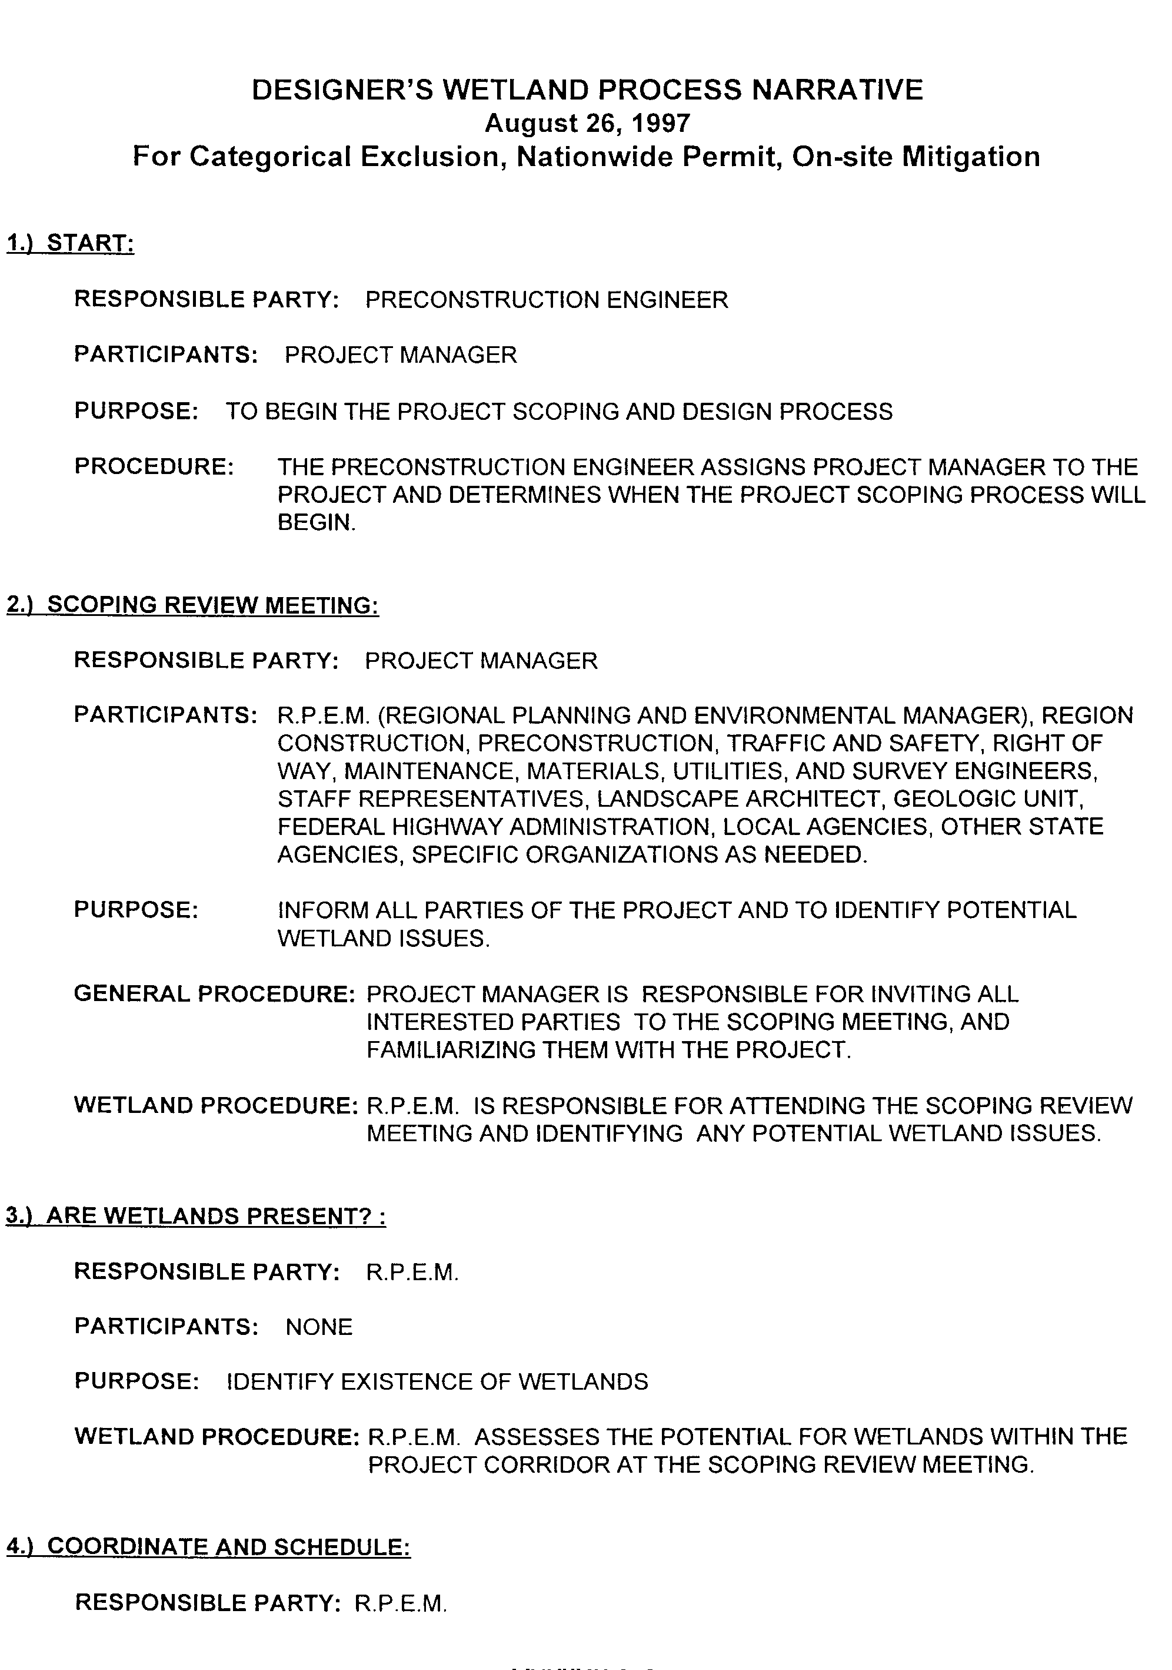
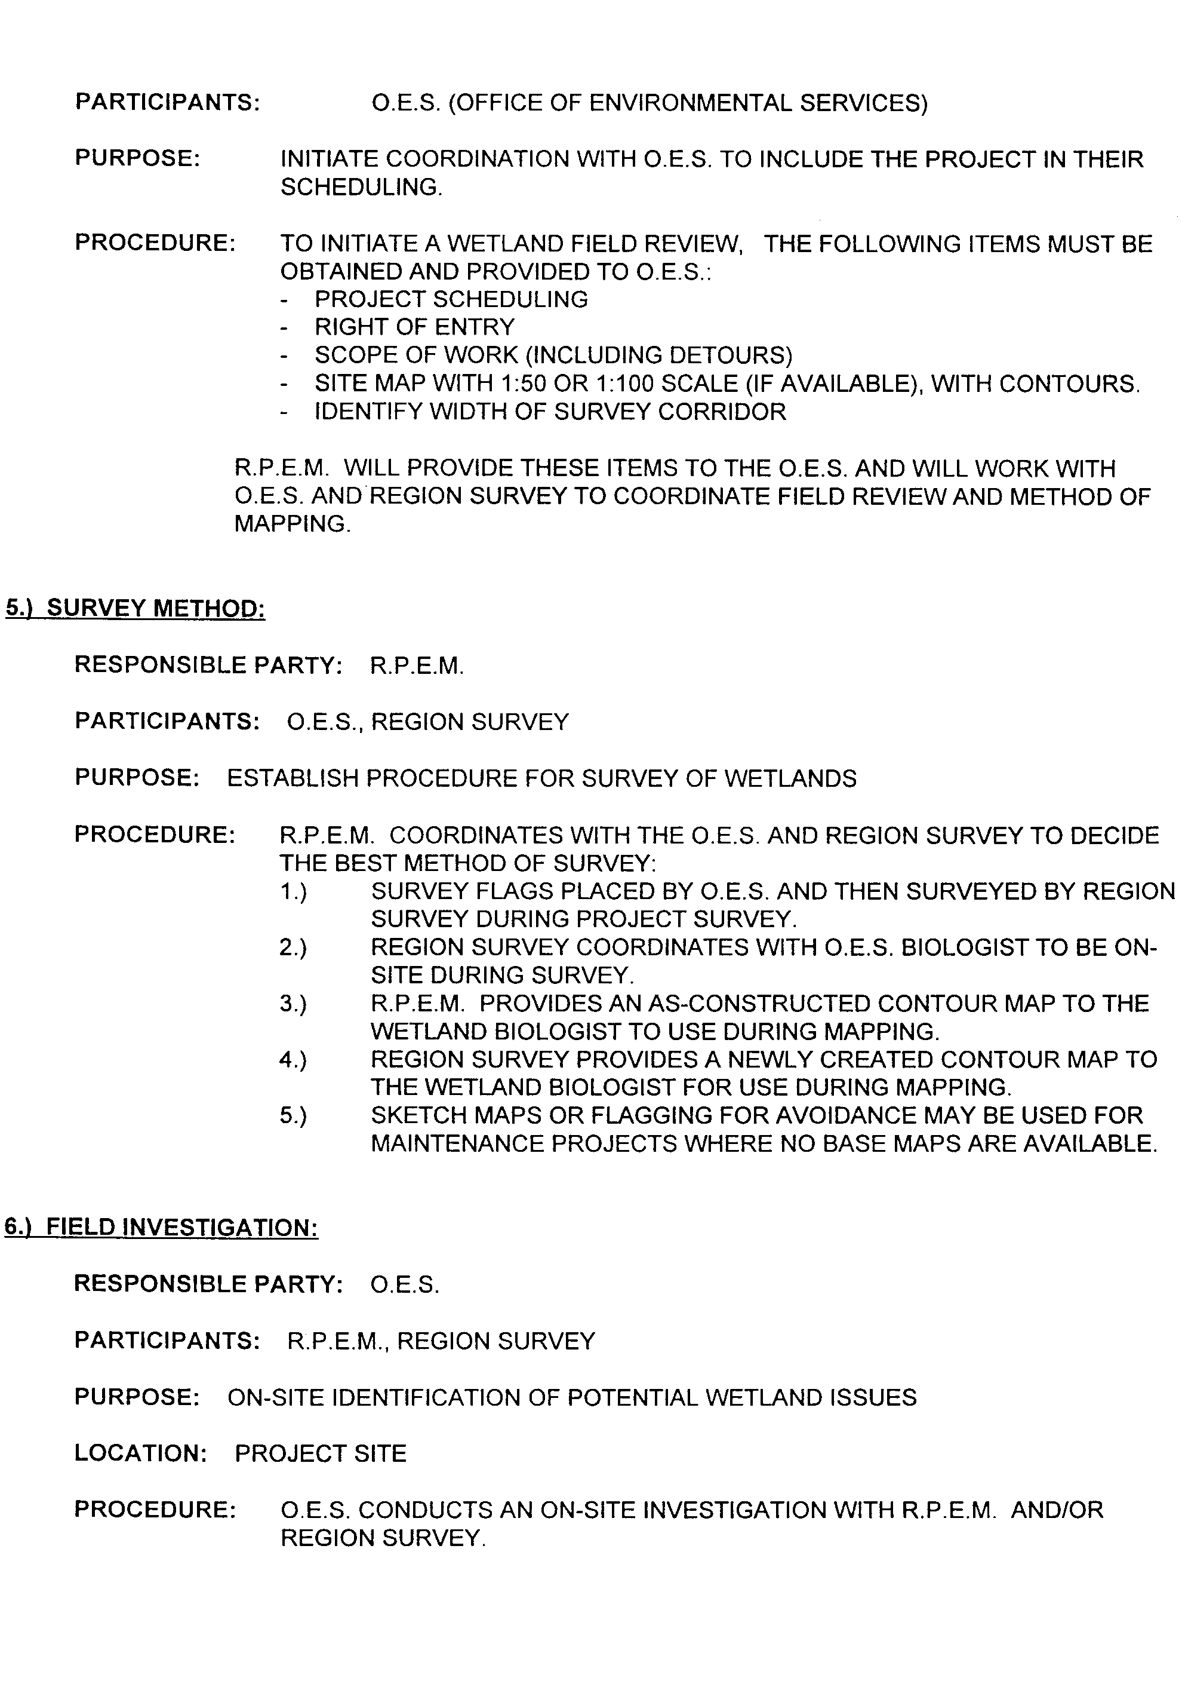
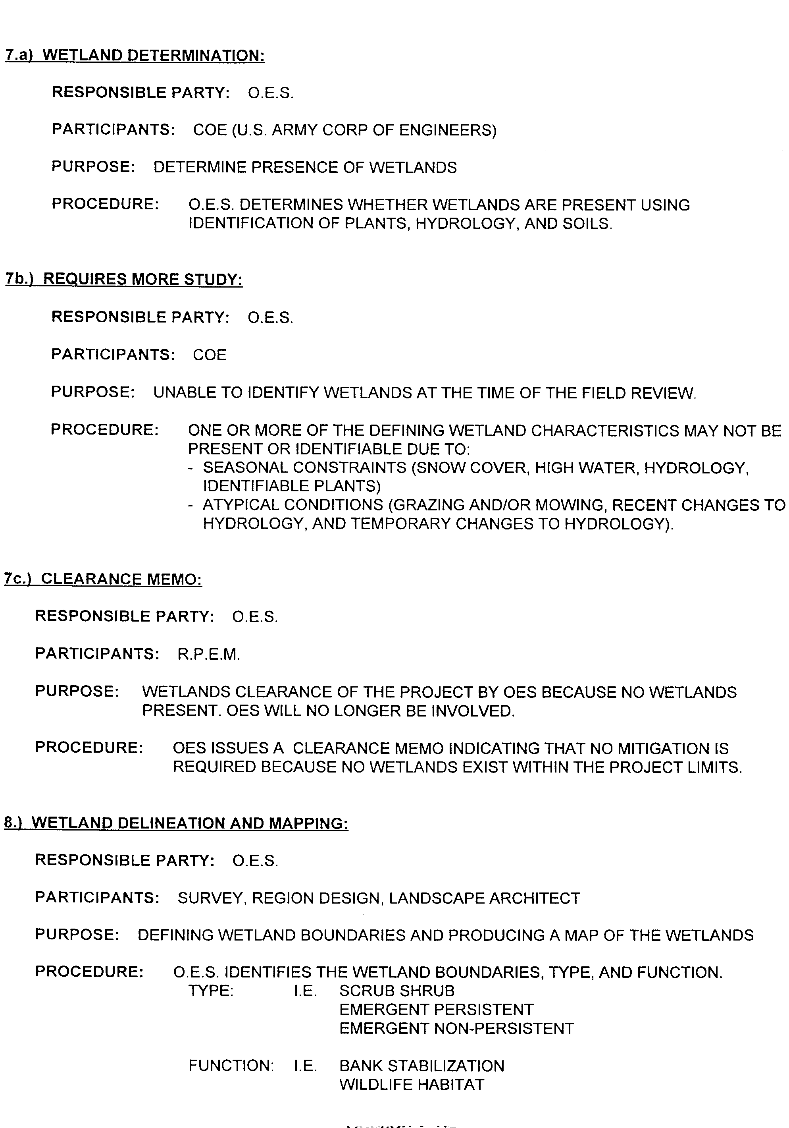
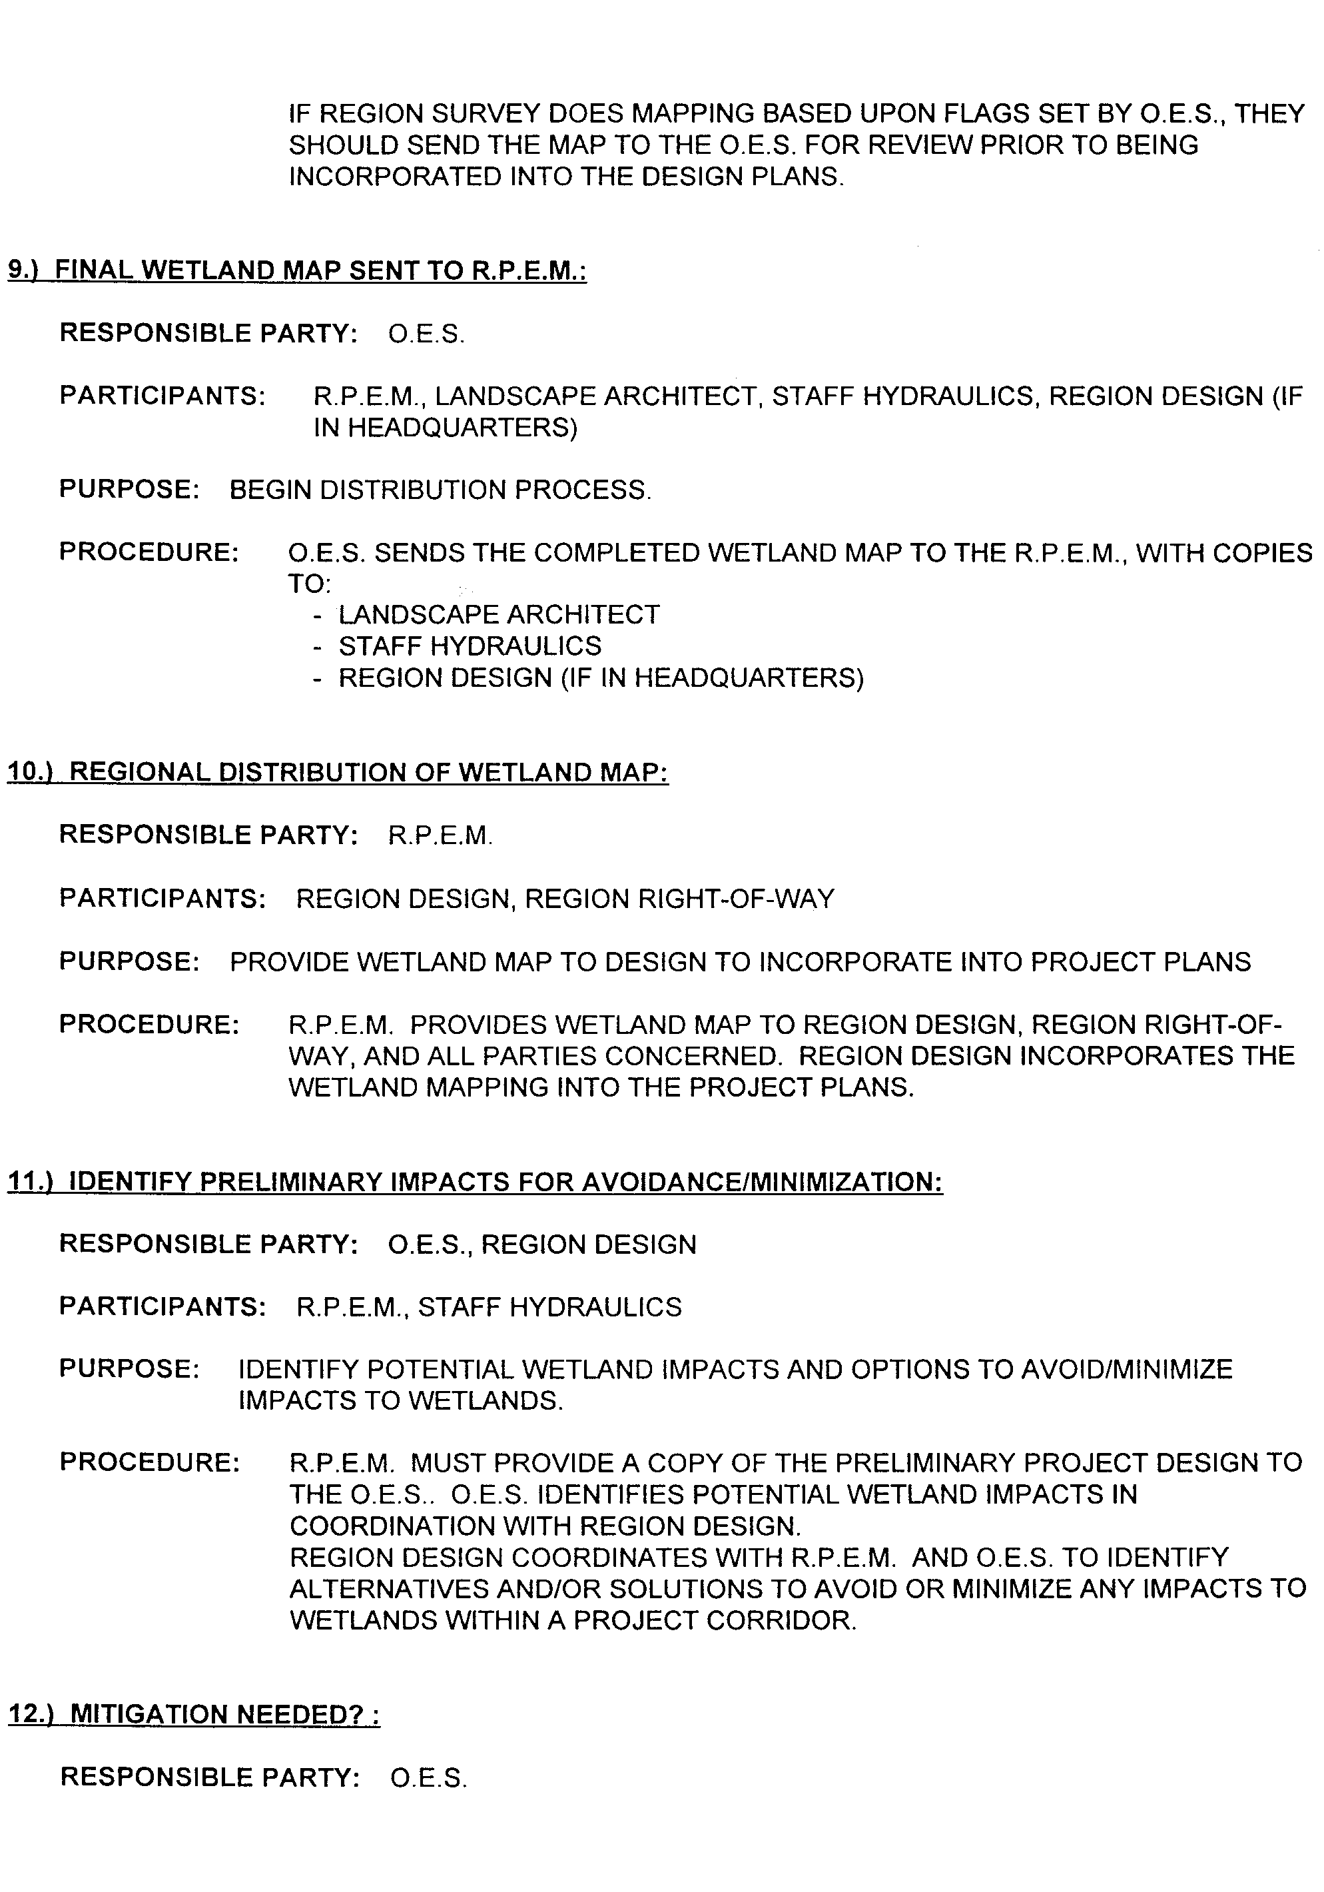
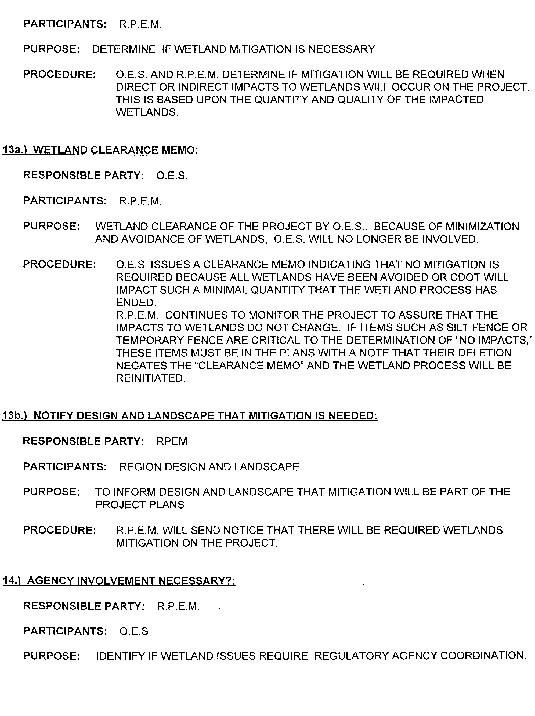

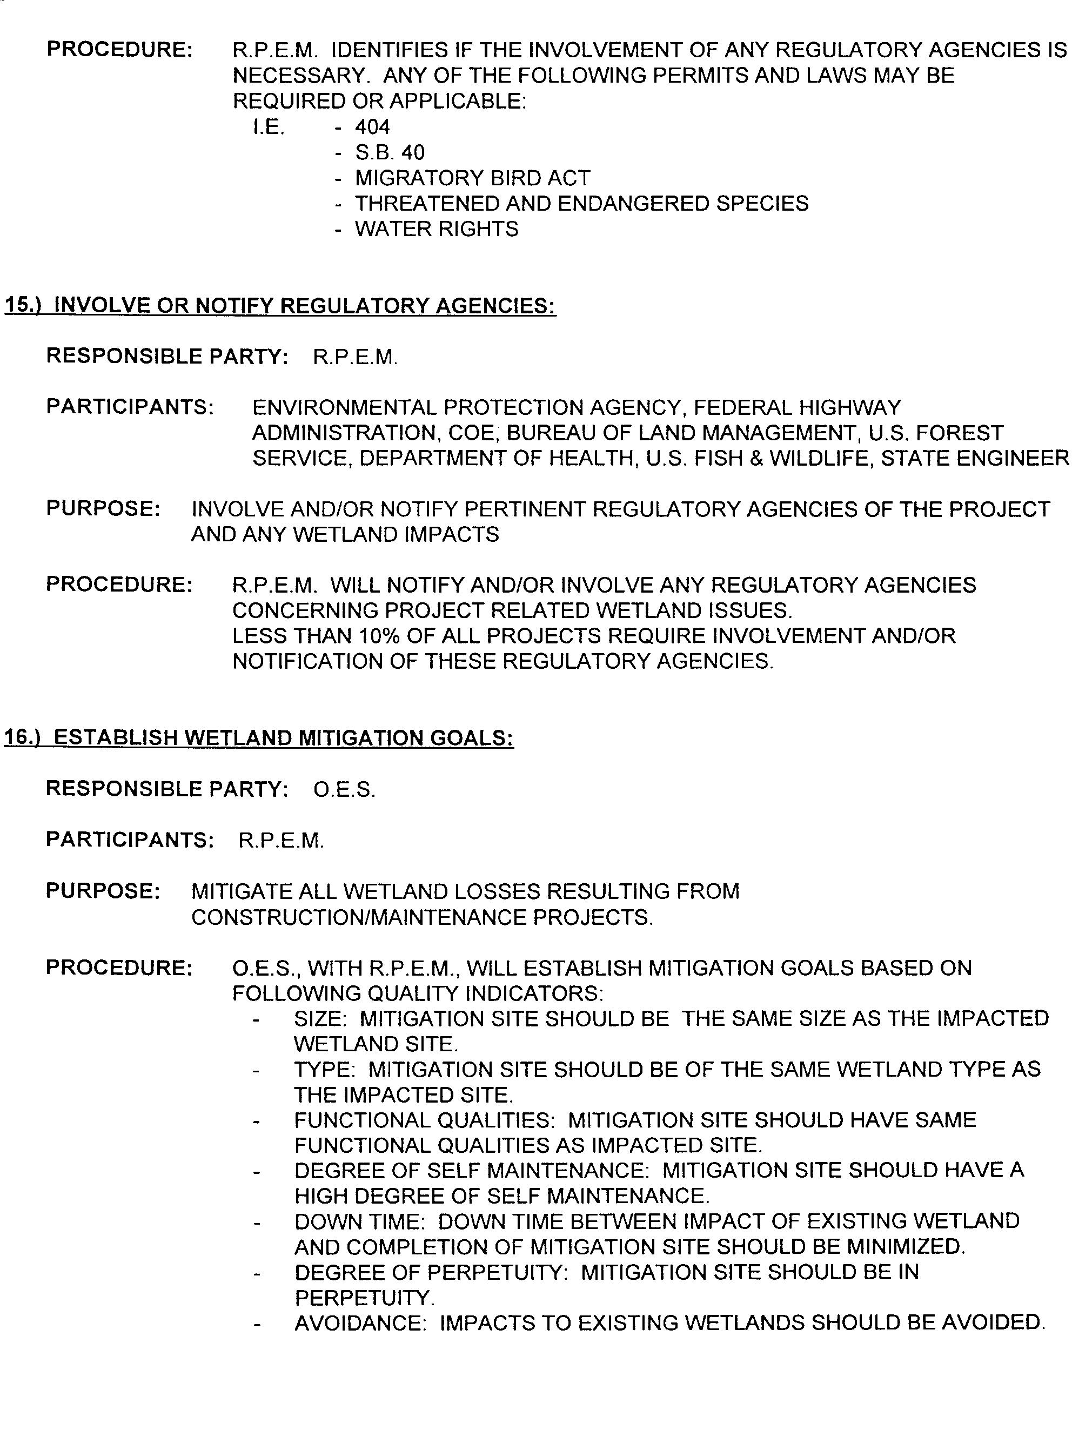
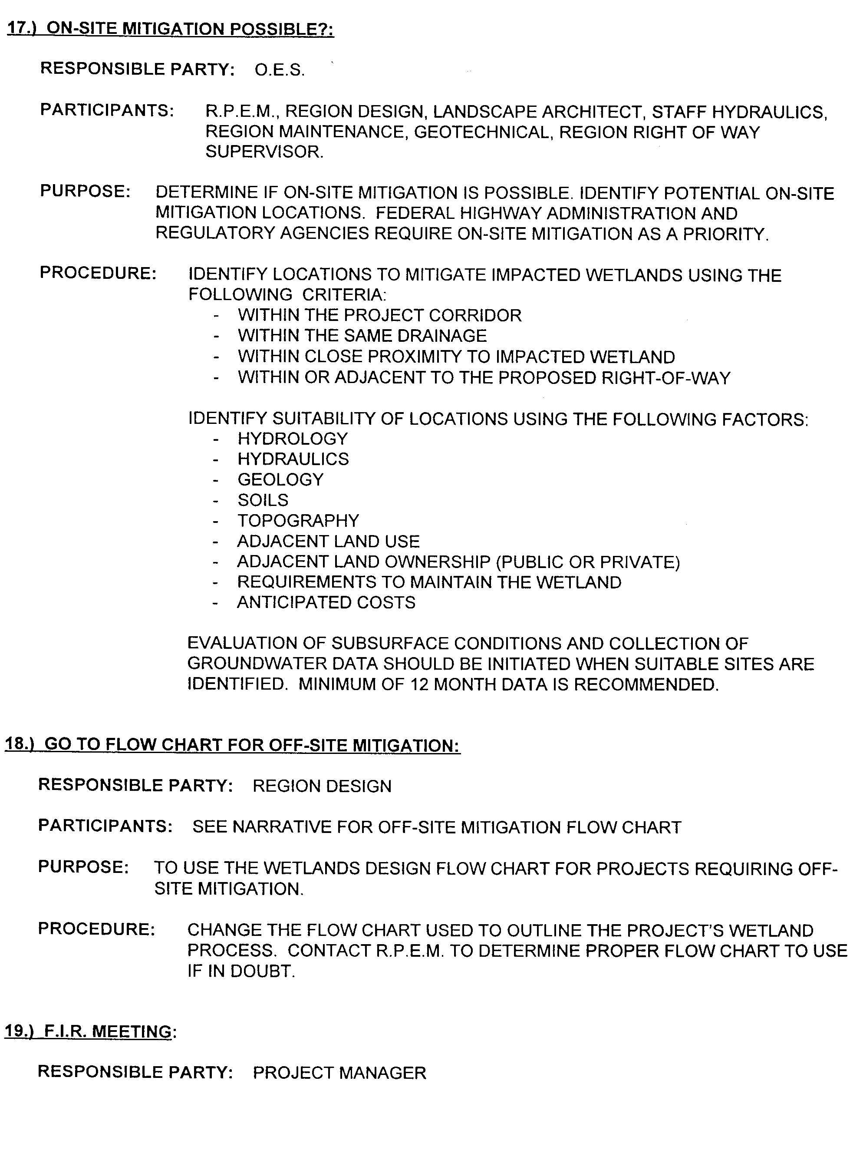

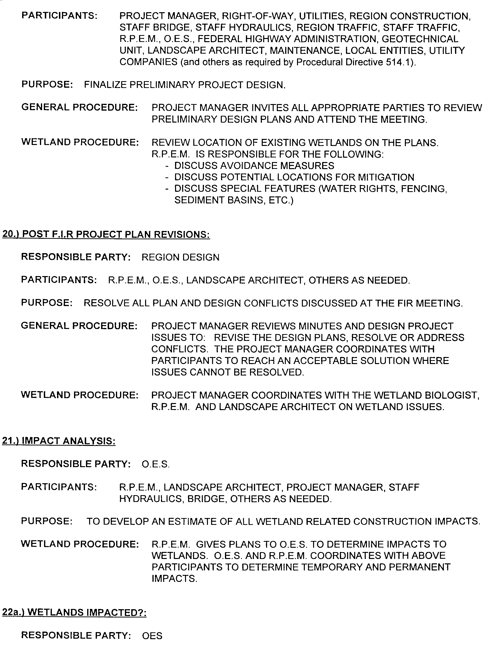

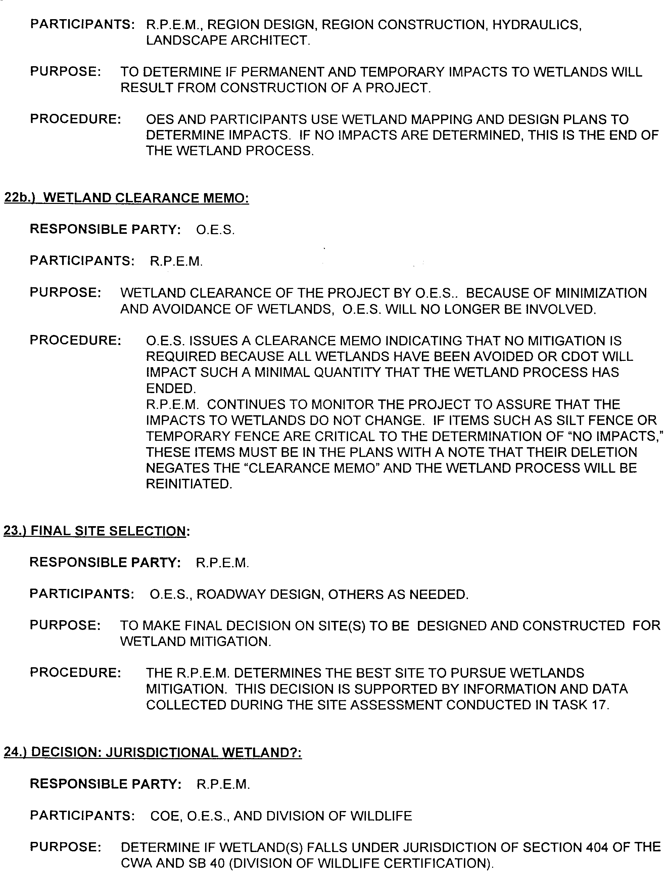

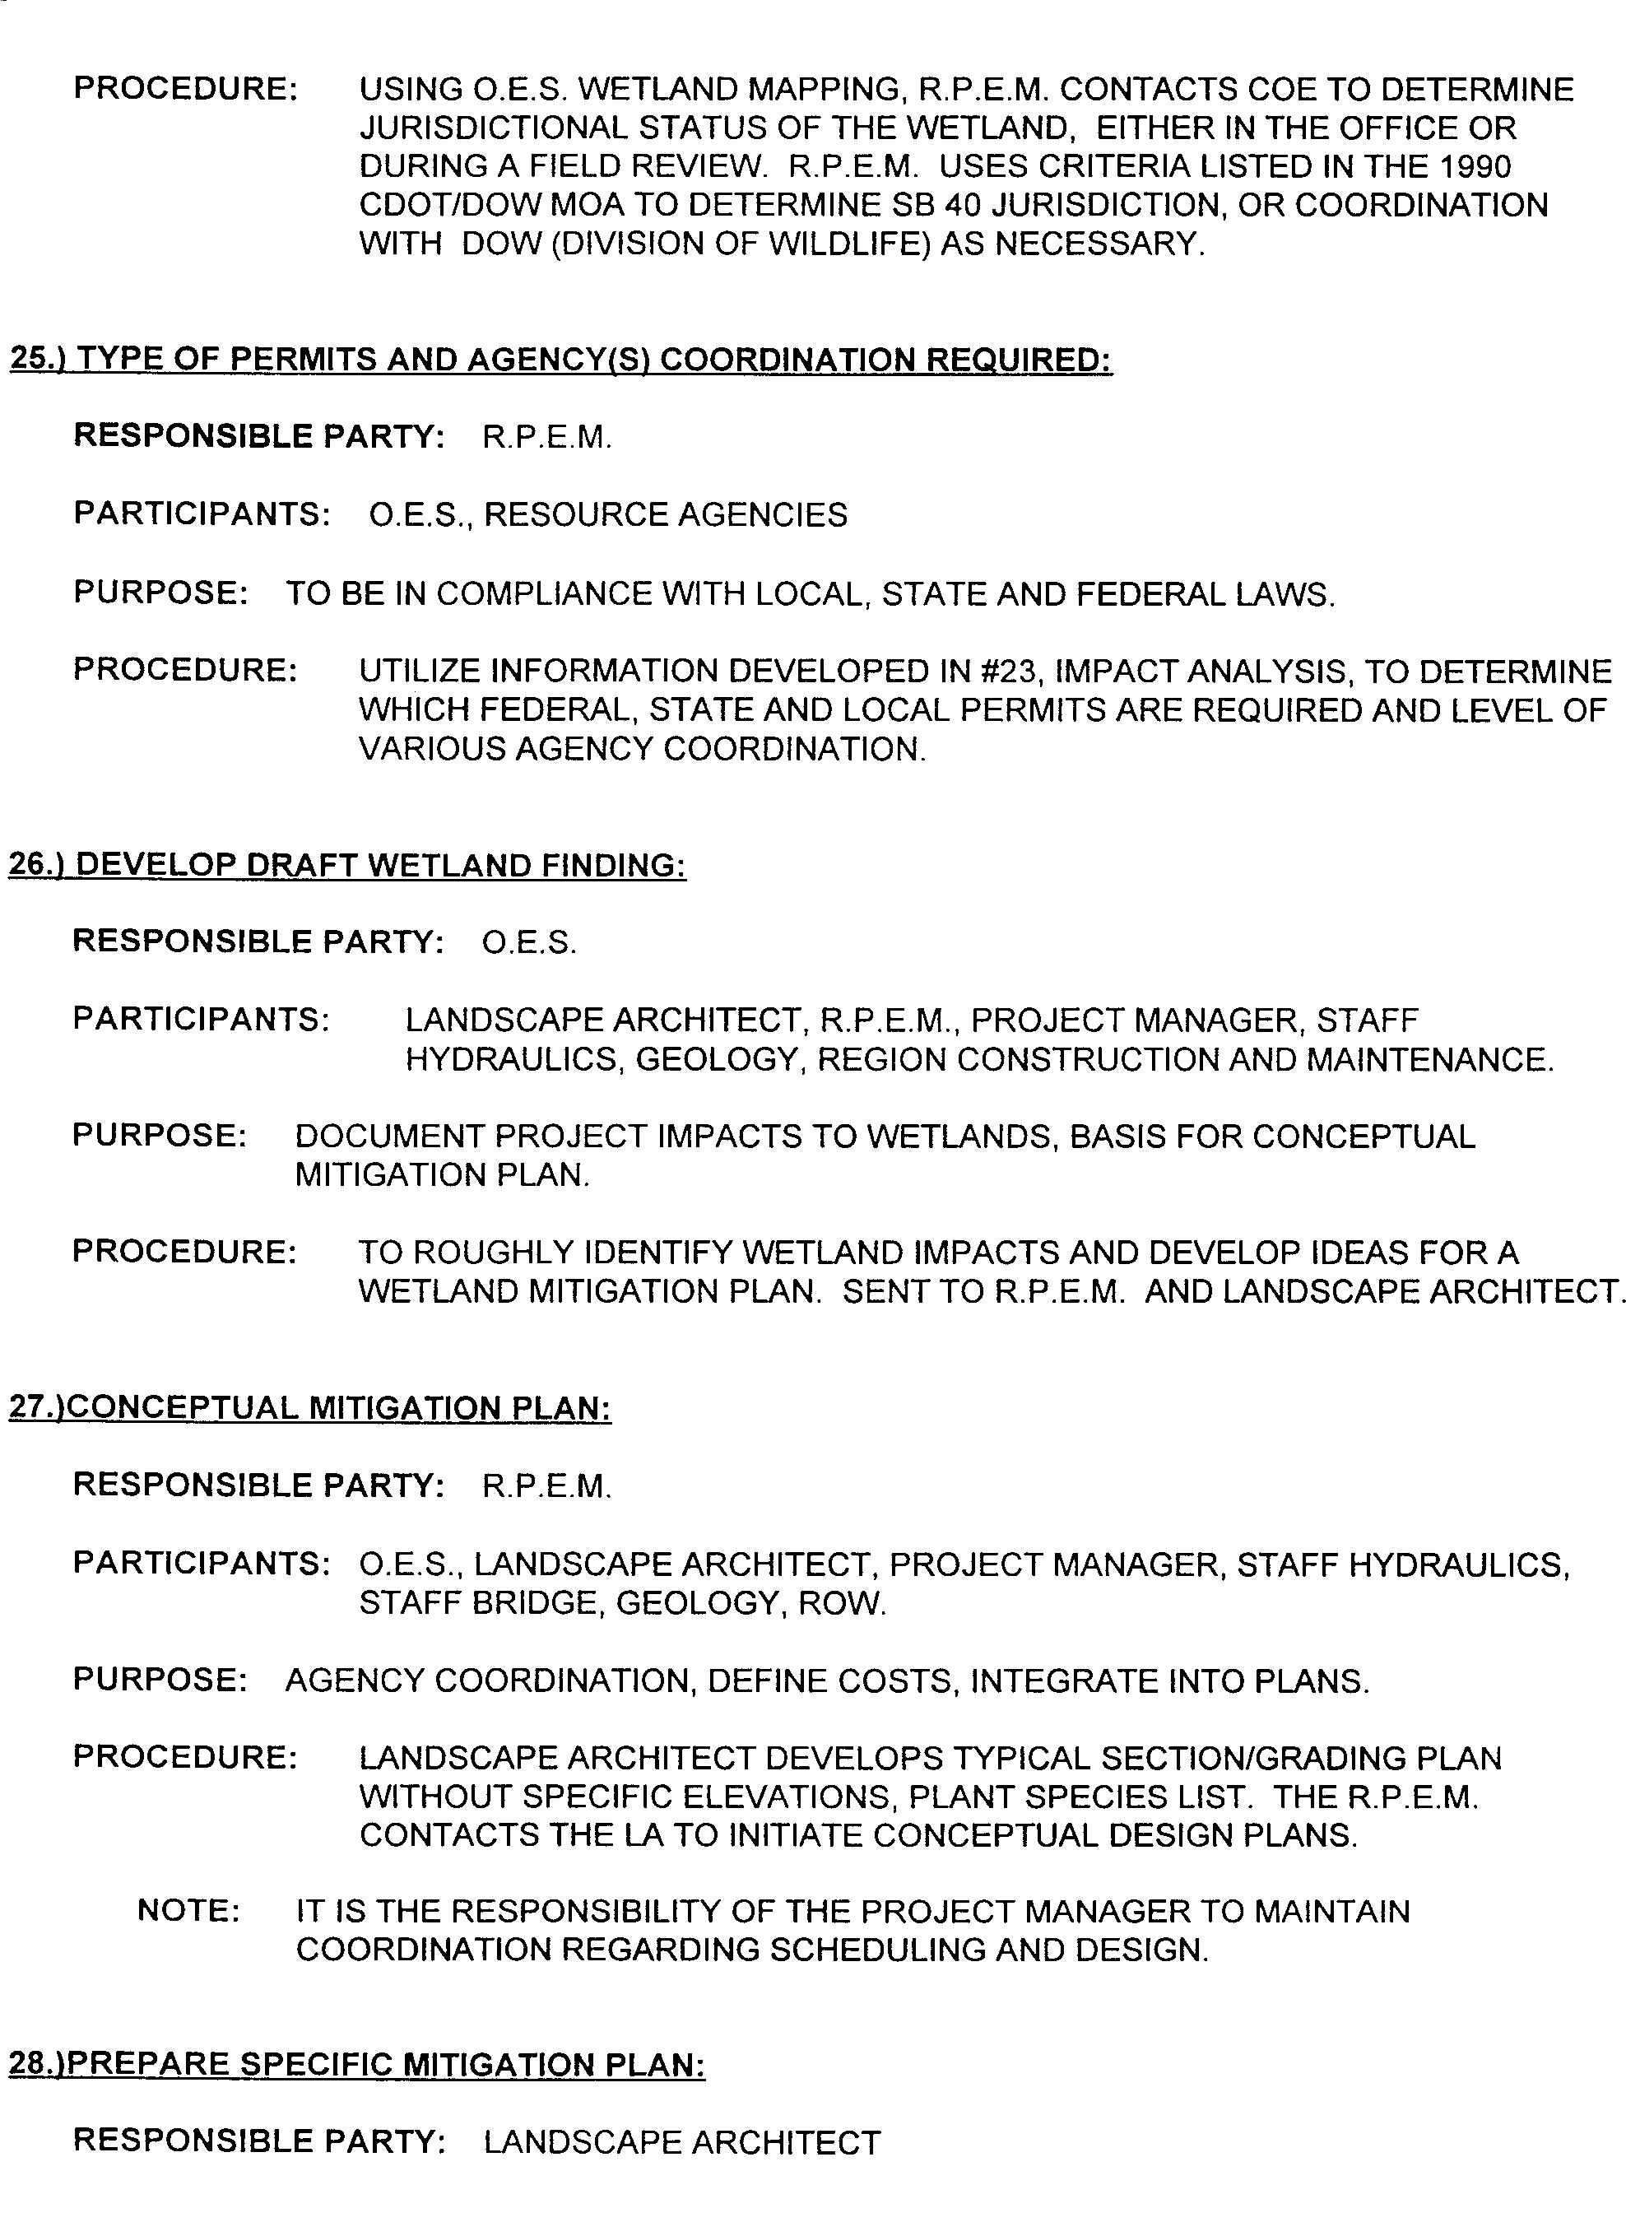
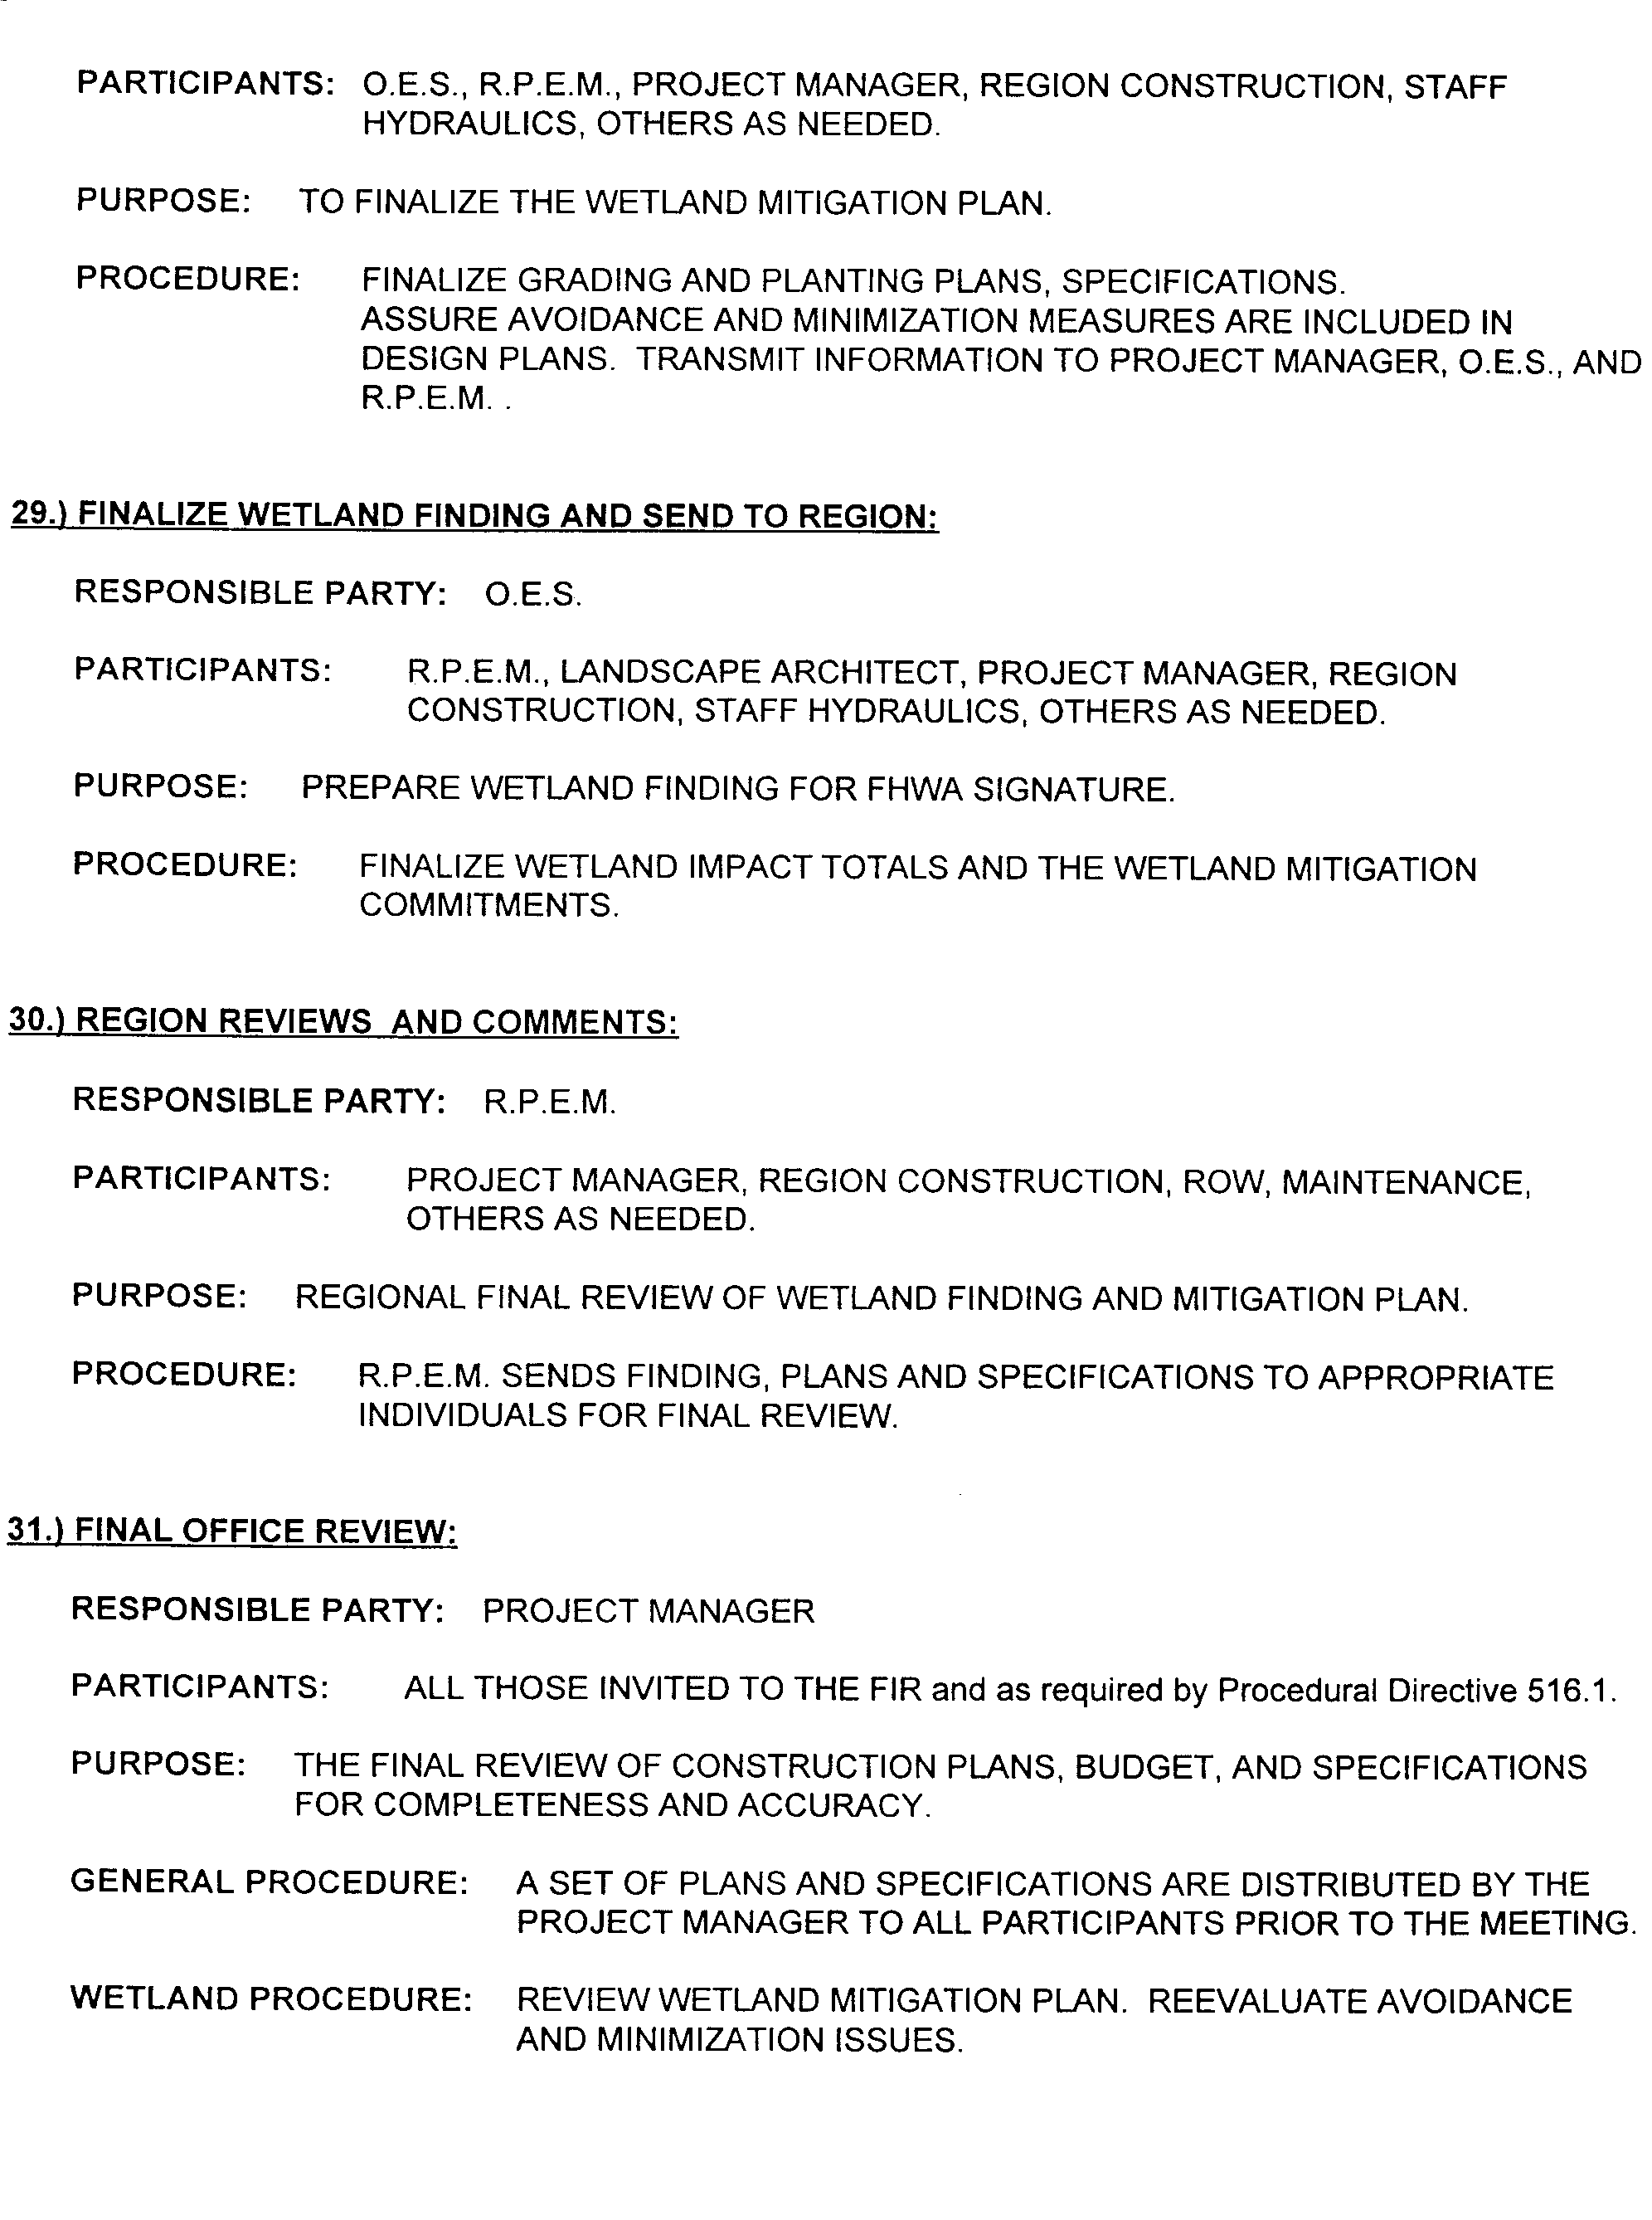

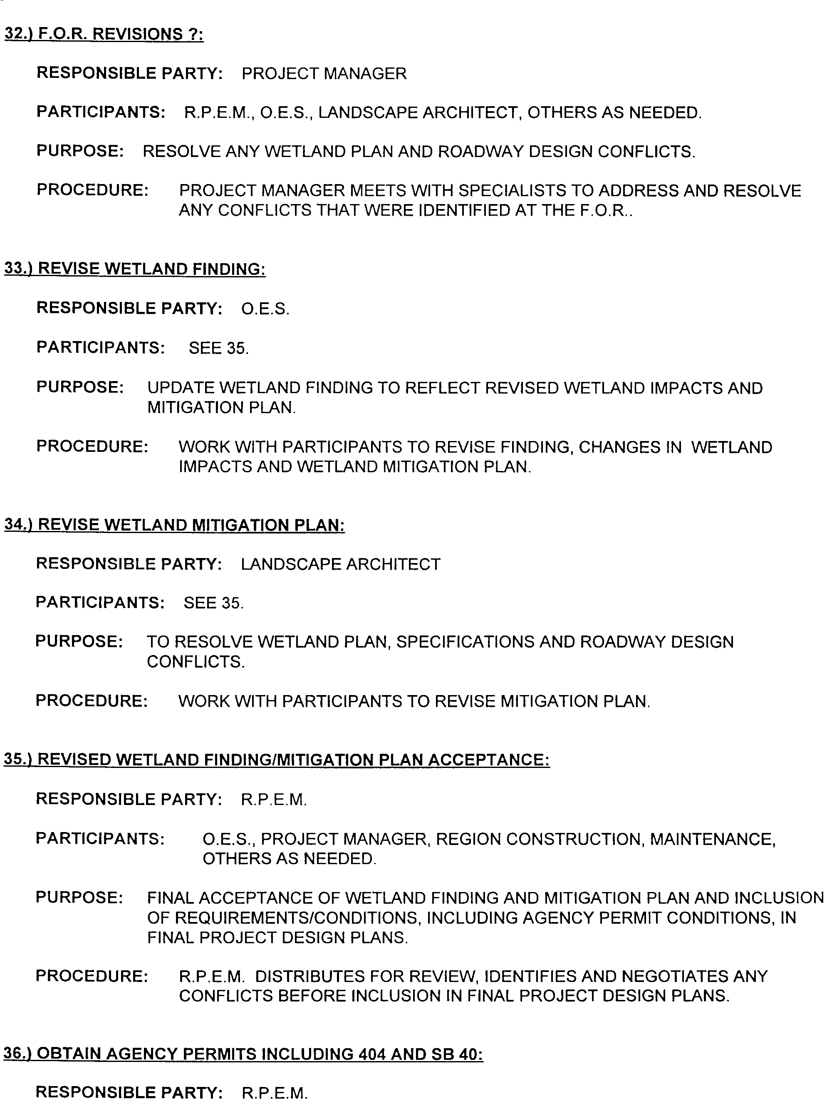

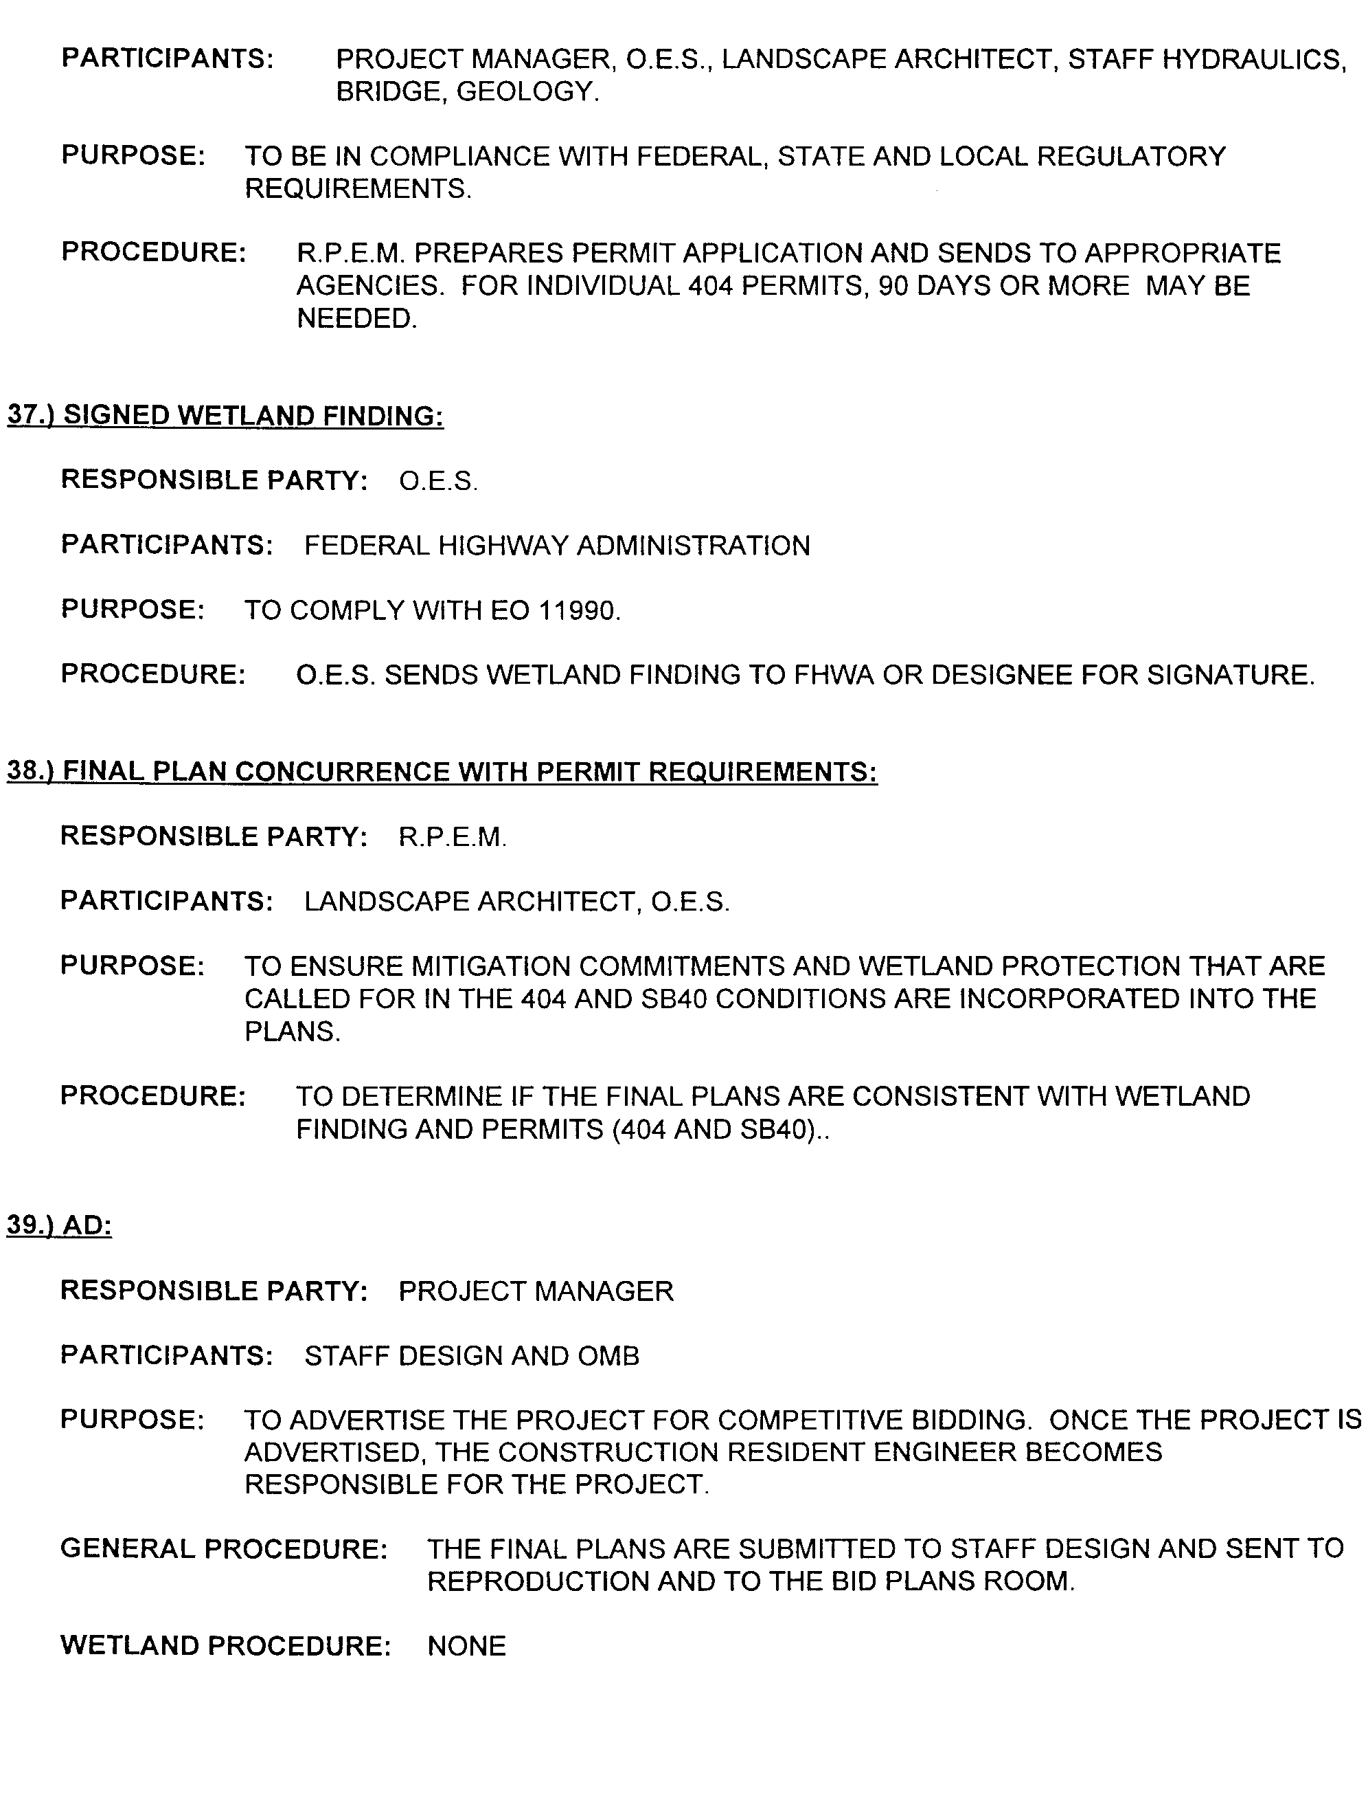
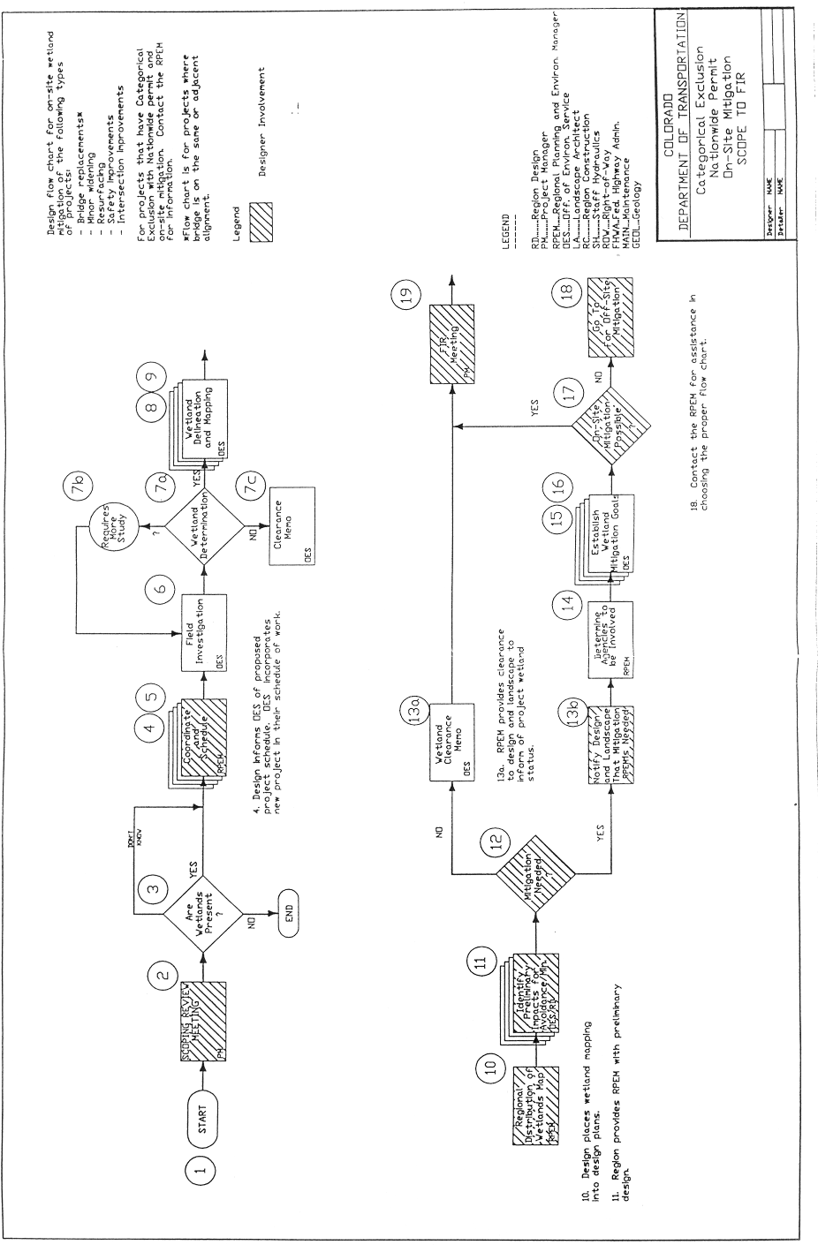Figure 2(c)

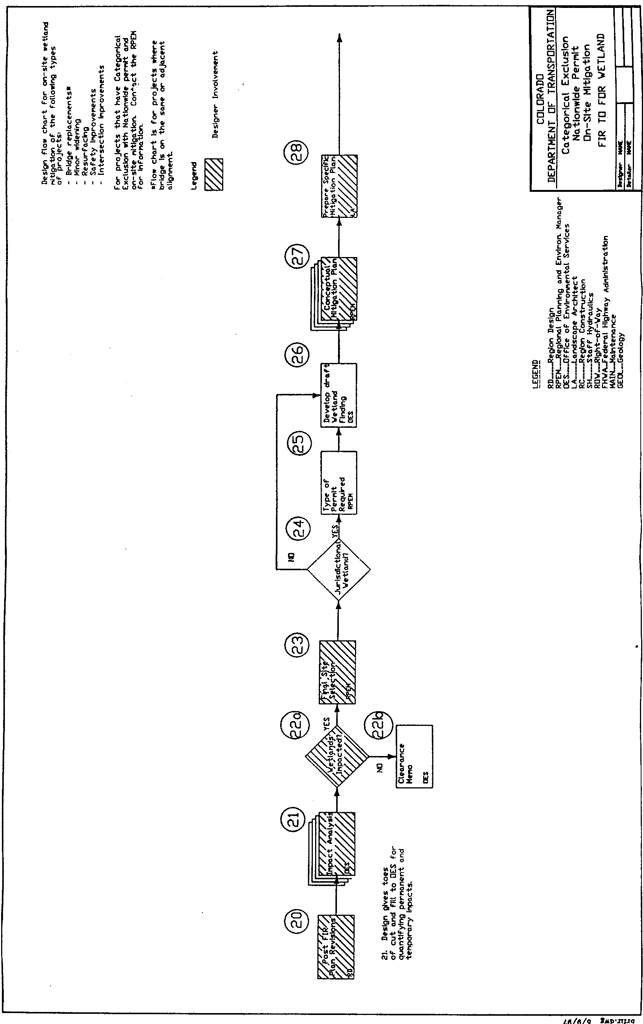Figure 2(d)
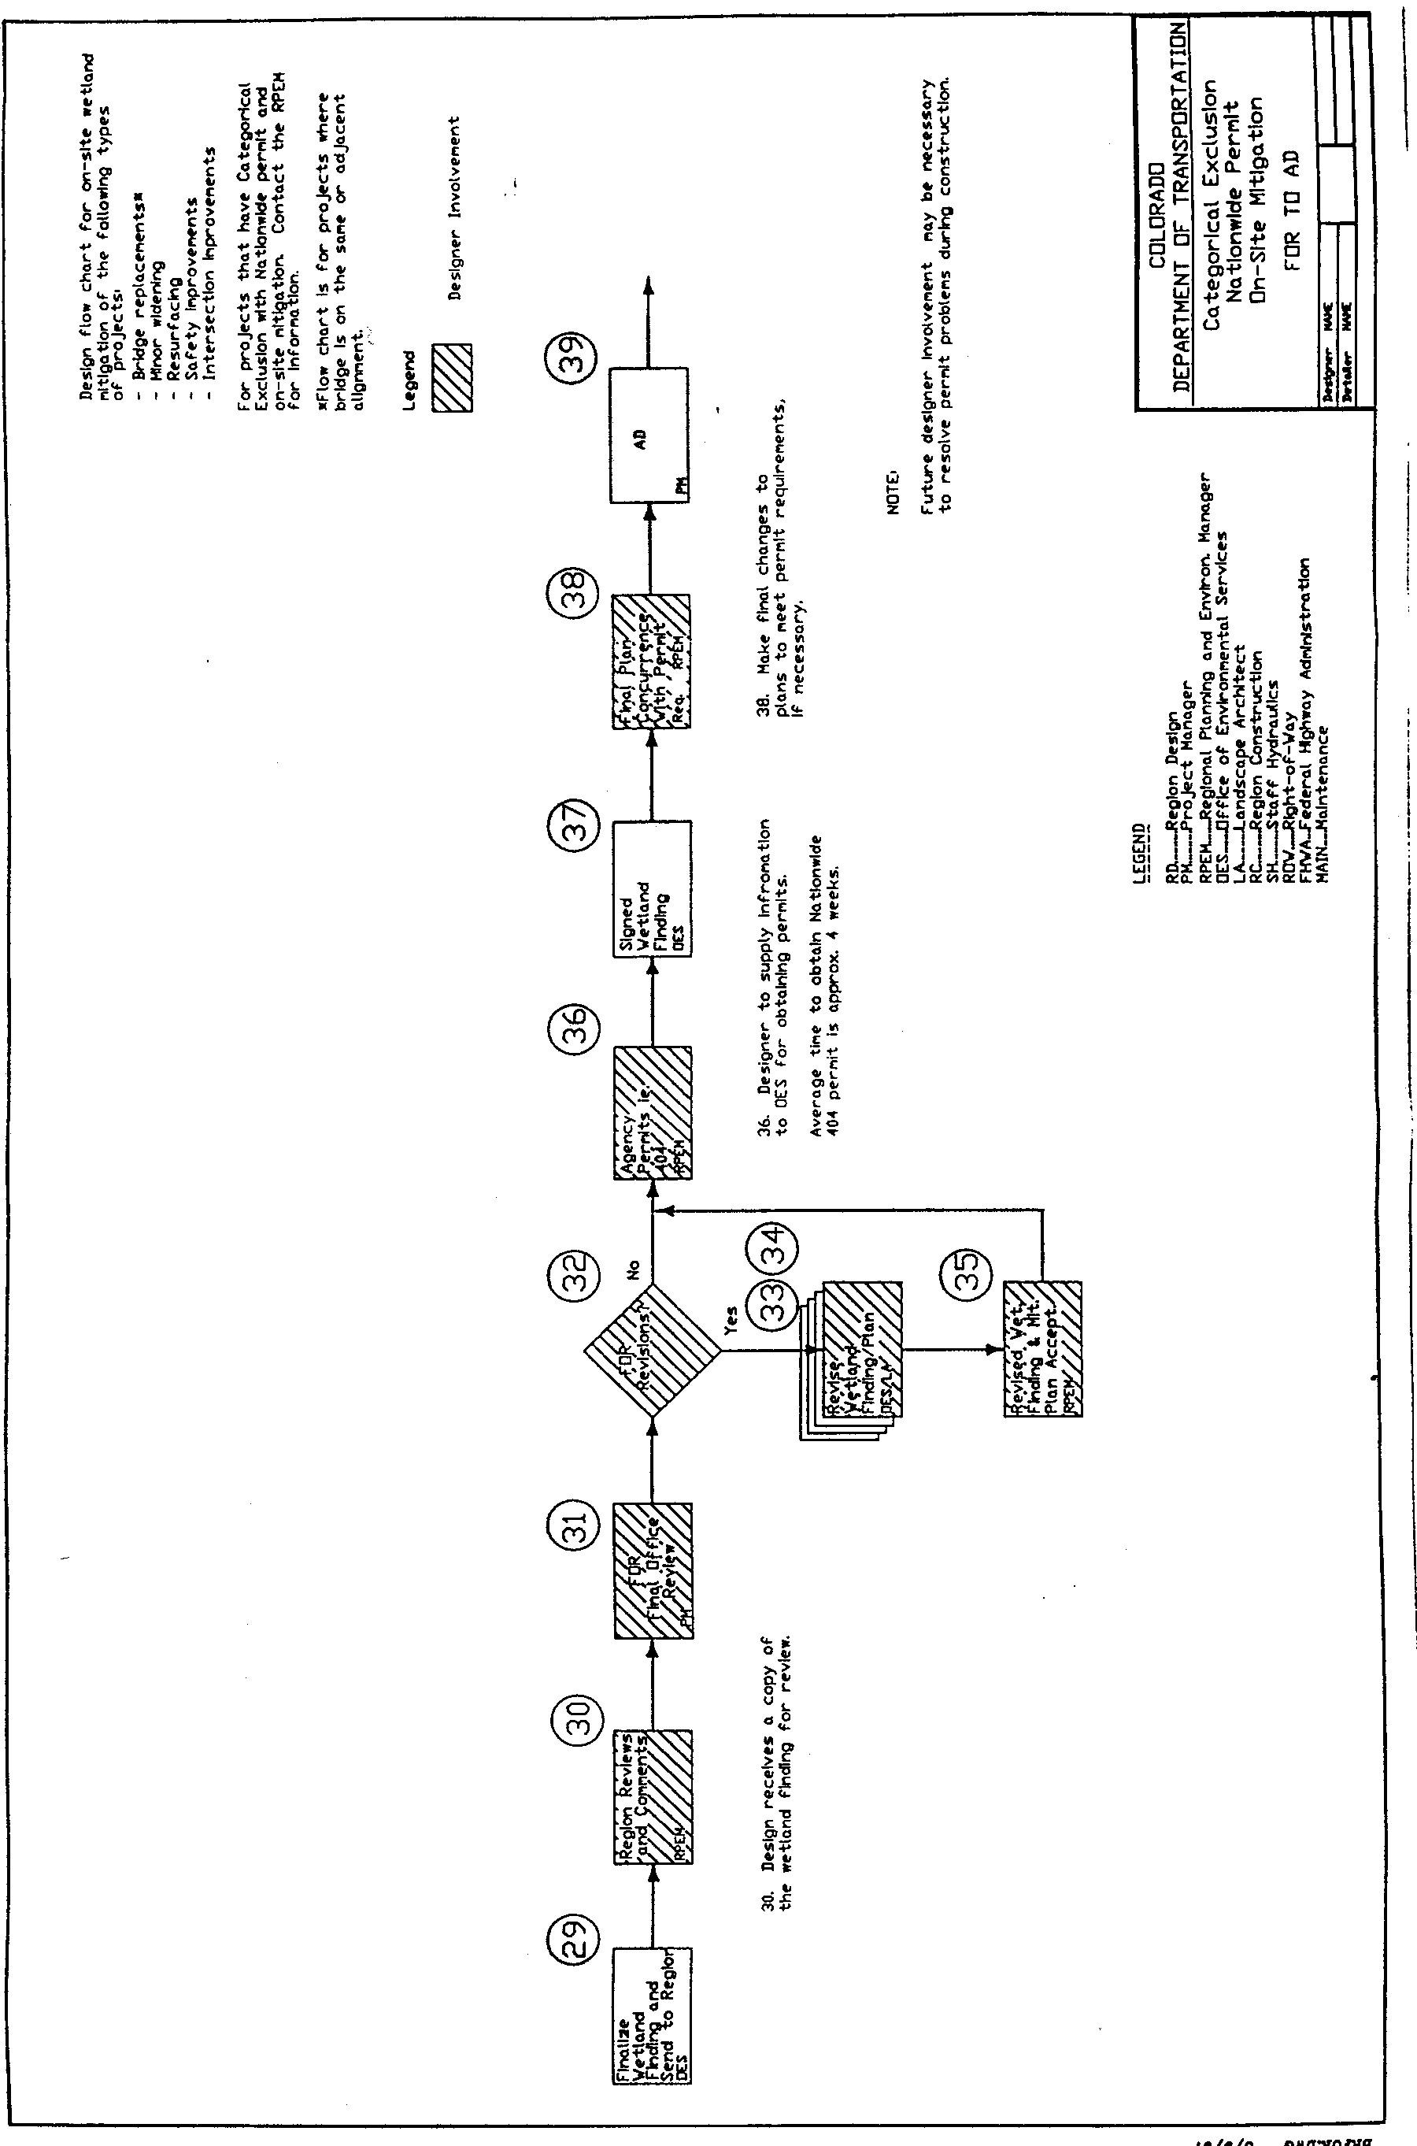
Figure 2(e)

2.12 DIVISION OF WILDLIFE (Senate Bill 40)

It is the intent of CDOT to protect Colorado’s fishing streams and fish and wildlife resources from impacts from CDOT construction projects and maintenance activities. The Region Planning/Environmental Manager, in coordination with the Environmental Programs office in the Project Development Branch, is responsible for all requirements concerning encroachments into streams, rivers, lakes, and associated wildlife habitat.

A Colorado Senate Bill 40 (SB40) certification must be initiated whenever any project or maintenance activity may obstruct, damage, diminish, destroy, change, modify, or vary the natural shape and form of any stream, its immediate banks, tributaries, or as much of the bankside (riparian) areas as could reasonably be expected to contribute to the quality of the general stream habitat.

CDOT has an agreement with the Division of Wildlife regarding projects at points that cross streams (and dry gullies that provide water to perennial streams). That agreement basically states that if project impacts are below certain thresholds, CDOT is charged with overseeing the Division of Wildlife interests in maintaining the quality of streams in CDOT project areas.

Construction cannot begin without SB 40 clearances being granted, whether by CDOT environmental personnel in the case of lesser impacts, or by the Colorado Division of Wildlife. SB 40 clearances and requirements are legally binding agreements between CDOT and the Division of Wildlife. This means that changes in project design, changes made to projects in the field, and changes in erosion control and similar procedures that may alter project impacts cannot be made until all parties have agreed to the changes and those changes have been documented.

The Region Planning/Environmental Manager will be responsible for the following:

- Submitting an application and design information to the Colorado Division of Wildlife when formal application is required. When a project falls under the CDOT and Division of Wildlife Memorandum of Agreement, the programmatic certification may be used provided the specified mitigation conditions are included in the project plans.
- Coordinating with the Colorado Division of Wildlife on any questions concerning the application.

Projects that require SB 40 clearances may also require permits under Section 404 of the Federal Clean Water Act. Refer to Section 2.19 of this manual for a discussion of Section 404 Permit requirements.

Additional References:
- Colorado Senate Bill 40 of 1969
- CRS 33-5-101, Protection of Fish, Wildlife, and Fishing Waters of Colorado
- CDOT Erosion Control and Stormwater Quality Guide
- 23 CFR Part 771, Environmental Impact and Related Procedures
- http://www.fhwa.dot.gov//////legsregs/directives/techadvs.htm FHWA Technical Advisory T 6640.8A, Guidance for Preparing and Processing Environmental and Section 4(f) Documents
- 42 USC 4321, National Environmental Policy Act
- Memorandum of Agreement and referenced materials in SB40 are available from the Project Development Branch, Environmental Programs office.

2.13 THREATENED AND ENDANGERED SPECIES

When a transportation construction project or maintenance activities may affect sensitive species (endangered, threatened, candidate, and proposed species of animals or plants listed under the Endangered Species Act of 1973, as amended) the project impacts must be assessed. Impacts also must be evaluated if a project has the potential of modifying or destroying areas proposed or designated as critical habitat.

The Federal Highway Administration (FHWA) is primarily responsible for consulting with the U.S. Fish and Wildlife Service to determine the presence or absence of threatened or endangered species or their critical habitat. The Region Planning/Environmental Manager and the Staff Biologist in the Environmental Programs office in the Project Development Branch are authorized to act on behalf of FHWA and conduct informal consultations with the U.S. Fish and Wildlife Service and/or prepare biological assessments.

The Staff Biologist is responsible for obtaining information relating to sensitive species or critical habitat through contacts with the U.S. Fish and Wildlife Service, the Colorado Division of Wildlife, and the Colorado Natural Heritage Program, and through the use of biological surveys, expert opinion, published reports, and available databases.

The Region Planning/Environmental Manager and the Staff Biologist are responsible for notifying design engineers of potential problems and also collaborate on mitigation measures.

When sensitive species or critical habitat may be present, the Region Planning/ Environmental Manager and the Staff Biologist first determine if there will be an effect on any species or critical habitat protected under the Endangered Species Act. If a project is determined to have “no effect,” then the consultation is not recommended; however, it is recommended that a concurrence letter be obtained from the U.S. Fish and Wildlife Service. If a project is determined to have a “may effect” designation, the consultation process with the U.S. Fish and Wildlife Service is initiated. This process, generally known as Section 7 Consultation, may take the form of a formal consultation or conference, a biological assessment, or a combination of the above.

A biological assessment determines the effects a project will have on listed and proposed species and designated or proposed critical habitat. It also determines whether formal consultation or a conference with the U.S. Fish and Wildlife Service is necessary. The biological assessment is submitted to the U.S. Fish and Wildlife Service by the Region Planning/Environmental Manager or Staff Biologist.

All of this information must be documented in the Environmental Assessment or Environmental Impact Statement prepared for the project. For Categorical Exclusion (Minor) projects, documentation in the project file is required using Form 128, Categorical Exclusion Determination.
Additional References:
- 16 USC 1531-1543, Endangered Species Act
- 42 USC 4321, National Environmental Policy Act
- 23 CFR Part 771, Environmental Impact and Related Procedures
- 50 CFR Part 402, Interagency Cooperation -- Endangered Species Act
5. http://www.fhwa.dot.gov//////legsregs/directives/techadvs.htm FHWA Technical Advisory T 6640.8A, Guidance for Preparing and Processing Environmental and Section 4(f) Documents
6. See Appendix A for forms

2.14 HAZARDOUS WASTE AND MATERIALS

CDOT strives to identify during the early stages of transportation project development any problems dealing with properties that have been or are being contaminated with hazardous substances or hazardous waste. Studies must be conducted to determine if hazardous waste is present in the area of a proposed CDOT construction project or maintenance activity.

Hazardous waste can be a solid waste, or combination of solid waste (garbage, refuse, sludge) and other discarded material including solid, liquid, semisolid, or containing gaseous material resulting from various activities including industrial/commercial operations, mining, and agricultural or community operations (such as groundwater contamination, leaking underground storage tanks). Hazardous waste sites are primarily regulated by the Resource Conservation and Recovery Act and the Comprehensive Environmental Response, Compensation and Liability Act.

The Region Planning/Environmental Manager is responsible for completing hazardous waste studies and for determining the potential for encountering hazardous waste on a CDOT project. Hazardous waste studies address the identification, evaluation, and mitigation of hazardous waste. Although hazardous waste sites affect relatively few projects, their discovery late in the project development process or during construction can lead to unexpected and costly delays or unexpected remedial costs. Hazardous waste issues should be resolved prior to construction of the project, and prior to right-of-way acquisition.

An Environmental Site Assessment is prepared which includes conducting a records search and a visual inspection of the project area. The Environmental Site Assessment should be completed prior to the acquisition of any property. If the potential for hazardous waste is indicated from the Environmental Site Assessment, then a site investigation is initiated to determine the type and extent of the contamination. If the contaminated area can be avoided, a site investigation may be necessary. Early coordination with the Regional Office of the Environmental Protection Agency and the Colorado Department of Public Health and Environmental as well as local regulatory agencies will aid in identifying potential waste sites.

If contaminants are located on the property and it has been determined the property cannot be avoided (this decision is made in consultation with the Region Right-of-Way unit and the Federal Highway Administration), the Region Planning/Environmental Manager conducts further site investigation. The object of this further site investigation is to delineate the vertical and lateral extent of contamination on the site and to identify the type and concentrations of contaminants. This additional site investigation also provides recommendations for remedial actions. A Materials Management Plan is prepared that is used to establish site-specific-action levels for the management and handling of contaminated soils or waters that may be encountered during construction. Section 250 of the Standard Specifications (Environmental Health and Safety Management) provides the procedures and protocols for managing waste issues during construction.

Any mitigation recommendations, potential public health concerns, potential agency liabilities, and project alternatives must be discussed in the Environmental Assessment or Draft Environmental Impact Statement. The Finding of No Significant Impact or Final Environmental Impact Statement should resolve any issues raised by public and government agencies. For Categorical Exclusion (Minor) projects, documentation in the project file is required using Form 128, Categorical Exclusion Determination.

Additional References:
1. 23 CFR Part 771, Environmental Impact and Related Procedures
2. 29 CFR Parts 1910.1-1910.999, Occupational Safety and Health Standards
3. 40 CFR Parts 100-399, Protection of the Environment
4. 49 CFR Parts 100-199, U.S. Department of Transportation Hazardous Materials Transportation Act
5. 42 USC 4321, National Environmental Policy Act
6. 42 USC 6901, Resource Conservation and Recovery Act
7. 42 USC 9601-9651, Comprehensive Environmental Response, Compensation, and Liability Act
8. CDOT Standard Specifications 250, Environmental Health and Safety Management
9. CDOT Interim Guidelines for Acquisition of Property Containing Hazardous Waste
10. FHWA Interim Guidance - Hazardous Waste Sites Affecting Highway Project Development
11. http://www.fhwa.dot.gov//////legsregs/directives/techadvs.htm FHWA Technical Advisory T 6640.8A, Guidance for Preparing and Processing Environmental and Section 4(f) Documents
12. See Appendix A for forms

2.15 NOISE ANALYSIS

CDOT has established procedures for noise studies and noise abatement measures that are in accordance with the Federal-Aid Highway Act and the National Environ- mental Policy Act.

The CDOT guidelines, listed at the end of this section, are used to determine noise levels for traffic and transportation construction projects, evaluate impacts, and recommend mitigation where feasible and reasonable. Sources of highway traffic noise (automobiles, trucks, and other vehicles) are engine, exhaust, and tire noise. Projects that require a noise analysis under Federal Highway Administration (FHWA) regulations are denoted as either Type I or Type II.

Type I Projects are proposed federal-aid projects for the construction of a new highway or the physical alteration of an existing highway that either significantly changes the roadway alignment or increases the number of through traffic lanes. Examples of Type I projects are road widenings, addition of or alteration interchanges, climbing lanes, or the addition of high-occupancy vehicle lanes. These projects will analyze noise impacts and potential noise mitigation as part of the design and construction.

Type II Projects are proposed federal-aid projects for noise abatement on an existing highway. Type II projects are not mandatory requirements according to FHWA guidelines. CDOT does not currently administer a Type II program.

For Type I Projects a noise analysis is required and must be performed in accordance with the CDOT Noise Analysis and Abatement Guidelines for all project alternatives. In determining noise impacts, noise abatement will usually be effective only where noise sensitive activities occur and within 300 feet of the centerline of the proposed project. For highways with a projected average daily traffic of 70,000 vehicles/day, the area is expanded to 500 feet of the centerline.

A noise analysis document is to be prepared for each project. The following steps are to be followed for all Type I and II projects:

- Identification of land uses and activities;
- Determination of existing noise levels;
- Prediction of future noise levels;
- Determination of traffic noise impacts;
- Identification of mitigation measures;
- Determination if mitigation measures are feasible/reasonable; and,
- Development of recommendations (completion of Form 1209, Noise Abatement Determination).

For most cases, FHWA noise analysis guidelines are used. However, in the case of a project that contains rail (light rail, commuter rail, etc.) or certain types of fixed facilities (i.e., parking or terminal facilities), noise analysis in regards to those elements is covered under Federal Transit Administration guidance.

The noise analysis must be addressed and summarized in the required environmental documents (Environmental Assessment/Environmental Impact Statement) for Major and Intermediate projects. For Categorical Exclusion (Minor) projects, documentation in the project file is required using Form 128, Categorical Exclusion Determination. Noise mitigation, if recommended, should be incorporated into and be an integral part of the project.

Additional References:
- 23 CFR Part 771, Environmental Impact and Related Procedures
2. 23 CFR Part 772, Procedures for Abatement of Highway Traffic Noise and Construction Noise
3. 23 USC 109(I), Noise Standards for Highway Traffic
4. 42 USC 4321, National Environmental Policy Act
5. CDOT Noise Analysis and Abatement Guidelines
6. CDOT Noise Guide for Highways (Volume IX of the CDOT Design Guide)
7. CDOT Policy Directive 1601.0, Interchange Approval Process
8. CDOT Procedural Directive 1606.1, Selection of Type II Noise Abatement Projects
9. CRS 25-12-101 through 25-12-108, Noise Abatement

10. DOT Highway Traffic Noise Analysis and Abatement - Policy and Guidance
11. DOT-T-95-16, Transit Noise and Vibration Assessment
12. http://www.fhwa.dot.gov//////legsregs/directives/techadvs.htm FHWA Technical Advisory T 6640.8A, Guidance for Preparing and Processing Environmental and Section 4(f) Documents
13. FHWA-RD-76-58, Noise Barrier Design Handbook
- Public Law 92-574, as amended, Noise Control Act of 1972
- See Appendix A for forms

2.16 AIR QUALITY

All CDOT projects and activities should: (1) comply with federal and state air quality laws and regulations, and (2) not cause or contribute to a violation of National Ambient Air Quality Standards.

All transportation projects that require federal action or use federal funds must comply with the Federal Clean Air Act. In air quality nonattainment/maintenance areas (see below), projects must be developed in coordination with air quality planning and regulatory agencies, metropolitan planning organizations, and local government planning agencies. CDOT maintenance activities, such as highway sanding in winter, also may require evaluation.

It is the responsibility of the Air Quality Specialist in the CDOT Project Development Branch, Environmental Programs office in the Project Development Branch, to coordinate projects with the Air Pollution Control Division of the Colorado Department of Public Health and Environment. This coordination is necessary to inform the Air Pollution Control Division about the project, discuss Air Pollution Control Division concerns, and determine the appropriate level of analysis required to assess the air quality impacts of the project.

A discussion of the air quality impacts, including a summary of the hot-spot analysis (if required), must be included in the Environmental Assessment or Environmental Impact Statement for the project. The air quality concurrence letter from the Air Pollution Control Division also must be included in the appendix of the Environmental Assessment or Environmental Impact Statement. A copy of this analysis shall be sent to the Region Planning/Environmental Manager. For Categorical Exclusion projects, documentation of the air quality clearance in the project file is required before the Form 128, Categorical Exclusion Determination, is signed and submitted to the Federal Highway Administration (FHWA).

CDOT is primarily concerned about projects located in the air quality nonattainment and/or areas of the state. Nonattainment areas are where violations of National Ambient Air Quality Standards have been recorded for ozone, carbon monoxide, or PM-10 (fine particulates). Air quality maintenance areas are previous nonattainment areas where air quality attainment/maintenance plans have been approved by the Environmental Protection Agency.

Nonattainment/maintenance areas in Colorado include:

- Denver, for ozone, carbon monoxide, and PM-10.
- Colorado Springs, Fort Collins, Greeley, and Longmont, for carbon monoxide.
- Rural or smaller urban areas include Aspen, Pagosa Springs, Telluride, Steamboat Springs, Canon City, and Lamar; for PM-10.

Transportation plans, programs, and projects in nonattainment/maintenance areas must comply with the conformity provisions of the Federal Clean Air Act. In the urbanized nonattainment/maintenance areas of Colorado, projects must be included in the conforming, long-range Transportation Plan and the Transportation Improvement Program. The FHWA will not complete any final environmental approvals until a project is included in a conforming Plan and the Transportation Improvement Program. This includes all projects that are federally funded or require federal action, as well as "regionally significant" non-federal-aid projects.

The project level air quality conformity and clearance process consists of the following tasks that are to be completed by the Environmental Programs office air quality specialist in coordination with the Region Planning/Environmental Manager:

- Scope the project for potential carbon monoxide and PM-10 impacts.
- For projects requiring an Environmental Assessment or Environmental Impact Statement, coordinate with the Air Pollution Control Division to determine the level of analysis required. The Memorandum of Agreement between CDOT and Air Pollution Control Division outlines that Categorical Exclusion projects do not require coordination with the Air Pollution Control Division.
- Complete the analysis and obtain concurrence from Air Pollution Control Division.
- Send the analysis and concurrence letter (for Environmental Assessment or Environmental Impact Statement projects) to the CDOT Region. For Categorical Exclusion projects, send a clearance memo to the CDOT Region.
- Select appropriate mitigation measures in coordination with the Region Planning/ Environmental Manager.

Additional References:
- 23 CFR Part 771, Environmental Impact and Related Procedures
- 23 USC 109(j), Highway Project Consistency with State Implementation Plans
- 42 USC 4321, National Environmental Policy Act
- http://www.fhwa.dot.gov//////legsregs/directives/techadvs.htm FHWA Technical Advisory T 6640.8A, Guidance for Preparing and Processing Environmental and Section 4(f) Documents
- Public Law 105-178, Transportation Equity Act for the 21st Century, (1998)
6. See Appendix A for forms

2.17 401 CERTIFICATION

A Section 401 Water Quality Certification is required in conjunction with an Individual 404 Permit (dredge and fill permit) for any transportation construction project or maintenance activity where work occurs below ordinary high-water line or adjacent to wetlands.

Section 401 requires an applicant to obtain certification for any activity on a project that may result in a discharge of any pollutants. The Region Planning/Environmental Manager is responsible for applying for a 401 Certification from the Colorado Department of Public Health and Environment. The Region Planning/Environmental Manager is also responsible for coordinating any questions or concerns between the two agencies.

The 401 Certification must be obtained from the Water Quality Control Division of the Colorado Department of Public Health and Environment as prescribed in Regulation 82, 5 Colorado Code of Regulations 1002-82, 401 Certification Regulation. A 401 Certification application should be initiated at least four to six months prior to construction. All information required by the 401 application, design information, and best management practices to be used on the project must be submitted to the Corps of Engineers, Water Quality Control.

If a 404 Nationwide or General permit has been issued, a 401 Certification is not required. If an Individual 404 Permit is needed, the Department of Public Health will notify the Region Planning/Environmental Manager of the need for 401 Certification.

The Environmental Assessment or Environmental Impact Statement should be used to review potential adverse impacts and identify proposed mitigation measures. For Categorical Exclusion (Minor) projects, documentation in the project file is required using Form 128, Categorical Exclusion Determination.

Additional References:
- 23 CFR Part 771, Environmental Impact and Related Procedures
- 33 USC 1251-1376, Clean Water Act
- 42 USC 4321, National Environmental Policy Act
- CRS 25-8-101 through 258-105, Colorado Water Quality Control Act
5. http://www.fhwa.dot.gov//////legsregs/directives/techadvs.htm FHWA Technical Advisory T 6640.8A, Guidance for Preparing and Processing Environmental and Section 4(f) Documents
6. See Appendix A for forms

2.18 402 PERMIT

The 402 permitting process was established by the National Pollutant Discharge Elimination System to regulate the discharge of pollutants from point sources (Section 402 of the Clean Water Act).

A point discharge into state water results from discharge from sources such as dewatering operations. Precipitation induced roadway drainage from culverts or storm drains is not considered a point source discharge.

Typically, the Contractor will prepare a permit application and submit it to the Colorado Department of Public Health and Environment. In some cases, the Region Planning/ Environmental Manager may prepare 402 Permit applications. The Region Planning/ Environmental Manager is also responsible for coordinating any questions or concerns between the two agencies.

A 402 Permit application should be initiated at least 30 days prior to construction.

The need for a 402 Permit should be addressed and identified in the Environmental Assessment or the Draft Environmental Impact Statement prepared for the project. The environmental document should address the potential adverse affects caused by point source discharges. For Categorical Exclusion (Minor) projects, documentation in the project file is required using the Form 128, Categorical Exclusion Determination.

The Final Environmental Impact Statement or the Finding of No Significant Impact should include every reasonable effort to resolve any issues raised by other agencies regarding 402 Permits. The Region Planning/Environmental Manager will also coordinate the Permits for Categorical Exclusion projects with all responsible offices.

The following activities will require the acquisition of a 402 Permit:

- Construction dewatering operations associated with activities such as utility excavation, bridge pier installation, foundation or trench digging, or other subsurface activities.
- If discharge is expected to occur from a point source discharge from mechanical wastewater treatment plants, vehicle washing, or industrial discharges.

The Contractor or the Region Planning/Environmental Manager and the Resident Engineer must compile the information on the project activity that requires the acquisition of the 402 Permit and the general project description as it relates to stream or wetland encroachment for the permit application. The Resident Engineer will coordinate with the Hydraulics Engineer.

Additional References:
1. 23 CFR Part 771, Environmental Impact and Related Procedures
2. 40 CFR Part 122, Clean Water Act – The National Pollutant Discharge Elimination System
3. 33 USC 1251-1376, Clean Water Act
4. 42 USC 4321, National Environmental Policy Act
5. CRS 25-8-101 through 25-8-105, Colorado Water Quality Control Act
6. http://www.fhwa.dot.gov//////legsregs/directives/techadvs.htm FHWA Technical Advisory T 6640.8A, Guidance for Preparing and Processing Environmental and Section 4(f) Documents
7. Regulation No. 61 Colorado Discharge Permit System Regulations
8. See Appendix A for forms

2.19 404 PERMIT

The Section 404 Permit is used to obtain compliance with the Federal Water Pollution Control Act Amendments administered by the U.S. Army Corps of Engineers.

A 404 Permit is required whenever construction projects or maintenance activities requiring dredging or filling occurs below the ordinary high-water line in any body of water considered a water of the United States (navigable waters of the United States and adjacent wetlands; all tributaries to navigable waters and adjacent wetlands; interstate waters and their tributaries and adjacent wetlands; and other waters of the United States such as isolated wetlands and lakes, intermittent streams, and prairie potholes).

Ordinary high-water line is defined as that line of the shore established by the fluctuations of water and indicated by physical characteristics such as a clear, natural line impressed on the bank; shelving; changes in the character of the soil; destruction of terrestrial vegetation; the presence of litter and debris; or other appropriate means which consider the characteristics of the surrounding areas.

The Region Planning/Environmental Manager is responsible for preparing and submitting 404 Permit applications in coordination with the Corps of Engineers. The Region Planning/Environmental Manager will transmit the permit application and any permit stipulations required by the Corps of Engineers to affected Region and Staff offices. Maintenance activities are also regulated.

Permits are obtained from the U.S. Army Corps of Engineers. There are three levels of permits, generally based on the amount and type of impact:

- Individual Permit - a Corps of Engineers authorization that is issued following a case-by-case evaluation of a specific project involving the proposed discharge and a determination that the proposed discharge is in the public interest. The greater the wetland impacts on a project, the more likely that an Individual Permit will be required. If an application for a permit cannot be addressed with a Nationwide or Regional permit, then a detailed application must be submitted requesting an Individual Permit. A 30-day public review is required.
- Regional Permit - for activities authorized by the Corps of Engineers on a regional basis. A 15-day public review is required. Examples of activities include minor excavations in wetlands and stream habitat improvement projects.
- Nationwide Permit - general permits that cover common design elements and/or construction activities. Specific requirements are attached to each Nationwide Permit. If certain conditions are met, the specified activities can take place without the need for an Individual or Regional permit. Each Nationwide Permit contains a description of the permit and may include the size of the area that can be impacted, the quantity of allowable fill, and other relevant information. A written predischarge notification of the Corps of Engineers may be required before work can begin. The approval process for a Nationwide Permit is fairly easy; however, it can take up to 45 days to receive the permit.

For all these permits, it is important that the Resident Engineer provide the required information in a timely manner to facilitate the approval process.

The Environmental Assessment or Environmental Impact Statement prepared for the project should identify by alternative the general location of each dredge or fill activity, and determine the impacts and proposed mitigation measures. All Categorical Exclusion (Minor) projects involving waters of the United States also require 404 Permits and documentation is required using Form 128, Categorical Exclusion Determination.

Construction cannot start without a signed 404 Permit. The 404 Permit is a legally binding agreement between CDOT and the U.S. Army Corps. This means that changes in design or changes made in the field that alter impacts cannot be made until all parties have agreed to the changes and those changes have been documented.

Additional References:
- 23 CFR Part 771, Environmental Impact and Related Procedures
- 33 CFR Parts 320-384, U.S. Army Corps of Engineers – General Regulatory Policies
- 33 USC 1251-1376, Clean Water Act
- 42 USC 4321, National Environmental Policy Act
- CDOT Erosion Control and Stormwater Quality Guide
- CRS 25-8-101 through 25-8-105 and 25-8-201 through 25-8-205, Colorado Water Quality Control Act
7. http://www.fhwa.dot.gov//////legsregs/directives/techadvs.htm FHWA Technical Advisory T 6640.8A, Guidance for Preparing and Processing Environmental and Section 4(f) Documents
8. See Appendix A for forms

2.20 NATIONAL POLLUTANT DISCHARGE ELIMINATION SYSTEM PERMIT

The National Pollutant Discharge Elimination System (NPDES) program was established to control the discharge of pollutants into waters of the United States. It is defined as “the national program for issuing, modifying, revoking and reissuing, terminating, monitoring and enforcing permits, and imposing and enforcing pretreatment requirements, under sections 307, 402, 318, and 405 of the Clean Water Act” (40 CFR Part 122.2).

The National Pollutant Discharge Elimination System program requires permits for the discharge of pollutants from any point source into waters of the United States.

“Waters of the state” mean any and all surface and subsurface waters which are contained in and flow in or through the state to include all rivers, streams, creeks, dry gulches, arroyos, ditches, irrigation ditches, lakes, ponds, wetlands, or storm sewers.

A point source is any discernible, confined, and discrete conveyance, including but not limited to, any pipe, ditch, channel, tunnel, conduit, well, discrete fissure, container, rolling stock, concentrated animal feeding operation, landfill leachate water collection system, vessel or other floating craft from which pollutants are or may be discharged. This term does not include return flows from irrigated agriculture or agricultural stormwater runoff (40 CFR Part 122.2). Discharges from wastewater treatment plants, dewatering operations, and even drainage from construction sites and roadway drainage are considered point sources.

“Discharge” is pumping, dumping, conveying by gravity flow, spraying, spilling, or otherwise causing waste water containing pollutants to flow into state waters. This also includes land application.

“Pollutant” is defined as dredged spoil, dirt, slurry, solid waste, incinerator residue, sewage, sewage sludge, garbage, trash, chemical waste, biological nutrient, biological material, radioactive material, heat, pH, wrecked or discarded equipment, rock, sand, any industrial or agricultural waste.

Colorado is a National Pollutant Discharge Elimination System state; therefore, the administration of the program was delegated to the State of Colorado. In Colorado, the program is administered by the Colorado Department of Public Health and Environment under the Colorado Discharge Permit System program.

Requirements and responsibilities for the Colorado Discharge Permit System stormwater permit are described in Regulation No. 61 Colorado Discharge Permit System Regulation.

The following activities will necessitate a Colorado Discharge Permit System discharge permit:

- Dewatering operations associated with construction
- Point source discharges from rest area wastewater treatment plants
- Vehicle washing
- Other regulated point source discharges

This information and general project description, including commencement and termination dates, as it relates to stream or wetland encroachment, is to be provided to the Hydraulics Engineer by the Resident Engineer.

The following activities will necessitate a Colorado Discharge Permit System stormwater discharge permit:

- State highway system within municipalities with populations of 100,000 or more (50,000 after March 2003).
- Construction activities, except those that disturb less than five acres of total land area and are not part of a larger common plan (less than one acre after July 2003).
- Sand and gravel pits for which CDOT also holds the Division of Minerals and Geology permit.

Stormwater permit procedures for construction activities are described in Regulation No. 61 Colorado Discharge Permit System Regulation. Permits and applications can be found on the Colorado Department of Public Health and Environment Water Quality Control Division's website http://www.cdphe.state.co.us/wq/wqhom.html.

Additional References:
1. 23 CFR Part 771, Environmental Impact and Related Procedures
2. 23 CFR Part 777, Mitigation of Environmental Impacts to Privately Owned Wetlands
3. 40 CFR Part 122, Clean Water Act
4. CDOT Erosion Control and Stormwater Quality Guide
5. CDOT Procedural Directive 704.1 Section 404 Permit Access Process
6. CRS 25-8-101 through 25-8-105 and 25-8-201 through 25-8-205, Colorado Water Quality Control Act
7. “New NPDES Procedure for Construction Activities,” memo, attached
8. http://www.fhwa.dot.gov//////legsregs/directives/techadvs.htm FHWA Technical Advisory T 6640.8A, Guidance for Preparing and Processing Environmental and Section 4(f) Documents

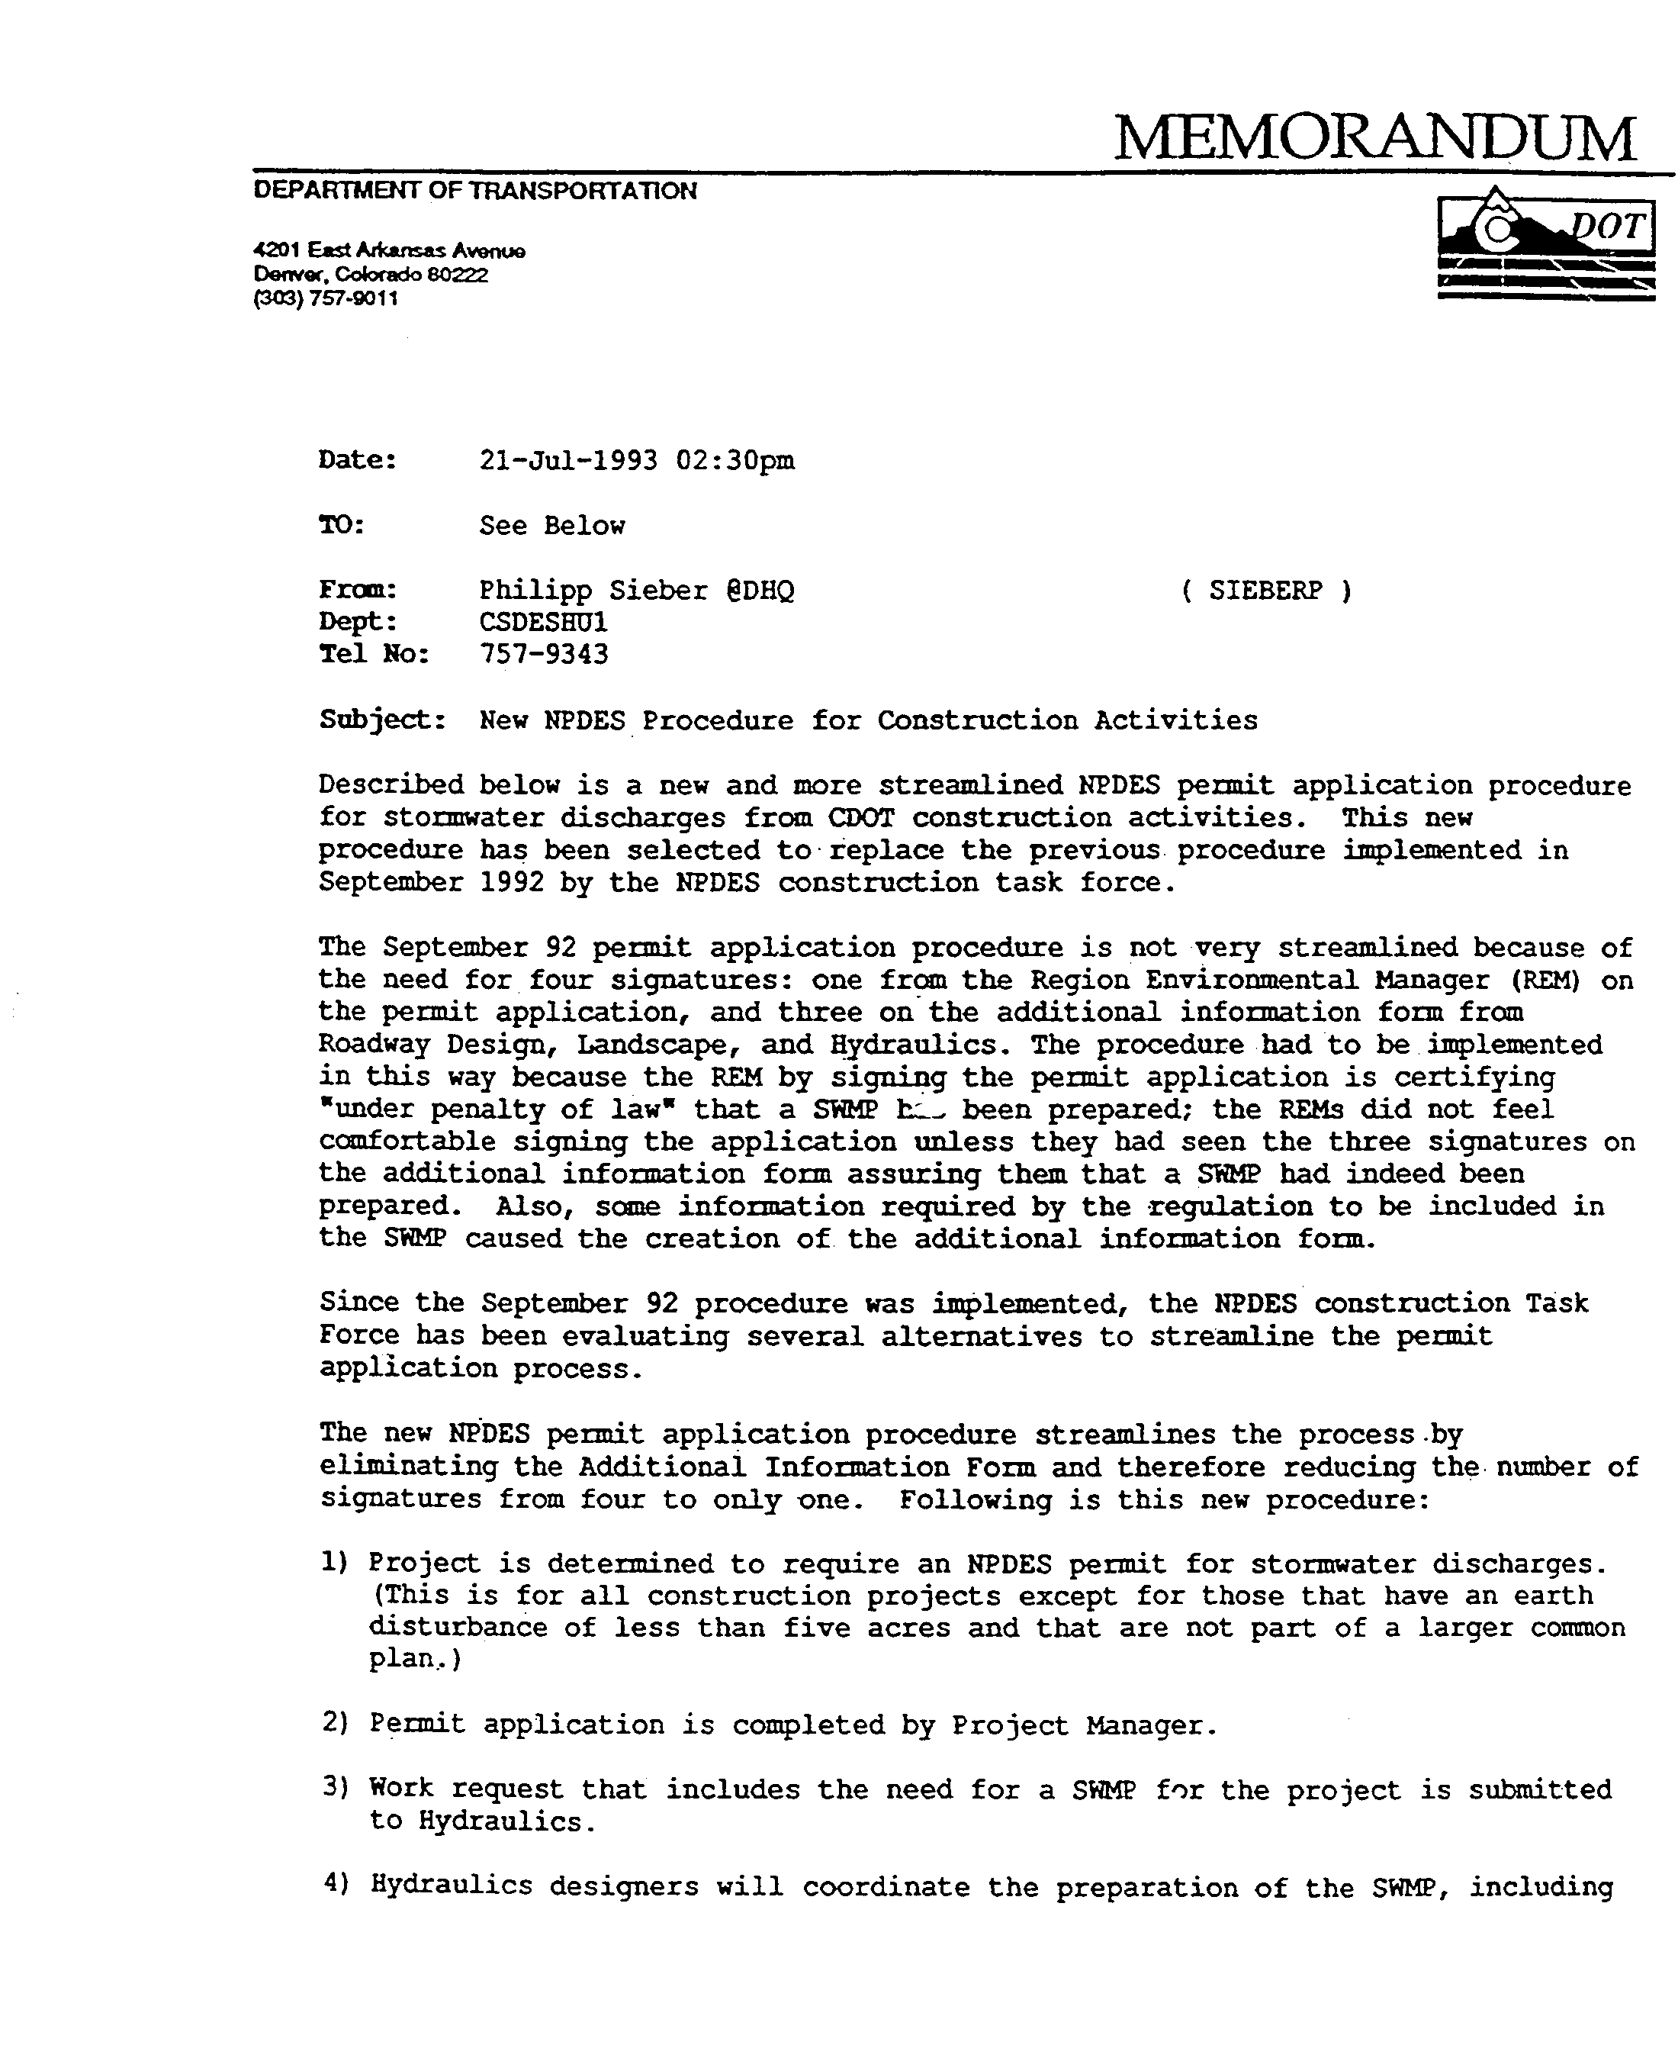
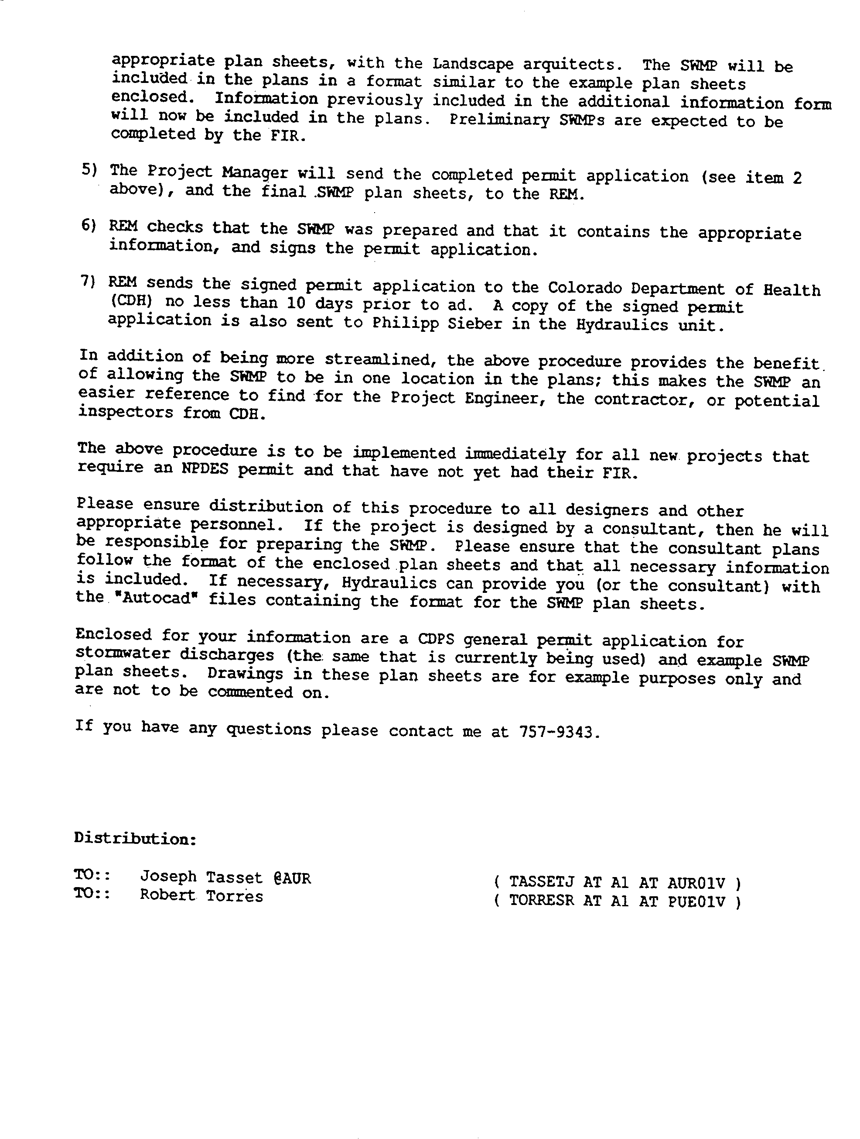
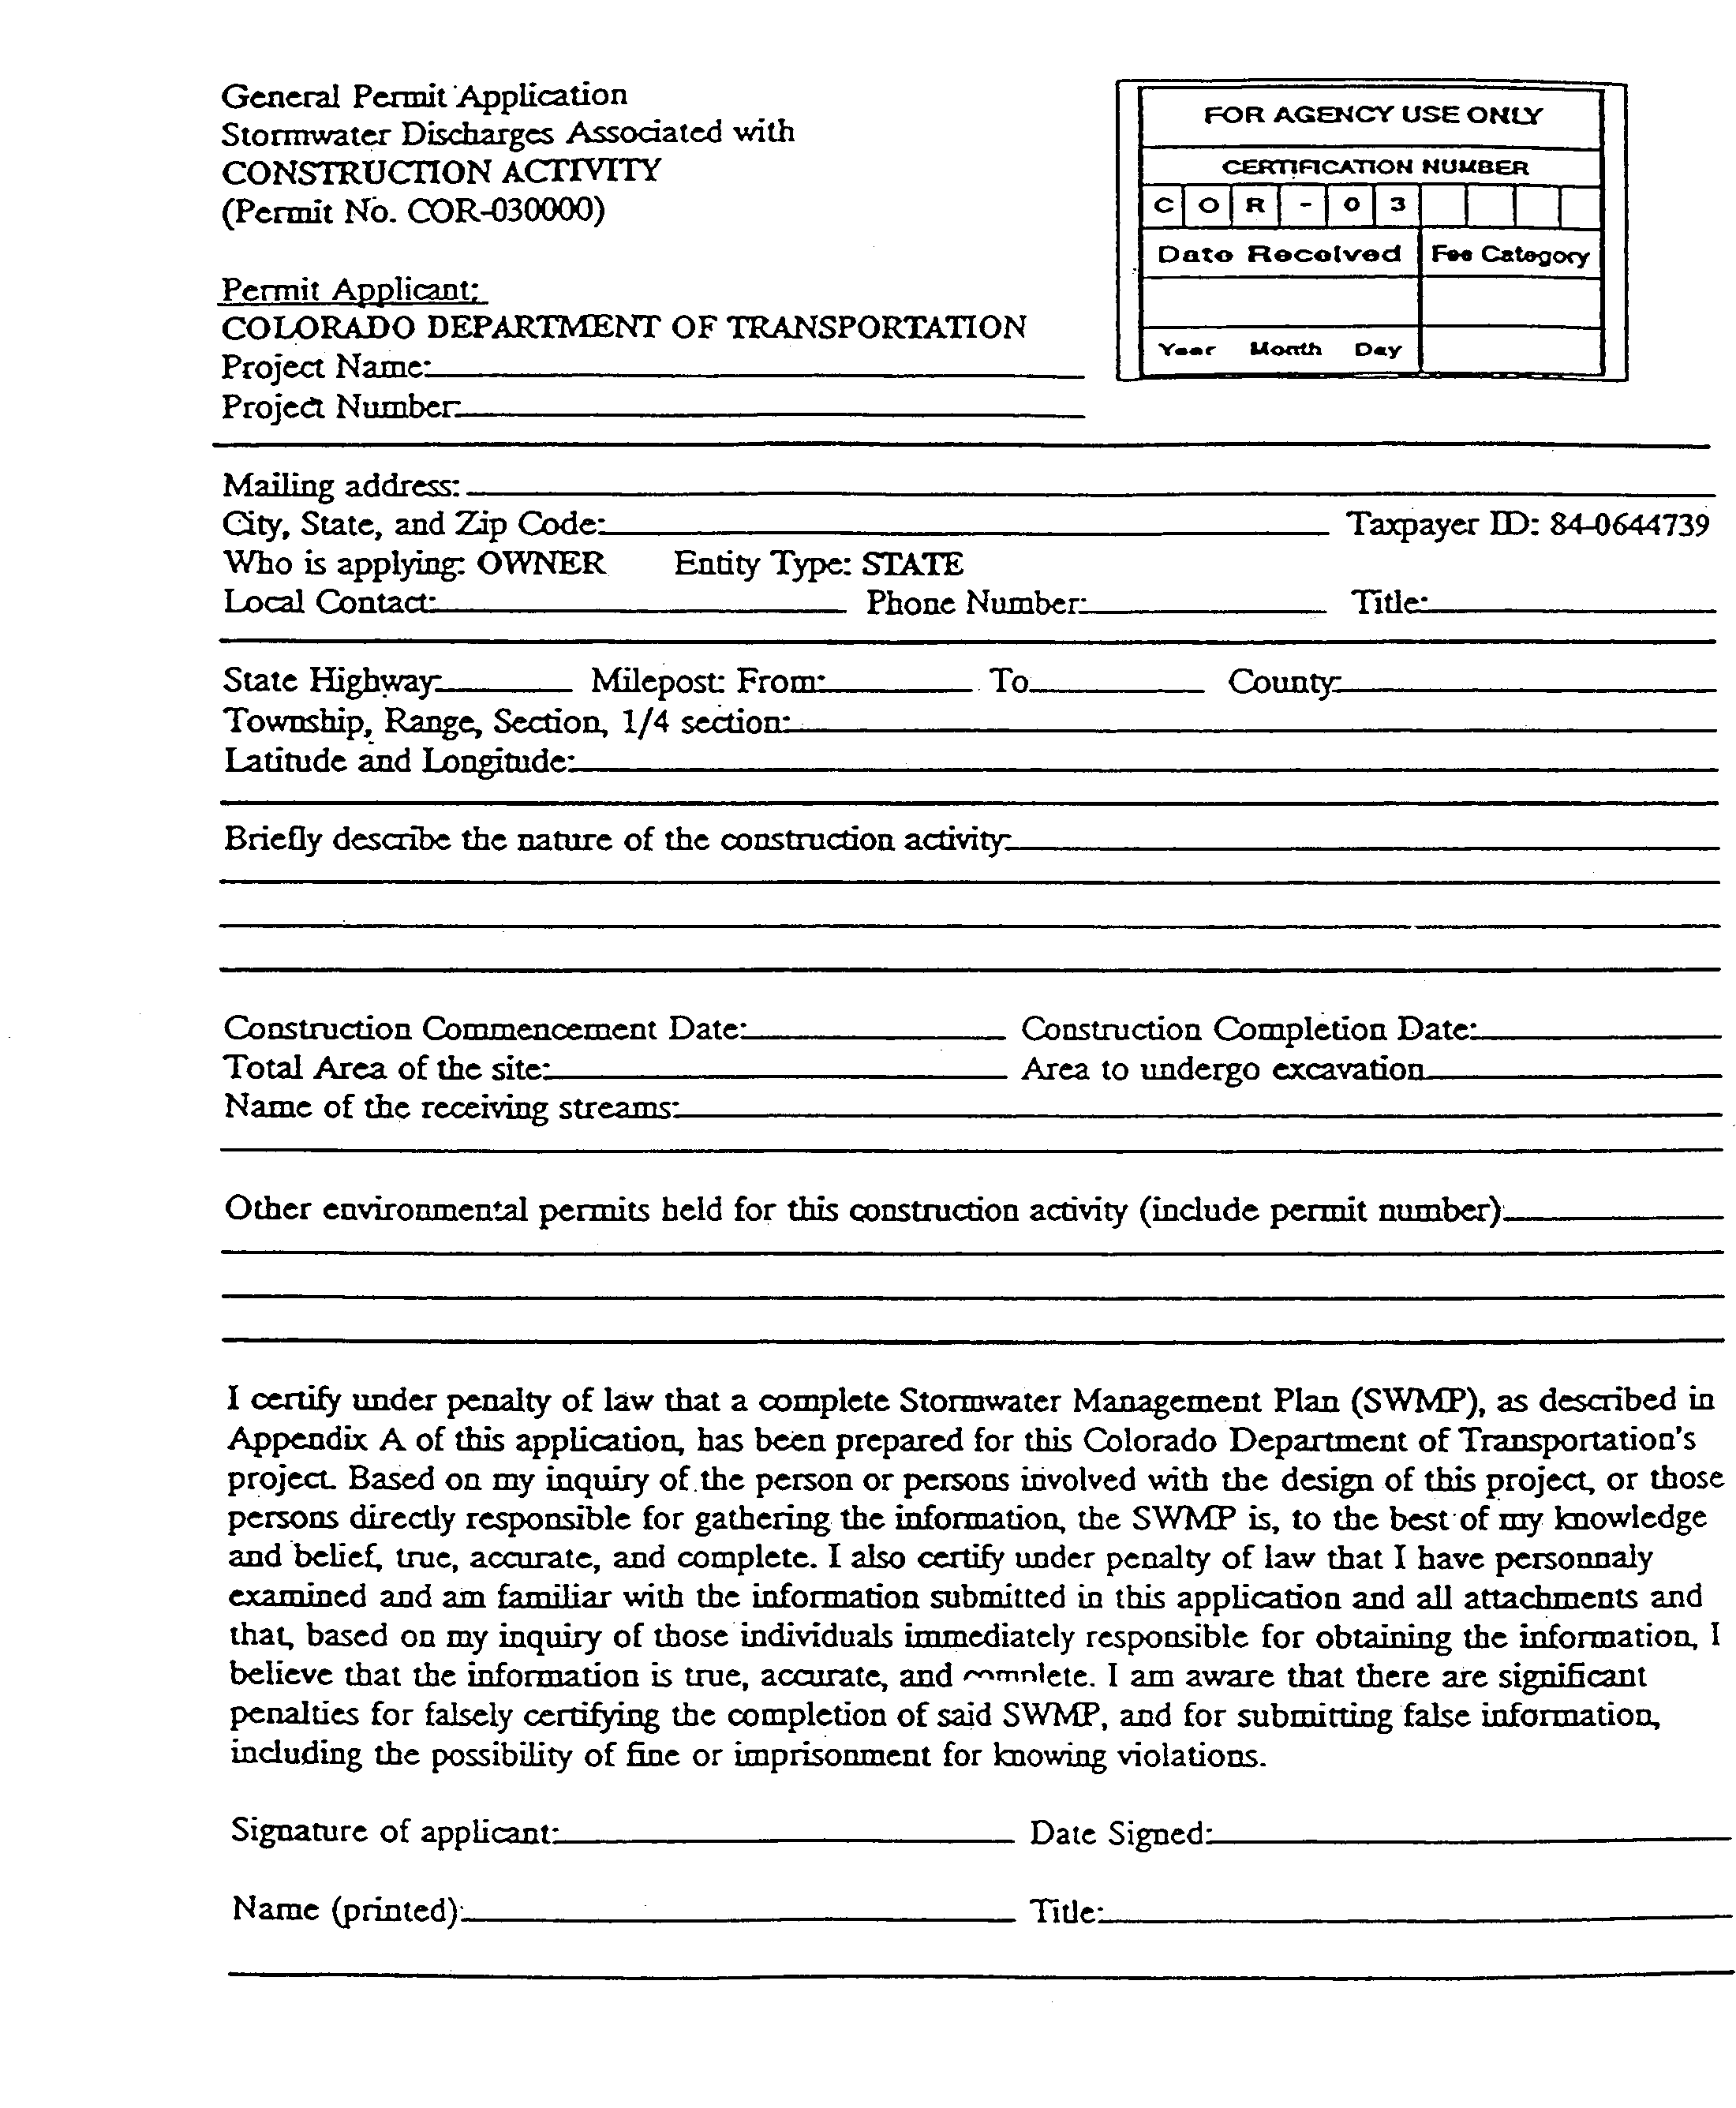
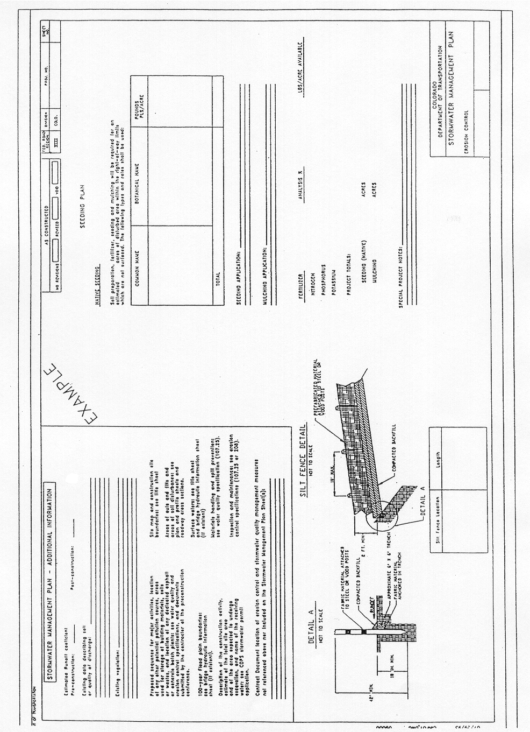

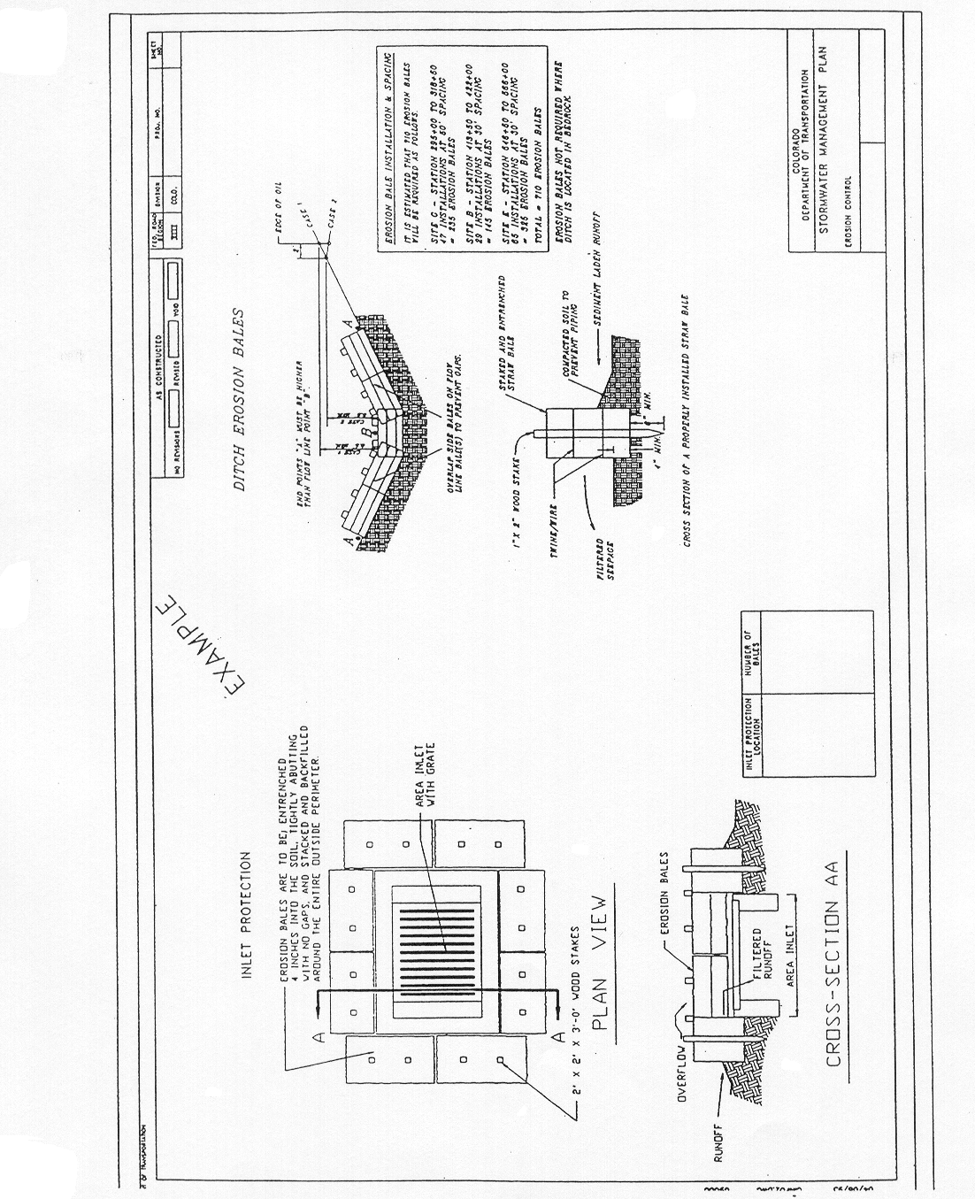

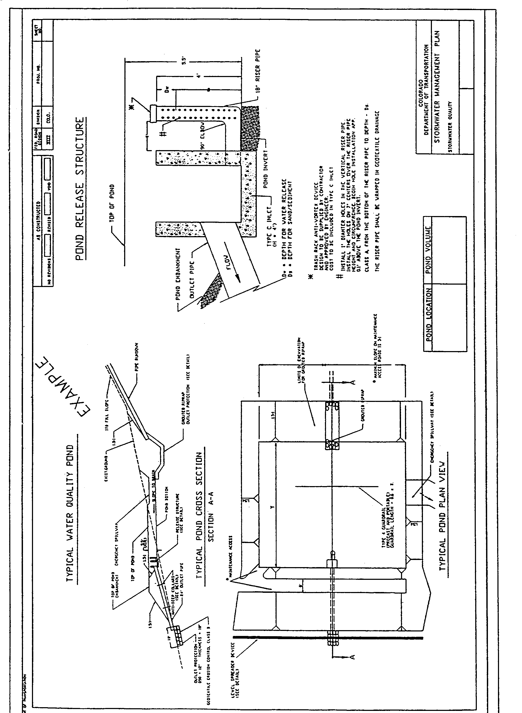

2.21 EROSION CONTROL

CDOT has written policies and procedures for the control of erosion, abatement of water pollution and prevention of damage by sediment deposits.

Erosion control measures are installations used to inhibit dislodging of soil particles by water or wind. Sediment control measures are installations used to remove settleable sediments from surface runoff.

Erosion and sedimentation control solutions are briefly outlined below:

- Shield soil from rainfall and runoff - mulches, blankets, and nettings are available, also chemical soil binders.
- Reduce soil exposure time between earthwork and slope revegetation.
- Control runoff water - keep natural or clear water runoff separate from construction or project runoff.
- Trap sediment - using silt fences, erosion bales, erosion logs, or sediment basins.
- Revegetation with permanent or temporary seed mixes throughout construction.
- The Landscape Architect provides the Resident Engineer with a Stormwater Management Plan for incorporation into the Final Office Review plans. For projects by consultants or local agencies, the CDOT Landscape Architect reviews the plans.

The following erosion control measures and procedures required for construction (including sediment control) are:

- Show erosion control measures in the plans, specifications and estimate.
- Establish permanent erosion control practices at the earliest practicable time.
- Coordinate temporary erosion control measures with permanent measures to assure an economical, effective and continuous control throughout construction.
- Monitor, maintain, or revise erosion and sediment practices during construction of the project.
- Not allow stockpiling or disposal of pollutants used during construction in or near any watercourse.

Additional References:
- CDOT Erosion Control and Stormwater Quality Guide
- 23 CFR Part 650B, Bridges, Structures and Hydraulics – Erosion and Sediment Control on Highway Construction Projects
- 23 USC 109g, Erosion Control
- 40 CFR Part 122, Clean Water Act
- 33 USC 1251-1376, Clean Water Act
6. CDOT Environmental Procedures Manual

2.22 LANDSCAPING

Landscape design applies to the land within and affected by construction projects. Landscape features are incorporated into the project through plan development.

Landscape projects provide enhanced aesthetics, erosion control, safety and reduced consumptive water use on the project.

The Landscape Architect is responsible for preparing landscape plans, including incorporating environmental mitigation in the plans.

All landscaping should fulfill functional and aesthetic requirements along with those mandated by CDOT policy and Federal regulations. Throughout the design process the Landscape Architect should collaborate with other professional disciplines. Discussions with Region Environmental, Engineers and Maintenance aid in resolving design problems. All consultant design projects should be reviewed by the CDOT Landscape Architect to ensure the landscape being provided will thrive and that safety and regulatory standards are being met.

Project specific environmental commitments made during project development by the environmental specialists whether in Environmental Impact Statements, Environmental Assessments or during minor project development must be incorporated into the design plans. Project specific mitigation commitments generally involve avoidance, protection, minimization or replacement of protected resources.

Landscape plans may include: planting, grading, erosion control, irrigation system, environmental mitigation such as wetland replacement, and architectural features, depending on the scope of the project.

The preliminary landscape plans should include the following activities:

- Base map preparation or site plan.
- Determination of alternate designs based on pre-design meetings, and appropriate standards.
- Coordination of special permits as required for mitigation.
- Checking of availability of all plant material.
- Coordination with Staff, Region or local agencies for any special design requirements such as specifications or agreements.

The final landscaping design will be documented in the project file and completed based on the following:

- Field Inspection Review minutes, revisions, and written safety and design decisions.
- Special permit requirements.
- Special provisions.
- Coordination with the Region Environmental staff, the Landscape Architect, the Resident Engineer and the local agency.
- Final Office Review changes and review minutes for final sign-off.
- Fulfillment of landscape requirements mandated by CDOT policy, state and federal regulations.
- Environmental mitigation requirements.

Landscaping guidelines are in the CDOT Environmental Procedures Manual.

Federal-aid projects shall include the planting of native wildflower seeds, seedlings or both as provided in 23 CFR Part 752.11(b), unless a waiver is granted.

Additional References:
- AASHTO Guide for Highway Landscape and Environmental Design
- CDOT Erosion Control and Stormwater Quality Guide
- CDOT Policy Directive 503.0, Landscaping With Native Plant Material
- 23 USC Section 319, Landscaping and Scenic Enhancement

2.23 SEEDING

A site-specific revegetation plan is required on all projects where earthwork disturbance has occurred to prevent excessive soil and water loss, improve water quality and to increase aesthetics of the project.

The plan should include soil preparation, provisions for topsoil or amending existing soil, fertilizer, seed or sod placement, mulch, tackifier and soil retention blankets.

The CDOT Environmental Procedures Manual provides generic seed mixes for the Eastern plains. For wetlands, a site-specific seed mix should be developed for areas not covered in the manual or areas where greater detail is required.

The CDOT Landscape Architect typically provides the Region or consultant with information and requirements for specific site seeding. The CDOT Landscape Architect should review revegetation plans developed by the consultant.

The plans should include coordination with the Region or local entities for any special design requirements or specifications.

The seed plan will be included in the Stormwater Management Plan. The final design plan should reflect all federal, state and CDOT policies regarding revegetation requirements.

Wildflower seed shall be provided on all federal-aid projects, per 23 CFR 752.11(b), unless a waiver is granted.

Additional References:

23 CFR Part 752, Right-of-Way and Environment - Landscape and Roadside Development
2. CDOT Erosion Control and Stormwater Quality Guide

2.24 IRRIGATION SYSTEMS

Irrigation systems may be required in areas where irrigation is needed on new landscape material, such as on interchanges rest areas, or areas where existing sprinklers are disturbed, damaged or relocated due to construction. Irrigation systems are required if requested by the Region.

The Landscape Architect is responsible for preparing design plans as requested by the Resident Engineer. On consultant prepared plans, the CDOT Landscape Architect should review the plans. The irrigation plans should be included in the Final Office Review plans. Irrigation systems shall incorporate xeriscape principles such as irrigation zoning to conserve water.

The Landscape Architect designs and prepares a site plan of the irrigation system, a tabulation of required items (such as pipe, sprinkler heads and controls) and special detail requirements or specifications required by maintenance and/or entities. A Finding in the Public Interest will be required and documented if any proprietary or experimental items are to be used (see Sections 8.01, 8.07 and 8.16 of this manual).

The Region coordinates special permits, and coordinates special requirements with the local agencies.

Additional References:

1. 23 CFR Parts 752, Right-of-Way and Environment - Landscape and Roadside Development

2. 23 USC 319, Landscaping and Scenic Enhancement
3. AASHTO Guide for Highway Landscape and Environmental Design
4. CDOT Erosion Control and Stormwater Quality Guide
5. CDOT Environmental Procedures Manual

2.25 WILDFLOWERS

Whenever a project is to be constructed using federal-aid funds, the use of wildflower seeds or seedlings shall be a part of the planting or seeding plan. However, the Department prefers to have wildflowers added to all projects.

Wildflower seeding is used on projects where landscaping is required. The costs of the wildflowers should amount to one-fourth of 1 percent of the total cost of landscaping. Wildflowers should be included in seed mixes, or planted to diversify and enhance establishment of natural vegetation.

The Landscape Architect, in coordination with the Region, is responsible for providing the seeding and planting recommendations for construction projects. On consultant-designed projects, the CDOT Landscape Architect shall review their plans.

Wildflowers can be incorporated as seed into the native seed mix and tabulated on the Stormwater Management Plan or if in plant form, tabulated on the Landscape Plan.

The following procedures are to be used as guidelines for the planting of wildflowers:

- For areas in the Eastern plains (from the foothills to the eastern Colorado border) refer to the CDOT Environmental Procedures Manual.
- For areas not included in this manual or areas of special concern, the Landscape Architect should develop the seeding plan.
- Wildflower seed, seedlings, or both, shall be provided on all federal-aid projects per 23 CFR 752.11(b).
- To grant a waiver for No. 3 above, the highway agency must certify that native wildflowers or seedlings cannot be grown satisfactorily, or there is a scarcity of available planting areas, or the planting areas will be used for agricultural purposes. (See 23 CFR Part 752.11 for more details).

Additional References:
- 23 CFR Part 752.4, Landscape and Roadside Development - Landscape Development
- 23 CFR Part 752.11, Landscape and Roadside Development - Federal Participation
- Title 23 USC 319, Landscaping and Scenic Enhancement
- CDOT Erosion Control and Stormwater Quality Guide

2.26 NOXIOUS WEEDS

The design objective is to protect the environment by controlling noxious weeds.

A State Noxious Weed List is designated in the Colorado Noxious Weed Act. Management of the listed designated weeds and the prevention of new weed species onto the project site should occur during the project development process. Integrated noxious weed management may include cultural, biological and chemical controls.

Integrated noxious weed management should be incorporated in the design and construction process. The presence of noxious weeds should be determined in environmental documents (Environmental Impact Statement or Environmental Assessment) and/or during the project scoping.

The Landscape Architect is responsible for providing the integrated noxious weed management plan. On consultant-designed jobs, the CDOT Landscape Architect should review the plans. The person responsible for developing the plan should coordinate with CDOT’s weed coordinators and the Region for special requirements. The noxious weed management plan should be included in the plans and specifications.

The following criteria should be used for the management of noxious weeds:

- Identification of existing noxious weeds: Determine what weeds are present within the project. Mapping source may include: (a) CDOT Geographic Information Systems noxious weed database, (b) mapping data in the National Environmental Protection Act document, (c) field mapping performed by the environmental specialists, and (d) field mapping performed by the Contractor.
- Potential for impacts from invasive weed species: Analysis of impacts should include: (a) the area disturbed by construction of the projects and areas adjacent to the project, (b) the impacts if the weeds spread within the project or adjacent to the project, (c) the impacts to wetland, riparian habitat or other sensitive areas, and (d) the potential for spreading into agricultural areas.
- Potential impacts of chemical and mechanical controls: A mechanical control would be mowing whereas chemical control means herbicides. If the designer recommends herbicides, the application method and herbicide type is driven by the proximity of sensitive environments. If a restricted herbicide is recommended, a licensed Colorado applicator should be contacted.
- Preventive and Control Measures: Native plant species are suited to the local environment and climate and their use is encouraged. Herbicides or other controls may be applied to on-site topsoil prior to salvaging. Debris and soil should be removed from equipment prior to transport. Mulch used for the project must be inspected and regulated by CRS 35-27.5-101, Weed Free Forage Crop Certification Act. Herbicides should be applied where specified in post-emergent condition. On-going weed management controls should be required during the contract period for plant establishment.

Additional References:
- CRS 35-5-101 through 35-5-110, Colorado Noxious Weed Act
- Integrated Noxious Weed Management Plan, CDOT 2000
- Federal Executive Order 13112 (1999), Invasive Species
- State of Colorado Executive Order D 006 99 (1999), Development and Implementation of Noxious Weed Management Programs

