The following Construction Manual sections are hereby revised, as follows:
120.7.3 Preparation of Change Orders
120.7.3.1 Requirements and Responsibilities

The use of Adobe Sign® to electronically sign the CDOT Form 90, Contract Modification Order is allowed. A PDAC Task Force to identify the process for utilizing electronic signatures and Adobe Sign software is active and has a deadline to formalize and finalize this process by July 2020. The Task Force is focused on finalizing the electronic signature Change Order process and will issue the results when complete. This Construction Bulletin will expire when the final guidance is issued. Contact the Area Engineers for more information on the process.

- Whenever possible, follow the existing change order process in the Construction Manual for review, documentation, and signature of change orders.

- If obtaining signatures on a hard copy of the Form 90 is not possible or efficient, use these temporary guidelines for obtaining electronic signatures.

To utilize Adobe Sign, the person initiating signatures is required to have access to Adobe Sign software; however, signing documents as a recipient does not require a software license.

Adobe Sign Training I, is available on the SAP Learning Management System (LMS). If you do not have LMS access, go to the TETP homepage (https://www.codot.gov/programs/tetp) then click Register for Courses to request access. Adobe Sign login instructions are also available on the TETP Adobe Sign Training page. Joshua Palmer (Joshua.J.Palmer@state.co.us) is available to answer questions related to accessing Adobe Sign. Note: The CDOT P.E.s who were provided electronic seals should first try logging into Adobe Sign, many have access but have not logged into Adobe Sign. If you are a CDOT employee and still need access to Adobe Sign, please submit a request using this Adobe Sign Account Setup Request.

Consultant Project Engineers, may initiate the signature process with their company’s Adobe Sign license. CDOT Resident Engineers or CDOT delegates will need to initiate the signatures in Adobe Sign if the Consultant Project Engineer does not have a license.

This guidance does not change the pre-approval process or the content requirements for change orders. For a single change order, mixed formats, i.e., using both electronic and hard copies, is not allowed. The final change order will be either all electronic or all hard copy. Distribution of the electronic final copy is addressed below; distribution of change orders signed with wet signatures will not change.
Temporary eSign Guidelines
Electronic change orders may have two PDFs (portable document format) when obtaining signatures:
- The Form 90 and the attachments referenced in it (Form 90 Document) and
- The Letter of Explanation and its supporting attachments (Letter of Explanation Document).
Form 90 Document
The Engineer will combine the Form 90 and its attachments into one PDF document. If the Form 90 is developed in Site Manager, print the Form 90 in PDF from SiteManager. When setting up the Form 90 PDF document and before routing for signature in Adobe Sign, check the appropriate boxes related to PoDi and Participating funds. This document is routed for electronic signature to the contractor, CDOT personnel, and FHWA personnel (when applicable) (Table 1-Order of Signatures on Form 90). Examples of the Form 90 attachments include new or revised plan sheets or special provisions. The revised or added plan sheets also require the responsible engineer’s seal before routing for signature.
Table 1 - Order of Signatures on Form 90
CDOT Project Engineer |  | Consultant Project Engineer
Standard | PoDi/ PTE / *Admin. Settlement | Standard | PoDi/ PTE / *Admin. Settlement
CDOT Project Engineer | CDOT Project Engineer | Resident Engineer | Resident Engineer
Contractor | Resident Engineer | Contractor | Program Engineer
Resident Engineer | Program Engineer | Program Engineer | FHWA Area Engineer
Program Engineer | FHWA Area Engineer |  | Contractor
 | Contractor |  | RTD or Chief Engineer*
 | RTD or Chief Engineer*
PoDi - Projects of Division Interest
PTE - Project Termini Extension
Admin. Settlement - Administrative Settlement
RTD - Region Transportation Director
FHWA - Federal Highway Administration
Letter of Explanation Document
The Engineer will prepare a PDF of the Letter of Explanation and all supporting documentation. Typically, the supporting documents include correspondence, email, independent price justifications, schedules, Form 65, etc. that are referenced in the Letter of Explanation. The attachments to the Letter of Explanation will be sequentially numbered and referenced in the Letter of Explanation and include the Project Code and Project Number on each page. This letter is not distributed to the Contractor and does not require signatures.
Quick Steps for Signatures in Adobe Sign
- In Adobe Sign be sure you are in the “SEND” tab.
- Input email addresses (copy and paste) of people who need to sign the document in the order you want them to sign. See Table 1-Order of Signatures on Form 90 for correct order of signatures.
- Click on the “Agreement Name” and type. This is the title of the email which Adobe Sign will automatically send to signers for routing.
- Under “Agreement Name” type in the content of the email (Example “Please sign”).
- In the “Files” block drag and drop the Form 90 PDF document.
- In the lower left of the page click “Next.”
- On the right column you will see “Recipients” and under that “Signature Fields.”
- In “Signature Fields” click on “Signature” (do not select “Digital Signature”) and drag and drop a signature block on the form where that person needs to sign.
- Scroll down below “Signature Fields” to “Signer Info Fields.” Click on “Signer Info Fields” and drag and drop, “Date” in the appropriate date block.
- Go back up to the “Recipients” field and click on the second signer and repeat steps 8 and 9.
- Once you have all signature and date blocks created on the form click the “Sign, then Send” at the bottom left.
- Each individual will follow the steps/arrows to sign the document.
- The person initiating the workflow will receive emails as individuals sign the document confirming progress.
- Once you see all recipients have signed the document, place the document in the appropriate ProjectWise Change Order folder (See Figure 1) or if the source document is originated from ProjectWise, Adobe Sign will automatically file the completed and encrypted document in ProjectWise.
Archiving Final Change Order in ProjectWise
NOTE: Upon completion of all documentation, Project Engineer shall notify the Finals Administrator and Karen Sullivan by email, including the ProjectWise file path hyperlink, that the change order documentation is complete and in ProjectWise.
Once signed and completed the Project Engineer may combine the two documents in Adobe Sign or keep the documents separate and place the change order PDF documents in the project’s Change Order folder in ProjectWise. Include the Project Code, CMO or MCR, change order number, and Form 90 or Letter of Explanation in the file name (e.g., 22391_CMO002_Form90). See Figure 1 for a file path example.
Figure 1 ProjectWise File Path Example
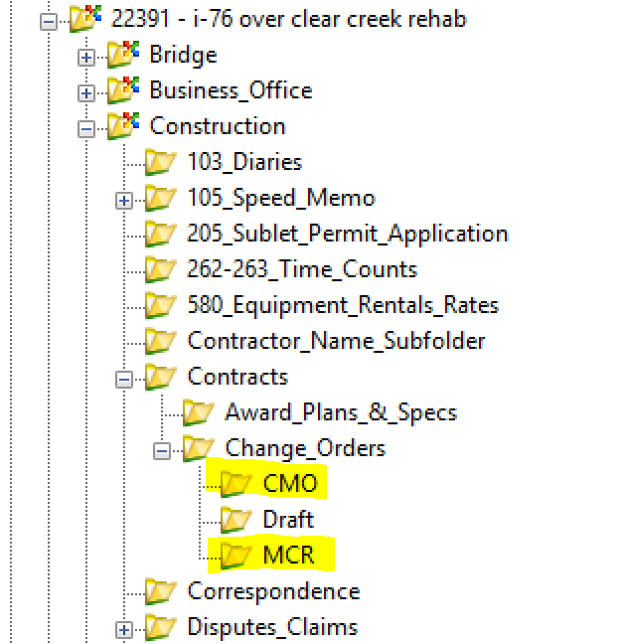
Resources

Questions about change orders or the change order process can be directed to the Area Engineers or Karen Sullivan.
Region 1 and ITS Mark Straub - Mark.Straub@state.co.us
Region 2 and 5 Kevin Ryburn - Kevin.Ryburn@state.co.us
Region 3 and 4 Laura Zamora - Laura.Zamora@state.co.us
Karen Sullivan - Karen.Sullivan@state.co.us
For questions about logging into Adobe Sign contact Joshua Palmer, Joshua.J.Palmer@state.co.us, for questions about using Adobe Sign contact the OIT Help Desk, and for questions about the TETP Adobe Sign Training, contact Allison Wilson, Allison.Wilson@state.co.us.

