Finals Process Updates from QAR and CBs

Findings from a Quality Assurance Review (QAR) of the Finals Process recommended numerous changes in the CDOT Construction Manual. Areas addressed by the QAR include, but are not limited to:

- Experience and responsibility of the Finals Checker
- Statewide uniformity of the Finals Process
- Standardizing the error tracking process
- Standardizing the risk assessment process
- Clarification of documentation requirements
- Accountability for time spent in finals closure
- Streamlining of detailed PE documentation requirements
- Refining requirements for time allowed to close projects
- Specifying requirements for as-constructed drawings
- Establishing audit requirements

In accordance with recommendations made by the Quality Steering Committee, changes have been made to subsection 109.9.2 and Sections 120 and 121 of the Construction Manual. At the same time, additional changes authorized by Construction Bulletins were made to the same sections in the Construction Manual. The following bulletins were merged into the manual:

CB 2008-7 Revision to Minor Contract Revision (MCR) Process
CB 2010-3 Proper use of Form 105 - Speed Memo
CB 2010-11 Overweight Hauling Vehicles
CB 2010-13 Payment for Change Order Work
CB 2011-3 Required Documentation from Contractors
CB 2011-6 Escrow of Project Funds
CB 2011-7 Written Notification
CB 2011-9 FHWA Approval of Major CMOs
CB 2012-1 Completion and Distribution of the Form 1212

These Construction Bulletins, which have now been incorporated in the Construction Manual, have been removed from the “Current” list of Construction Bulletins on the CDOT website.

Attached below are replacement files for the changed Construction Manual Sections. Print them out (double-sided) and insert them in the hard copy version of the CDOT Construction Manual. Changes made as a result of the QAR recommendations are highlighted with red text. Changes made from Construction Bulletins are highlighted with a bold vertical line (▐ ). Older changes (i.e. 2004 revisions) are highlighted with a thin vertical line (│).

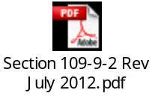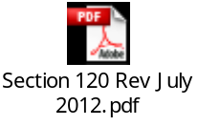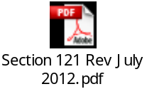

Please print a copy of this bulletin and keep it with your copy of the Construction Manual.
If you have questions, please contact your Area Engineer in Contracts & Market Analysis.
The Construction Manual and Construction Bulletins can be found on the Design and Construction Project Support web page at:
http://www.coloradodot.info/business/designsupport

