Naming Conventions for Scopes, Schedules, and Cost Estimates

This bulletin provides guidance on naming conventions for project-level scopes, schedules and cost estimates in ProjectWise.

Background: In order to support program management and cash management, CDOT needs to have a better understanding on when projects anticipate spending funds. Access to timely and accurate project schedules and cost estimates during all phases of preconstruction is crucial for accurately forecasting project expenditures. Consistent file management and naming conventions assist with accessing this data. A uniform file structure for documenting revisions to project scopes, schedules and cost estimates is described in this bulletin.

Project Manager Guidance

SCOPES (Project Descriptions):

A succinct project description should be entered in SAP for each project. This description should be entered on the line immediately after the Project Name (which is always the first line of text) in the Long Text tab in the CJ20N - Project Builder at the project level (Look for this symbol ) not the WBS level. Information entered in the Project Long Text tab transfers to the Comments field of the ZJ40 - Project Tracking Report. Include a brief summary of: the project scope, the highway with beginning and ending mile points, the type of work being performed, and any significant CDOT assets being impacted, e.g. critical culverts, bridge expansion joints, etc.

SCHEDULES:

Project schedules are recommended at the Scoping, FIR, FOR, and Advertisement milestones in Microsoft Project format (.mpp). Use the following file naming convention for schedules:

  - JPC#_PMO_Scoping_Sch.mpp (Design)
  - JPC#_PMO_FIR_Sch.mpp (Design)
  - JPC#_PMO_FOR_Sch.mpp (Design)
  - JPC#_PMO_AD_Sch.mpp (Construction)

Where JPC# indicates the 5-digit project code.The AD schedule should be the schedule developed for Form 859. Place schedules in ProjectWise in the Project Manager/Schedules folder specific to the appropriate project code, as shown in the example below:

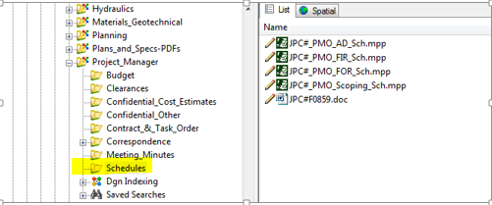

COST ESTIMATES:

Design estimates are recommended during the scoping phase of the project and should encompass the internal design estimates and consultant design estimates (as needed).

Estimates of Construction costs are recommended at the Scoping, FIR, FOR and Advertisement, in Microsoft Excel format (.xlsx) and should adhere to the following file naming convention:

  - JPC#_PMO_Scoping_Est.xlsx
  - JPC#_PMO_FIR_Est.xlsx
  - JPC#_PMO_FOR_Est.xlsx
  - JPC#_PMO_AD_Est.xlsx

Where JPC# stands for the 5-digit project code as before. Place estimate files in ProjectWise in the appropriate project phase of the Engineering_Estimate folder specific to the appropriate project code, as shown in the example below. A final Engineer’s Estimate prepared by EEMA will be required at Advertisement.

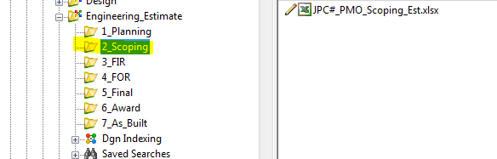

Resources:

For assistance contact the Interim Region Program Management Representative.

Name Phone Number Email
Region 1 Hilary Hawthorn (720)497-6910 [1-6910] hilary.hawthorne@state.co.us
Region 2 Joe Garcia (719)546-5727 [2-5727] joe.garcia@state.co.us
Region 3 Karen Berdoulay (970)378-9934 [3-9934] karen.berdoulay@state.co.us
Region 4 Brian Schafer (970)350-2219 [4-2219] bryan.schafer@state.co.us
Region 5 Tom Bovee (970)385-1412 [5-1412] thomas.bovee@state.co.us

For technical assistance, contact your Region SAP Power/Super User or the SAP Project System BPXs.

Name Phone Number Email
Region 1 Ken Largent (303)757-9780 [1-9780] ken.largent@state.co.us
Region 2 Cynthia Bailey (719)227-3206 [2-3206] cynthia.bailey@state.co.us
Region 3 Terri BrookeHasstedt (970)683-6261 [3-6261] terri.brookehasstedt@state.co.us
Region 4 Karen Reed (970)350-2114 [4-2114] karen.reed@state.co.us
Region 5 Karen Peterson (970)385-1411 [5-1411] karenk.peterson@state.co.us
PS BPX Tawnya Nicholson (303)512-5207 [7-5207] tawnya.nicholson@state.co.us
PS BPX Valerie Metaiguer (303)757-9837 [7-9837] valerie.metaiguer@state.co.us

References:

Design Bulletins can be found on the CDOT website at:
http://www.coloradodot.info/business/designsupport/bulletins_manuals/design-bulletins

