Milestone Dates in SAP Project Builder (CJ20N)

CDOT uses Critical Path Method (CPM) scheduling to help manage our design and construction projects. For CPM to be effective, the schedule must be maintained. Entering and reporting Milestone dates for a CDOT project is an important task for managing the schedule. However, it has historically been time-intensive. The SAP Project Systems team has eliminated several layers of networks and activities that were not being used in the CDOT Engineering template in Project Builder (CJ20N) and we have streamlined the configuration of the templates to include only the major Work Breakdown Structure (WBS) and Milestones. This new template will not have the extraneous ROW WBS, Design Networks and Design Activities. This has resulted in a simple layout that is easier for Project Managers to use and report project status. The new template became available on July 31, 2013.

The new templates have the same names (Std. Project – Eng. Cap. (with ROW) – 00010 and Std. Project – Eng. Cap (without ROW) – 00011). (See screenshot in Figure 1.) The Milestones in the templates are the Standard Milestones outlined in the “Controlling Our Critical Path” document. With this change you can add additional Milestones to any WBS in the project. There is no limit to the number of additional milestones you can add. However, only the first five additional milestones will display on the Project Status Report (ZJ40).

There are two reports you can use to report Milestone dates. The first report, Project Status Report (ZJ40), will display most of the Project information including the Standard Milestones and up to five additional Milestones. (See Project Status Report sample in Figure 2.) The second report is Milestones (CN53N). With this report you can call-up the Milestone dates by Project or WBS Elements.

To add a template to a new project, refer to the help document “CJ20N - Add Template to Project” or “CJ20N - Add Standard Template to Bridge Enterprise Project” in SAP Training.

If you created a project, added a template and released the project BEFORE August 1, 2013 you can change the template. To do this and include the new Milestones refer to “CJ20N – Update Old Template to Include New Milestones”:

To add dates to Milestones refer to “CJ20N – Add Milestone Dates to WBS Template”:

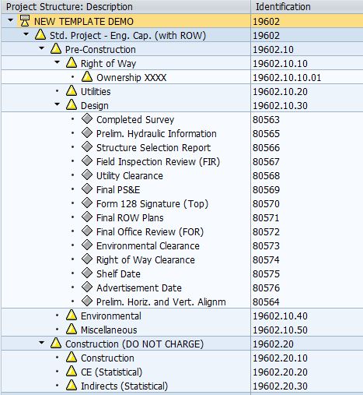
- = WBS Element
= Milestone
Figure 1
Screenshot of Std. Project – Eng. Cap. (with ROW) Template

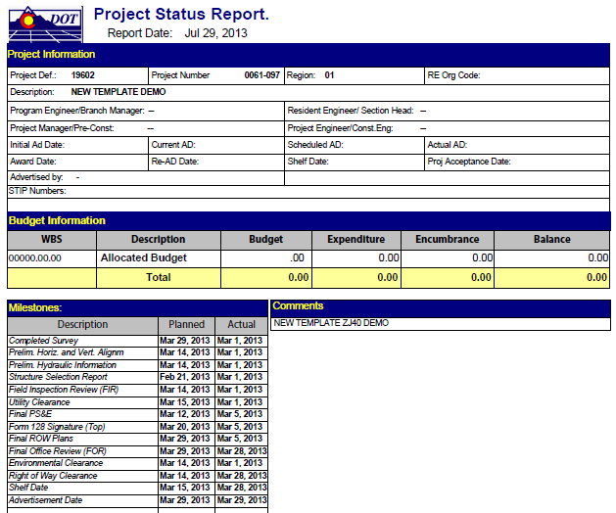
Figure 2
Screenshot of Project Status Report

We are continuing to work on additional help documents and will let you know by amending this bulletin. The help documents we are working on are: “CN53N – Milestone Reporting” and “CJ20N – Add Additional Milestones”.

If you need assistance on Milestones in SAP or SAP Project Systems, please contact the BPXs:

Tawnya Nicholson Valerie Metaiguer
tawnya.nicholson@state.co.us valerie.metaiguer@state.co.us
(303)512-5207 [7-5207] (303)757-9837 [7-9837]

To update milestone information in the Project Development Manual, print-out the attached file and replace old pages 1-47 and 1-48 with the new pages.

References:

Design Bulletins can be found on the CDOT intranet at:
http://www.coloradodot.info/business/designsupport/bulletins_manuals/design-bulletins

