Two New Options for Post Construction Landscape Establishment

Background
Construction projects may include an extended landscape establishment period to ensure the successful establishment of revegetation, environmental mitigations, plantings, and seeding. Successful landscape establishment is required to close permits (e.g., US Army Corps of Engineers Section 404 Permit, US Fish and Wildlife Service Section 7 Consultation, and the Colorado Discharge Permit System - Stormwater Construction Permit) and to ensure that landscapes (ground cover vegetation that prevents erosion of the soils/embankments) perform as designed. Post construction maintenance activities can include watering, re-seeding, re-planting, noxious and invasive weed control, erosion and sediment control, inspections, and Control Measure (CM) installation, repair, and removal. The vegetation establishment period can extend for one or more years after construction is complete, postponing final project acceptance and closeout.

Purpose and Goals
The purpose of this Design Bulletin is to provide information concerning two new options for completing landscape/vegetation re-establishment maintenance work for low and medium risk, design-bid-build projects. For these options, final project acceptance is issued when construction is complete and a new Post Construction Landscape Establishment Phase (PCEP) is initiated. Work during the PCEP will be completed by CDOT Maintenance or a specialized landscape contractor also referred to as a PCEP contractor.

These options support improvement in CDOT’s performance toward the following goals:
- Final project acceptance and close out can be completed sooner. CDOT is required to complete administrative and financial closure of projects (including releasing unspent project funds) within 12 months of final acceptance, to comply with Colorado Senate Bill 16-122.
- The need for revegetation and rework will be reduced, thus saving costs. With CDOT Maintenance or specialized landscape experts completing PCEP work, the quality of work and success rate for establishment of plantings and seeding will improve.

Landscape Establishment Options
The available methods for completing landscape establishment requirements now include the existing approach and two new options, as follows:
- The existing method is to include Standard Specifications Section 214.04 “Landscape Establishment” in the construction contract, directing the Prime Contractor to complete landscape establishment work. Final project acceptance is issued when the landscape establishment period is complete, as required by the specifications.

In this case, the CDPHE Colorado General Permit for Stormwater Discharges stays with the Prime Contractor until the landscape establishment period is complete.

- For the two new PCEP options, landscape establishment work is not completed by the Prime Contractor. Final project acceptance will be issued and the Prime Contractor will be released when construction is complete. The Colorado General Permit for Stormwater Discharges will be transferred from the Prime Contractor according to the option that is selected:

  - The first option is to engage CDOT Maintenance staff to manage the completion of landscape establishment work. Based on the available resources, Maintenance staff may complete the work using CDOT staff, or manage a PCEP contractor through a Task Order that uses one of the new Master Agreements.

In this case, the Stormwater Discharge Permit will be transferred to CDOT Maintenance.

  - The second option is for a Resident Engineer (RE) or Construction Project Engineer (CPE) to use one of the new Master Agreements to issue a Task Order, prior to final project acceptance award, to a PCEP contractor.

In this case, the Stormwater Discharge Permit will remain with CDOT, and may be transferred to the project’s RE or CPE.

To select the best suited option for a project, REs, Project Managers (PM), CPEs, and Maintenance staff need to consider the complexity of the project, local agency requirements, and required environmental mitigation and permit requirements. Criteria for selecting the best option based on the project level of risk are included in Appendix A - Table 1: “Considerations for Accomplishing Post Construction Landscape Establishment Phase.” Decision logic is illustrated in Figure 1.

Figure 1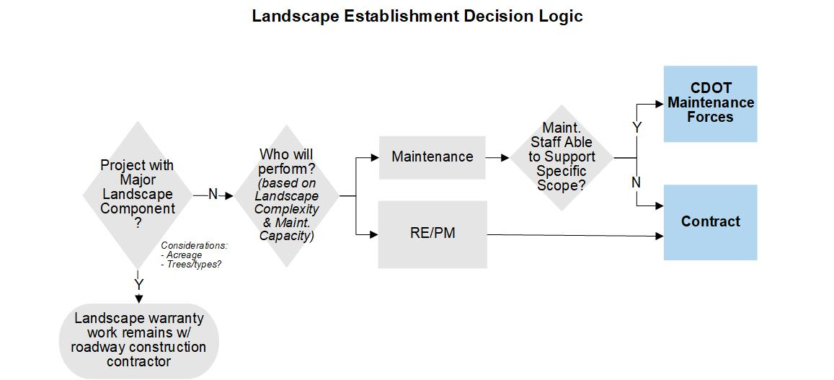

Considerations for Projects in Construction
For projects that are in construction when the construction contract includes landscape establishment (Standard Specifications, Section 214.04), the RE and/or CPE may wish to reassess the approach to take advantage of one of the new landscape establishment options. If CDOT Maintenance or a PCEP Contractor is the preferred delivery method, the RE/PCE will need to prepare a change order to remove landscape work and adjust the construction completion schedule. In addition, the RE/PCE will need to consult with the Civil Rights Office to determine the impact of removing work from the construction contract on the contractor’s ability to achieve the project’s Disadvantaged Business Enterprise (DBE) goal, including eliminating financial penalties.

The RE/CPE will need to notify CDOT Maintenance or initiate a task order for a PCEP Contractor at least 60 days prior to final project acceptance so that the appropriate resources are onboard as needed to continue and complete work required by open permits.

Considerations for Projects When Construction Contract Has Not Been Awarded
For projects that are in preconstruction, REs and PMs, in consultation with Region Planning and Environmental Managers, will need to select the landscape establishment approach preferably by FIR, and no later than the FOR milestone. Depending on the option selected, they will need to either incorporate the appropriate Standard Specifications in the construction contract, or coordinate with the CPE to notify CDOT Maintenance or initiate a PCEP Task Order at least 60 days prior to final project acceptance, to make sure that resources are available when needed.

Master Agreements and Funding
CDOT Engineering Contracts has awarded three master agreement contracts to specialized landscape contractors for PCEP Task Orders. Each master agreement has a fixed unit price schedule and a duration of one year from the date of execution, that is renewable for up to 4 additional 1-year terms, based on performance. Please contact Engineering Contracts for assistance with PCEP task orders.

Traffic control services for PCEP activities are also available via a separate master agreement. For assistance with task orders for Traffic Control, contact the Division of Maintenance and Operations (DMO) Traffic Field Operations Engineer.

The Transportation Commission approved a one-time $900,000 of FY19 Maintenance MLOS roll forward state funds for PCEP work performed by Task Order or CDOT Maintenance. This funding is managed by CDOT’s Division of Maintenance and Operations. For more information, contact the DMO Engineering Assets Roadside Environmental and Roadside Specialist.

Appendix A: Table 1
Considerations for Accomplishing Post Construction Landscape Establishment Phase
Level of Risk | Risk Description* | Revegetation Disturbance Area (acres) | Other Considerations | Suggested Type of PCEP Treatment
Ultra Low | Low potential to discharge (i.e., not near water) | 1-2 | Small strips of disturbance (< 5’ wide) | PCEP Contractor and/or Maintenance
Low | Low potential to discharge (i.e., not near water) OR Medium potential to discharge (i.e., near water or MS4 systems) | 1-10 | Slopes flatter than 4:1 | PCEP Contractor and/or Maintenance
Medium | Medium potential to discharge (i.e., near water or MS4 systems) ... OR High potential to discharge (i.e., next to water) * | 10-20 | Hard to establish areas: medians, south facing slopes, slopes steeper than 3:1 | Possible 1-year establishment phase by Prime Contractor and PCEP Contractor, or just PCEP Contractor depending on the site conditions and project size. Decision on project by project basis.
High | High potential to discharge (i.e., next to water), or  Includes formal containerized plantings, or  Includes wetland/ threatened and endangered habitat replacement not using a mitigation bank (reporting requirements 3-5 years), regardless of disturbance area. | 20+ | Hard to establish areas, medians, south facing slopes, slopes steeper than 3:1, many erosion blow outs, difficult soils, etc. | 1 or 2 year establishment phase by Prime Contractor and PCEP Contractor
*Note: There are always exceptions to these situations that need to be considered on a case by case basis; decisions will be made at the Region level. Medium and High risk situations could be considered a Major Landscaping Component.

Appendix B
PCEP Task Order Procedure

The items below will be completed by the Resident Engineer, Project Manager, or Project Engineer.
- Select a contractor from available Master Agreement Contracts (see list in Appendix E). Confirm that the contract applies to the location of the project.
- Determine the services needed for your specific project, the anticipated timeframe for doing the work and estimate the cost, using the unit prices in the Master Contract and the PCEP Task Order Cost Estimate Worksheet. As needed, consult with Region or HQ Landscape Architect, Hydraulics Engineer, Biologist, or others, for reviewing the proposed services and timeframes prior to finalizing scope of services.
- Prepare PCEP Task Order Request
- Contact the Master Contract Manager with an estimate of the cost, to verify that contract capacity is available. The current CDOT Contract Manager is the Maintenance Engineering Asset Manager, Tyler Weldon.
- Contact one or more of the Contractors to discuss the statement of work and Contractor availability.
- Negotiate cost and schedule with Contractor, in accordance with the terms of the Master Contract.
- Complete the Task Order Request Form (Appendix D) and the cost estimate worksheet (see link below).
- Create SRM Shopping Cart with the following attachments:
- Completed Task Order Request Form
- Cost Estimate Worksheet
- Task Order specifications with special and standard provisions, and plan sheets for landscaping, drainage, traffic control etc., and relative plans from the construction project.
- Traffic control plans. Consult with Region Traffic Engineer as needed, to ensure that the appropriate MUTCD typical applications, signs, devices, etc., are used and also, compliance with Region lane closure policy.
- Copy of email from Region/HQ Landscape Architect confirming concurrence with attachments (a thru c)
- Submit Shopping Cart for approval.
- Engineering Contracts will issue a Notice to Proceed to the Contractor, which will stipulate the date the Contractor is allowed to begin work.
- Notes for completing work under the Task Order:
  - The Construction Project Engineer/RE will direct the PCEP Contractor to perform the required work per PCEP Task Order. All issues/findings will be brought to the attention of the RE.
  - If work is required that is not included in the Task Order statement of work, such as seeding and/or drainage improvements, then the RE will submit a separate Task Order request, with a SOW specific to that work and possibly a funding source different than the PCEP fund. Proposed changes to drainage likely require review by the Region or HQ Hydraulics Engineer.
  - To closeout SCP permits and Section 7 and Section 10 Consultations, the Biologist, LA/LS, RWPCM and/or the RE will inspect work and recommend when a permit can be terminated.
  - When the work is accepted and permits have been terminated, the RE will provide final acceptance of the work to close out the Task Order. PCEP Task Orders are closed when the final invoice and an email are sent to OFMB Program Operations and Project Execution (currently, Eric Ehrbar or Sara Grusing) requesting remaining funds to be released back to the program pool.
  - A copy of the invoice and other task order documentation will be saved in ProjectWise folders for the construction project.
Appendix C
Procedure: CDOT Maintenance Performs and/or Manages PCEP Work

- Contact Maintenance Superintendent and communicate needs, including a list of the requirements and a cost estimate.
- Maintenance will reserve funds for reimbursement to the Maintenance Section performing the work.
- Following the final walk through with the prime contractor, permits will be transferred to Maintenance, and CDPHE contact information will be updated, per the Region Environmental Program Manager or designee.

Appendix D
Task Order Template

Task Order Project Name/Title: Provide a brief Project Name/Title (include project subaccount number)
PCEP Contractor Name (See Appendix E):
CDOT Resident Engineer/Project Manager/Project Engineer:
- Description of Task Order Work:
[Provide a brief narrative of work to be accomplished by the task order work. Include the main elements of the work and the location of the job site, including the county, roadway, and MM's/MP's, etc.].
- Task Order Specs and Plans, with Table of Contents:
[Provide detailed Specs and Plans to further define the work requirements for completing the Task Order, and a table of contents. This is similar to Specs and Plans for a design-bid-build project, but scaled down to only include information relevant to the Task Order work, including Special Provisions, Standard Provisions.]

- Total Price Proposal:
[Use the Task Order Cost Worksheet (link) to calculate the estimated cost of the work based on the unit prices associated with the Master Contract and estimated quantities. The final version should reflect negotiations with the contractor. Attach the Cost Worksheet to the Shopping Cart.]

Note: For Task Orders valued at more than $150K, the price proposal will incorporate the costs of a performance and payment bond in the mobilization line item.

- Performance Period:
[Provide the performance period as the number of days from the date of the Notice to Proceed (or other starting date) to the end date.]

Appendix E

Available PCEP and Traffic Control Contractors

Contractor | Applicable Region
DeAngelo Brothers, LLC  100 North Conahan Drive  Hazleton, PA 18201  570-459-1112  Contact Person: Brad Maddy  bmaddy@dbiservices.com | All
Erosion Controls of Colorado, Inc.  8231 Quail Run Road  Watkins, CO, 80137  303-261-4441  Contact Person: Don Harding (Vice President)  don.harding@erosioncontrols.net | All
Horizon Environmental Services, Inc.  PO Box 9057  Durango, CO, 81302  970-259-4346  Contact Person: Levi Mead (Vice President)  NealM@horizonenvservices.com | 3 and 5
PCEP Traffic Control Contractors  Separate Master Agreement Contract are in progress; use Force Account in near term | TBD

Appendix F
Sample Documents

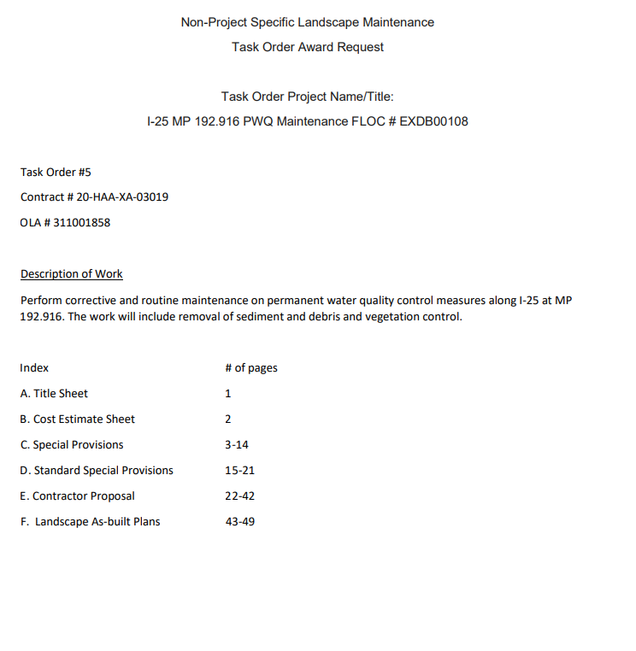

Sample Task Order (complete package)

