INTERIM
Project,
Program,
and
Cash Management
Workbook
June 2015

Table of Contents
RESOURCES v
PREFACE vii
ACKNOWLEDGEMENTS ix
JOB AIDS AND FLOW CHARTS 1
1.0 PROJECT INITIATION 2
1.1 Creating a Project and Generating a Project Number 2
1.1.1 SAP ZJ08 Procedures 2
1.1.2 CJ20N (Project Builder) 3
1.1.3 Entering Milestone Dates in SAP 10
1.2 New Milestone Dates in SAP Project Builder (CJ20N) 12
1.2.1 Estimate Project Work Hours 13
1.2.2 Gather Specialty Group Managers’ Unit Work Hour Estimates 14
1.2.3 Super Circular Guidance 16
1.3 Budget Actions 18
1.3.1 Budget Actions - All Projects 18
1.3.2 RAMP Partnership and Operations Projects 19
1.4 Safety Assessment 19
1.5 Traffic Safety Maintenance and Operations (TSM&O) Evaluation 19
1.6 Surface Treatment Program Distribution for Regional Planning 20
2.0 PROJECT SCOPING 22
2.1 Design Scoping Review (DSR) Meeting 22
2.2 Schedule 22
2.2.1 Project Design Schedule 22
2.2.2 Project Schedule Storage Location 24
2.2.3 Project Pipeline Model (Recommended but not Required) 25
2.2.4 Independent Plan Review 28
2.3 Cost Estimate 28
2.3.1 Location of Project Cost Estimates: 29
2.3.2 Planning and Scoping Level Estimates 30
2.4 Personnel Time Charges During Design 33
2.5 Innovative Contracting Methods 33
2.5.1 Background 33
2.5.2 Project Delivery Methods 34
2.5.3 Conclusion 34
3.0 OTHER PROJECT CONSIDERATIONS 36
3.1 Risk Management 36
3.2 Project Bundling 37
3.3 Asset Management 38
3.3.1 Transportation Asset Management Plan 39
3.3.2 Assets 40
3.4 Decision Authority Matrix 40
3.4.1 Definitions 40
3.4.2 Roles and Responsibilities 41
3.4.3 Authority Matrix 41
3.5 Form 463 41
3.6 Milestone Reporting Tool in CAR 42
3.6.1 How to Access the Design Milestone CAR Report 43
3.6.2 Sample Design Milestone Report 57
3.7 Drawdown Schedules 57
3.7.1 Project Manager Guidance - Pre-Advertisement Drawdown Schedule Procedures 58
3.8 Use of ProjectWise 59
4.0 FIELD INSPECTION REVIEW (FIR) 61
4.1 Pre-FIR 61
4.1.1 Program and Cash Management Required Items for the FIR 61
4.1.2 Project Bundling 61
4.1.3 Update Milestones in SAP 61
4.1.4 Generate Form 65 61
4.2 Post FIR 61
4.2.1 Update Project Schedule 61
4.2.2 Update Milestones in SAP (Includes Super Circular Update) 62
4.2.3 Create Cost Estimate in Web Trnsport and Coordinate with EEMA 62
4.2.4 Adjusting the Project Budget (PD 703.0) 63
4.2.5 Update Drawdown Schedule 63
5.0 FINAL OFFICE REVIEW (FOR) 64
5.1 Pre-FOR 64
5.1.1 Prepare Draft 859 64
5.1.2 Program and Cash Management Required Items for the FOR 65
5.1.3 Update Milestone Dates in SAP 65
5.1.4 Milestone Reporting Tool in CAR 66
5.1.5 Decision Authority Matrix 66
5.2 Post FOR 66
5.2.1 Update Project Schedule 66
5.2.2 Update Milestone Dates in SAP (Includes Super Circular Update) 67
5.2.3 Generate Form 65 67
5.2.4 Update Cost Estimate in Coordination with EEMA 68
5.2.5 Budget Actions 68
5.2.6 Decision Authority Matrix 68
5.2.7 Update Drawdown Schedule 68
5.2.8 Construction Staffing Matrix 69
6.0 PREPARATION FOR ADVERTISEMENT 70
6.1 Construction Schedule and the Form 859 70
6.2 Drawdown Schedule 70
6.3 OJT and DBE Goal Request 70
6.4 Form 1180 Process 71
6.5 Shopping Cart (Purchase Requisition) 74
6.5.1 General Data Fields: 75
6.5.2 Item Overview Fields: 75
6.5.3 Item Data Fields: 75
6.5.4 Account Assignments Fields 75
6.5.5 Finish Shopping Cart 76
6.5.6 After Completion of the Shopping Cart 76
6.6 Go Sheet (ZJ44) 77
6.6.1 Accurate Advertisement Dates 77
6.6.2 Instructions for Generating the Go Sheet in SAP 77
6.6.3 New Fields in CJ20N 80
6.6.4 Email to Project Manager and Resident Engineer 81
7.0 CONSTRUCTION 83
Appendix A Change Record A-1

RESOURCES
For questions related to the phase level funding contact Eric Ehrbar. Contact Sam Pappas for questions related to indirect and construction engineering rates, encumbrances, and the Form 65 – Project Financial Statement.
Link to CE and Indirect Rates:
http://intranet.dot.state.co.us/business/ofmb/budget/ce-indirect-rates
Name Phone Number Email
Eric Ehrbar (303)757-9581 [7-9581] eric.ehrbar@state.co.us
Budget and Cash Management Reporting Manager
Scott Howard (303)757-9328 [7-9328] scott.howard@state.co.us
Cash Management Manager
Sam Pappas (303)757-9628 [7-9628] sam.pappas@state.co.us
Projects Accounting and Reporting Manager
Joe Duhon (303)757-9638 [7-9638] joseph.duhon@state.co.us
Budget Manager
For technical assistance entering the drawdown schedule into SAP, contact your Region SAP Power/Super User or the SAP Project System BPXs. Please contact your Resident Engineer for the name of your region’s current representative.
SAP Project System BPX
Tawnya Nicholson (303)512-5207 [7-5207] tawnya.nicholson@state.co.us
SAP Project System BPX
Valerie Metaiguer (303)757-9837 [7-9837] valerie.metaiguer@state.co.us

For general guidance or support regarding Program and Cash Management implementation and specific requirements for Program and Cash Management found in Design and Construction Bulletins, contact the respective Region Program Management Representative listed below:
Name Phone Number Email
Region 1 Hilary Hawthorn (720)497-6910 [1-6910] hilary.hawthorne@state.co.us
Region 2 Michael Nusen (719)546-5779 [2-5779] michael.nusen@state.co.us
Region 3 Sherry Dunn (970)683-6207 [3-6207] sherry.a.dunn@state.co.us
Region 4 Bryan Schafer (970)350-2219 [4-2219] bryan.schafer@state.co.us
Region 5 Tom Bovee (970)385-1412 [5-1412] thomas.bovee@state.co.us

PREFACE
This workbook has been created as a consolidation of source documents that have been released in various forms over the last couple of years related to Project, Program, and Cash Management. It was put together in a short amount of time so that it could be distributed to the Regions for their use. It was checked prior to distribution but sometimes things slip through. We ask your indulgence and if you see an error please bring that to our attention by sending an email to Ryan Sorensen. Also, if you have suggestions additional information that should be added to make this workbook better please share that information with us as well. This document is a work in progress that will be updated as there are changes in the process and is considered a work in progress and not a final document.
Examples of source documents used to compile this information include Policy Directives, Chief Engineer Memos, Design Bulletins, Construction Bulletins, and any other documents that have been released in support of Project, Program, and Cash Management. Throughout this workbook, the source documents are listed following the section title or subtitle. This will allow the project team to explore the source document if further information on a given subject is desired. If the user of this document has questions about processes they should consult with their Region PMO representative listed above in the Resources section or with their Resident Engineer.
This document will be housed and maintained by the Standards and Specifications Unit within the Project Development Branch. It is anticipated that numerous changes in support of Project, Program, and Cash Management will continue to take place over the next few years, therefore, this document will not formally be distributed in hard copy format. Rather this document will be kept electronically on the CDOT external website allowing for updates to occur as appropriate. The Program Management Office working with the Project Development Branch anticipates channeling any updates into a monthly timeframe. Changes to this document will be clearly logged on the Addendums section along with the date of the Addendum. It is recommended that users refer to this section often to learn of changes and additions. This workbook will be housed at the following link: https://www.codot.gov/business/designsupport/bulletins_manuals
This document is not intended to be an all-encompassing project delivery document at this time, rather it serves as a consolidation of recent information to help project staff navigate the current Project, Program, and Cash Management environment. This should be used in conjunction with all other resources. It is anticipated that over time, the information contained herein will be merged with CDOT’s normal resources such as the Project Development Manual.
As Program and Cash Management is primarily controlled by project scope, project schedule (milestone dates), project cost estimate, and in turn, expenditures to date on a project, this manual primarily focuses on any project delivery guidance documents related to scope, schedule, cost, and drawdowns. There are also a number of items that have been recently developed by CDOT Headquarters, and the PMO that may not be directly related to schedule, or cost, but have been recently released, and this is a good opportunity to help consolidate this information by including it in this document.
It should be noted that anytime throughout this document where the Resident Engineer is mentioned, this can also be interpreted as the Resident Engineer or designated representative, whether that be CDOT personnel or a Consultant Team member as appointed by the Resident Engineer.
This manual was produced with the understanding that various regions and residencies have slightly different business practices and preferences to deliver projects. If there is any guidance in this document that you have questions about or disagree with, please refer to your supervisor for clarification, or to confirm requirements.

ACKNOWLEDGEMENTS
The development of this workbook is a consolidation of various guidance documents, workflows, and other guides. Also, a large amount of content was borrowed from Arthur Miller’s Region 5 design guide. Thank you to Arthur and the individuals listed below for their contributions.
Tom Bovee
Steve Markovetz
JoAnn Matson
Neil Lacey
Roselle Drahushak-Crow
Gary Null
Nabil Haddad
Mark Straub
Ian Broussard
Erik Nyce (AECOM)
Greg Mormon (AECOM)
Ryan Sorensen

JOB AIDS AND FLOW CHARTS
The embedded Excel file below, the Project Development Manual Checklist, was created as a step-by-step quick reference for Project Managers. This workbook, as a whole, focuses on schedule, cost estimate, and drawdowns for a project, however the embedded checklist is more encompassing.
The attached embedded flow chart is also included to provide a “quick glance” for project actions:

PROJECT INITIATION

Creating a Project and Generating a Project Number
Primary Source Documentation: PDM 1.04 Project Creation and Finances
The process starts in SAP with Transaction Code ZJ08 – Project Creation. ZJ08 starts a workflow that is routed to OFMB, the person who initiates ZJ08, and the Region Business office.
Each region business office has different requirements for what is required from the project manager when creating a project in SAP. Some regions require a form be filled out and sent to the business office, and others do not require anything. If you are unfamiliar with your region’s process, contact your region business office representative.

SAP ZJ08 Procedures
There are only four fields that need to be completed in the first step of ZJ08, they are:
- PROJECT DESCRIPTION (NAME) - The information should be as descriptive as possible using state roads or federal highways and cities or counties.
- USER REGION ID - Select the Region overseeing the project. For projects not created in the Region, select Statewide (ST). Do not select HQ.
- START DATE – Enter the date that you create the project in SAP.
- PROJECT DESIGNATORS –Select the radio button and corresponding dropdown item for the roadway segment in which the project is located. The Project Designators is the general location of the project which is used to generate the project number.

Detailed SAP work instructions are on the SAP Training site at:
http://vupweb.dot.state.co.us/gm/cabinet-1.25.201?mode=EU. Select the Engineering folder, then Project Creation, and finally ZJ08.
After you have initiated the project creation workflow, a SAP e-mail is sent to the Region Business Manager (RBM) and OFMB with instructions to approve or reject the project creation request.
After the RBM and OFMB approved the project creation, a five digit project number and the OFMB Project Number (without the alpha code, which comes later) are assigned to the project. An e-mail will be sent to you notifying you of this. The e-mail that is sent appears as follows:
From: SAP Workflow System [WF-BATCH@dot.state.co.us]
Subject: Notification: Proj 17145 Ready for Modif - PM

Project 17145 is ready to be modified.
Details of the project are:
Project Profile : Z000001
Project Description: US 285, SOUTH OF SAGUACHE
OFMB Project Number: 2852-016
This is a system notification email. Do not reply to this email.

CJ20N (Project Builder)
After you receive the e-mail notification, use the link in the SAP Business Workplace Inbox to complete entering the project information This is located on the first screen when you open SAP, at the top where there is a menu bar with the following options: Menu, Edit, Favorites, etc. Click on Menu and in the pull down box, highlight and click on Business Workplace. Click on the folder that says Inbox on the left hand side of the screen. Click on the Workflow folder, and then highlight and click on the unread message. This will automatically take you into CJ20N (Project Builder). Below are some basic instructions for completing the CJ20N. For complete insructions, see http://vupweb.dot.state.co.us/gm/cabinet-1.25.201?mode=EU. Select the Engineering folder, then Pre-Construction/Construction, and choose “CJ20N – Open Project in Project Builder”.
The first step when entering Project Builder is to click on the Long Text tab on the right side of the screen and enter a Project Description. The text entered here will transfer to the Comments field of the ZJ40 – Project Status Report. In the description include a brief summary of: the project scope, the highway with beginning and ending mile points, the type of work being performed, and any significant CDOT assets being impacted, e.g. critical culverts, bridge expansion joints, etc.
Next click on the Custom Enhancements tab to the right side of the screen, then click on Custom Fields below the tabs.

Make sure the top level in the WBS is highlighted.

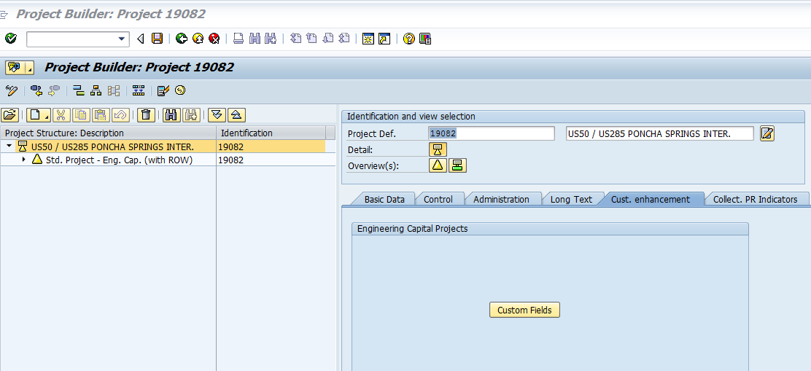
Highlight Top Level

Then click on the Project Manager tab to the middle right side of the screen; this screen is ZPS01. If this screen is grayed, call OFMB (Eric Ehrbar) to change the user status so that you can complete the fields.

Naming Conventions for Project Scope
Primary Source Documentation: DB 2014-14 Naming Conventions for Scopes, Schedules, and Cost Estimates.
Primary Resources: See Resources list in the front of this workbook.
SCOPE (Project Description):
A succinct project description should be entered in SAP for each project. Include a brief summary of the project scope, the highway with beginning and ending mile points, the type of work being performed, and any significant CDOT assets being impacted, e.g. critical culverts, bridge expansion joints, etc. This description should be entered on the line immediately after the Project Name (which is always the first line of text, and should not be changed once it has been entered) in the Long Text tab in the CJ20N - Project Builder at the project level (Look for this symbol ) not the WBS level. Information entered in the Project Long Text tab transfers to the Comments field of the ZJ40 - Project Tracking Report. Include a brief summary of: the project scope, the highway with beginning and ending mile points, the type of work being performed, and any significant CDOT assets being impacted, e.g. critical culverts, bridge expansion joints, etc.

Project Manager Details
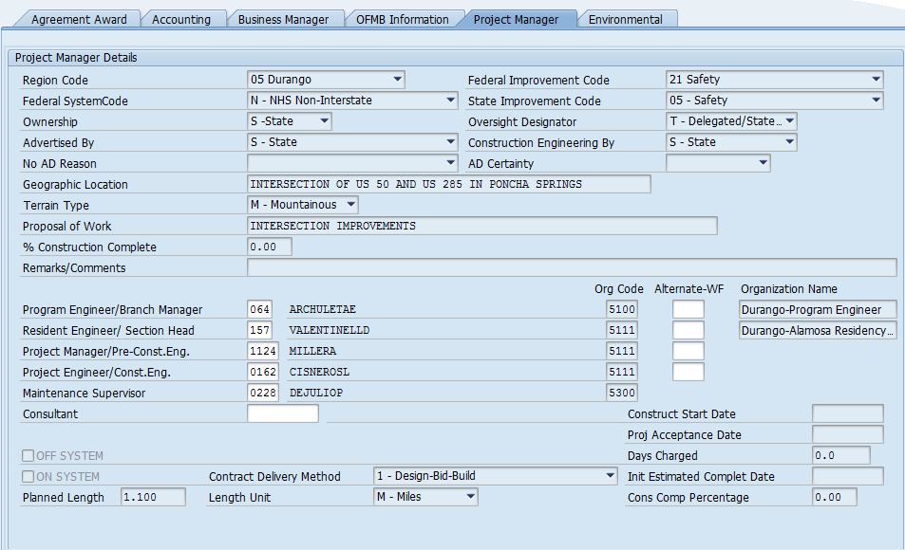
Below is a description of most of the fields to be completed in the Project Manager Details section. All fields with a check mark are required to be completed before you can exit the screen. For more information, click in the field and then press the F1 button on your keyboard. . For the complete SAP instructions for completing the Project Manager’s Tab, click on the link below:
http://vupweb.dot.state.co.us/gm/folder-1.11.37215?mode=EU&originalContext=1.11.30034
- Region Code – Select the Region overseeing the project. For projects not created in the Region, select Statewide (ST). Do not select HQ.
- Federal System Code:
  - I – Interstate
  - N – NHS Non Interstate
  - – Other Federal Aid Highway
  - X– For conversion purposes (do not use)
  - Z– Not on any federal aid highway (local agency off system projects for example)
- Advertised By:
  - None – The project is design only or a study and will not go to Ad; another reason is that the project is a shelf project with no construction funding identified in the cureent 4 year plan. In this case, this field will need to be updated when funding is available and the project becomes active.
  - State – This is a project advertised by CDOT and will go to ad. If you choose this option, the business manager must enter an ad date into SAP.
  - Local – This is a project that is advertised by a Local Agency (not CDOT). If None is chosen above, a reason must be given from the pull down menu.
- Federal Improvement Code
Choose an option that best corresponds with the majority of funding or work. For example, if the project is mainly bridge funds then select “bridge replacement (either added capacity or no added capacity).” Please do not use Federal Improvement Code "1" New Construction unless for the New Construction of a brand new roadway or the extension of a roadway, FHWA's definition of New Roadway:

Construction of a new roadway that will not replace an existing roadway. A new roadway will provide: (1) a roadway where none existed, or (2) an additional and alternate roadway to an existing roadway that will remain open and continue to serve through traffic.

Recommended alternatives include:
For new signals or IT equipment, use 21 "Safety" or 44 "Other".
For trails use 28 "Facilities for Pedestrians and Bicycles."
For new bridges use 8 "New Bridge"

Please refer to the complete list of improvement code definitions in the embedded pdf document below.

FHWA will review the code to make sure the work is in line with the funding.
- State Improvement Code
The selection here should be similar to the Federal Improvement code based on the funding available.
- Oversight Designator
  - A – CDOT administered – This is the majority of the projects.
  - N – Full FHWA (NHS) The Resident Engineer is responsible for determining whether the project is under CDOT or FHWA oversight. The oversight responsibilities are outlined in the Stewardship Agreement between the FHWA Colorado Division and CDOT. Unless the STA/FHWA agreement differs, full FHWA involvement projects will tend to be new construction or reconstruction projects on Interstate routes with an estimated value greater than $1 million. The Resident Engineer can contact the FHWA for further guidance.
  - O- Other – This is almost never used. FHWA will indicated if it is needed.
  - X- Full FHWA (Non-NHS) – This is rarely used. FHWA will indicate if it is needed.
- Construction Engineering by:
  - C- Cons/Contr – This is a unique situation. Only use if told to do so.
  - L- Local – Construction oversight by Local Agency.
  - O- Other – Only use if instructed to use for special reasons.
  - S- State - This is standard for CDOT projects.
  - X- For conversion purposes – Do not select
- Geographic Location, Terrain Type, Proposal of Work.
  - For the Geographic Location be as precise as possible (similar to, if not exactly the name of the project) by naming the Federal or State road and the city or county (i.e. – CR 520/CR 616 on SH 69 in Huerfano County).
  - For terrain type the options are: Level, Mountainous, Plains, Rolling or Urban. (This can be found using OTIS).
  - For Proposal of Work list the major activity to be completed (e.g. – Intersection Design, Drainage improvements, Surface Treatment or Safety improvements).
- % construction complete – this is usually zero
- Remark or Comments – Add more information here if needed.
- Project Personnel
  - This information is key if someone needs to contact appropriate party during any of the project development process.
  - The people entered are tied to their organization code and are what is used when SAP sends workflows for key processes in the project development.
  - The organization codes associated with the project personnel need to be correct and if there are more than one organization involved in the project there is an alternate Org code.
- On System or Off System – If it is on a state highway then it is ON SYSTEM. If it is on a City or County road or not on a highway, then OFF SYSTEM.
- Contract Delivery Method
  - Select the contract delivery method for your project. Design-bid-build is the traditional method for projects.
  - For information on other options, refer to the Innovating contracting manual.
- Planned Length and Length Unit
  - This information is not tied to the information given in OTIS at this time. Make sure the Planned Length entered matches the mileposts in OTIS. This information goes into Form 463.

Location Details
Toward the middle of the Project Manager screen, there is a tab that says “Map-Click on the Button to get GIS Details”. Click on this tab. This will take you to a SAP Project Manager Login screen. Enter SAP User Name and Password (this is the regular SAP password used for entering into SAP) then click the on the Sign In Tab. When the Project Manager screen appears there will be a pop up window that says “This project has no locations defined yet”. Click on the okay box and use this screen to add locations to the project. Next click on the left hand side the tab that says to, “Add on System Location”. After clicking to add a location then to the right hand side of the screen choose a route (highway number) and the begin and end reference points (mileposts). Then click on the green arrows to the right of the reference points. You’ll see the limits of work on the route map Now at the bottom of the same screen, enter additional information related to the project such as:
- County, congressional and commission districts, etc.
- Below this there is other information that must be checked that is related to the particular highway.
Then click on the tab that says Save and Return to Project Details, and then click on the OK on the next box that appears. Then last of all click on the tab that says Send Changes to SAP. Click on OK on the next two boxes that appear and then click on the Log Out tab on the top right of the screen.
When back in the SAP screen click, which is the Project Manager tab screen that has ZPS01 visible on the bottom right. In the middle of this screen now click on the Refresh tab, then click on the Calculate County Percentage tab, then click on the Calculate Congressional District Percentage tab. Now after you’ve filled in the Project Manger screen, click on the green back arrow to take you back to the previous screen (Project Builder Screen – CJ20N). Once in this screen click on the green back arrow then on the amber up arrow or exit arrow and then a small dialog box will appear that says “Do you want to save the Data.” Click on yes. Then another box will appear that says, “This Work Item to be Completed Explicitly.” This box will also have the project code and the project name toward the top in dark letters. At the bottom of this dialog box, click on the tab that has a check mark and the words “Complete Work Item.” After clicking on this tab, the box will disappear, you’ll be back in the Business Work screen, which you can now exit out of.

Attaching a Template to the CJ20N
After setting up the project per the instructions, then you will be sent an e-mail within several days that says the project has been successfully created. It looks and reads as follows:
From: SAP Workflow System [WF-BATCH@dot.state.co.us]
Subject: Notification: Proj 17145 Success. Created

Project 17145 has been Successfully Created. If changes are necessary, please contact OFMB.
Details of the project are:
Project Description: US 285, SOUTH OF SAGUACHE.
Program Engineer/Branch Manager: KEITH POWERS
Resident Engineer/Section Head: GERALD SJAASTAD
Project Manager/Pre-Constr. Engineer: JAMES MARTINEZ
ProjectEngineer/Constr. Engineer: JAMES MARTINEZ
This is a system notification email. Do not reply to this email.

A template must be attached to the CJ20N, and this can be done at any point in the process. These steps are from SAP help which can be found by clicking on the following link: http://vupweb.dot.state.co.us/gm/folder-1.11.51576?mode=EU&originalContext=1.11.30034
- Open the project by typing the project code
- Click on green arrow, open
- On the middle left of the screen there are two tabs; one is a Worklist tab, and the other is Templates tab. Click on the Templates tab.
- Click or highlight the Standard Templates tab
- Click or highlight the Standard WBS Elements tab
- Now highlight either one of two tabs; one says 00010 Std. Project Eng. Cap. (with ROW), and the other says 00011 Std. Project Eng. Cap. (without ROW) for projects that do not have right of way involvement
- For a project having ROW, right click over the tab that says 00010 Std. Project Eng. Cap. (with ROW)
- In the box that appears, click on Replace
- Another box will appear again click replace
- Back at the Project Builder box, now click include
- Click on the green arrow or the YES button depending on the selection available to you.
- SAP will then display the message, “scheduling carried out”.
- Highlight the Level 1 WBS element on the upper left hand side of the screen it will read “Std. Project-Eng. Cap (with or without ROW)”
- In the lower right portion under Responsibilities fill in the Resp. cost cntr xxxx RXxxx-xxx.
- Click Enter (white check mark in green circle).
- Click Save. A message displays stating “Project JPC# is being changed” [where JPC# is the 5-digit project code].
- Next click on Exit, the white up arrow in the amber circle at the middle left at the top of the screen to exit from the CJ20N.
Once a template is added to the project in SAP, the Resident Engineer can notify the business office that the project is ready to be budgeted.

Entering Milestone Dates in SAP
Primary Source Documentation: DB 2014-3 Milestone Dates in SAP Project Builder (CJ20N) (to become PDM 1.07.12 Project Estimate), and DB 2014-4 SAP Milestone Schedule.
As part of CDOT’s Critical Path Method (CPM), scheduling is used to manage design and construction projects, Project Managers must enter specific milestone dates into SAP. These milestone dates are used by the Program Management Office to develop master program schedules, forecast construction expenditures, and monitor key performance indicators (KPI). Timely and accurate entry and maintenance of milestone dates by the project manager is crucial to implementation of program and cash management at CDOT.
These KPI’s can then be used by Resident Engineers on up through executive management to evaluate and, if necessary, adjust project schedules to align with cash availability.
These milestones are required for all projects that will be advertised for construction, including design-bid-build, design-build, and construction manager/general contractor (CMGC) projects.

Design-Bid-Build | CMGC | Design-Build
- Scoping  - FIR  - FOR  - Ad  - Begin construction  - End construction | - Scoping  - FIR  - FOR  - Ad/CAPP  - Begin construction  - End construction | - Scoping  - Statement of interest (SOI)  - Draft RFP  - Final RFP date  - Begin construction  - End construction

Milestone dates are entered under the Design WBS. Note that in SAP Project Builder the planned date is the Basic fix.date (Bsc fixed). Planned dates are required for each of the six milestones above. For projects with a combined FIR/FOR, enter the same date for both milestones.
In an effort to provide consistency among project schedules, an explanation of when each standard milestone is considered complete is provided in more detail below.
- Scoping — The Design Scoping Review (DSR) or equivalent meeting has been held, a project schedule has been agreed upon with specialty units, and a preliminary cost estimate has been developed.
- Field Inspection Review (FIR) — This milestone is achieved when the FIR meeting has been conducted.
- Final Office Review (FOR) — This milestone is achieved when the FOR meeting has been conducted.
- Advertisement Date — Date that project is advertised for proposals.
- Begin Construction — Date that contractor is anticipated to begin work. During the preconstruction phase, use the first of the month as the date. For example, if work is expected to begin in May, use May 1st as the begin date.
- End Construction — Date the project is anticipated to be open to traffic. Do not include warrantee periods. Use the last day of the month for simplicity.
- Ad/CAPP — Date the Contract Agreed upon Price is requested from the vendor.
- Statement of Interest – Date the request for Statements of Interest is published.
- Draft RFP — Date the draft RFP is published for vendors.
- Final RFP — Date the final RFP is published for vendors.
The above milestones must be entered for project scoping to be considered complete. Between Scoping and FIR, the project manager can revise the schedule with the concurrence of specialty units and the Resident Engineer. Between FIR and FOR, milestone dates can only be revised with the concurrence of the specialty units and the Program Engineer. After FOR, milestone dates can only be revised with the approval of the Program Engineer in consultation with the RTD. Some higher risk projects may also require concurrence of a program control board.
Additional milestones may be added, as needed, based on the complexity of individual projects.

CJ20N SAP Milestone Entry
- Open your project in CJ20N.
- In the Project Structure: Description (Left side of screen) highlight the “Design” under Std. Project→Pre-Construction→Design.
- In the Identification and view selection pane (To the right of the Project Structure: Description pane), click on the gray diamond
- Fill in the milestone dates using the approved Microsoft Schedule.
- Save when complete.

New Milestone Dates in SAP Project Builder (CJ20N)
Primary Source Documentation: DB 2014-3 Milestone Dates in SAP Project Builder
The CDOT Engineering template in Project Builder (CJ20N) has been streamlined to include only the major Work Breakdown Structure (WBS) and Milestones. The new template, available as of July 31, 2013, does not have the ROW WBS, Design Networks and Design Activities.
The WBS names are the same (Std. Project – Eng. Cap. (with ROW) – 00010 and Std. Project – Eng. Cap (without ROW) – 00011). (See screenshot in Figure 1-2A.) The Milestones in the templates are the Standard Milestones outlined in the “Controlling Our Critical Path” document. You can now add an unlimited number of additional Milestones to any WBS in the project. However, only the first five additional milestones will display on the Project Status Report (ZJ40).
To add dates to Milestones refer to “CJ20N – Add Milestone Dates to WBS Template”:
There are two reports that include Milestone dates. The first report, Project Status Report (ZJ40), will display most of the Project information including the Standard Milestones and up to five additional Milestones. (See Project Status Report sample in Figure 1-2B.) The second report is Milestones (CN53N). With this report you can call-up the Milestone dates by Project or WBS Elements.
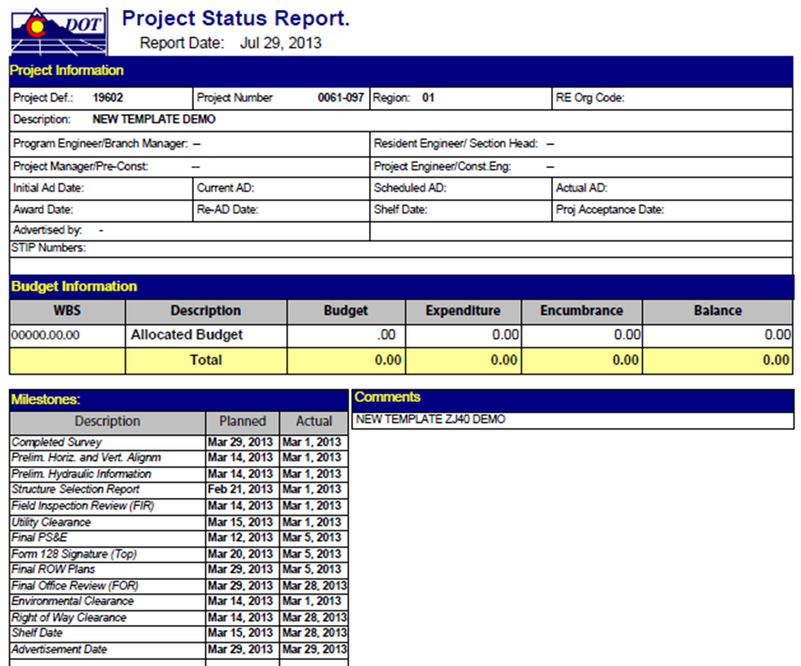
To add a template to a new project, refer to the help document “CJ20N - Add Template to Project” or “CJ20N - Add Standard Template to Bridge Enterprise Project” in SAPTraining. New milestone templates have been added to all existing projects.
If you need assistance with Milestones in SAP or SAP Project Systems, please contact the BPXs:
Tawnya Nicholson Valerie Metaiguer
tawnya.nicholson@state.co.us valerie.metaiguer@state.co.us
(303)512-5207 [7-5207] (303)757-9837 [7-9837]

Estimate Project Work Hours
Primary Source Documentation: PDM 1.02 Estimated Initial Project Cost and Schedule.
The Resident Engineer will be responsible for the development of a preliminary work-hour estimate for the project. This work-hour estimate will be required on all projects, regardless of personnel involved (State or consultant) and shall represent reasonable work-hours needed to complete all project activities. On projects which involve consultant contracts, the work-hour estimates shall be done independently of any consultant-provided estimate and shall serve as a resource in work-hour negotiations.
The Project Estimate is the summary of total costs for a project. This is broken out into Phases identified as ROW, Utilities, Design, Environmental and Miscellaneous (RUDEM) phases. Additionally, the Project Estimate will include projected costs for Construction of the project. At initial budgeting the construction budget may not be relevant. The ROW and utility phases may not be able to be estimated until after the FIR plan level.

Gather Specialty Group Managers’ Unit Work Hour Estimates
Primary Source Documentation: PDM 1.02.04 Pre-project Budgeting, and DB 2013-2 Cost Estimates and Federal Authorization, and Superseded DB 2009-1
Below is a series of recommended best practices for generating work hour estimates. Various regions, units, and specialty units have differing business practices, and may differ in your area. Please consult with your Resident Engineer to verify
The Resident Engineer will provide a copy of the baseline schedule and preliminary work-hour estimate to all internal specialty units at least two weeks prior to the project Scoping Review Meeting. The CDOT specialty unit manager will be notified by the RE of project scoping activities on all projects. For both in-house and consultant design projects, the CDOT specialty unit manager, or designee, will participate in the scoping activities when the project involves their discipline or when requested by the RE. The CDOT specialty unit manager will review the project in advance and prepare any information that may be needed for the scoping meeting, i.e. the structural engineer would review and present existing bridge information on projects involving structures.
The CDOT specialty unit manager will review the baseline schedule for both in-house and consultant design projects and recommend changes as needed to accommodate the project work activities identified for the subject discipline.
- The specialty unit manager may recommend additions to the minimum milestones as needed for the specific needs of the project. For example, on a retaining wall project that requires extensive geotechnical work that will be in the critical path, additional milestones pertaining to this work may be recommended.
- The CDOT specialty unit manager will participate in the development of the consultant scope-of-work and write the portions pertaining to their discipline as needed or assigned by the RE/PM.
- The specialty unit manager will provide review and comments to the RE/PM on the final draft of the consultant scope-of-work.
The CDOT specialty unit manager will provide the RE/PM with an independent work-hour estimate to accomplish the specialty project work. Critical assumptions on which the estimate is based will be included in the submittal. The specialty unit manager will attend work-hour negotiation meetings, or provide consultation, as requested by the RE/PM or Agreements on consultant design projects. Project schedule review comments and work-hour estimates may be prepared by the CDOT specialty unit manager’s designee, but will be reviewed and submitted to the RE/PM by the specialty unit manager.
The Resident Engineer will be responsible for coordinating the project Scoping Review Meeting. This meeting shall include representatives from all appropriate specialties. The purpose of this meeting will be to discuss the scope of the proposed project and to identify appropriate project Work Breakdown Structure (WBS) elements, work activities, durations and relationships, as well as to thoroughly assess the draft baseline schedule and preliminary work-hour estimate. The Resident Engineer and the other specialties will consider current work load factors and future projects that may have an impact on their work activities and durations. Feedback obtained from the Scoping Review Meeting will be used by the Resident Engineer and accurately reflected in the draft baseline schedule and preliminary work-hour estimate.
The Resident Engineer will provide the revised draft baseline schedule and work-hour estimate to all key specialties (Bridge, ROW, Environmental, Traffic, Materials, etc.) for final resolution of any potential conflicts of logic or deliverables. Upon this review, any changes will be incorporated by the Resident Engineer.
Upon review by the Region Management team, the Resident Engineer will make any necessary modifications to the draft baseline schedule and preliminary work-hour estimate. These modifications will be the last changes to either document. The RE/PM will save and refer to these files as the final baseline schedule and final work-hour estimate. These final documents shall not be altered at any time during the remainder of the project.
The Resident Engineer will develop a preliminary cost estimate for the project, including estimates for each phase of the project (Right of Way, Utilities, Design, Environmental, Miscellaneous and Construction). The RE/PM should consider the phase and respective personnel resources (in-house or consultant). The phased estimates will include any respective consultant services for the project.
The CDOT specialty unit manager will participate in the development of the consultant scope of work and write the portions pertaining to their discipline as needed or assigned by the RE/PM. The specialty unit manager will provide review and comments to the RE on the final draft of the consultant scope-of-work. Alternatively, the specialty unit manager may provide the RE with a separate consultant scope of work and preliminary cost estimate for consultant services that the specialty unit manager may choose to directly contract for.
The CDOT specialty unit manager will provide the Resident Engineer with a cost estimate for each phase of the project, as appropriate, to accomplish the specialty project work. Construction, right of way, and utility cost estimates will be rough at this phase of the project. The specialty unit managers will be responsible for updating these cost estimates and keeping the RE/PM informed of significant changes throughout the project design.
The Resident Engineer will review the preliminary cost estimate with the Program Engineer and make revisions, where appropriate. Any revisions made to the cost estimate must be reviewed with affected specialty units prior to finalizing.
It is a good best practice to develop a “closure document” that includes the baseline schedule and work-hour estimate, along with documented assumptions and risks associated with the project scope and schedule and any other relevant information used in developing the project schedule. This document should be kept in the project files and distributed to members of the project team including management.
As a reference, below is Design Bulletin 2009-1 which was superseded by Design Bulleting 2013-2 work hour estimate:
This contains some useful attachments which may assist in generating a WHE.

Super Circular Guidance
Primary Source Documentation: Chief Engineer Memo Dated December 23, 2014
The Code of Federal Regulations (CFR) affects many aspects of how CDOT administers its programs and projects. It is periodically updated to consolidate, eliminate or add regulations. One highly relevant portion of these regulations is 2 CFR Part 200. This document is referred to as the “Super Circular”, as it is largely a compilation of regulations from eight, separate federal “circulars”, documents which contained regulations on various topics. The implementation guidance document is found at:
http://www.fhwa.dot.gov/cfo/2cfr200guidance.cfm
The administrative requirements in the “Super Circular” which affect project management apply to newly authorized projects and changes in project scope, schedule or budget on or after December 26, 2014.
Critical elements of the Super Circular include:
- Project phases must have an end date. After this date no additional costs may be incurred on that authorized portion of the work and CDOT cannot be reimbursed by FHWA for any work performed past the end date. This does NOT mean that the PM must provide an inflexible end date for construction at the authorization of the design phase. In fact, phases and even portions of phases can be authorized independently as a project progresses. For example, if the PM requests authorization of design through FIR, then the end date would be the date of the end of the FIR phase. Furthermore, end dates can be adjusted at any time if circumstances beyond CDOT’s control arise, such as discovery of a threatened or endangered species or hazardous materials, challenges in coordinating with outside property owners or entities, such as railroads, ditch companies or private landowners, weather events and conditions (especially as related to landscape establishment), CMO’s or termination of a contractor. Also, modifications to end dates are allowable if projects are advanced or delayed for program and cash management reasons. It is imperative that project managers be proactive about monitoring end dates, schedules, scope and budget. Preferably, changes in end dates during construction should be made at least 6 months in advance. If contract modifications result in an extension of contract time, the end date should be modified when the CMO is executed.
- When an authorized phase or portion of a phase reaches its end date, CDOT must request reimbursement within 90 days. This is especially important when finishing a construction project. A reasonable amount of time for finalizing the project must be accounted for when establishing the construction end date.
The following interim process for providing end dates to the Office of Financial Management and Budget (OFMB) has been developed for Project Managers, Business Managers, Program Management Office representatives, and all others involved in Federal Aid projects. Final procedures will be developed in collaboration with OFMB, Program Management Office, Office of the Chief Engineer, Project Development and FHWA.
No less than weekly, OFMB will correspond with regional business managers and PMO representatives, listing the projects requiring end date validation. Those individuals shall provide and/or validate the estimated end dates for phases requesting FHWA authorization or modifying the scope, schedule or budget of an existing authorization. The date will be required prior to submission to FHWA.
Date validation and/or requested changes during the project authorization or modification process shall be communicated back to:
- OFMB Federal Aid and Project Budgeting
- Dariann (Dee) Perry for Regions 1, 4 and Flood related activities;
- Matthew Buck for Regions 2, 3, 5 and Statewide programs.
Estimated end dates shall follow closely the current policies and procedures for phase closure milestones, being both conservative yet reasonable. The following defaults will be inferred by OFMB and others for use in populating the end date provided that the respective “Current Planned Ad Date” and/or the “End Construction Milestone Date” have been pre-populated into CJ20N.
- Design Phase End Date will default to 120 days after the Scheduled Planned AD Date;
- Environmental Phase End Date will default to 120 days after the Scheduled Planned AD Date;
- ROW Phase End Date will default to 270 days after the Scheduled Planned AD Date;
- Utilities Phase will default to 180 days after the End Construction milestone date;
- Miscellaneous Phase will default to 270 days after the Scheduled Planned AD Date;
- Construction Phase will default to 180 days after the End Construction milestone date.
Prior to submission to FHWA, OFMB will ask the regions to verify that the default date is appropriate or to populate the date if the fields are currently blank.
If the regional staff prefers a different date be used, they should communicate that preferred date to OFMB with a brief justification that will be provided to FHWA.
OFMB will then input the verified date into CJ20N User Fields and upload the date into the FMIS during the FHWA authorization process.

Budget Actions

Budget Actions - All Projects
Primary Source Documentation: Policy Directive 703.0
Policy Directive 703 .0 (Revised August 27, 2014) establishes the policy by which CDOT determines and submits annual and project budgets to the Colorado Transportation Commission. Programs and projects are budgeting on a 4-year planning basis. Appendix C: “Project Related Transactions” lists by Project Type, the approval required for changes to initial project funding, pre-award adjustments and contract modification orders during the construction phase. For any changes in funding needs for your project, it is critical to adhere to these requirements.
Policy Directive 703 (https://www.codot.gov/about/transportation-commission/documents/2014/august-2014/02-pd703-workshop.pdf)

RAMP Partnership and Operations Projects
Additional projects controls have been established for RAMP Partnership and Operations projects to improve total program cost forecasting. The December 19, 2014, memo below includes a flow chart that depicts the steps needed to advertise RAMP projects, and a template memo for requesting additional funds. Some projects will require independent cost estimates. Transportation Commission approval is required for project increases that exceed 1%.

Safety Assessment
Project Managers will need to initiate the process for Safety Assessment at their earliest convenience to see what safety issues may need to be incorporated into the project based on accident data history and assessment of safety data. [Note – add in link for webpage to fill out for requesting safety assessment of project from CDOT website.

Traffic Safety Maintenance and Operations (TSM&O) Evaluation
Starting in 2015 all CDOT administered engineering projects will require an TSM&O evaluation from the Division of Transportation System Management & Operations (TSM&O) prior to going to advertisement. The work flow for this process is still being developed, however, the Project Manager should contact their Region Traffic Sections to initiate this process. Note: This section will be revised in the future once the work flow for the process is defined. Maintenance projects and Local Agency projects do not fall under this requirement at this time.
The purpose of the TSM&O evaluation is to ensure a consistent and inter-disciplinary approach among Maintenance, Access, Regions, Operations, Safety, ITS, and the FHWA starting early in the Design Scoping Review (DSR) phase of a project. Note that as part of the TSM&O evaluation recommendations will be provided that may request additional work items to be added to the project to enhance existing Operations and Safety infrastructure or improve operations within the corridor which may then trigger a request for additional funding, change in schedule etc. Project Managers should discuss these recommendations with their Resident Engineer and Program Engineer regarding action for implementation.

Surface Treatment Program Distribution for Regional Planning
A Division of Project Support Memo (DPSM) was issued April 24, 2015 which establishes regional planning budgets for delivery of the Surface Treatment Program (STP) in FY 2017 to 2020. In addition, the methods for managing the statewide Surface Treatment design and construction pools are included.
The memorandum embedded below establishes regional planning budgets as percentages of the total annual surface treatment funds in order to:
- Ensure that the pavement management system (PMS) effectively directs project delivery,
- Establish annual project plans that reflect statewide pavement asset needs,
- Provide reliable annual planning budgets for effective project planning and delivery,
- Recognize the optimal statewide design and construction budgeting methods,
- Implement the Drivability Life (DL) analysis method and associated traffic-based pavement category condition targets treatment guidelines, and
- Meet the pavement asset practices and condition goals established in Policy Directive 14.
The following table states the recommended percentages for the regional planning budgets utilizing the calendar year 2015 PMS model and anticipated $240M annual Surface Treatment Program funding.

Table 1 – Statewide Distribution of Surface Treatment Funds for Regional Planning
Region | Planning Budget for Fiscal Year (%) |  |  |  | Region Design Pool (% of Region Budget) (3) | Planning Budget (estimate) (%)
 | 2017 (1) | 2018 (1) | 2019 (2) | 2020 (2) |  | 2021 (2) | 2022 (2)
1 | 21.8 | 17.0 | 13.2 | 14.7 | 10 | 17.5 | 20.8
2 | 20.7 | 21.3 | 22.6 | 21.0 | 7 | 20.8 | 18.2
3 | 20.7 | 20.6 | 22.5 | 21.6 | 7 | 17.2 | 20.0
4 | 24.3 | 26.4 | 23.6 | 24.4 | 8 | 29.7 | 26.2
5 | 12.5 | 14.6 | 18.1 | 18.3 | 10 | 14.8 | 14.8
- Final values based on 2013 DL PMS Analysis, and advanced from the 2013 Chief Engineer Policy Memo #19.
- Final values based on 2015 DL PMS Analysis.
- Design Pool is the percentage of total planning budget assigned to each region.
See the memorandum embedded below for more information:

PROJECT SCOPING

Design Scoping Review (DSR) Meeting
Primary Source Documentation: PDM 2.01
The Design Scoping Review is an early, on-site review of a project prior to preliminary design. This enables development of a scope of work that will be consistent with the planning and design characteristics. Some projects will be created and budgeted before the scoping review meeting. It is acceptable to have two scoping meetings. One before the project is created and budgeted and another after the project is created and budgeted. The Project Development Branch working with representative from the regions is looking as making changes to the scoping process to create a more solidified “Scoping Phase”. More on this concept will be rolled out in the future.
The scoping review process establishes the objectives of a project, the identification of design standards, funding sources, and the required resources necessary to complete a project.
Scope is an important element of Program and Cash Management as it is understood that the design process is a “process of discovery”, and that changes to the project develop over time. It is important to know and communicate the “why” when a design schedule changes, or cost estimate escalates. This can be done by thoroughly scoping and collecting requirement for the project upfront, and then tracking the changes along the way.
It is important to enter the project description as explained in section 1.1.2.1.

Schedule
Primary Source Documentation: PDM 1.02 Estimated Initial Project Cost and Schedule
In order to support program management and cash management, CDOT needs to have a better understanding of when projects anticipate spending funds. Access to timely and accurate project schedules and cost estimates during all phases of preconstruction is crucial for accurately forecasting project expenditures.

Project Design Schedule
A recommended best practice is to prepare a design schedule for each project to determine the critical path, milestones including SAP milestones, and projected advertisement date. The schedule can be used by the Resident Engineer and Design Project Manager to monitor the progress of preconstruction activities. Bar charts may be used for simple design projects, but for most projects, Microsoft Project is recommended for creating the project schedule.
The project schedule will be developed by, or under the supervision of the Resident Engineer. A generic project schedule template is embedded below. It is important to note that the template is just a starting point. Each project has its own unique features that will require some adjustments to the template.

The Resident Engineer should consider the availability of funds when determining the schedule. For example, preliminary engineering should not be started until funds have been budgeted and obligated for the design phase, and a project may not be advertised until funds are available for construction, particularly if federal aid is involved. In addition, local agencies may provide funds and their processes and time constraints for providing these funds have to be considered.

The Resident Engineer should give priority attention to critical path tasks that often require considerable time such as right-of-way acquisition, complex bridge design, consultant selection, environmental investigations, local agency agreements, utility and railroad agreements, specialty clearances (i.e. SHPO etc.) and hazardous materials mitigation.

It is important to engage each specialty group discipline as early as the scoping meeting, so that each group can begin planning for resources to complete its portion of the work. Specialty groups need to provide input for completion dates of assigned tasks and to help estimate schedule milestones that will be entered in SAP. The Region PMO representative will be using the six milestone dates that are required in SAP as mentioned in section 1.1.3, however it is encouraged that the project manager track the additional milestone dates listed below to aid the project manager in managing the design schedule.

  - Completed Survey
  - Preliminary Horizontal and Vertical Alignments
  - Preliminary Hydraulic Information
  - Structure Selection Report
  - Field Inspection Review (FIR)
  - Form 128 Signature (Top Portion)
  - Final ROW Plans
  - Final Office Review (FOR)
  - Environmental Clearance
  - Right of Way Clearance
  - Utility Clearance
  - Final PS&E
  - Shelf Date
  - Advertisement Date

Developing and managing a project schedule includes the following activities:
- Conduct the project design scoping prior to preliminary design by initiating a Design Scoping Review.
- Develop a proposed project schedule, preferably in time for the scoping meeting to get team input and finalize within 30 days after the Design Scoping Review with an electronic copy stored in ProjectWise as stated below.
- Coordinate, monitor and update the project schedule with other appropriate milestones as mentioned above.
- If using Microsoft Project, update the electronic schedule as needed.
As design progresses, the Resident Engineer should monitor the timely completion of important events and activities including right-of-way acquisition, environmental clearances, utility work, and other associated tasks required to finalize design of a project. The project team should be informed of activity schedule changes and accomplishments in order to coordinate plan development. Strategies should be developed for resolving critical path activity delays. The Resident Engineer should inform impacted parties of any changes to the schedule and adjustment to the advertisement date.

Project Schedule Storage Location
Primary Source Documentation: DB 2014-14 Naming Conventions for Scopes, Schedules, and Cost Estimates.
In order to provide project consistency and support program and cash management, schedules should be stored in the ProjectWise folder location as described below. Project teams should follow the file naming procedures below so that specialty units and other members of the design project team can easily locate files as needed to review schedules.
Any changes to the schedule or notes to be added should be coordinated through the Resident Engineer.
It is recommended that Project schedules are preserved at the Scoping, FIR, FOR, and Advertisement milestones in Microsoft Project format (.mpp). Use the following file naming convention for schedules:
- JPC#_PMO_Scoping_Sch.mpp (Design)
- JPC#_PMO_FIR_Sch.mpp (Design)
- JPC#_PMO_FOR_Sch.mpp (Design)
- JPC#_PMO_AD_Sch.mpp (Construction)
(JPC# indicates the 5-digit project code.)
The AD schedule should be the schedule developed for construction for the CDOT Form 859. Place schedules in ProjectWise in the Project Manager/Schedules folder for the appropriate project code, as shown in the example below:
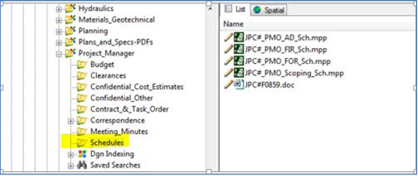

Project Pipeline Model (Recommended but not Required)
The Project Pipeline Model is used differently by different regions and residencies. It’s use is not mandatory statewide. Please check with your Resident Engineer and/or PMO Representitive for requirements on using the Project Pipeline Model.
The Project Pipeline Model is a statistical based tool that uses a database of task durations which occur from project inception to advertisement. The database of task durations was built from approximately 30 projects in the former Region 6. Although Gantt charts are different for every project, in order to build the model, a ”standardized” project design Gantt chart was created and hardwired into the model. The pipeline model uses this Gantt chart along with the data set of 30 projects to generate a likely project design duration, and level of effort based on user inputs. The pipeline model generates a forecasted Ad date and total work hours required for a project based on project characteristics and specific confidence limits. The model can also generate the likelihood of a project meeting a specific Ad date once the project characteristics are entered into the model.
Components of the Pipeline Model
One “Storybook” (a MS Excel workbook) per project, linked to a central repository of data (the Probability Generator) and one or more copies of a report that compares projects (the Portfolio Monitor).
Outputs of the Pipeline Model
Most likely date that a project in development is ready for advertising and the most likely hours of effort required to develop the project. The confidence limits around those two forecasts. Estimates the probability that a project will be ready to advertise on a date other than the most likely date.
Golden Rules of Empirical Forecasting
“Use the Force, not the computer.” It’s only a model and it’s only as good as the data that are in it. The best way to use it is to put numbers in and used your own intuition. If you think the numbers are wrong, they probably are.
The best forecast is the next one. Forecast frequently because things change. And let the models themselves evolve: they learn from new data but are constrained by old assumptions.
The whole is better than the sum of its parts. Unlike engineering, it’s better to aggregate things.

Project Pipeline Model Future Plans
As of June 2015 the Project Development Branch is working with the Division of Transportation Development (DTD) and are negotiating with a consultant to convert the Project Pipeline Model into a web-based user friendly tool similar to the Cost Planner Tool. Timelines will be released as information is solidified.

Using the Project Pipeline Model
Important Note: You should only enter data in any Yellow shaded cells throughout the Model. Do not enter data into any White cells because they contain formulas.
How to Use the Model:
- Create a Storybook for your project to calculate a forecasted Ad date.
- Next, use the Portfolio Generator to analyze different Ad dates or efforts for your project.
- Finally, enter actual dates into your Storybook to help improve model accuracy.
How to create a Storybook:
- Open Internet Explorer and paste the following SharePoint Address in the URL window:
http://connectsp/statewide/ppm/SitePages/Home.aspx
- In the left hand column click on your Region by selecting “Region x” under “Storybooks”
- Click on the “FILES” tab.
- Below “FILES”, click “New Document”.
  - A selection menu will display “Storybook”. Select “Storybook”.
  - If a warning window appears with the message “some files can harm your computer…” click “OK”.
  - If a pop-up asks if you want to: Update, Don’t Update, or Help. Select “Update”.
- An Excel spreadsheet named “-SubAcct-“ will open.
  - Select “Enable Content” at the top of the page if this message appears.
- Rename and save your file before you begin to enter data. Click on the File tab in the upper left corner and choose Save As (Be patient this takes a few moments). Click on the folder location below “Current Folder” (This should be in your PPM Region SharePoint location). Rename your file to “xxxxx Storybook”, where “xxxxx” is the 5-digit project code for your project. (i.e.,“54321 Storybook”)
- Modify the document as appropriate for your project and then save it again.
Navigating the Storybook:
- Enter your project characteristics in the following worksheets: ‘Design Factors’, ‘ENV Factors’ and ‘ROW & Utilities Factors’. You can also over-ride duration and effort estimates in these three worksheets by entering data in the (Yellow) “Over-ride” column.
- View and over-ride forecasts for tasks in the ‘Override ENV’ and ‘Override Others’ worksheets.
- View the ‘Detailed Forecast” worksheet, columns E though H, for a list of forecasted start, end dates and duration, by WBS number, of tasks.
- The ‘Summary Forecast’ worksheet displays forecasted start, end, and durations for higher level tasks, by WBS number. You can change the tasks that are listed by typing over the WBS Number in column B (Yellow), rows 18 through 34.
- Enter actual start dates, end dates and efforts in the ‘Actual’ worksheet.
How to create a new Portfolio Monitor:
- Open Internet Explorer and paste the following SharePoint Address in the URL window:
http://cdotsp/statewide/PPM/SitePages/Home.aspx
- Under “Portfolio Monitors” on the left side of the screen, click on your Region.
- Click on the Documents Tab at the top of the screen.
  - In the upper left corner, click on the down arrow to the right of “New Document” and then click on “Portfolio Monitor”.
  - If a warning window appears with the message “some files can harm your computer…”, click “OK”.
  - A window will ask if you want to: Update, Don’t Update, or Help. Select “Update”.
- An Excel spreadsheet named “Rx Portfolio Monitor Template1“will open.
  - Select “Enable Content” at the top of the page.
- Rename and save your file before you begin to enter data. Click on the File tab in the upper left corner and choose Save As. Delete the word “Template1” from the title and enter a new, unique title (i.e., Subaccount number, Residency, etc.).
Using the Portfolio Monitor:
- The first line in the file contains all of the formulas. Copy the entire first line and paste it into the first blank line in your file. Highlight the newly pasted line. Click on the Find & Select icon in the upper right corner of the screen. Click on “Replace” and a dialog window will open.
- Type “0000x” (where x is your Region number) in the “Find What:” window, and in the “Replace With:” window, type the 5-digit Project Code of the number of the project that you wish to analyze. Then click “Replace All” in the lower left portion of the dialog window. You should get a message that 13 Replacements were made.
- Column G provides the “Mostly Likely Forecast End Date”. Column M allows you to enter a different Completion date and Column N provides the probability of achieving that date. Column O allows you to enter a different Effort, and Column P reports the probability of completing the project with that level of effort.

Independent Plan Review
It is recommended that the schedule include time in between the FOR and advertisement for an independent review of the plan sets. Larger, more complex projects should allow more time for an independent check of the plan sets. See section 5.2.1.1 for further discussion.

Cost Estimate
Primary Source Documentation: PDM 1.02 Estimated Initial Project Cost and Schedule
Every project shall have a scoping level Project Cost Estimate. This can be generated using the Cost Planner Tool, or other methods if the Project Team wishes. The cost estimate for the design phase needs to be discussed at the scoping meeting with all of the specialty groups as the Project Manager will need to account for CDOT staff time charges for those that will be anticipated to be working on the project – see Section 2.4 Personnel Time Charges During Design and sections 1.2.1 and 1.2.2 for more specific information on this topic. Also, the scoping level estimate is a good time to be thinking about any design consultant or professional services which will need to be included as part of the design costs.
The Project Estimate is the summary of total costs for a project. This estimate is often broken out into ROW, Utilities, Design, Environmental and Miscellaneous (RUDEM) phases. Additionally, the Project Estimate will include projected costs for Construction of the project. Reasonably accurate Project Estimates are important, as budgets and project limits are often established from them.
When estimating the cost of a project, consideration should be given for the identified risks on a project. Risks should be identified early on, tracked during the design, and strategies to mitigate the risks identified and pursued to reduce the extent of the risk throughout the project delivery cycle. When identifying risks and estimating the cost of the project, it should be understood that if all negative risks come to realization the cost of the project will be higher and likely longer in duration than if none of the negative risks are realized. With this concept, a cost estimate is actually a range of costs depending on the level of identified risks. Theoretically, the risks are mitigated throughout the project life cycle as more information in the design becomes available to rule out previous assumptions, and range of the cost estimate narrows as the project progresses. CDOT is moving toward developing a formalized approach to assessing potential risks on projects and then leading to discussing project cost estimates in terms of a range based on given levels of risks.

Location of Project Cost Estimates:
Primary Source Documentation: DB 2014-14 Naming Conventions for Scopes, Schedules, and Cost Estimates.
In order to promote consistency and to support program and cash management, cost estimates should be kept in the ProjectWise location as described below. The cost estimates should also be named as shown in the naming convention displayed below.
Location consistency will facilitate the ability of specialty units and other members of the design project team to review the cost estimate. Any changes to the cost estimate or notes to be added should be coordinated through the Resident Engineer.
1. JPC#_PMO_Scoping_Est.xlsx
2. JPC#_PMO_FIR_Est.xlsx
3. JPC#_PMO_FOR_Est.xlsx
4. JPC#_PMO_AD_Est.xlsx

Where JPC# stands for the 5-digit project code as before. Place estimate files in ProjectWise in the appropriate project phase of the Engineering_Estimate folder specific to the appropriate project code, as shown in the example below. A final Engineer’s Estimate prepared by EEMA will be required at Advertisement.
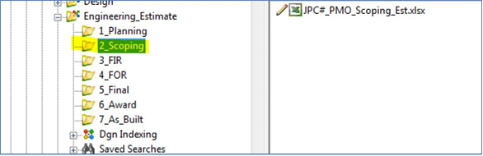

Planning and Scoping Level Estimates
The Cost Planner application was developed to assist CDOT project engineers to prepare preliminary cost estimates for CDOT projects and to provide information to Resident and Program Engineers to assist in determining the reasonableness of those estimates. The Cost Planner takes advantage of low bid and engineer’s estimate data to provide users with historical CDOT project cost data. It is recommended that project engineers use the Cost Planner Tool to help generate cost estimates.
The Project Development Branch is building enhancements to Cost Planner Tool that will be released in the Summer of 2015. At that time the instructions below will be updated to reflect the changes.

Cost Planner Tool
- Access the Cost Planner Tool, using Google Chrome Browser by copying and pasting this link into the address bar: http://dtdintapps/CostPlanner/ Please note that it will not run using Microsoft Explorer. Once you have accessed the webpage, you can access the User’s Guide on the tab labeled “About.” The information listed below is a summary of the User’s Guide.
- Once on the Home page find the Historic Cost Data box and Click on the button. This will bring up the Search Historic Data page which will provide data to help you estimate the cost of Minor Construction Items as a percent of the Major Items.
- Select the filters that you want and then click on the button. (Start with a Work Type and Region filter first and then broaden the search to other regions if you can’t find enough representative projects.)
- Search through the data and if a project looks like it may be a match you can click on the button to look at the project description and the major pay items. Once done reviewing it, click the gray X in the upper right-hand corner.
- If the project was a match then click the button. This will place the project in your Selected Projects located at the bottom of the page.
- Continue this process until you feel you have a good representation of similar projects. (Recommend selecting 8 to 10 projects if possible.)
- When satisfied with your historic data click located at the bottom of the page. This will bring up the Select Initial Inputs page.
- On this page select the Type of Estimate and the Work Type. You can usually leave the Planning Project Blank. Then click on the button.
- Fill in the Project Input section (general project information).
- Then fill in the Project Major Construction Items section. If you type in a pay item in the Bid Item box, it will show what you have typed in the box and also beneath the box. The one below the Bid Item Box has in small letters Add. After you have typed it in the box, click on the text below the box to add it to the Bid Items. If you do it any other way, you will loose your entry!
- When the major items have been entered with quantities and unit costs, then the Project Minor Construction Items should be entered. This will be a percentage of the Total cost of the Major Items, based on the historical project data that you selected. To see the historical percentage of the major items for the projects you selected, click the by the minor pay item you are interested in. A pop up box will display the engineers estimate and the low bid minimum percentage, average percentage of all the projects selected, and the maximum percentage for that pay item. Based on your knowledge of the project, select an appropriate percentage and the cost will show up for that category. Click the to close the Historic Project Data box.
- Next, enter percentages (based on the estimated total of bid construction items – Line B) for force amount – miscellaneous as well as for minor contract revisions. Once a percentage has been estimated for each of these items, the estimated total of bid construction items and force account items is shown on Line C.
- Then based upon the estimated total of bid construction items and force accounts (Line C), enter percentages for design engineering and construction engineering. Once a percentage has been estimated for each of these items, estimated project design and construction cost is shown on Line D.
.
- Next, enter percentages (based on the estimated project design and construction cost – Line D) for right-of-way and utilities. Once a percentage has been estimated for each of these items, the estimated project design, construction and miscellaneous cost is shown on Line E.
- Finally, enter a contingency percentage in the box on Line F as a percentage of total cost of design engineering, construction engineering, right-of-way and utilities (the total of the D and E lines). Once a contingency percentage has been entered, the estimated total project cost estimate appears as Line G.
- When the estimate is complete, click on the 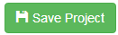 button at the lower right-hand corner of the form. This will save the project and take you to the Search Cost Estimates Page. Type in your projects 5 digit sub Account Number and apply filter to bring up your project. From there you can view the estimate, edit the estimate or print a hard copy of the estimate for your files.

Personnel Time Charges During Design
Primary Source Documentation: Chief Engineer Memo Dated March 3, 2015
On March 3, 2015 a Chief Engineer Memorandum was released to assure consistency for project staff when charging time to projects. The Memo embedded below should be considered when estimating project costs and, should be followed by project personnel to charge time to projects.
If, after reading this memorandum, you feel the need for additional instruction, consider enrolling in the on-line eLearning course, Time Entry for Engineering:
http://vupweb.dot.state.co.us/gm/folder-1.11.30071?mode=EU

Innovative Contracting Methods
Primary Source Documentation: PDM 1.08 Innovative Contracting
The demand to deliver highway design and construction in less time and under limited budgets has resulted in many DOT’s adopting innovative contracting methods to deliver highway projects. Since determining an appropriate delivery method for highway projects is a complex process, CDOT has adopted the Project Delivery Selection Matrix (PDSM) as a tool to assist Project personnel in choosing the optimal project delivery method for their particular project. The PDSM provides a formal approach for selecting project delivery methods for highway projects. After performing a PDSM Workshop, a brief Project Delivery Selection Report can be generated for each individual project. Additional information regarding the CDOT PDSM can be found at:
https://www.codot.gov/business/designsupport/innovative-contracting-and-design-build/pdsm

Background
The project delivery method is the process by which a construction project is comprehensively designed and constructed including project scope definition, organization of designers, constructors and various consultants, sequencing of design and construction operations, execution of design and construction, and closeout and start-up. Thus, the different project delivery methods are distinguished by the manner in which contracts between the agency, designers and builders are formed and the technical relationships that evolve between each party inside those contracts. Currently, there are several types of project delivery systems available for publicly funded transportation projects. The most common systems are Design-Bid-Build (DBB), Design-Build (DB), and Construction Manager/General Contractor (CMGC). No single project delivery method is appropriate for every project. Each project must be examined individually to determine how it aligns with the attributes of each available delivery method.

Project Delivery Methods
Design-Bid-Build is the traditional project delivery method in which an agency designs, or retains a designer to furnish complete design services, and then advertises and awards a separate construction contract based on the designer’s completed construction documents. In DBB, the agency “owns” the details of design during construction and as a result, is responsible for the cost of any errors or omissions encountered in construction.
Design-Build is a project delivery method in which the agency procures both design and construction services in the same contract from a single, legal entity referred to as the design-builder. The method typically uses Request for Qualifications (RFQ)/Request for Proposals (RFP) procedures rather than the DBB Invitation for Bids procedures. The design-builder controls the details of design and is responsible for the cost of any errors or omissions encountered in construction. For additional information regarding Design-Build, please refer to the CDOT Design-Build Manual at:
https://www.codot.gov/business/designsupport/innovative-contracting-and-design-build

Construction Manager / General Contractor is a project delivery method in which the agency contracts separately with a designer and a construction manager. The agency can perform design or contract with an engineering firm to provide a facility design. The agency selects a construction manager to perform construction management services and construction works. The significant characteristic of this delivery method is a contract between an agency and a construction manager who will be at risk for the final cost and time of construction. Construction industry/Contractor input into the design development and constructability of complex and innovative projects are the major reasons an agency would select the CMGC method. Unlike DBB, CMGC brings the builder into the design process at a stage where definitive input can have a positive impact on the project. CMGC is particularly valuable for new non-standard types of designs where it is difficult for the agency to develop the technical requirements that would be necessary for DB procurement without industry input. For additional information regarding CMGC, please refer to the CDOT CMGC Manual at:
https://www.codot.gov/business/designsupport/innovative-contracting-and-design-build

Conclusion
The Innovative Contracting Program at CDOT is strong and robust. Between 2010 and 2014, CDOT has delivered more than 30 Design-Build, Streamlined Design-Build, and CM/GC projects, totaling more than $1 Billion. Innovative contracting techniques are rapidly being used more and more statewide, nationwide, and worldwide, and more CDOT talent is being cultivated internally. All these innovative contracting techniques are fully supported by CDOT’s Executive Management Team, and are increasingly embraced by more CDOT staff.

To learn more about CDOT’s Innovative Contracting Program, or to access the different on-going innovative contracting project websites, please contact the CDOT Innovative Contracting Program Manager at (303) 757-9104, or visit the CDOT Innovative Contracting website at:

https://www.codot.gov/business/designsupport/innovative-contracting-and-design-build

OTHER PROJECT CONSIDERATIONS

Risk Management
Currently, the regions and residencies have various means by which they document, and management project risks, but there is not a statewide methodology. The Project Development Branch in cooperation with volunteers from the Regions are currently developing methodologies and guidance for integrating risk management into the project delivery process. There are two main considerations that are occurring for this development. One, is risk management as described by industry standard publications such as the Project Management Body of Knowledge (PMBOK) (5th edition), which is the quintessential guide for the Project Management Professional (PMP) exam, published by the Project Management Institute (PMI). The second is to examine other DOT’s risk management processes. Two such examples of using risk management on DOT projects is how WSDOT (Washington State DOT) and FDOT (Florida DOT) and how they assess and manage risk on a project. CDOT is looking at these examples from these two states as well as others, and industry standard to develop the best approach for CDOT Projects.
Washington State DOT Risk process can be found at the following link:
http://www.wsdot.wa.gov/Projects/ProjectMgmt/OnlineGuide/PreConstruction.htm
*Under “Plan the Work”, click on “Risk Management Plan”.
According to the PMBOK (5th edition), risk management consists of the following components:
- Plan risk management: How to conduct risk management activities
- Identify risks: Determine which risks may affect the “project” or “program” and document their characteristics.
- Perform qualitative risk analysis: Assess and combine risks according to their probability of occurrence and impact in order to prioritize them for further analysis or action.
- Perform quantitative risk analysis: Numerically analyze the effect of identified risks on overall “project” or “program” objectives.
- Plan risk responses: Develop options and actions to enhance opportunities and to reduce threats to “project” or “program” objectives.
- Control risks: Document project procurement decisions that specify the approach and identify potential sellers.
The procedures below are under development, and may not represent the exact outcome of the risk management initiative, however current considerations are given.
The Project Development Branch is leading a statewide task force for that considering a scaled approach to risk management. CDOT Region 5 has already begun the process of doing risk assessment for their projects, so the task force is building on Region 5’s experience. As part of “Plan risk management” listed above, the project team runs the Risk Assessment Worksheet early in the project delivery cycle to determine if the project is a low, medium, or high risk project. The use of this tool also supports identification and discussion of various project risk considerations. This initial assessment will direct the project team to further guidance documents for further actions in order to identify, assess, and monitor project risks. The team is currently looking at implementing two risk registers during the design phase. One risk register would be for the design schedule. In other words, identification and control of risks that pose a risk to meeting the advertisement date. The other risk register, is developed during design, but considers construction risks, such as identification of a gas line in conflict with a storm sewer pipe.
The Risk Assessment Worksheet is embedded below:
Risk Management guidance is under development and will be piloted, and then rolled out in the near future.

Project Bundling
CDOT has recently experienced difficulty with either high bid prices, or having no contractors bid on some projects. This likely was due in part, to the projects either not having a clear delineation as to the type of contractor that would build the work (i.e. half of the job is bridge work, and half is paving), or projects being generally too small in total dollar amount for contractors to be interested to submit a bid. With the increase in total design and construction program, it is recommended that the project staff consider in what logical ways projects may be bundled and/or work together in such a way that it will be more attractive for contractors to bid the work leading to greater competition, and CDOT will get competitive bid proposals. Considerations on how to bundle projects, and work are given below.
Consideration for logical bundling should be given for projects that are lower in cost. The risk of high pricing, or lack of competitive bidding generally increases as the project size decreases. It is often the smaller, individual projects that experience the most difficulty. Work that generally benefits from project bundling are projects less than $5,000,000.
Consideration should be given for bundling work by asset class. The project team should work with the Asset Managers to determine if there is an opportunity to bundle a number of individual items in an asset class together into one project. Specific types of work (bridge deck rehabilitation, replacement of expansion joints, culvert repairs, cable guardrail, etc.) there may be fewer contractors that regularly bid this type of work so consideration for packaging this with other work or increasing the number of locations to increase the total contract dollar amount will likely attract more interest. An example would be repairing or replacing all the required culverts within a corridor, as opposed to, smaller projects to repair a small number of culverts. For more information on Asset Management see section 3.3.
Consideration should be given for when to best advertise a project. Typically for single season work it is best to have the project advertised by no later than mid-January – there is a three week advertisement period, three weeks typically to award the project, and three weeks for Notice to Proceed and there is two to three weeks for the preconstruction conference, mobilization, submittals etc. prior to starting the work. Contractors bidding on work are looking to build their season program and will seek out projects that are within their work area where they can be competitive on mobilization. Mid-January advertisement approximates the Notice to Proceed around early April. HMA resurfacing projects are best advertised in the fall between October through January, but hopefully not later than March for single season construction – the goal is to be ready in May, if not before, when temperatures are good to start the work. Also, for those regions in the higher elevations, the construction season is shorter than in other portions of the state, which also must be taken into account when advertising projects.
Consideration should also be given to using floating start dates as much as possible so that Contractors can know how to assign their workforce and equipment and have the flexibility to still complete multiple projects in a single construction season.

Asset Management
FHWA defines asset management as “a strategic and systematic process of operating, maintaining, and improving physical assets, with a focus on engineering and economic analysis based upon quality information, to identify a structured sequence of maintenance, preservation, repair, rehabilitation, and replacement actions that will achieve and sustain a desired state of good repair over the lifecycle of the assets at minimum practicable cost.” FHWA defines risk as “the positive or negative effects of uncertainty or variability upon agency objectives.”
In other words, asset management is an approach to transportation investment in physical assets that seeks to minimize life-cycle costs while maintaining acceptable performance outcomes.
CDOT has recognized that asset management for the full state highway network is a good way to do business. The Transportation Asset Management Structure, which includes an Oversight Committee, a Working Committee and several task forces, provides the support, guidance, and leadership to address how CDOT optimizes life-cycle investments in transportation assets.
In many ways this is just an extension of what CDOT has been doing for many years with pavement, bridge, and MLOS. At the same time, it represents a shift in thinking about how we allocate funding throughout the state. Rather than allocating funds to several small pots of money throughout all the regions, asset management will look at the entire state, recommend the projects or equipment for investment based on the relative benefits and costs, and then allocate funding to the projects or equipment that provide the greatest value.

Transportation Asset Management Plan
The Federal Transportation Act, Moving Ahead for Progress in the 21st Century (MAP-21), requires that each state develop a risk-based asset management plan for the National Highway System (NHS) to improve or preserve the condition of the assets and the performance of the system.
Every state DOT is required to develop a risk-based asset management plan which includes:
- A summary listing of the pavement and bridge assets on the NHS in the State, including a description of the condition of those assets;
- Asset management objectives and measures;
- Performance gap identification;
- Lifecycle cost and risk management analysis;
- A financial plan; and
- Investment strategies.
CDOT has completed its Risk-Based Asset Management Plan (RB-AMP), and it can be found on the internet at this address: http://coloradotransportationmatters.com/data/your-cdot-dollar/asset-management/. Be sure to scroll to the bottom of the page to access the link to the document.

Assets
The assets that are currently part of the Asset Management budget workshops and the current Asset Managers as of April 3, 2015 are:
Surface Treatment: Bill Schiebel
Bridge: Mark Nord
Maintenance (MLOS): Al Martinez
Road Equipment: Bill Pentek (acting)
ITS: Saeed Sobhi
Geohazards: Ty Ortiz
Buildings: Marcella Broussard
Tunnels: Tyler Weldon
Culverts: Brooke Podhajsky
Walls: Brooke Podhajsky
Traffic Signals: Nitin Deshpande
The Asset Management Branch Manager in the Division of Transportation Development is William Johnson (will.johnson@state.co.us).

Decision Authority Matrix
Primary Source Documentation: Chief Engineer Memo Date December 9, 2014
As CDOT has been transitioning to Program and Cash Management, questions have arisen regarding roles, responsibilities and levels of decision making authority for staff involved in program and project delivery.

Definitions
Program: Set of projects to be managed as a whole to deliver an/several outcome(s). It is NOT the asset or color of money.
Program Management: Activities for managing the success of the program.
Project Management: Activities for managing the success of a single project.
Cash Management: Definition under development.

Roles and Responsibilities
The following are roles and responsibilities in developing/managing the four-year work plan as defined by the Lean event team.
Asset Managers Manage funding allocations and identify eligible assets to achieve performance goals for their asset class.
RTD Responsible for the delivery of the Region’s program.
Program Engineer Executes program management at the Region level.
Region PMO Rep Coordinates between the Regions and the PMO, maintains the Region master program schedule and supports/mentors Region staff in project reporting, tracking and delivery of projects.
Resident Engineer Responsible for delivering projects and reporting/tracking on those projects.
Project Manager/Engineer Supports the Resident Engineer and manages the individual project.
HQ PMO Responsible for coordinating the management of programs with the office of Cash Management at the statewide level. Provide information in making statewide program delivery decisions.
OFMB Provide information to help align project cash needs with cash availability and same project budgeting roles as always.

Authority Matrix
The embedded Excel file shows the Program Management Decision Authority Matrix as defined by the Lean event team.

Form 463
As soon as possible in the project development process, get started on the Form 463. This form will have to be completed before submitting the Form 1180. The roadway segments that are automatically incorporated into the form 463, are taken from the CJ20N. So make sure when you initiate the project you put in the correct locations.
Form 463 is completed in SAP using ZJ14. When you are in the CDOT Form 463 Design Data Screen type in the 5-digit Project Code in the Project ID field and click the Execute button. Then fill out the form. A good practice is to start by printing the form so you can see how many roadway segments there are and in what order they are in. This is important to know because when you fill in sections 9 and 11 there is a pull down box for the route. This selection box gives you A, B, C, D, and E. You have no idea what roadway segment you are filling in for unless you print the form first. Remember that after you fill in the data for let’s say Route A, then you need to click the SAVE button before selecting Route B to fill in its data.
Once all the data is inputted print out a copy for the Resident Engineer to review. If there are design variances then a Form 464 will also need filled out and approved.

Milestone Reporting Tool in CAR
Available now to all who have SAP access is a powerful Milestone Reporting tool. The reporting tool was conceived and designed out of a need to monitor and analyze project milestones in relation to the Schedule Performance Index (SPI) in a quest to achieve higher probability AD dates which directly impact construction drawdown cycles. Project drawdown cycles, in turn, provide direct information for the Office of Cash Management to manage CDOT's cash on hand used to finance our Capital projects. The new tool was specifically designed with Regional Management in mind and is located in the Colorado Application for Reports (CAR).
All report data and calculations are generated real-time using the SAP Project Builder Transaction code CJ20N, where Engineering staff enter project Planned and Actual Milestone dates for Capital projects. With the exception of the one-page Summary SPI report, each Milestone Report consists of a PDF file which contains three identical reports, sorted differently to suit different objectives.
- The first report was designed to be a management level report and is sorted by organizational responsibility.
- The second report is sorted by sub-account.
- The third report by Advertisement/Shelf date.
Reports can be generated and filtered at various Region organizational levels from the Resident Engineer up to and including the Region Transportation Director. Use of this report should almost eliminate the need for managers to analyze the report data in depth, because the report promotes "management by exception" through the use of various color codes to graphically display potential "hot-spots" for SPI, planned milestone date attainment, and planned milestone dates within 30 days of the report date.

How to Access the Design Milestone CAR Report
The purpose of the Design Milestone report is to capture project data and milestone dates in one report. The report generates SPI based on milestone dates. It has three calculated fields for monitoring project milestone attainment:
% Duration Expended: How much time has been expended between the milestone’s planned date and the earliest planned date within all milestones in the project. Data is real time and calculations are in relation to the report run date. % Duration Expended is generated only if actual data is present.
Variance in Days: Once an actual milestone date is entered, this field calculates the number of days ahead of schedule (-) or the number of days behind schedule (+) the actual milestone date was in relation to the planned milestone date.
SPI: There is currently a task force working to set project metrics, and define SPI.

To Generate Report: Click on the SAP Portal and Log in with your Windows ID and Password
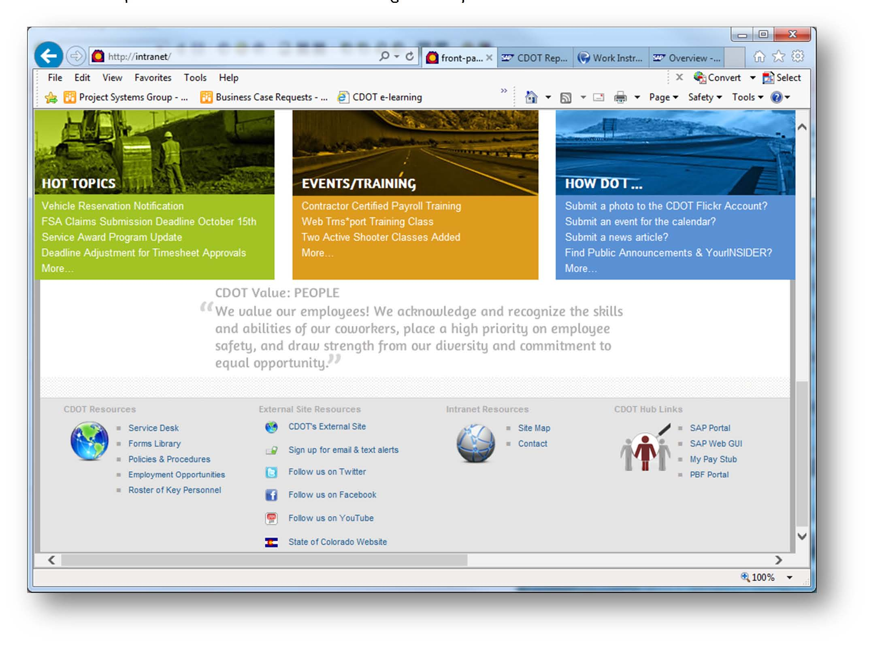

Click on the REPORTS tab
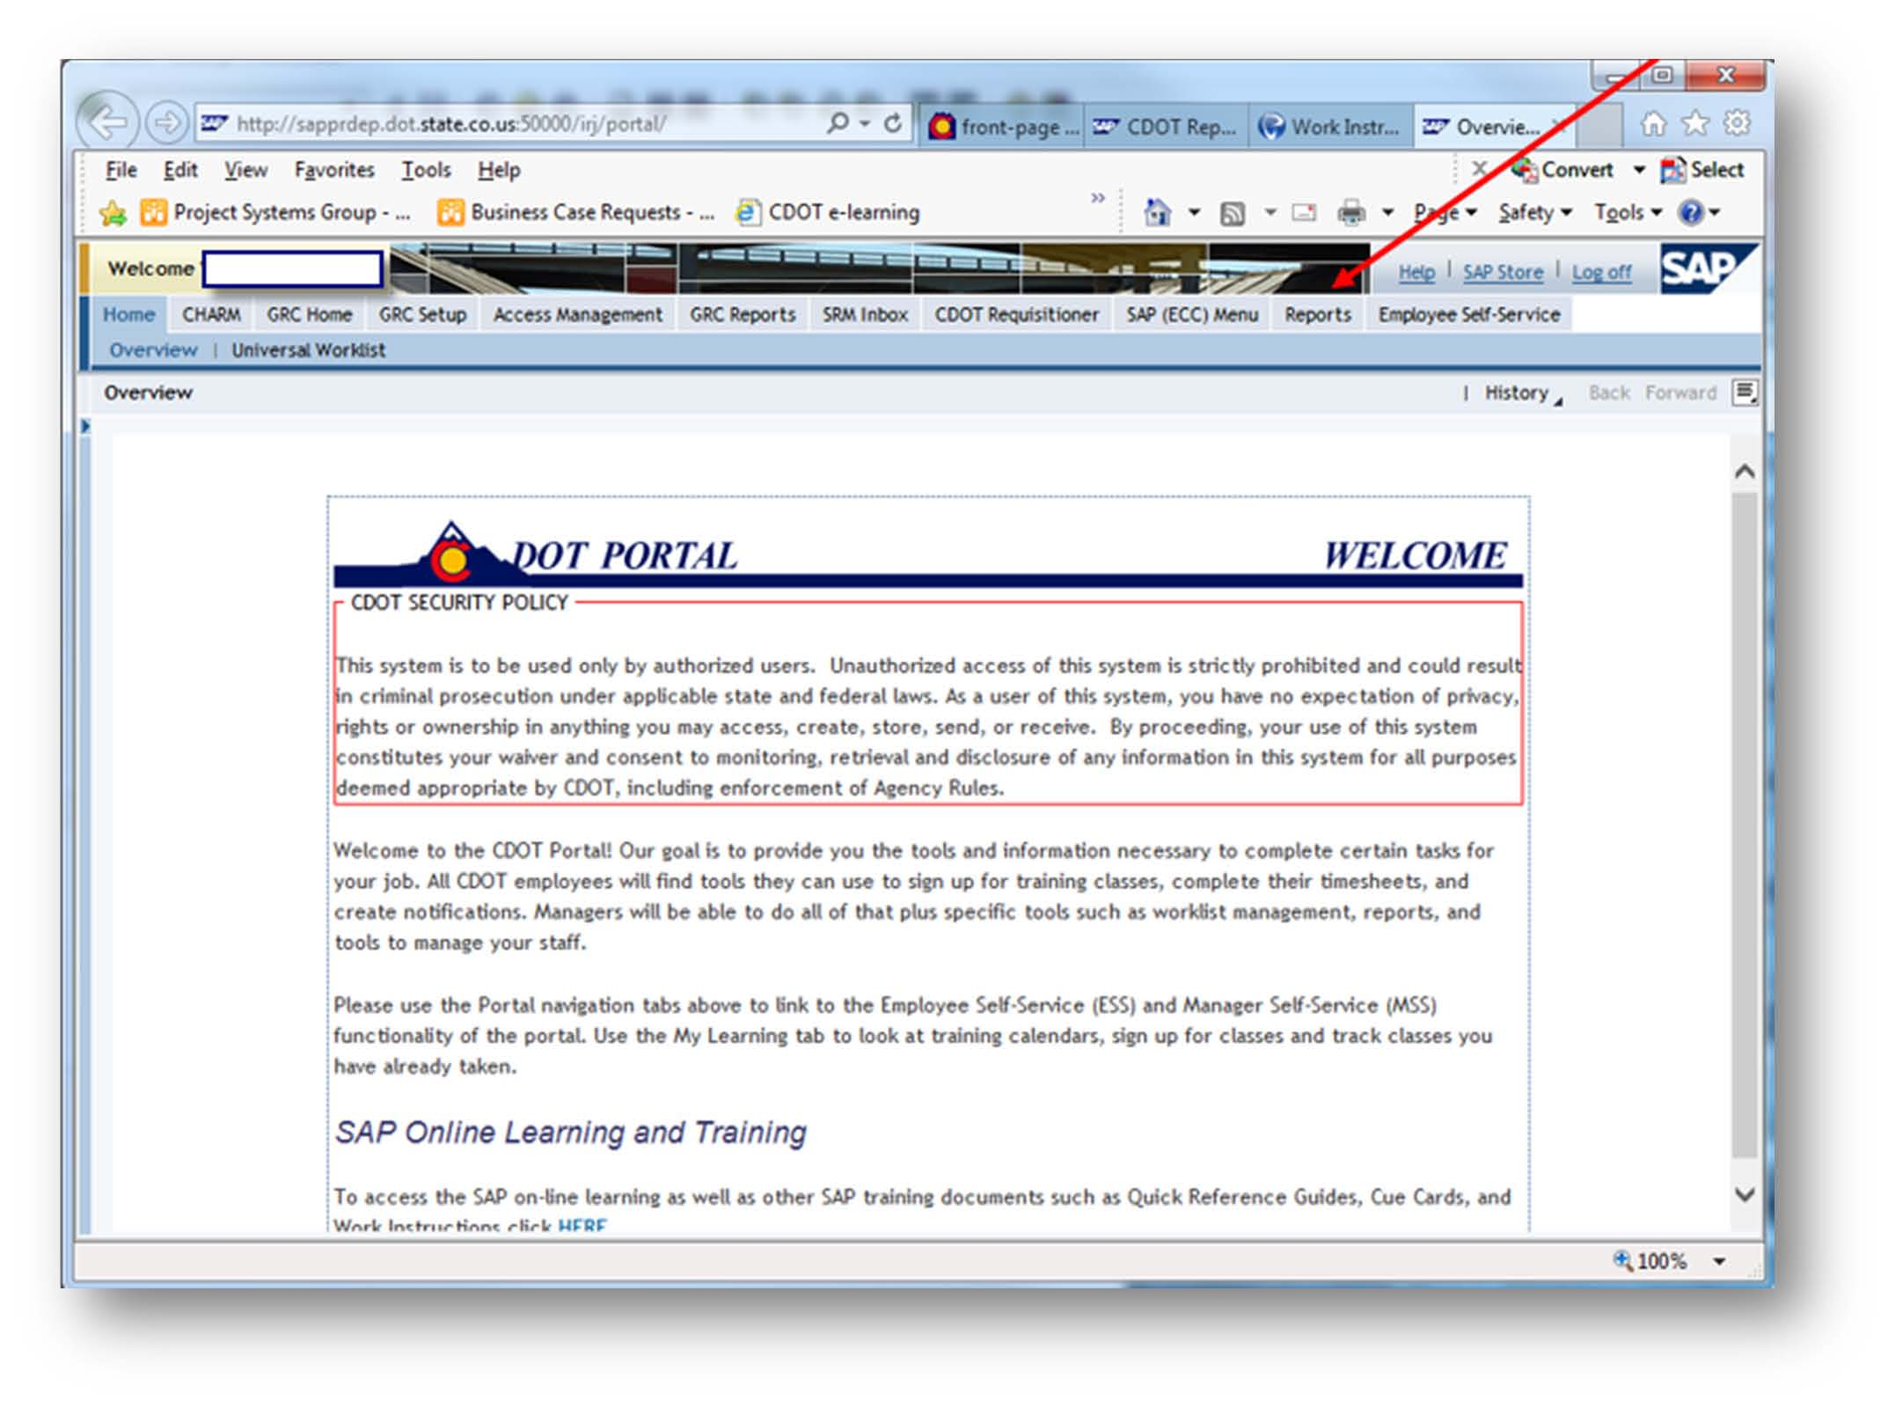

Click on CAR to access the CAR environment for reports
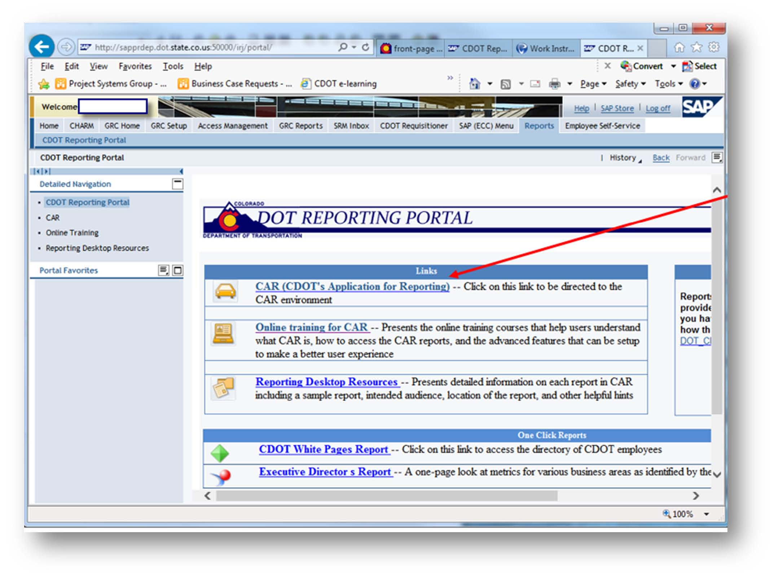

Click on Documents
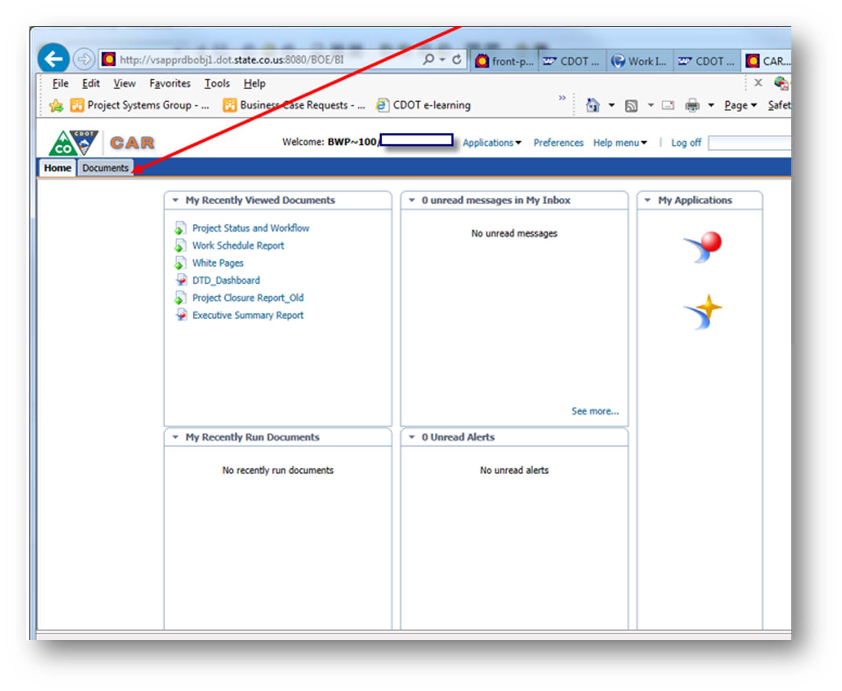

Click on Folders
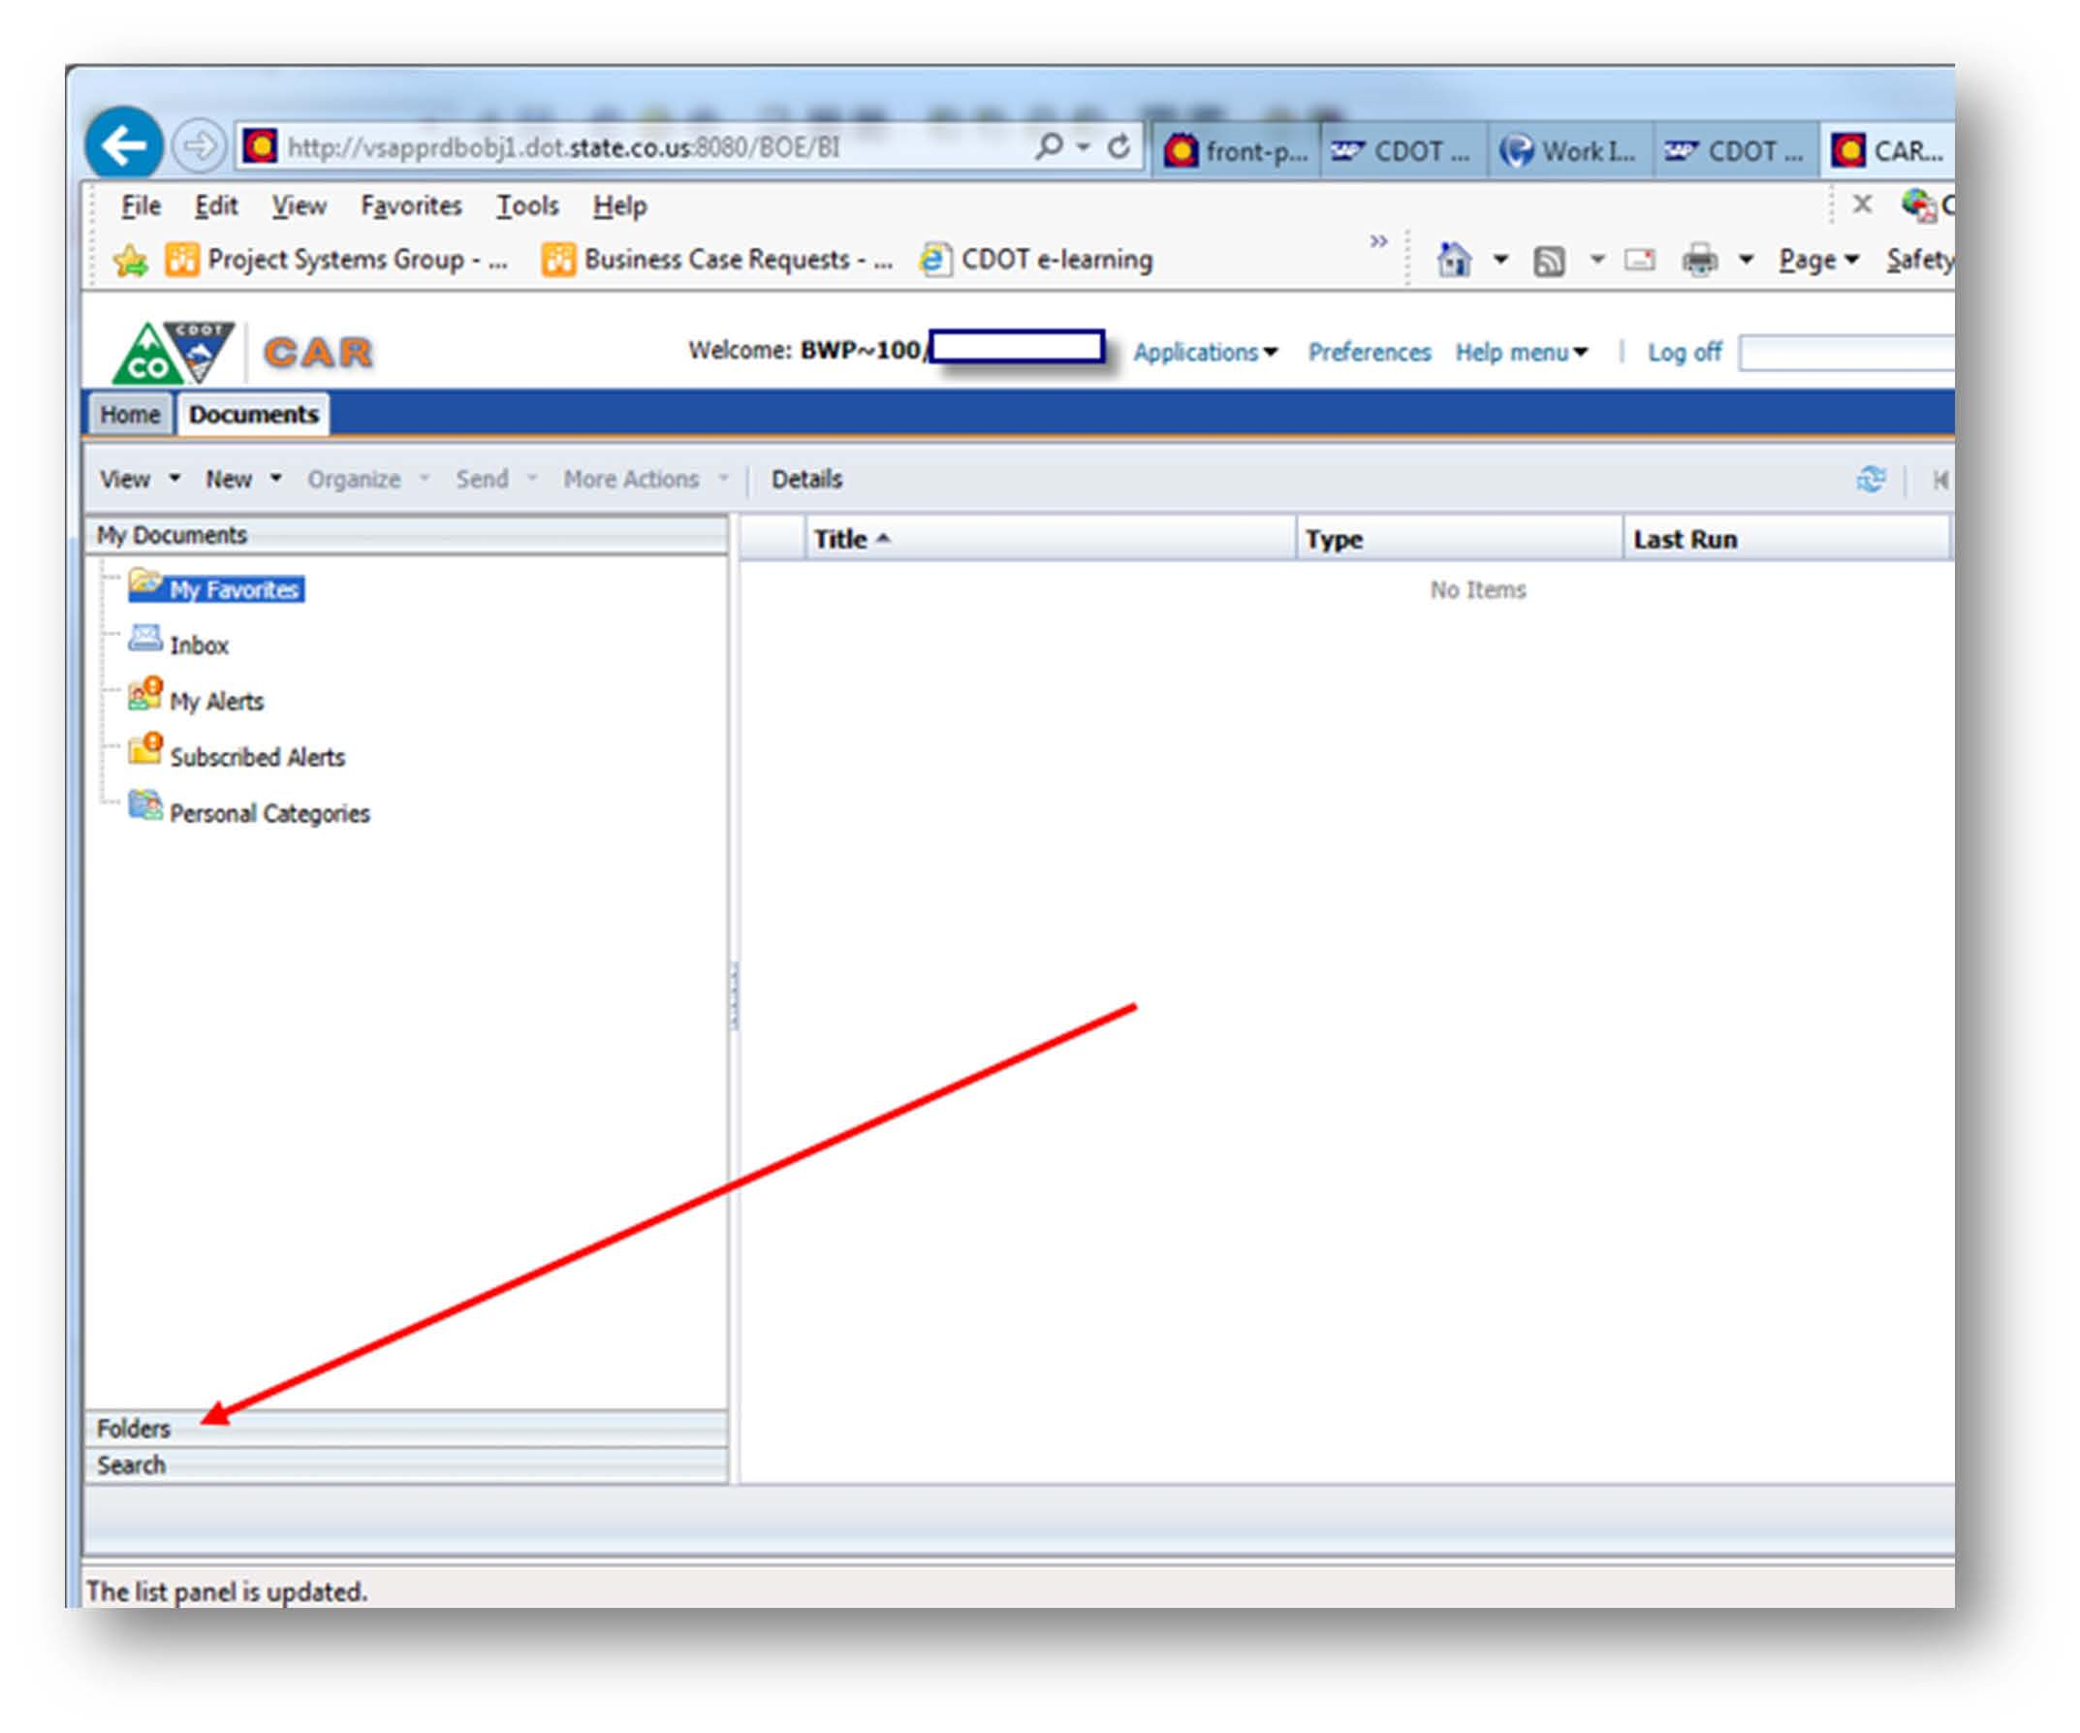

Click on Public Folders
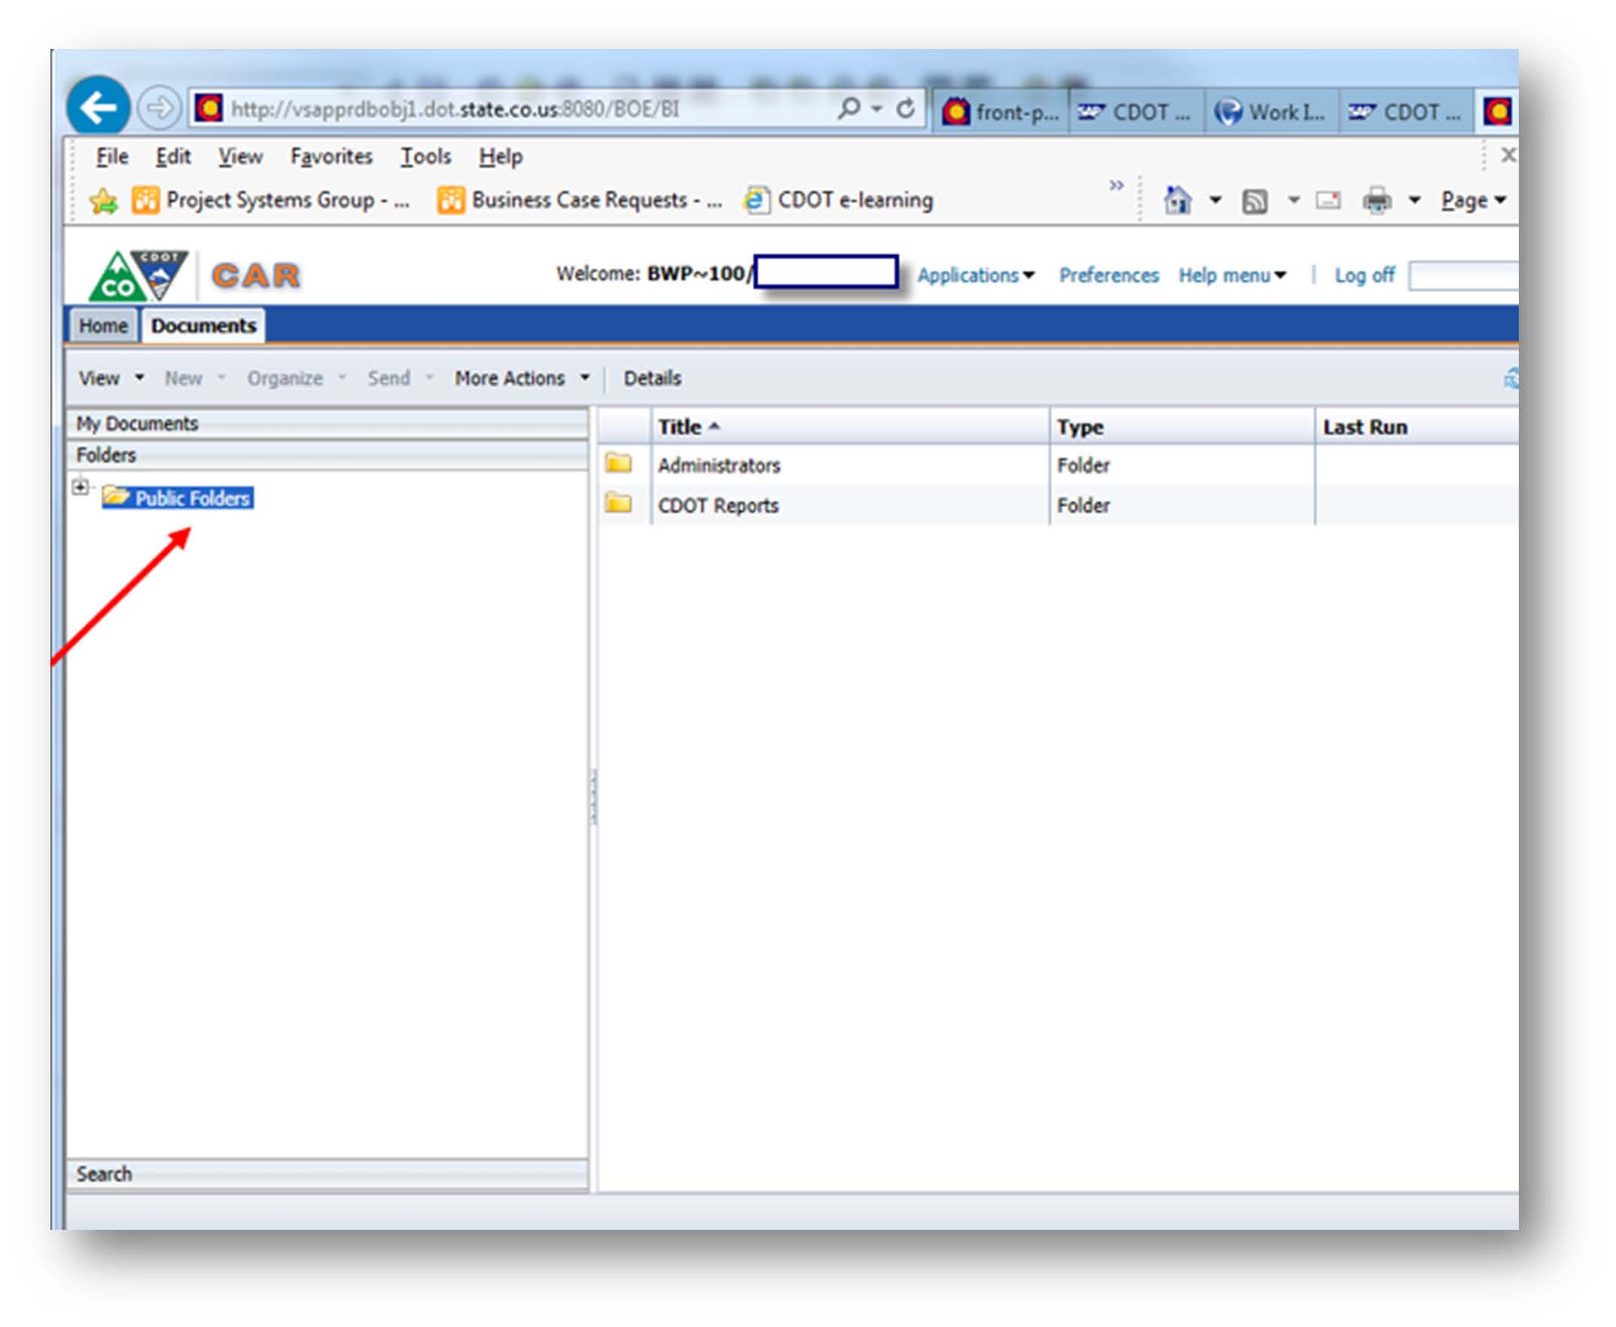

Click on CDOT Reports, then click on Project Systems folder
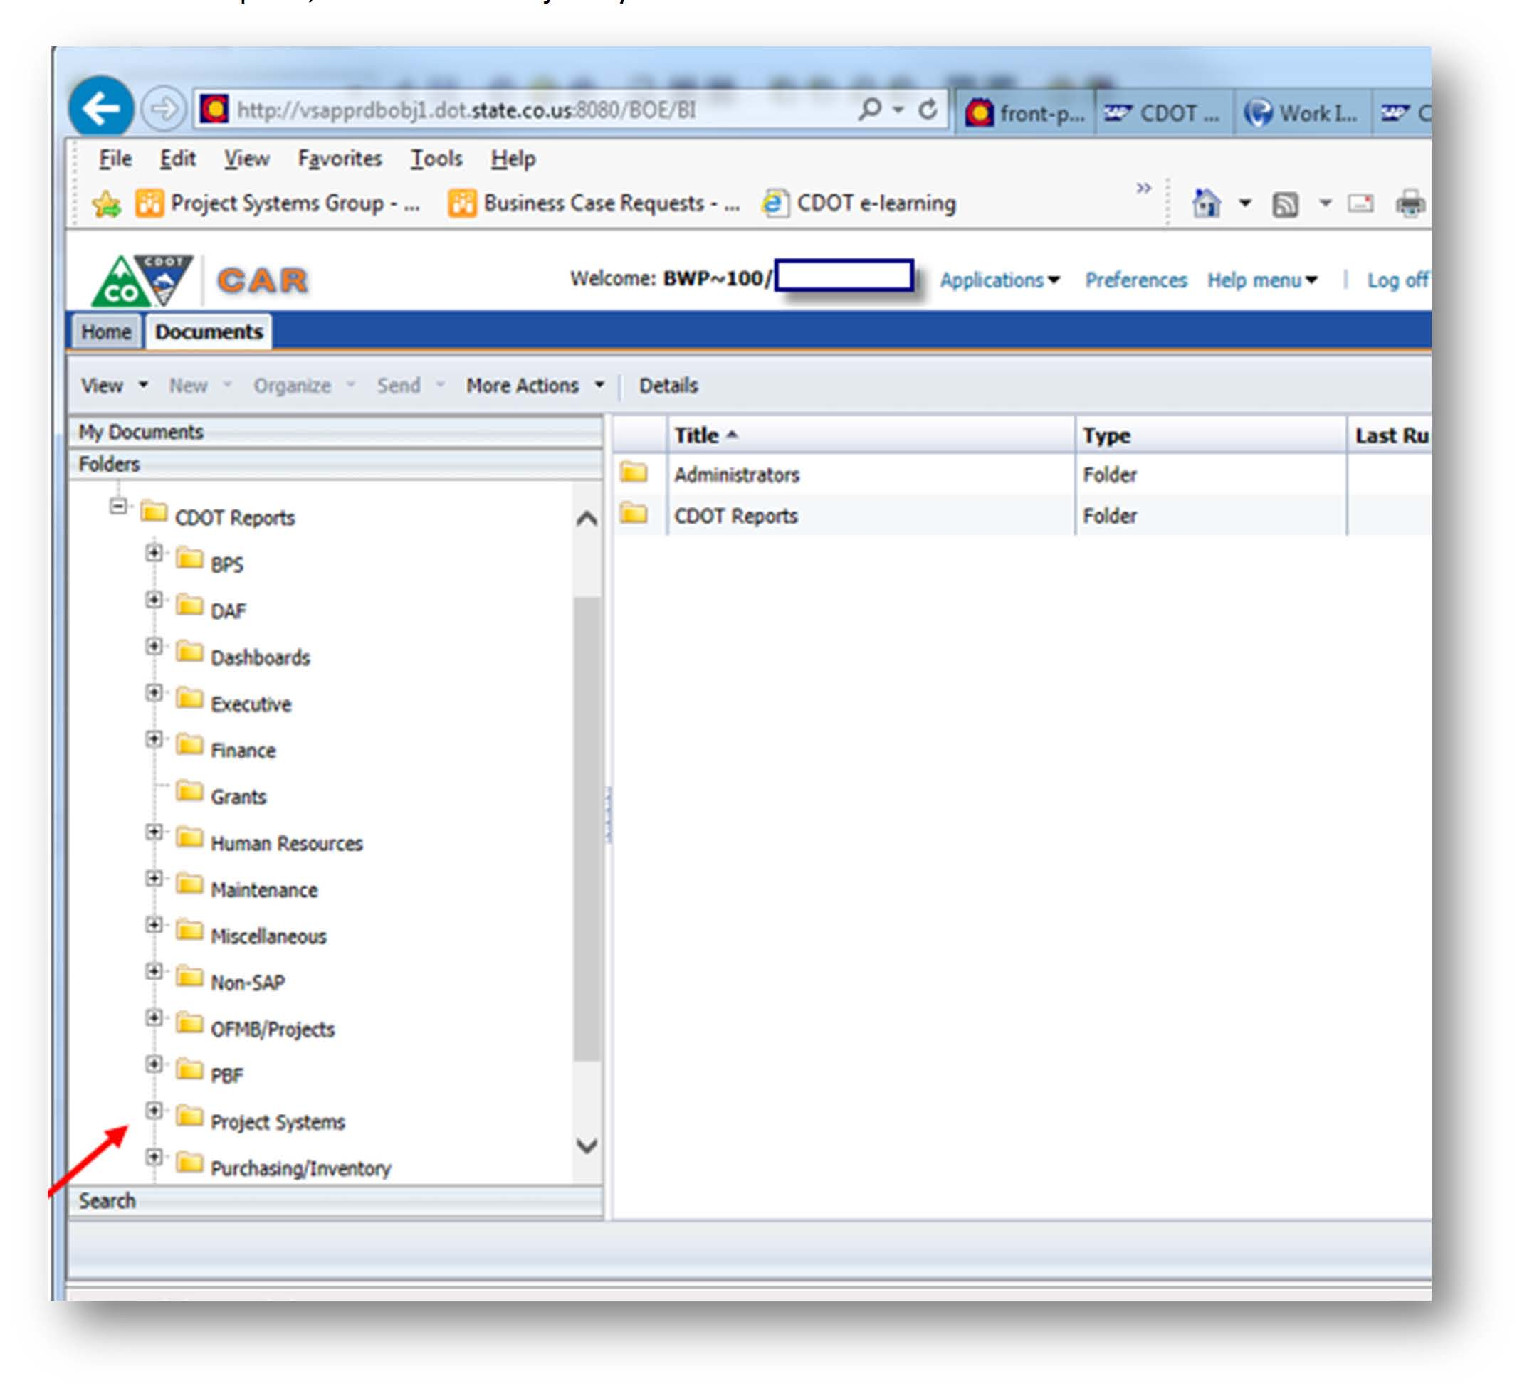

Double click on the Design Milestone report and begin populating the prompts in order to filter for the data you want.
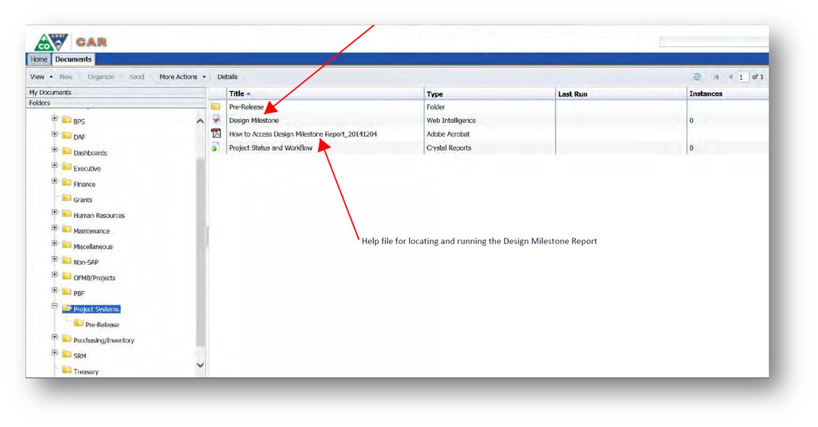

A prompt to enter data selections will appear
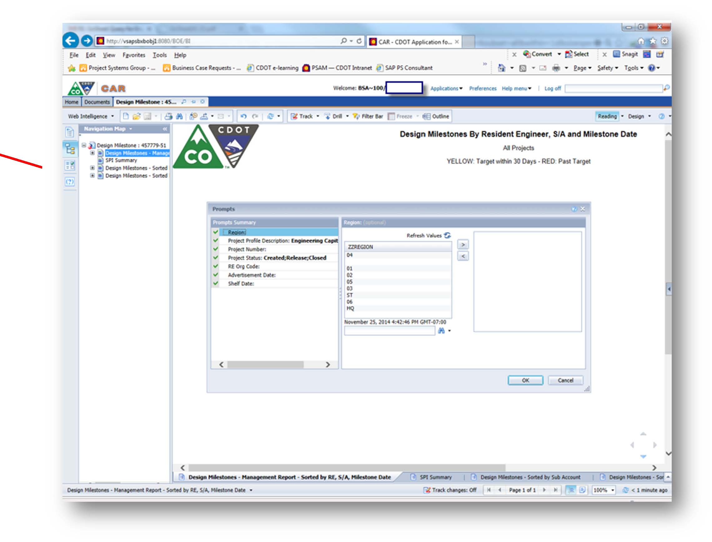
There are seven optional prompts you can pick from to limit the amount of data which is returned. You can use as many prompts as you like for selections. Two of the prompts have default values filled in for you but you can change these if needed. The two prompts are:
- Project Profile is equal to Engineering Capital Projects
- Project Status is equal to Created and Released projects
To select a value, highlight the value and click on the “>” to move the value to the right box. To remove a value, highlight the value in the right box and click the “<” to move the value to the left. As an alternative, you can also double-click on a selected value to move it back and forth between the two boxes.
Once you have completed all of your data selection criteria, click on OK to run the report.
Example: Suppose I want to run a Report for Region 5 and a specific RE Org Code (5111). First, highlight the word “Region” in the 1st box, then select the Region number “05” in the 2nd box. Next click on the “>” to move the region to the 3rd box.
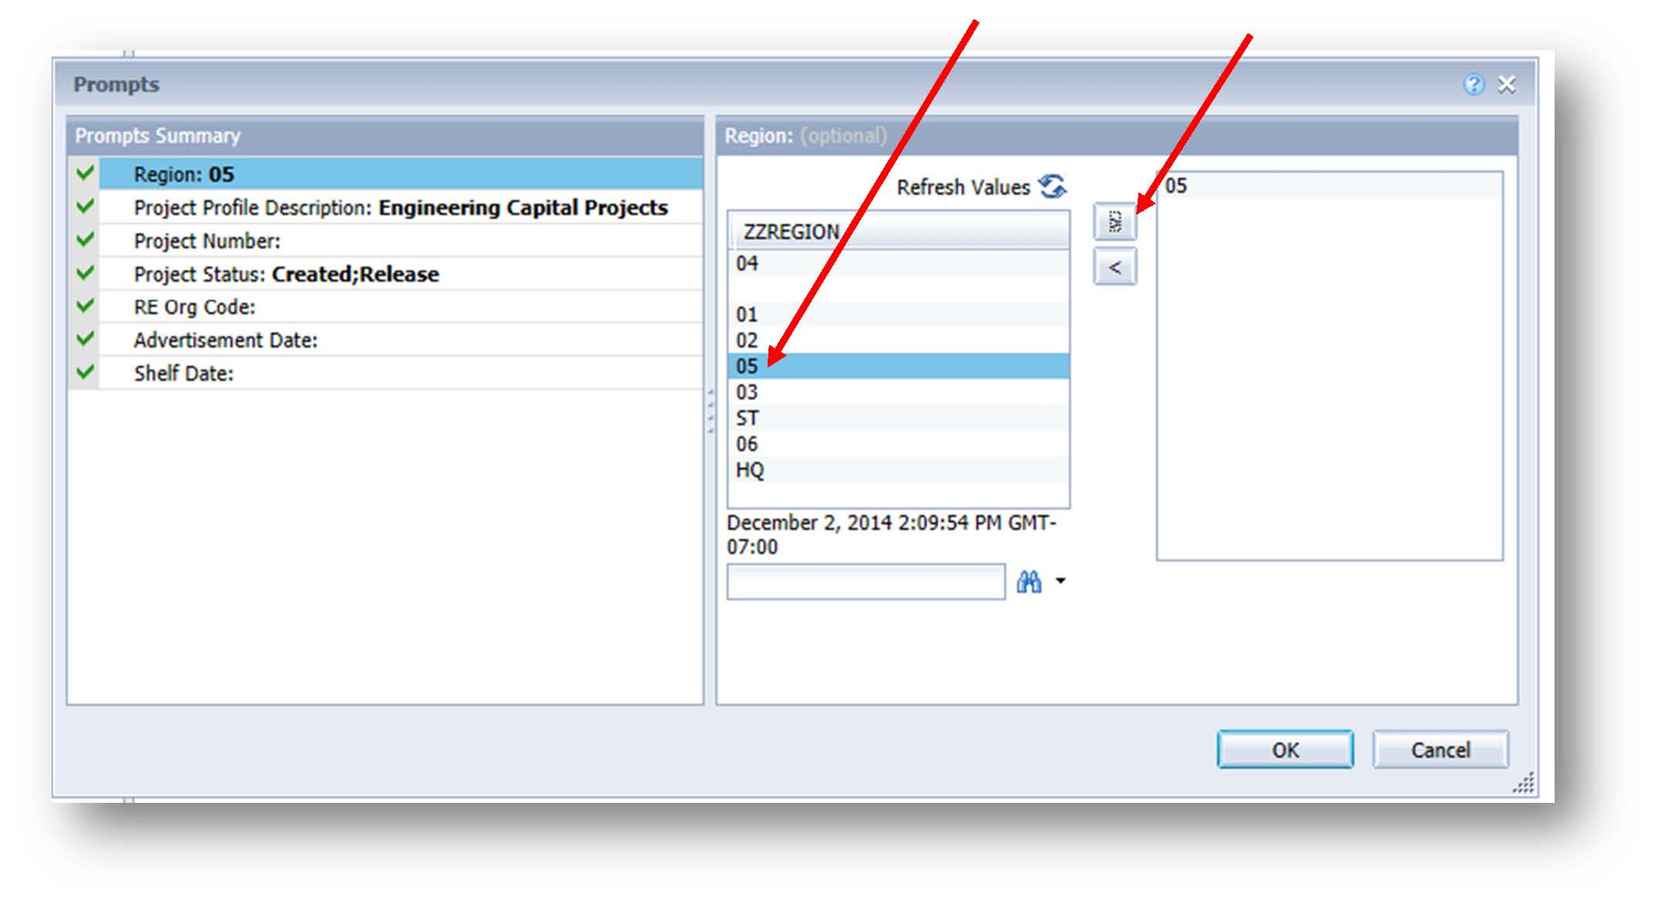

To select the RE Org Code, highlight the RE Org Code title in the first box (“Prompts Summary” box). Then do one of the following to enter the RE Org code:
- If the ZZORG_CODE box shows hundreds of entries instead of only one RE Org Code entry (5111) as you see in the graphic below, you can double-click the ZZORG_CODE bar and the list will sort in numeric order and then you can use the slider bar to get to and select the one you want (5111).
- Alternatively, because the report understands the use of “Wild Cards,” you could enter “5*”in the entry box left of the binoculars and then click on the binoculars and all available RE Org Codes will appear to pick from beginning with “5”
Once the Org Code is selected in the 2nd box, click on the “>” to move the Org Code to the 3rd box. Finally, click on OK to run the report.
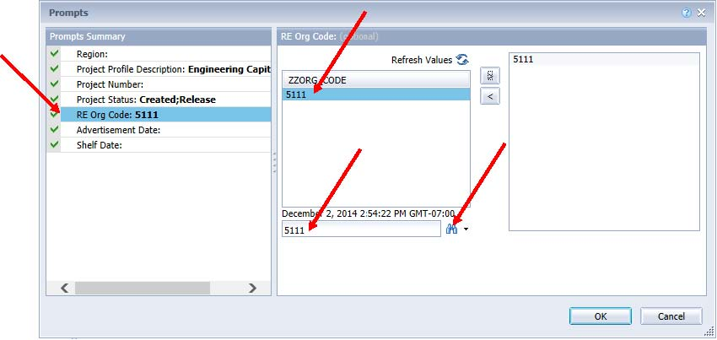

The report has multiple identical tabs located both at the side and bottom of the page. With the exception of the SPI Summary Report, these tabs represent individual reports with the same data but are sorted differently for different objectives. When the report first opens, if you don’t see the Navigation Map window on the left side of your screen, click on the 3 box diagram icon on the vertical left edge of the report.
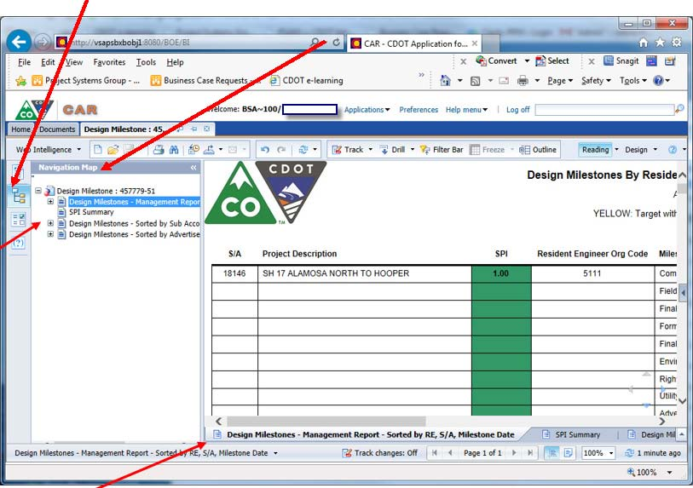

These reports can be exported as PDF, Excel, or CSV (text) files by clicking on the Export icon in the tool bar then clicking on the “Export Document As” and selecting the type of file you would like the file exported to. The difference between using the printer icon or the Export Icon is that the Export icon provides different file export choices whereas the Print icon produces only one file type i.e., PDF. You well seldom need any file format other than PDF.
These reports can also be sent indirectly to a printer by first clicking on the printer icon and selecting either Save or Save-As. These two options will produce reports in PDF format only. If you select the Save option, the file will be stored in your local machine Downloads folder or you can direct where you want the file saved. The resulting PDF file can then can be sent directly to a printer.
However, you have two options for viewing/analyzing the report other than printing:
1. One option is on the screen when the report is first produced. With this method, close the Navigation Map window to make the report full screen and then either use the slider bar to move up and down the report pages or briefly open the Navigation Map window and select the desired report option and then close the Navigation Map window to go back to full screen mode.
2. The other option is to view the resulting PDF file with Adobe Reader, Standard, or Pro. The benefits of this method of viewing are twofold
a. You can locate any of the three reports quickly with Adobe tabs which mimic the tabs in the Navigation Map view on screen.
b. Since the PDF report is fully searchable, you can search for individual sub-accounts, project descriptions, or a portion of a project description by using the Adobe search feature: Ctrl+Shif+F (for find) and entering your search criteria.

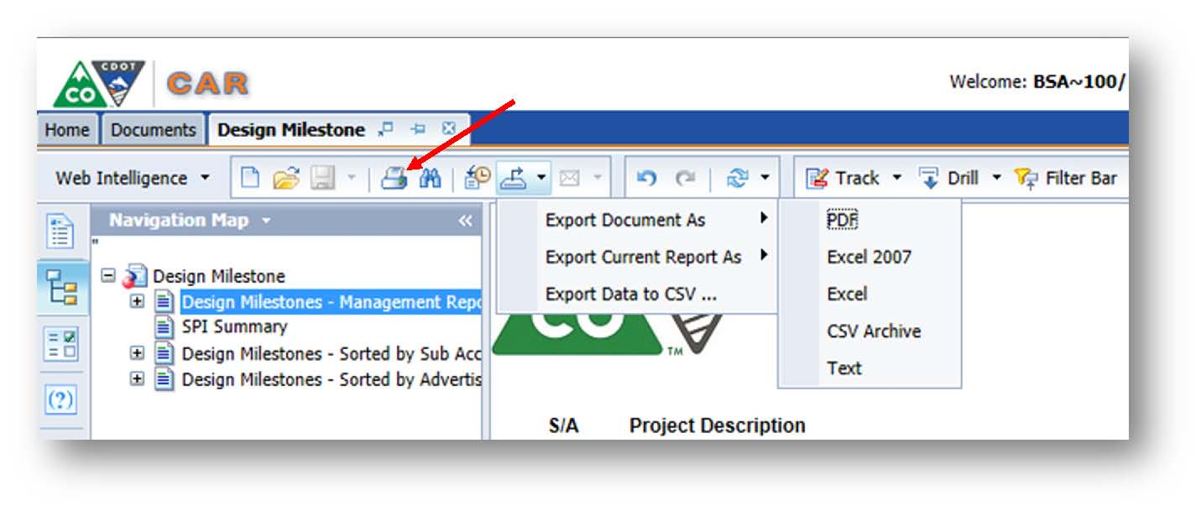
Additional Information on CDOT’s reporting application can be found on the SAP Training Website:
http://vupweb.dot.state.co.us/gm/folder-1.11.30052?mode=EU

Sample Design Milestone Report
This embedded file presents a sample design milestone report
.

Drawdown Schedules
Primary Source Documentation: DB 2014-1 Estimating Drawdown Schedules
CDOT is moving from a budget-based project funding system to an expenditure-based project funding system. What this means is that CDOT will now only encumber funds as they are needed on a fiscal year basis. Moving to an expenditure-based system will allow CDOT to more effectively use our cash reserves and deliver more projects.

In order to move to an expenditure-based funding system, CDOT needs to have a better understanding on when projects anticipate spending funds. Recognizing construction projects comprise the largest portion of our cash obligations, it was decided to focus on obtaining anticipated drawdown information for the construction phase dollars without including CE and indirect costs, before addressing the pre-construction phases.

Project Manager Guidance - Pre-Advertisement Drawdown Schedule Procedures
- Send the scoping level estimate and type of work to the Project Management Office (PMO). They will develop a scoping level construction drawdown and coordinate with the Project Manager and RE for feedback. Once there is agreement that the drawdown is reasonable, the Project Manager will enter the anticipated expenditures by fiscal year in SAP. Instructions for SAP entry are below.
- In coordination with PMO, update the anticipated construction phase drawdown at FIR using the latest construction estimate and update the drawdown in SAP.
- In coordination with PMO, update the anticipated construction phase drawdown at FOR using the latest construction estimate and update the drawdown in SAP.
- In coordination with PMO, update the anticipated construction phase drawdown at least one week before processing the Form 1180 using the Engineer’s Estimate (Line 7 from Form 65 Project Commitment Amount ), and update the drawdown in SAP.
- Include the appropriate construction drawdown standard special provision in your specification package (single or multiple construction years).

https://www.codot.gov/business/designsupport/construction-specifications/2011-Specs/standard-special-provisions/section-100-revisions/108psscy.docx/view

https://www.codot.gov/business/designsupport/construction-specifications/2011-Specs/standard-special-provisions/section-100-revisions/108psmcy.docx/view

Instructions for SAP entry are below. This process will be repeated at the FIR, FOR, and Construction to update the drawdown schedule as described in later sections.

Drawdown Schedule SAP Upload Instructions
Design-Bulletin DB2014-1 “Estimating Drawdown Schedules Rev 041015 contains instructions and templates for completing and uploading Drawdown Schedules in SAP.
Use the link below to access DB 2014-1 (Rev 4/10/2015).
https://www.codot.gov/business/designsupport/bulletins_manuals/design-bulletins/current/db-2014-1/view
FIELD INSPECTION REVIEW (FIR)
The Field Inspection Review is intended to be the on-site review of preliminary construction plans that signifies the end of the preliminary design phase. Often, the FIR is held in an office meeting environment with an optional field trip to visit the site. Field Inspection Review plans are preliminary in nature, but still must contain applicable required items and details of all salient features. The Field Inspection Review is held to conclude all unresolved issues identified during preliminary design and to establish the specific criteria and direction that are to be used in the final design.
The following instructions establish the procedures preparatory to and for the conduct of the Field Inspection Review meeting. These instructions apply to all projects on which Plans, Specifications, and Estimate (PS&E) are developed by the Resident Engineer's team.

Use of ProjectWise
In order to realize statewide efficiencies in project delivery and CDOT’s general business practices, CDOT’s Executive Director recently emphasized the need for consistency and uniformity at CDOT. ProjectWise is a resource that supports this objective.
Management is encouraging the use of ProjectWise by employees and consultant for all project design documents, however there are certain project items such as schedule, and cost estimate that are required to go into ProjectWise. It is anticipated that ProjectWise will be the standard in the future for storing all project documents, so maximizing its use now is encouraged to help CDOT to adapt to a more collaborative work environment.
ProjectWise is a permission-based document management solution that provides read-write privileges on a project-specific basis. Access control provides assurance that the project can only be modified by authorized personnel. ProjectWise includes directory structures for active and as-constructed plans. All CDOT employees have access to ProjectWise with read-only permission.
ProjectWise is collaborative with many different software packages, in particular Microstation and all associated Microstation file types. ProjectWise is managed by the Computer Aided Drafting (CAD) department and has a dedicated development team managing permissions to insure data integrity. Anyone experiencing difficulties in ProjectWise can call the help desk for a quick resolution to their issues. ProjectWise is also collaborative with SAP. When a project is set up in SAP, it is concurrently set up in ProjectWise.
The ProjectWise directory structure for projects accommodates each specialty group that could be engaged in a project. For example, folders are established for roadway construction, hydraulics, bridge, ITS, etc. And each of these specialty groups can work on the same project from disparate locations. The centralized file storage is not only efficient but protects documents from loss due to workstation failure or hard-drive corruption.
Prior to adoption of ProjectWise, project plans were maintained in hard copy which required physical storage space. Documents had to be copied and distributed to those that needed them. With the use of ProjectWise, documents are now retained electronically, saving space and labor. This has also proven to be beneficial for compliance with the Colorado Open Records Act (CORA) which requires timely delivery of requested records. Finally, when a project has been completed and the final’s engineers have archived the as-constructed plans, those plans must be permanently retained per regulatory requirements. Each project has a unique set of attributes (meta data) that allow retrieval of documents based on the location or some other attribute unique to that project.

FIELD INSPECTION REVIEW (FIR)

Pre-FIR

Program and Cash Management Required Items for the FIR
- Scoping, Budgeting, and Planning
  - Current Project Scope
- Preliminary Cost Estimate
  - Create a Preliminary Cost Estimate in Transport and send to Engineering Estimates and Market Analysis Unit for current pricing.
  - An Estimate, Form 65 will be required.
- Preliminary Schedule

Project Bundling
Further consideration should be given for appropriate methods to bundle projects as described in section 3.2.

Update Milestones in SAP
Primary Source Documentation: DB 2014-4 SAP Milestone Schedule.
Primary Resources: Tawnya Nicholson (303) 512-5207 or
Valerie Metaiguer (303) 757-9837.
The Milestone dates will need to be updated in SAP. See section 1.1.3 for more information.

Generate Form 65
Primary Source Documentation: PDM 1.04.04 After Award of Low Bidder.
It is recommended that you generate and print a form 65 at this time. Use SAP transaction ZJ20 to access Form 65.

Post FIR

Update Project Schedule
Primary Source Documentation: PDM 2.17.07.03 Update Project Schedule.
Update the project schedule or complete the baseline schedule if it was not done at the scoping. This may be the case for more complex projects where the scoping is better defined.

Update Milestones in SAP (Includes Super Circular Update)
Primary Source Documentation: DB 2014-3 Milestone Dates in SAP Project Builder (CJ20N) (to become PDM 1.07.12 Project Estimate), and DB 2014-4 SAP Milestone Schedule.
Update the basic fixed date and actual date in SAP CJ20N Project Builder. CDOT is not using the Forecast Fixed Date for reporting at this time. (See detailed instructions in Section 1.1.3.)
For more information about the Milestone Reporting Tool in CAR, see Section 3.6.
For more information about end dates and the Super Circular, see Section 1.2.3.

Create Cost Estimate in Web Trnsport and Coordinate with EEMA
Primary Source Documentation: PDM 2.27 Estimate Review By Engineering Estimates and Market Analysis Unit
If quantities have not yet been entered into Trnsport, enter the quantities into the Web Trnsport system, and have an estimate ready to take the FOR. This FOR estimate should be coordinated with, and priced by the Engineering Estimates and Market Analysis Unit.
Copies of estimates prior to bid will be sent to CDOT Regions and FHWA when applicable. Estimates will be confidential prior to the bid opening, after the bid opening they are no longer confidential.

Estimate Security
To provide for the confidentiality of the estimate, the following restriction shall be adhered to:
      - Engineers Estimate prepare their cost estimates using the CDOT computerized estimating system.
      - Consultants prepare “quantity only” estimates.
      - The Engineer’s Estimate is protected by the Trns*port computer system and is confidential by CDOT policy.
Review the Project Development Manual Section 2.27 for more information.

Adjusting the Project Budget (PD 703.0)
To change the Project Budget during the pre-construction phase of a project, refer to PD 703.0, Appendix C to determine the level of approval required to authorize the change. See section 1.3 for more information.

Update Drawdown Schedule
Primary Source Documentation: DB 2014-1 Estimating Drawdown Schedules
In coordination with PMO, update the anticipated construction phase drawdown at FIR using the latest construction estimate and revise the drawdown schedule in SAP. Instructions for entering the drawdown information into SAP can be found above in Section 3.7.

FINAL OFFICE REVIEW (FOR)
The Final Office Review is a final review of construction plans, specifications, and cost estimates for completeness and accuracy. A good rule of thumb is to have a 90% or greater set of plans developed for the FOR. Some regions have specific requirements, so check with your Resident Engineer if you are unsure. A Final Office Review is conducted for all projects on which the Plans, Specifications and Estimate (PS&E) are finalized by CDOT or its consultants. Prior to the Final Office Review, the Resident Engineer should ensure that all variances have been approved.

Pre-FOR

Prepare Draft 859
Primary Source Documentation: PDM 2.26 Project Control Data (Form 859) and CM 108.8.3
The Form 859, Project Control Data, is used to establish the contract time, and critical or salient features for a construction project at the Final Office Review or shortly thereafter prior to advertisement for bids.
The completed Form 859 contains information that is relevant to the determination of contract time, affected pay item quantities, and a Microsoft (MS) Project Critical Path Method (CPM) schedule showing established time allotted for the “critical items of work” and “salient features.” A draft schedule should be prepared early in the project Design phase. Subsequent modification and updates throughout the project development process will help the project team make important and informed project decisions with accurate schedule information.
Note: A “critical item of work” is an item of work that will extend the overall completion time of the project if the duration of this item is increased. A “salient feature” is an item of work that may be of special interest in coordinating the project schedule, but may not affect the overall completion of the project.
All specific project features, construction requirements, and other special requirements that may impact contract time should also be included in the Form 859. The Resident Engineer is responsible for initiation and completion of this form.
In addition to the items on the form the following key issues should also be documented when completing the Form 859:
- Urgency of proposed improvement.
- Impact of construction on local businesses and property access.
- Need for coordination with other projects.
- Irrigation requirements.
- Special events, schedules, and holiday impacts.
- Production rates used.

The procedures for preparing the Form 859 are:
- Identify the critical items of work, salient features, and related working days.
- List items of work in chronological order on the Bar Chart of Form 859 or the MS Project CPM.
- Determine contract time for the project.
- Complete the Form 859 four weeks prior to the scheduled advertisement date and receive Program Engineer approval signature.
- Distribute Form 859 and attachments.

Program and Cash Management Required Items for the FOR
  - Cost Estimate (Not to be distributed)
An updated cost estimate of all finalized plan quantities, including planned force account work and other items chargeable to the project such as design, right of way, utilities, construction engineering, and indirect costs.
  - Form 859
  - Updated Scope of Work
  - Updated Project Schedule
  - Current Form 65

Update Milestone Dates in SAP
Primary Source Documentation: DB 2014-3 Milestone Dates in SAP Project Builder (CJ20N) (to become PDM 1.07.12 Project Estimate), and DB 2014-4 SAP Milestone Schedule.
Update the basic fixed date and actual date in SAP CJ20N Project Builder. CDOT is not using the Forecast Fixed Date for reporting at this time. (See detailed instructions in Section 1.1.3.)
For more information about the Milestone Reporting Tool in CAR, see Section 3.6.
For more information about end dates and the Super Circular, see Section 1.2.3.

Milestone Reporting Tool in CAR
The Milestone Reporting Tool in CAR can be used to assess a project’s milestone dates in a given, Residency Engineer, Sub-Account, or Advertisement Date as described in section 3.6.

Decision Authority Matrix
The Decision Authority Matrix as described in section 3.4 should be checked for level of authority to make changes on a project.

Post FOR
- Update the project schedule.
- Update the Trns*port estimate with latest quantities and finish all fields in Trns*port.
- Send estimate to your EEMA Cost Estimator representative to complete final check on the estimate.
- When received back from your Cost Estimator, update the Form 65.
- Prepare the Budget Action and submit OFMB. This needs completed 90 days before the AD date.

Update Project Schedule
Primary Source Documentation: DB 2014-1 Estimating Drawdown Schedules
(to become PDM 1.15 Estimating Drawdown Schedules).
Project Manager Guidance for Drawdowns
Pre-advertisement: (FY 14 Multiple Construction Season ONLY and ALL Future Projects)
- In coordination with PMO, update the anticipated construction phase drawdown at FOR using the latest construction estimate, and update the drawdown in SAP.
- Include the appropriate construction drawdown standard special provision in your specification package (single or multiple construction years).
http://www.coloradodot.info/business/designsupport/construction-specifications/2011Specs/standard-special-provisions/section-100-revisions/108psscy.docx/view
http://www.coloradodot.info/business/designsupport/construction-specifications/2011Specs/standard-special-provisions/section-100-revisions/108psmcy.docx/view

Independent Plan Review
It is recommended that the schedule include time in between the FOR and advertisement for an independent quality control review of the plan sets to enhance plan quality. Larger, more complex projects should allow more time for an independent check of the plan sets. Missing information and/errors in the plans corrected before advertisement can save costs later by not having to do a revision under advertisement to change the plans prior to the bid opening as well as save having to do a Change Modification Order once the project is awarded to a Contractor. An independent review of the plan set can be accomplished in a number of different ways. An independent review could range from having a designer not involved in the project review the plans and make comments, to hiring a consultant to do a thourough review and comment of the plan set. The general idea of an independent review is to “get a fresh set of eyes” to look at the plans.

Update Milestone Dates in SAP (Includes Super Circular Update)
Primary Source Documentation: DB 2014-3 Milestone Dates in SAP Project Builder (CJ20N) (to become PDM 1.07.12 Project Estimate), and DB 2014-4 SAP Milestone Schedule.
Update the basic fixed date and actual date in SAP CJ20N Project Builder. CDOT is not using the Forecast Fixed Date for reporting at this time. (See detailed instructions in Section 1.1.3.)
For more information about the Milestone Reporting Tool in CAR, see Section 3.6.
For more information about end dates and the Super Circular, see Section 1.2.3.

Generate Form 65
Primary Source Documentation: PDM 1.04.04 After Award of Low Bidder.
At the time of award, the construction phase budget will be adjusted so it matches Form 65 exactly. The preconstruction phases have to be closed shortly thereafter (approximately 30 days) or a request with justification has to be made to keep the funds open.
The Approved Commission Budget level is significant in determining the number of authorized actions over the life of a project. Use SAP transaction ZJ20 to access Form 65 which will indicate the Approve Commission Budget. It is from this dollar amount that the 10 percent will be computed for determining if Chief Engineer approval is required for project award during the project bid process. It is also from this amount that the 15 percent will be calculated to establish if Transportation Commission Action is required to increase the project budget or for award of a project at bid.
Any request for additional budget greater than 15 percent of the approved Transportation Commission budget will be processed through a budget supplement action, which occurs on a monthly basis.
If the budget request is less than 15 percent of the Transportation Commission approved budget, OFMB may approve the request as an “allotment advice.” Allotment advices include transfers to projects from pools or other projects. Allotment advices are usually processed within a few days.
Any surplus or deficit amounts will be corrected by the Regional Business Managers with a Budget Action submitted to OFMB for approval to de-budget or supplement the amount. If the Regional Business Office wishes to retain this surplus amount, the business office must request an approval to retain the surplus funds from the Chief Engineer. The request must be submitted to the Bids and Awards section by Monday, NOON, following the Letting Day. See PDM Section 2.36 for additional information on retaining surplus bids.

Update Cost Estimate in Coordination with EEMA
Primary Source Documentation: PDM 2.27 Estimate Review By Engineering Estimates and Market Analysis Unit
In preparation for project advertisement, coordinate the preparation of the Cost Estimate with the Engineering Estimates and Market Analysis Unit per section 2.27 of the Project Development Manual.

Budget Actions

Adjusting the Project Budget (PD 703.0)
To change the Project Budget during the pre-award phase of a project, refer to PD 703, Appendix C to determine the level of approval required to authorize the change.

Budget Action Procedures to Fund the Construction Phase of a Project
Chapter 4 of the Project Development Manual describes the process to request funding for the construction phase of a project. The process to fund the Construction Phase varies by region. Please check with your Region Business Office and Region PMO representative for information.

Decision Authority Matrix
Primary Source Documentation: Chief Engineer Memo Date December 9, 2014
The Decision Authority Matrix as described in section 3.4 should be checked for level of authority to make changes on a project.

Update Drawdown Schedule
Primary Source Documentation: DB 2014-1 Estimating Drawdown Schedules
In coordination with PMO, update the anticipated construction phase drawdown at FOR using the latest construction estimate and revise the drawdown schedule in SAP. Instructions on uploading drawdown information can be found above in Section 3.7.

Construction Staffing Matrix
A joint effort between CDOT and FHWA assessed how CDOT is staffing projects during construction. From that effort, a tool called the “Construction Staffing Matrix” was developed to help the Resident Engineer better determine the staffing needs for construction projects. Use the Excel document embedded below, to assist with making construction staffing decisions.

This document can also be found on the Area Engineers SharePoint site at the link below.
http://connectsp/sites/CRTool/SitePages/Home.aspx

PREPARATION FOR ADVERTISEMENT

Construction Schedule and the Form 859
Primary Source Documentation: PDM 2.26 Project Control Data (Form 859)
CM 108.8.3 Guidelines for Preparing Form 859.
The final Form 859 contains information that is relevant to the determination of contract time and should be completed by this point in preparation for advertisement. See the PDM section 2.26 and the CM section 108.8.3 for more information on the 859

Drawdown Schedule
Primary Source Documentation: DB 2014-1 Estimating Drawdown Schedules
In coordination with PMO, update the anticipated construction phase drawdown using the Engineer’s Estimate, at least one week before processing the Form 1180 and revise the drawdown schedule in SAP. Drawdown upload instructions can be found in Section 3.7

Include the appropriate construction drawdown standard special provision in your specification package (single or multiple construction years).

http://www.coloradodot.info/business/designsupport/construction-specifications/2011-Specs/standard-special-provisions/section-100-revisions/108psscy.docx/view
http://www.coloradodot.info/business/designsupport/construction-specifications/2011-Specs/standard-special-provisions/section-100-revisions/108psmcy.docx/view

OJT and DBE Goal Request
Primary Source Documentation: PDM 2.21 On-The-Job Trainee Approval , and PDM 2.22 Disadvantaged Business Enterprise Goals

The establishment final OJT and DBE goals is accomplished through contacting your Region Civil Rights Representative. Each Region EEO Representative will require slightly different items to establish the goals. Suggested information to provide is below:
In order to figure OJT hours, please submit the following information:
- Using a final engineer's estimate, the engineer refers to the OJT special provision for the minimum recommended hours.
- State the hours from the special provision in the request for the DBE goal.
- If you feel the OJT goal should be less than the recommended minimum, please state why when you request the DBE goal.
- The Civil Rights Office will review the OJT hours.
To request a DBE goal, please submit the following in your request:
- Final engineer's estimate
- Ad date
- Funding sources of the project
- Any other information about the project that you feel is important to consider
- Your recommendation for OJT hours

Form 1180 Process
Primary Source Documentation: PDM Plans, Specifications and Estimate Approval (Form 1180)
The process below is a best practice for execution of the 1180, but may vary by region. Please check with your Resident Engineer or Business Office for specific questions.
After the Plans, Specifications and Estimate have been reviewed and all clearances have been obtained and the Form 128 signed, and the final Form 463 and Form 859 have been approved and the budget action has been approved then the 1180 may be initiated in SAP using the ZJ23.
The Form 1180 is a certification process that says the Form 463 and 859 has been reviewed and has been fully executed. The Form 1180 is also the start of the process to obligate the construction phase funding so that the project may be advertised.
To execute the 1180 fill out the ZJ23 in SAP. There are only a few fields to fill out. Once this is executed, an e-mail will arrive in your mailbox which will ask those individuals working on the project to release or approve their part of the project work flow. You are the first one that needs to approve.
Prior to approving the Form 1180 you will need to check that the project funding amount information matches the information included on the Engineer’s Estimate from Transport and also the information on the Form 65. There have been instances where the information doesn’t all match which may indicate that some information in Transport was entered incorrectly.
This is accomplished by going into your SAP inbox, and clicking on the e-mail which will bring up a screen that must be filled out. Basically it asks you to certify that this project will meet or exceed the standards approved by the Secretary of Transportation, with the exception of approved variances.
After the RE and PM certify that the project meets the approved standards following the initiation of the 1180, it must also be approved by others in the work flow, and the order is as follows: After the PM, the RPE will approve or release, then the RBM will approve or release, and last of all to the OFMB office and FHWA as needed, for their approval or release.
When the e-mail is received, send a Submittal AD Package email to the following:
- Program Engineer
- Business Manager
- Resident Engineer
The AD Package needs to contain:
- Engineer’s estimate*
- Form 65*
- Form 463*
- Environmental Clearance (Form 128)*
- ROW Clearance*
- Utility Clearance
Note: Files with an * should be compiled in one PDF package. Also, they would like this package linked together in ProjectWise using a File Set. To create a File Set in ProjectWise follow these steps:
- Open the projects Project ManagerClearances folder.
- Right click in the upper right pane called the List pane and choose SetNew.
- Name the Document 1180 Set and click OK. A new dialog box will appear.
- Highlight the documents you wish to add to the set and drag and drop into the Set Dialog Box. You may add the necessary files by accessing each file location and then dragging and dropping into the Set Dialog Box.
- Once all files have been added, click the Close box.
- The set is now located in the folder location you selected in step one. You may modify the set, adding additional documents or deleting documents from the set as desired. To modify, double click on the set. The Set Dialog box will appear. You can add additional documents as you did in Step 4.
- To delete documents from the set, right click on the Set from its File Location. Select SetModify.
- The Document Sets Dialog Box will appear. Highlight the document you wish to delete from the set and use the left green arrow to remove and then select Close.
Let them know in the email that the 1180 has been initiated and is ready for their approval in SAP. Once they receive the AD package, the Program Engineer will review the package and if satisfied will approve the 1180 in SAP. After that the Business manager will review the Submittal Package and if satisfied will fill in the financial portion of the 1180 and approve. Then the Business Manager will forward the submittal package to OFMB. The Resident Engineer or Project Manager does not send the submittal package to OFMB.
The 1180 must be approved by FHWA before one can go to AD. It can take FHWA up to 10 days to approve, so this process should start about 15 days prior to the Monday before AD so that there is time to do the Shopping Cart and get the AD Letter sent out.
To find out if FHWA has approved the 1180 construction phase of the project you may go into SAP and run a CJ20N. When you get into CJ20N, open the project folder by typing in the project code (e.g. 17964) and clicking the execute button. A screen with project date will appear and on the left side of the screen highlight the WBS Element with the yellow triangle in front that has a number like this: 17964.20.10 (Construction) , then on the upper middle of the screen click on a blue tap that says “User Fields”. Now on the center of the screen you can see a field that read as follows: FHWA Agrmt. Date. If FHWA has approved/obligated this project the date will show. Use this date in your advertisement letter.
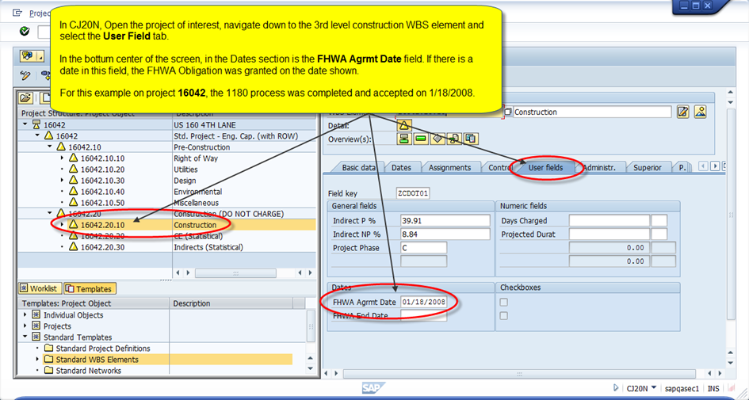

Shopping Cart (Purchase Requisition)
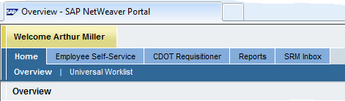
Once the funds are obligated by FHWA, the Project Manager (PM) creates and fills in a purchase Shopping Cart in SAP SRM. This is done through the SAP Portal that can be accessed through the CDOT Intranet Home Page. Towards the bottom of the page click on the SAP Portal link. Log in with your Windows Username and Password. Once you are logged in select the CDOT Requisitioner tab.
It is very important that this shopping cart be completed at least 5 to 10 working days before advertisement. Here are the procedures for completing the Shopping Cart.
Follow the steps below to create the Shopping Cart. This workflow is for funding the construction project only. The fields change depending upon the type of Shopping Cart you are creating. The steps below are for a Construction Project Shopping Cart.
Once you have the CDOT Requisitioner Tab open, select Detailed NavigationRequisitioning from the Purchasing Pane located on the left hand side of the screen. This will show any created Shopping Carts, if you need to edit an already existing shopping cart. Now select Shopping Cart from the ServicesCreate DocumentsShopping Cart from the Purchasing Pane on the left hand side of the screen. This will bring up the Create Shopping Cart Window. Follow these steps to fill in all the required fields.

General Data Fields:
Examples from R5 given below:
- Field Name of shopping cart: R5 subaccount # AD
- Field SC Type: YA
- Field Region: HA5
- Field PO Type: ZG
- Field Invoice to address: 8000065
- Field Approval Note: This purchase is for highway construction contract for project JPC# [where JPC# is the 5-digit project code]

Item Overview Fields:
- Select the Add LineAs New Line from the Add Line pull down menu
- Field Item Type: Material
- Field Product Category: 91327 (Construction manage NPS), “92500” for design or “91384” for maintenance and repair.
- Field Quantity: Enter the full dollar amount, i.e. Fed and local match total (line 7 Project Commitment Amount on the Form 65)
- Field Unit: AU
- Field Net Price/Limit: 1.0
- Field Delivery Date: enter a realistic completion date
- Field Account Assignment Type: Participating (for Fed funding) or Non-participating (for State funded)
- Hit Check button at the top of the page for list of errors
- Hit Details button (Top of the Item Overview section) and go to “Item Data” tab

Item Data Fields:
- Field Description: Construction
- Field Purchasing Group: PGR261 Marci Gray
- Field Location Plant: 11004261 (Example is plant 5003 (R5 Traffic))

Account Assignments Fields
- Go to Account Assignment Tab and click Details button and scroll down
- Field WBS Element: e.g.,subaccount#.20.10 (Example - 18970.20.10) (for Construction)
- Field Functional Area: 3300 (design 3020, construction 3300, misc. 3402, ROW misc. 3114, ROW 3100)
- Field General Ledger Account: 4231100011 (if project is participating) or 4231100010 (if project is nonparticipating.)

Finish Shopping Cart
- Click the Save button at the top of the screen
- Write down shopping cart # or name for later searching and to put in the Advertisement letter.
- When all errors are resolved click the Order button at the top of the screen
  - Cannot “Order” on Federal Aid projects until the 1180 is approved by FHWA
    - The following errors will appear until 1180 is approved:
      - Only Non participating code allowed at this posting date
      - Error in account assignment

After Completion of the Shopping Cart
After the shopping cart is complete, the Project Manager (PM) should send an e-mail to the Program Engineer, Business Manager, and Resident Engineer, asking him to release the Shopping Cart. The RPE will then notify the Region Business Manager (RBM) that he or she too must release or approve the project for advertisement. An example e-mail as shown below can be used to accomplish this:
Subject Line:
Shopping Cart Approval to Advertise US 160 At Lake Creek Construction, NH 1602-117 - Project Code 16661
Ed/Jeff (Program Engineer/Regions Business Manager)
We are planning to advertise this project next Thursday January 28, 2010, for 3 weeks. All clearances have been obtained and Forms 128, 463, and 1180 have been submitted to OFMB. FHWA Authorization was obtained on January 15, 2010. Plans have been submitted to reproduction. All information has been completed in SAP including the Header Information, stating that this requisition is to advertise the above referenced project. For your information to approve this request, the
Shopping Cart Number is 700 003 170.
Project number: ES5 1602-125
Project code: 17357
Project description: US 160 Shaw Creek To Del Norte Phase II
Thanks,
James
Once this is released, Agreements will then be able to advertise the project.

Go Sheet (ZJ44)

Primary Source Documentation: DB 2014-2 Go Sheet (ZJ44), Accurate Advertising Dates, and Ad Certainty (to become PDM 2.37 Go Sheet (ZJ44).
Primary Resources: Laura Zamora (303) 757-9233 or
Roselle Drahushak-Crow (303) 757-9015.
The Go Sheet is published weekly to inform contractors about upcoming bid openings for CDOT construction projects. The Go Sheet consists of the following four reports:
- Projects Advertised Revised this Week
- Advertised Project Lettings
- Projects to be Advertised within the next 90 days
- Local Agency Projects

Accurate Advertisement Dates
Information populating the Go Sheet now comes from SAP instead of Trns*port. It is very important for Project Managers to update project information in SAP, including the Current Planned Ad Date, Scheduled Ad Date, the Project personnel, Budget, and Contract Type. Currently only the Region Business Office can update the Scheduled Ad Date, but in the near future Project Managers also will be able to maintain this date.

Instructions for Generating the Go Sheet in SAP
- Log into SAP
- Enter Transaction Code (tCode) ZJ44
To generate the Go Sheet, Enter the Code ZJ44 in the Search Box located in the upper left corner of the screen. The screen below will appear with the default values as noted.
- Selection Screen Options
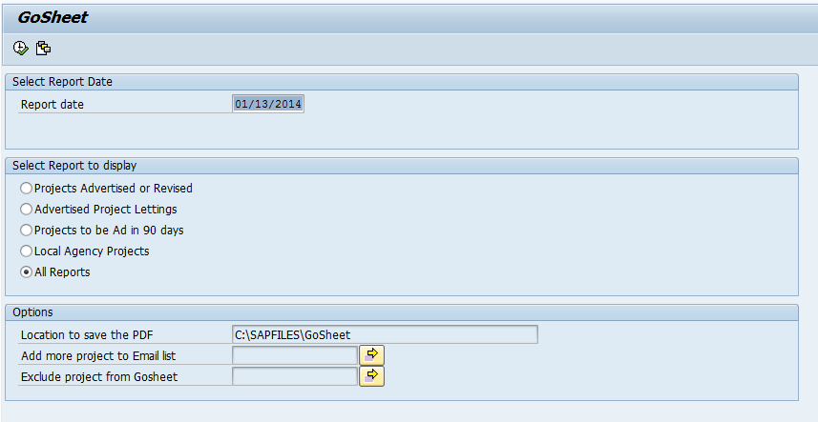
‘Report date’ Field:
- This is the date that the report is generated.
- The Default is today’s date but the date can be changed as needed.
- The projects in the “Advertised or Revised this Week” report will be those to be advertised on the Thursday following the Report Date.
‘Select Report to Display’ Option:
The Go Sheet report displays up to 4 different reports. Please note that all CDOT employees can view these Go Sheet reports in SAP but only Employees in the Agreements Unit can export the data to a PDF file. The reports are listed below:

- Projects Advertised or Revised this Week – Lists Projects that will be advertised or re-advertised on the Thursday following the Report Date.
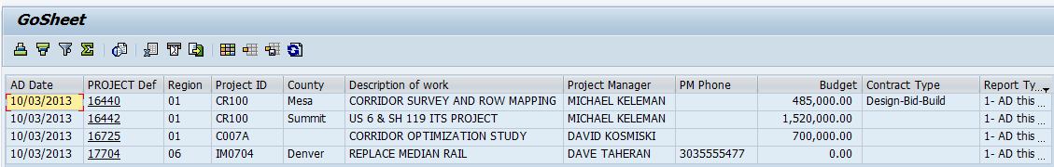

2. Advertised Project Lettings – Lists Projects scheduled for bid opening as of the ‘Report date’ selected.
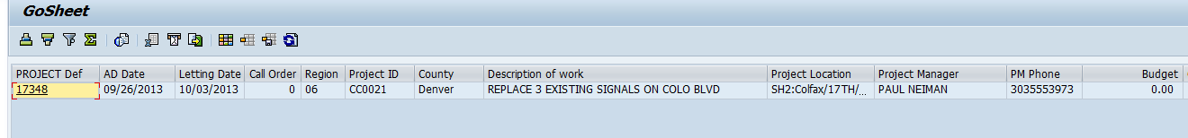

- Projects to be Advertised within next 90 days – List Projects scheduled to go to Ad in the next 90 days of the ‘Report date’ selected.
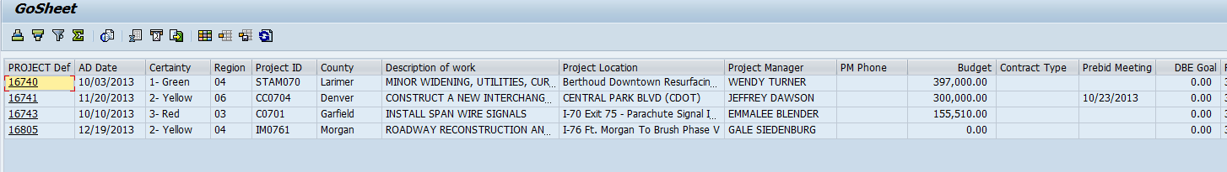
- Local Agency Projects – List Local Agency Projects scheduled to go to Ad in the next 90 days of the ‘Report date’ selected.
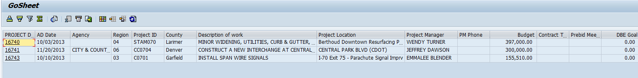

New Fields in CJ20N
Ad Certainty – New “Ad Certainty” field has been added to the Project Manager Custom Tab in CJ20N to indicate the likelihood a project will meet its ‘Scheduled Ad Date.’ It will appear on the “Projects to be Advertised within next 90 days” report as shown above. The Ad Certainty field is a required field located in CJ20N -> Custom Tabs -> Project Manager Tab. Users will select from a drop-down menu with the following choices:
  - 1 Green – High probability the project will be advertised on date listed (90%-100%)
  - 2 Yellow – Medium probability the project will be advertised on date listed (50%-90%)
  - 3 Red – Low probability the project will be advertised on date listed (<50%)
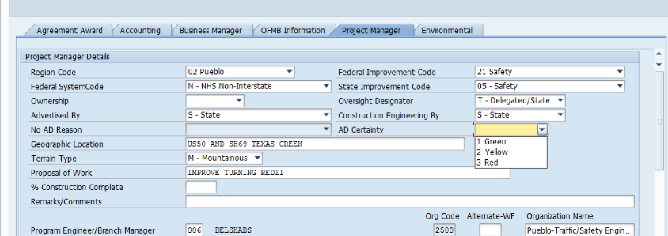
Pre-bid Meeting Date –A new date field has been added to the Agreement Award Custom Tab in CJ20N. Only Awards Officers can enter data on this tab, so Project Managers will need to notify the Agreements Group if a Pre-bid Meeting is required. Pre-bid Meeting dates will appear on the Go Sheet with a note that attendance is mandatory for bidders. The Pre-bid Meeting date is also required in the project Ad Letter.
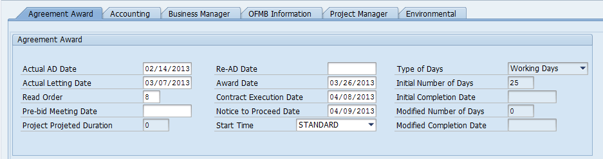
DBE Goal – The DBE Goal is a field in the Agreement Award Custom Tab in CJ20N. Only Awards Officers can enter data on this tab, so Project Managers will need to notify the Agreements Group of the anticipated DBE Goal.
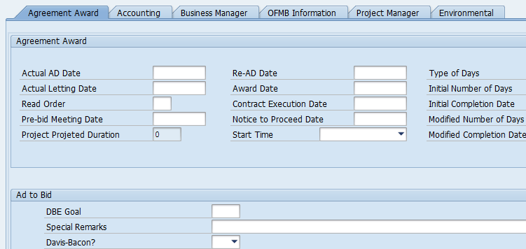

Email to Project Manager and Resident Engineer
An email will be sent to Project Managers and Resident Engineers who have Projects with a Scheduled Ad Date within the next 90 days. The email will remind them to verify that the Scheduled Ad Dates are accurate before projects appear on the Go Sheet’s 90 day report. If the project is not going to ad in the next 90 days it is important that you update the Scheduled Ad date by contacting the Region Business Office.

SAMPLE EMAIL
From: USER - BASIS JOBS BATCH <Basis.Jobs@dot.state.co.us>
Date: Thursday, Jan 16, 2014 at 3:12 PM
Subject: Project 18244 Please Confirm Scheduled Ad Date
Project Name: SH 9 Grand County Safety Improvements
Project 18244 will be published on the Go Sheet 90-day Report next week based on the project’s Scheduled Ad Date of 04/23/2014.
If this information is incorrect, please update your Scheduled Ad Date in SAP.
For questions, please contact SAP Project Systems BPXs:
Tawnya Nicholson 303-512-5207 or tawnya.nicholson@state.co.us
Valerie Metaiguer 303-757-9837 or valerie.metaiguer@state.co.us
This is a system notification email. Do not reply to this email.

In addition, the “GO Sheet Accuracy Report” is issued after the bid opening every Thursday, showing the accuracy of the GO Sheet compared to the actual projects for which bids were opened. It is transmitted to the Program Engineers and Project Managers with projects listed on the report.
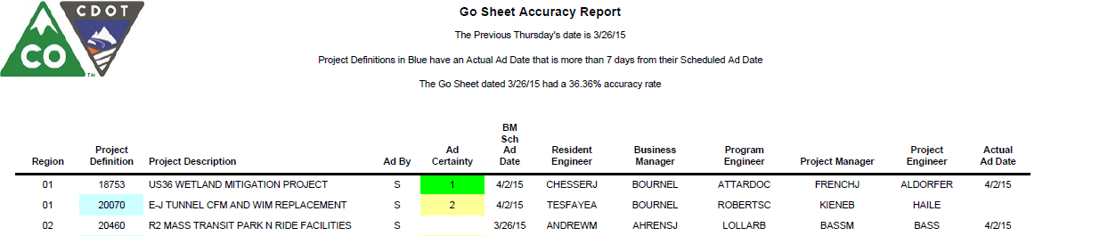

CONSTRUCTION
Primary Source Documentation: CB 2015-2 Incremental Encumbrance and Contractor’s Payment Schedule Process.
CB 2014-1 Entering Contractors’ Drawdown Schedules in SAP
The instructions below from CB 2015-2 describe the process for incorporating the Contractor’s payment schedule into the SAP drawdown schedule: (should this be embedded? )
“Incremental Encumbrance and Contractor’s Payment Schedule Process
In order to meet CDOT’s Program Management and Cash Management goals, CDOT needs to make sure we are efficiently using the spending authority and have decided to incrementally encumber certain projects. The purpose of this Bulletin is to provide information on how to review the contractor’s payment schedule (drawdown schedule) and manage the incremental encumbrance process on CDOT construction projects. Note that the Payment Schedule and drawdown schedule are the same thing. The contract just calls the drawdown schedule a Payment Schedule. A CDOT administered project will be incrementally encumbered when the Program Management Office (PMO) and Cash Management Office (CMO) determine it is in CDOT’s interest to incrementally encumber the project funds. It is important that the Project Engineer and contractor continue to communicate the status on the project expenditures compared to the encumbered amount. Typically the criteria to determine if a project will be incremental encumbered will be:
- The Engineer’s Estimate at the time of advertisement equal to or greater than $7 million. To determine the Engineer’s Estimate amount is refer to the Form 65, line 7 Project Commitment Amount. This amount includes all Force Account items. Note that this threshold may change at the discretion of the CMO. Contact OFMB, or your Region PMO Representative to confirm current threshold amount.
- The project’s construction duration is anticipated to span multiple fiscal years. If the project has a landscape maintenance period, such time will not be used in calculating the construction duration.

If one or both of the criteria above are changed after bids are opened, the PMO and CMO will determine if the project will be incrementally encumbered.
Process between Award and Pre-construction Conference:
- Award: The notice of the award letter will identify if the project will be incrementally encumbered. The Contractor is required to submit an initial payment schedule (drawdown schedule) within 15 days of award. When the payment schedule is submitted to the Project Engineer, review the payment schedule for signature from the contractor and immediately submit the payment schedule to CDOT Awards officer. If it not signed return the payment schedule to the contractor for signature. The contractor may also provide the payment schedule directly to the CDOT Awards Officer. The CDOT Awards Officer, will issue a contract for execution with the “Encumbrance Amount” for the current fiscal year in Section 4. Price – Payment Terms of the contract.

- Pre-Construction Conference: Per the Standard Special Provision Revision of Sections 108 and 109 (Multiple Construction Years), the contractor may submit a revised payment schedule (drawdown schedule) at the pre-construction conference. If the revised payment schedule changes the encumbrance amount by any amount for the current fiscal year, the Project Engineer will work with the Business Manager, the PMO and the Awards Officer to update the “Encumbrance Amount.” Once approved, the Project Engineer will update the “Encumbrance Amount” by following the Option Letter process and update the drawdown data in SAP based on the contractor’s revised payment schedule within 10 days of the pre-construction conference or as soon as the encumbrance is updated in the Construction Project Contract (as per Construction Bulletin 2014-1.)

Payment Schedule Updates: As the project progresses by the first day of the each month, the contractor is required to submit its payment schedule. It is important for the Project Engineer, contractor, PMO and CMO communicate where the project stands in regards to the “Encumbrance Amount.” The Project Engineer will review the payment schedule and watch the contractor’s progress for a trend that they will exceed the encumbrance amount. If the contractor’s percent expended is approaching 75% of the encumbrance, the Project Engineer will carefully monitor the contractor’s progress. The Project Engineer should be proactive and start a discussion with the contractor, region business office, PMO and CMO.
  - If the contractor’s payment schedule current fiscal year total matches or is less than the “Encumbrance Amount” in Section 4. Price – Payment Terms of the contract, the Project Engineer will update the drawdown schedule including the current month’s actual payments in SAP. (Construction Bulletin 2014-1).
  - If the current fiscal year total exceeds the “Encumbrance Amount”, by any amount, the Project Engineer will determine whether the cause for the increase is related to the contractor completing work more quickly or if it is related to a differing site condition, change, or extra work. The Project Engineer will immediately contact their Resident Engineer and Program Engineer who will discuss with the Region PMO representative to work with the PMO and the CMO. The Project Engineer will provide the anticipated amount of increase and the cause related to the increased amount.
    - If the increase is related to a differing site condition, change, or extra work, approve the payment schedule and update the drawdown schedule in SAP. The Project Engineer will also need to evaluate the project budget to determine if a funding letter or Commission Action is needed. Follow the typical funding letter and Commission action process.
    - If the increase is NOT related to a differing site condition, change, or extra work the Project Engineer will coordinate with their Resident Engineer and Program Engineer who will discuss with the Region PMO representative and the PMO and CMO to determine whether or not CDOT can accommodate the additional cash need during the current fiscal year.
  - If CDOT PMO and CMO approves the increase to the “Encumbrance Amount”, the Project Engineer will initiate the process to execute an option letter. After the option letter is approved, the Project Engineer will update the drawdown in SAP.
  - If CDOT does not approve the increase to the “Encumbrance Amount”, the Project Engineer will, in a Form 105, Speed Memo, notify the contractor that it anything past this amount will not be paid until the “Encumbrance Amount” is updated. The contractor shall update the drawdown to match the approved “Encumbrance Amount.” The Project Engineer will need to clearly identify to the contractor a timeframe for response (five to seven calendar days should be adequate) and update the drawdown in SAP with actual payments but will not exceed the current approved fiscal year encumbered amount.

Encumbering next fiscal year: When the contractor submits the April monthly Payment Schedule Update, the Project Engineer will use that amount to update the drawdown in SAP and notify PMO and CMO of the cash need for the next fiscal year. The contractor will certify by signing the Payment Schedule Update as the amount to encumber for the next fiscal year.
The Option Letter must be executed in early April to ensure encumbrance before the end of the fiscal year.
Option Letter Process: The Option Letter process can change the encumbrance amount for a fiscal year or can change the Project Commitment amount and the encumbrance amount related to a change order. The Project Engineer will verify if the Payment Schedule is certified by the contractor and the signature matches those listed in the contract. The contract includes a list of authorized people and an example of their signature. Once verified the Project Engineer forwards the Option letter to the CMO for review and signature. It is expected that this will be a 10 day period. Once approved by the CMO the option letter is sent to the controller for review and signature. The turn-around time for the Controller is 1 business day. Once complete the approved option letter is sent to the CDOT Awards Officer. The Awards Officer will notify the Project Engineer and Resident Engineer by email that the new encumbrance is approved and list new encumbrance amount.
References:
Please print a copy of this bulletin and keep it with your copy of the Construction Manual.
The Construction Manual and Construction Bulletins can be found on the Design and Construction Project Support web page at:
http://www.coloradodot.info/business/designsupport/bulletins_manuals”

Change Record

Section Number  Date Changed | Was | Is
Resources (Page v)  7/28/15 | Idirect Rates  [None]  [None]  [List of Region SAP Power/Super Users]  Region 2 Jennifer Billings | Indirect Rates  [Added phone number and email for Scott Howard.]  Please contact your Resident Engineer for the name of your region’s current representative.  [Deleted list]  Region 2 Michael Nusen

