Workflow MS 12- Accessing Aerial Imagery Files
This document guides you through the process of locating and downloading aerial imagery stored on CDOT servers.
Please Note: This workflow has been updated for use with ORD, however, we have included steps for MicroStation SS4/SS10 as well, to cover the minor differences.
In order to download the correct image files for a project, the names of the image tiles must first be determined. Both Denver Area (DRAPP) and Statewide (NAIP) image tiles can be identified using the Imagery Tile Viewer web application.
- You will need to create an account in GeoHub in order to access the Imagery Tile Viewer web application (as well as to access all future GeoHub applications). Please follow the instructions HERE to create your account (must be on the CDOT network or VPN)
- Once your GeoHub account has been created, you can open the Imagery Tile Viewer HERE
- The Imagery Tile Viewer will open as shown below:

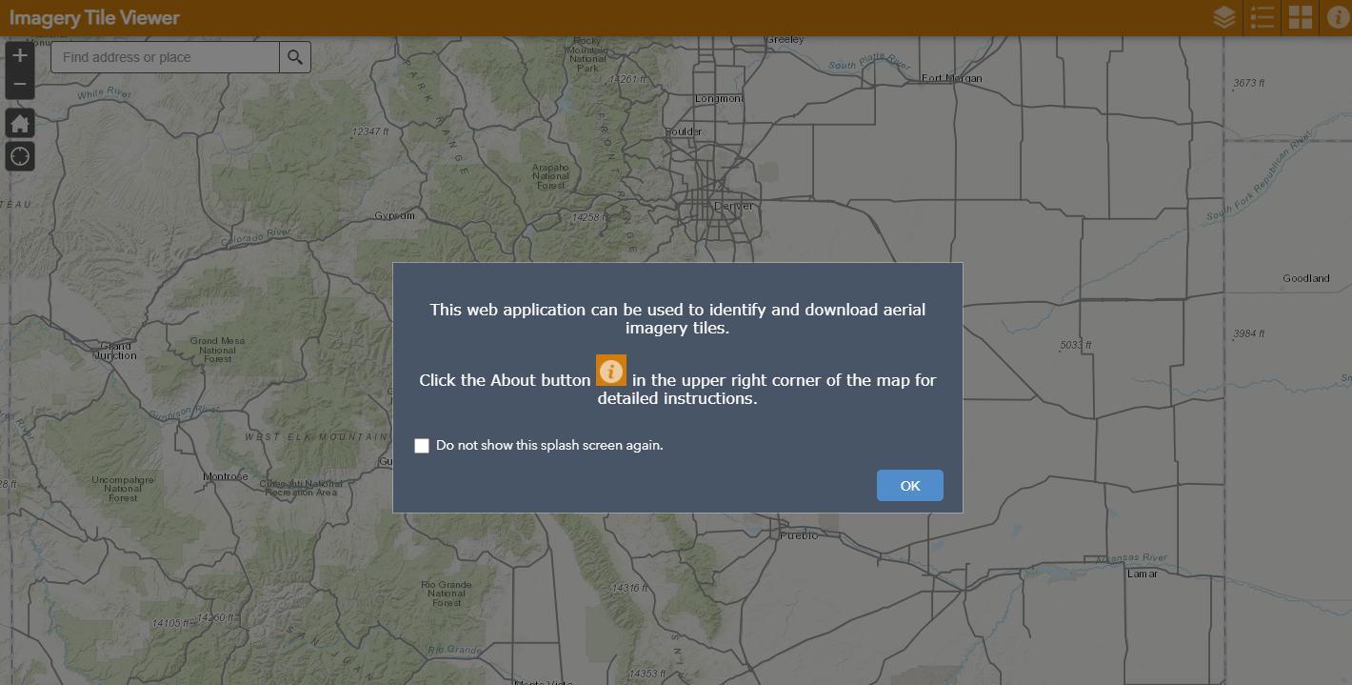

- Click the OK button to close the welcome window.

- The navigation tools in the upper left corner of the map area allow you to zoom in/out. The Home button will zoom you to the statewide extent. Scrolling the mouse wheel will also allow you to zoom in and out. Click and hold the left mouse button down to pan around the map.

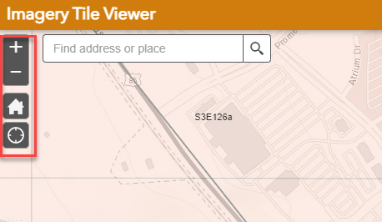

- Click the Layers List button to display the available data layers.
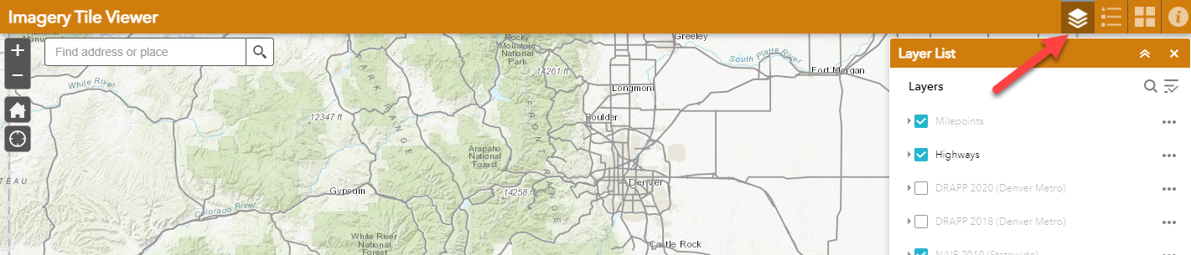

- To turn on a layer in the map area, check the box to the left of the desired layer (i.e. DRAPP 2020). If a layer is grayed out, you need to zoom in to be able to see that layer.

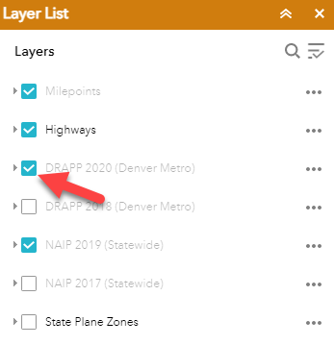

- Click the Legend button to see the symbology for the layers that are enabled (checked on) in the Layers list.

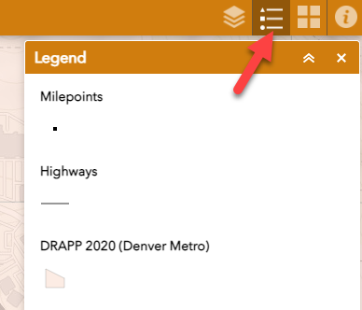

- In the map area, Left Click on a tile grid to select the tile (it will highlight) in order to view its attributes:
- Type of imagery (i.e. DRAPP 2014 TIF)
- Imagery Directory for that imagery type (i.e. \\public\Aerials\Aerials_2020\Orthoimagery)
- Imagery Tile name (i.e. N1W133)

Note: Other features such as Highways can also be selected to view their attributes.

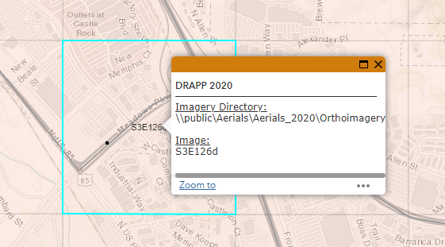

- Select the imagery directory location in the text box by quickly clicking three times on it until the entire directory is highlighted. Then Right Click and choose Copy (or hit Ctrl-C on your keyboard).

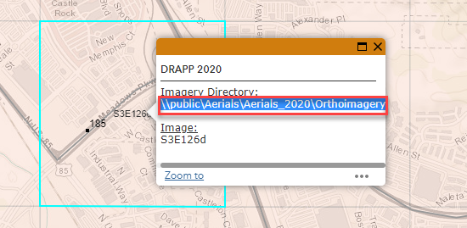

- Open a windows file explorer window by clicking the folder icon in your system tray.

- Paste the copied text into the address bar by Right Clicking in the address bar and then choosing Paste (or Ctrl-V on your keyboard). Then hit the Enter key and you should see the available sub folders.
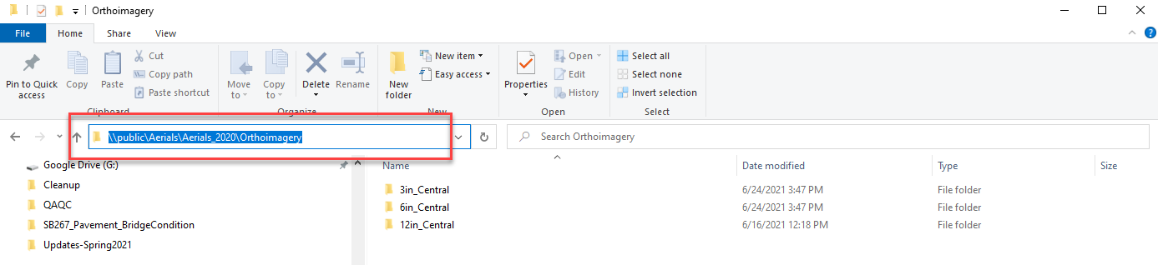

- Back in the Imagery Tile Viewer, highlight the entire image tile name in the text box by clicking twice on it until the entire name is highlighted. Then Right Click and Copy (or hit Ctrl-C on your keyboard).

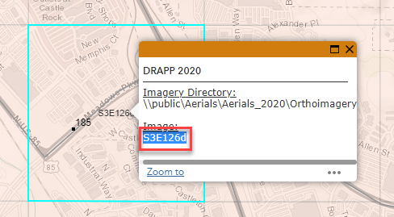

- In the same windows file explorer pane from earlier steps, paste the copied text into the search bar. Hit Enter to initiate the search for the image.
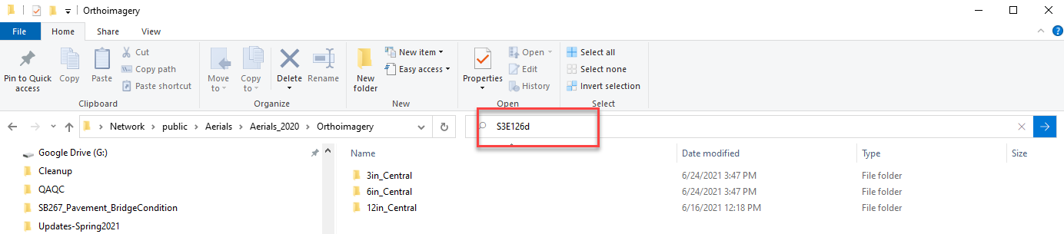

- Any files matching the search should display in the window as shown below. Select all found files and Right Click and Copy (or hit Ctrl-C on your keyboard).
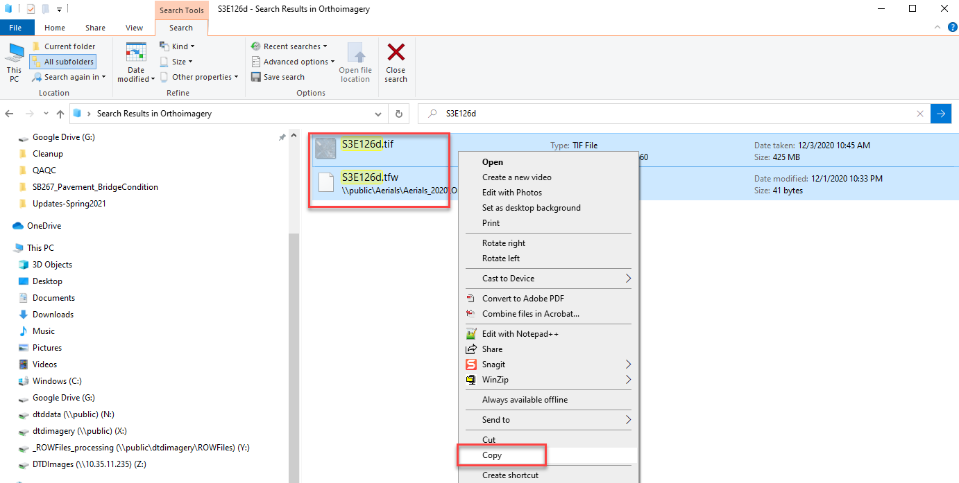

- Open a new windows explorer pane and navigate to the desired location on your local machine, then Right Click in the windows explorer pane and choose Paste (or Ctrl-V on your keyboard).

- Repeat above steps for any other files needed.

Tips/Tricks:
- Occasionally when you access the Imagery Tile Viewer, you may be prompted to sign in again. Please click the blue Enterprise Login button, which should sign you in automatically.

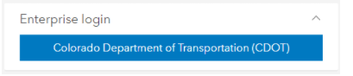

- You can change the base map if desired by clicking the Basemap Gallery button and choosing the desired basemap.
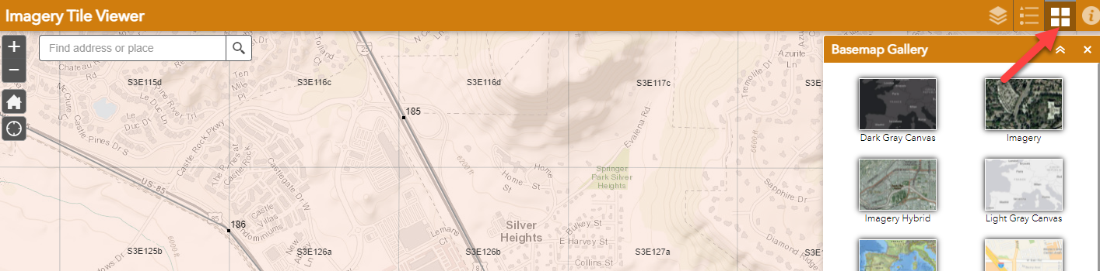

- If you have multiple layers turned on and you try to click on a grid to get the image tile attributes, be aware that you might have multiple features selected. If you see 1 of “X” in the upper left corner of the info box, you can click the arrow to the right to display the other selected feature’s attributes.
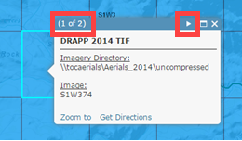

- Some help content is available by clicking the Help button.
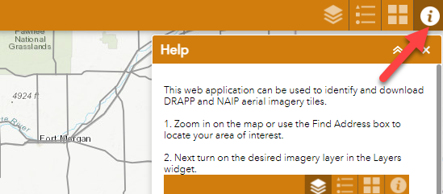

- Be aware that each NAIP TIFF will have one of two projections (UTM 13N NAD83 or UTM 12N NAD83) depending on where in the state it is located. This can be determined in the file name (12 or 13). The following western Colorado counties are UTM12N NAD83: Delta, Dolores, Garfield, La Plata, Mesa, Moffat, Montezuma, Montrose, Ouray, Rio Blanco and San Miguel. The rest are UTM 13N NAD83.

Attaching Image Files To A DGN File
The following steps describe how to attach the image files copied from the server to a DGN file and apply the proper geographic coordinate system associated with the images to the DGN file.
Note: Whether you are using MicroStation SS4/SS10 or OpenRoads Designer (ORD) and are working locally or on the ProjectWise Cloud, the following steps are the same, regardless of the application.
- Create a new file using the 2D seed file.
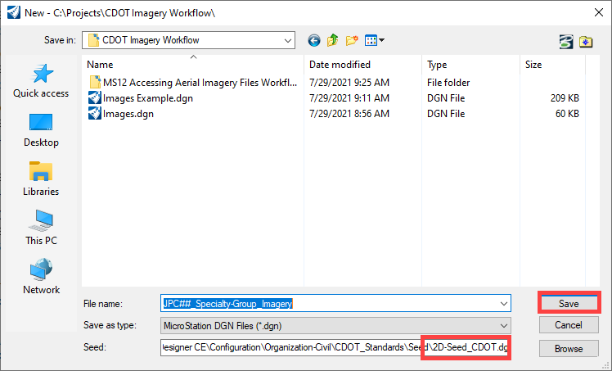
- Set the Level for the DGN file to DRAFT_Image. The illustration below show how to set the level in ORD. Be sure the workflow is set to Drawing and use the Home tab.

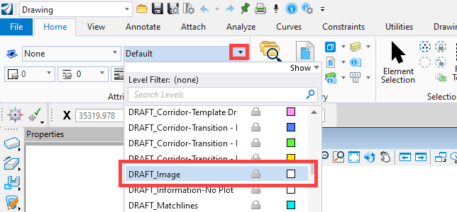

The illustration below shows how to set the level in the MicroStation SS series.
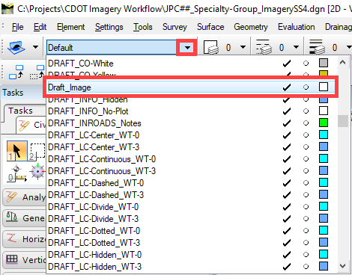
- Once you have set the level to DRAFT_Image, open the Raster Manager as shown below.

For ORD, From the Drawing workflow > Home tab > Primary section > Attach Tools >Raster Manager:
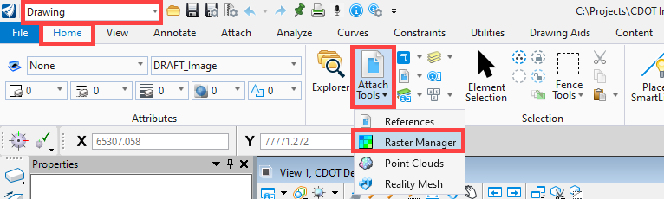
For the MicroStation SS series:
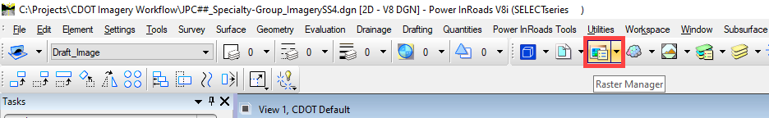

- In the Raster Manager dialog box, Select File > Attach > Raster.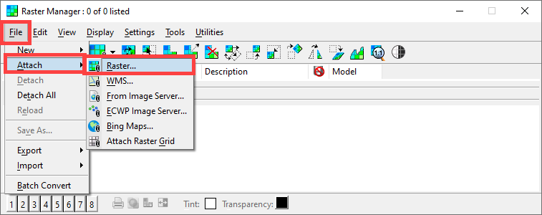
- In the Attach Raster Reference dialog box, navigate to the folder containing the images. Select only the *.tif image file, make sure Open Settings Dialog is toggled on, then click the Open Button.
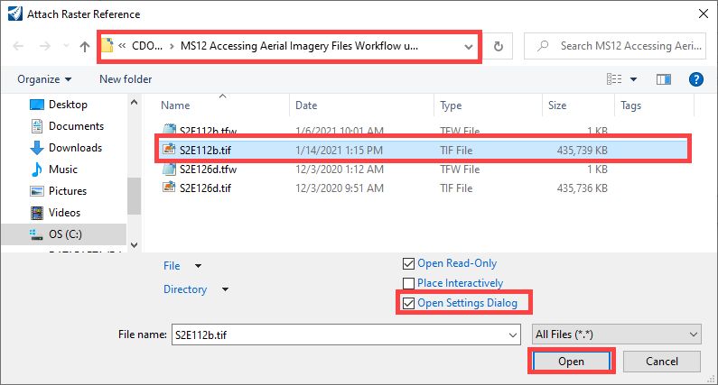
Note: If you are working in ProjectWise the Attach Raster Reference dialog box looks the image below. Highlight the desired file, Left Click the Add button, then, Left Click the OK button.
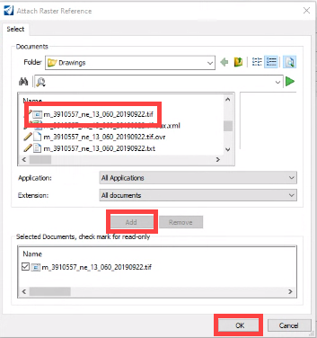

- This displays the Raster Attachment Options dialog box. For DRAPP images in the Geometry tab, select Sister File.
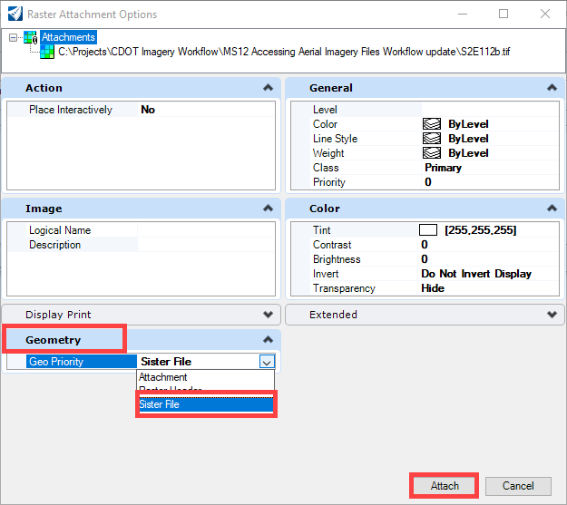
For NAIP images, select Raster Header for the GeoPriority. Set the Inherit GeoCS from Model to Not Inherited.
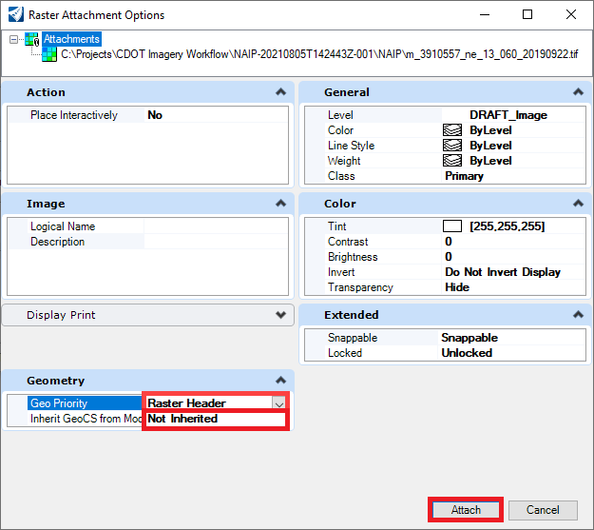
- Repeat steps 4 through 6 for all images to be attached.

Once the images have been attached, the next step is to assign the imagery’s geographic coordinate system to the DGN file.
- From the Drawing workflow > Utilities tab > Geographic section, select Geographic System tool.
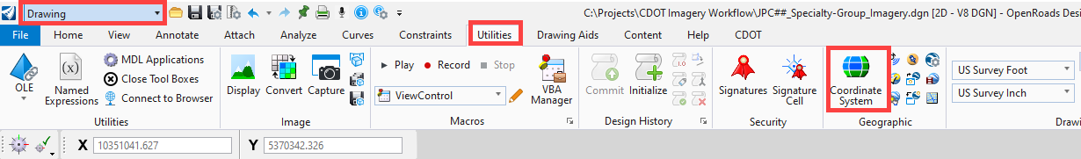

The same tool is found in the MicroStation SS series as shown below:

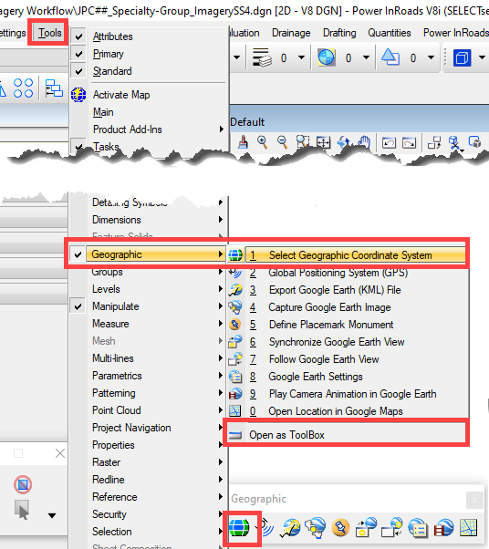
The following steps apply to both ORD and the MicroStation SS series.
- In the Geographic Coordinate System tool settings box, select the From Library icon.
- In the Select Geographic Coordinate System dialog box, expand Favorites and Colorado Projected. Select the appropriate coordinate system for your image file. In this example, the image is in the Colorado Central Zone, so CO83-CF is used as shown below:
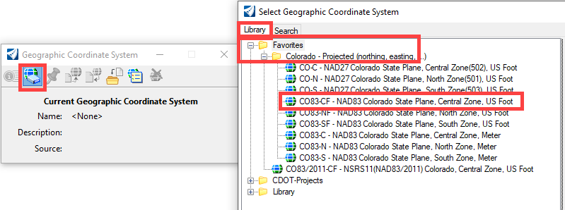
NAIP TIFF will have one of two projections (UTM 13N NAD83 or UTM 12N NAD83) depending on where in the state it is located. This can be determined in the file name (12 or 13). The following western Colorado counties are UTM12N NAD83: Delta, Dolores, Garfield, La Plata, Mesa, Moffat, Montezuma, Montrose, Ouray, Rio Blanco and San Miguel. The rest are UTM 13N NAD83.
These can be found using the search as shown below:
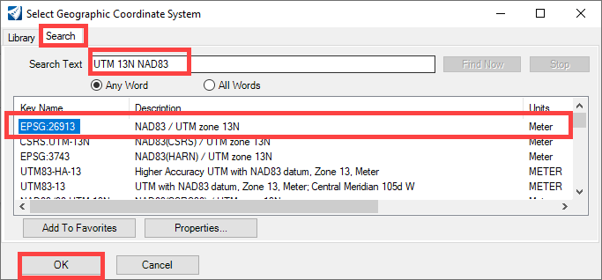

Note: The coordinate systems for both the DRAPP and NAIP images can be found in both the Colorado - Projected and the DRAPP & NAIP – Coordinate Systems for CDOT Imagery folders.
Once the coordinate system file has been assigned, it is shown in the Geographic Coordinate System tool settings box.
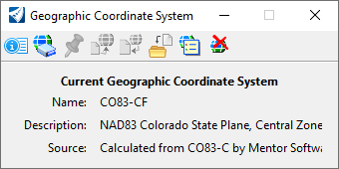
The image file is now ready to be used with Project Plan files by referencing it using the Geographic Reprojection option so that it aligns with the Project Specific Coordinate System set by the Survey Team in the survey file deliverable for this project. More details on reprojection are explained in workflow MS 24 Assigning Project Coordinate System.

