January 17, 2008

REVISION OF SECTIONS 105, 202, 401, 406 and 601
HOT MIX ASPHALT PAVEMENT ROADWAY SMOOTHNESS
(HIGH SPEED PROFILER)

NOTICE

This is a standard special provision that revises or modifies CDOT’s Standard Specifications for Road and Bridge Construction It has gone through a formal review and approval process and has been issued by CDOT’s Project Development Branch with formal instructions for its use on CDOT construction projects. It is to be used as written without change. Do not use modified versions of this special provision on CDOT construction projects, and do not use this special provision on CDOT projects in a manner other than that specified in the instructions unless such use is first approved by CDOT’s Standards and Specifications Unit. The instructions for use on CDOT construction projects appear below.

Other agencies which use the Standard Specifications for Road and Bridge Construction to administer construction projects may use this special provision as appropriate and at their own risk.

Instructions for use on CDOT construction projects:

Use on all projects having HMA pavement.

Use the following guideline to assign the pavement smoothness category for the project. Place the pavement smoothness category assignment in the General Notes.:

HRI Category I applies to the following asphalt pavement construction:
- Urban Reconstruction with or without curb and gutter;
- Construction of one layer over an intermediate treatment (Removal of Asphalt Mat (Planing), Cold Bituminous Pavement (Recycle), Heating and Remixing, Heating and Repaving, Full Depth Reclamation, leveling course with a thickness of 1.5 inches or less or other intermediate treatment);
- May be used in overlays meeting #2, with curb and gutter when a shoulder separates driving lanes from the curb and gutter. A minimal amount of utility boxes, intersections and grade changes are allowed. A note needs to be placed in the plans stating that the new asphalt driving lanes will not have to match curb and gutter.
- May be used in overlays meeting #2, with curb and gutter when pavement smoothness is very important. A minimal amount of utility boxes, intersections and grade changes are allowed. A note needs to be placed in the plans stating that the new asphalt driving lanes will not have to match curb and gutter.

HRI Category II applies to the following asphalt pavement construction:
- New construction with or without curb and gutter;
- Construction of more than one layer;
- May be used in overlays meeting #2, with curb and gutter when a shoulder separates driving lanes from the curb and gutter. A minimal amount of utility boxes, intersections and grade changes are allowed. A note needs to be placed in the plans stating that the new asphalt driving lanes will not have to match curb and gutter grades.
- May be used in overlays meeting #2, with curb and gutter when pavement smoothness is very important. A minimal amount of utility boxes, intersections and grade changes are allowed. A note needs to be placed in the plans stating that the new asphalt driving lanes will not have to match curb and gutter.

HRI percent improvement urban construction applies to the following asphalt pavement construction:
- When smoothness is affected by matching existing curb and gutter and/or numerous intersections and/or utility boxes.

HRI percent improvement rural construction applies to the following asphalt pavement construction:
- Only one layer of pavement is being placed without and intermediate treatment.
- Only one layer of pavement is being placed over Heating and Scarifying
- Heating and Repaving without an overlay
- Heating and Remixing without an overlay
- May be used in urban overlays meeting #1-4, with curb and gutter when a shoulder separates driving lanes from the curb and gutter. A minimal amount of utility boxes, intersections and grade changes are allowed. A note needs to be placed in the plans stating that the new asphalt driving lanes will not have to match curb and gutter grades.
- May be used in urban overlays meeting #1-4, with curb and gutter when pavement smoothness is very important. A minimal amount of utility boxes, intersections and grade changes are allowed. A note needs to be placed in the plans stating that the new asphalt driving lanes will not have to match curb and gutter.

No pavement smoothness category is applied to the following asphalt pavement construction:
- Cold Recycling without an overlay.
- Thin overlays (< 1.5 inches) of HMA or SMA without an intermediate treatment.
- Heating and Scarifying without an overlay.
- Chip seals

Projects may be broken into different sections with different pavement smoothness categories instead of using the easier pavement smoothness category for the whole project.

The Designer will assign the pavement smoothness category(s). At least 2 weeks prior to the F.O.R. meeting, send a copy of the plans to Staff Materials for review of the pavement smoothness category assignment.

The Designer will estimate the required number of Flagging Hours, Traffic Control Supervision, Traffic Control Devices and Uniformed Traffic Control necessary to implement the Department’s Quality Assurance portion of this specification. The designer will include these quantities in the quantities table to be bid.

Sections 105, 202, 401, 406, and 601 of the Standard Specifications are hereby revised for this project as follows:

Delete subsection 105.07 and replace with the following:

105.07 Conformity to Roadway Smoothness Criteria. Roadway smoothness testing and corrective work shall be performed as described below.

- Smoothness Quality Control Testing.

  - The Contractor shall perform Smoothness Quality Control (SQC) testing. The test results shall be submitted to the Engineer within 48 hours of completion. SQC test results shall show the Half Car Roughness Index (HRI) or Percent Improvement (%I) for each 0.10 mile or 0.05 mile section respectively. When the Contract specifies HRI, the test results shall show the results for localized roughness.

All traffic control costs associated with SQC testing will be paid for in accordance with Section 630.

When the Contract specifies HRI Category I, SQC results shall be in the form of HRI, SQC shall be performed on the first 2,000 tons for the final layer.

When the Contract specifies HRI Category II, SQC results shall be in the form of HRI. SQC shall be performed on the first 2,000 tons for both the final layer and the next lower pavement layer and at the completion of the next lower pavement layer.

When the Contract specifies HRI Percent Improvement, SQC results shall be in the form of HRI and HRI Percent Improvement. SQC shall be performed on the first 2,000 tons for the final layer.

SQC testing shall be performed using the Contractor’s inertial profiler, pursuant to the methods described in subsection 105.07(b) and in accordance with the manufacturer’s recommendations. The Contractor’s Profiler shall be certified according to CP 78. A list of certified profilers is located at http://www.dot.state.co.us/DesignSupport/

Production shall be suspended if SQC testing indicates that corrective work is required in accordance with subsection 105.07 (c). Production will remain suspended until the problem is identified and corrected. Each time production is suspended, corrective actions shall be proposed in writing by the Contractor.

When production resumes, the Contractor shall profile the first 2,000 tons of HMA. The conditions above for suspension of work will apply.

2. The finished transverse and longitudinal surface elevation of the pavement shall be measured using a 10 foot straightedge. Areas to be measured will be directed by the Engineer. The Contractor shall furnish an approved 10 foot straightedge, depth gauge and operator to aid the Engineer in testing the pavement surface. Areas showing high spots of more than 3/16 inch in 10 feet shall be marked and diamond ground until the high spot does not exceed 3/16 inch in 10 feet.

(b) Smoothness Acceptance Testing. The Contractor shall perform Smoothness Acceptance Testing (SA) which will be used for acceptance and calculation of incentive and disincentive payments.

All traffic control costs associated with SA testing will be paid for in accordance with Section 630.

      - Longitudinal Pavement Surface Smoothness Acceptance. Pavement surfaces shall be tested and accepted for longitudinal smoothness as described herein.

- Testing Procedure (General). The longitudinal surface smoothness of the final pavement surface shall be tested and evaluated by the Contractor in accordance with CP 74 and using the Contractor’s high-speed profiler (HSP). The Contractor’s Profiler shall be certified according to CP 78. A list of certified profilers is located at http://www.dot.state.co.us/DesignSupport/

The HSP instrumentation shall be verified in accordance with CP 74 prior to measurements. The Contractor shall lay out a distance calibration site. The distance calibration site shall be 1056 feet long and shall be on a relatively flat, straight section of pavement as approved by the Engineer. The site shall have a speed limit equal to the Project’s highest speed limit that allows for the HSP to operate uninterrupted. The limits of the site shall be clearly marked and the distance shall be measured to an accuracy of +/- 3 inches. The Contractor shall provide in writing the site location to the Engineer. The cost of the distance calibration site will not be measured and paid for separately, but shall be included in the work.

The entire length of each through lane, climbing lane and passing lane including bridge approaches, bridge decks and intersections from the beginning to the end of the project shall be profiled. Shoulders, ramps, tapers, turn slots, acceleration lanes, deceleration lanes, and medians shall not be profiled and will not be subject to incentive/disincentive adjustments. The profile of the entire length of a lane shall be taken at one time. However, the Contractor may break a project into sections to accommodate varying conditions or Project phasing if approved by the Engineer.

A sufficient distance shall be deleted from the profile to allow the profiler to obtain the testing speed plus a 300 foot distance to stop and start when required. Incentive/disincentive payments will not be made for this area. The final surface of these areas shall be tested in accordance with subsection 105.07(a) 2.

Shoulders, ramps, tapers, turn slots, acceleration lanes, deceleration lanes, and medians constructed as part of this project shall be measured in accordance with subsection 105.07(a) 2.

When the Contract Specifies HRI, the following applies:

- The profile shall include transverse joints when pavement is placed by the project on both sides of the joint. When pavement is placed on only one side of the joint, the area 25 feet from the joint shall be deleted from the profile before the HRI is determined. Incentive/disincentive payments will not be made for this area. Pavement within the area 25 feet on the newly constructed side of the joint shall be tested in accordance with subsection 105.07(a) 2.

- The profile of the area 25 feet each side of every railroad crossing, cattle guard, bus pad, manhole, valve box, gutter pan and intersection (where there is a planned breakpoint in the profile grade line in the direction of testing) shall be deleted from the profile before the HRI is determined. Incentive/disincentive payments will not be made for these areas. Areas deleted from the profile shall be tested in accordance with subsection 105.07(a) 2.

- When both new pavement and a new bridge or new bridge pavement are being constructed in a project, the profile of the area 25 feet each side of every bridge expansion device (joint) shall be deleted from the profile before the HRI is determined. Incentive/disincentive payments will not be made for this area. Areas deleted from the profile shall be tested in accordance with subsection 105.07(a) 2. Diamond grinding will not be measured and paid for separately, but shall be included in the work. For all other projects, the profile of the area 25 feet each side of every bridge expansion device (joint) shall be deleted from the profile before the HRI is determined. Incentive/disincentive payments will not be made for this area. If the Engineer determines that corrective work is required in this area, payment will be made in accordance with subsection 109.04.

- The Contractor shall notify the Engineer in writing at least five working days in advance of his intention to perform SA testing. The Contractor shall profile the Project within 14 days after the completion of paving operations. The Engineer will witness the SA profiling and take immediate possession of the SA data.

- The Contractor shall not perform any corrective work that will effect the pavement smoothness for ten working days after completion of the SA testing or as approved by the Engineer. This time is to allow for the Department to analyze the data and perform smoothness verification testing.

When the Contract specifies HRI Percent Improvement, the Contractor shall comply with the following:

- The Contractor shall notify the Engineer in writing of his intention to perform initial SA testing. This notification shall be at least five working days in advance of any work that will affect the smoothness of the lanes. This includes but is not limited to the following work; manhole adjustment, valve box adjustments, curb and gutter repair, milling, planing or patching.

- The Contractor shall perform the initial SA testing prior to any work that will affect the smoothness of the lanes. The Engineer will witness the SA profiling and take immediate possession of the SA data.

- The Contractor shall not perform any work that will effect the initial smoothness of the lanes for ten working days after completion of the initial SA testing or as approved by the Engineer. This time is to allow for the Department to analyze the data and perform smoothness verification testing.

- When the Contractor performs work on the existing pavement prior to the initial SA testing, the affected sections will not be subject to incentive payments, but will be subject to disincentive payments and corrective work.

- The Contractor shall notify the Engineer in writing at least five working days in advance of his intention to perform final SA testing. The Contractor shall profile the Project within 14 days after the completion of paving operations. Manholes and valve boxes shall be raised prior to final SA testing. The Engineer will witness the SA profiling and take immediate possession of the SA data.

- The Contractor shall not perform any corrective work that will effect the final pavement smoothness for ten working days after completion of the final SA testing or as approved by the Engineer. This time is to allow for the Department to analyze the data and perform smoothness verification testing.

- The profile shall include an additional 25 feet of pavement outside the project paving limits.

- Smoothness Testing Procedures. The Contractor shall mark the project limits, climbing lane limits and passing lane limits. When the Contract specifies HRI the Contractor shall mark 25 feet from each bridge approach slab, railroad crossing, cattle guard, bus pad, manhole, valve box, gutter pan and intersection (where there is a planned breakpoint in the profile grade line in the direction of testing). When the Contract specifies HRI Percent Improvement, the markings shall be located in a location that will not be disturbed, so that the section start and stop locations shall be identical for the initial and final pavement surface. The Engineer will verify that the Contractor's marks are located properly. The Contractor shall use traffic cones with reflective tape or reflective tape on the pavement at the beginning and end of each lane for triggering the start and stop locations on the profiler and at any other location, where portions of the profile are being deleted. These locations shall be marked with temporary paint so that the Department’s profiler uses the same locations for smoothness verification testing.

The Contractor shall clear the lanes to be tested of all debris before profiling.

The Contractor shall submit a Method for Handling Traffic (MHT) to the Engineer for approval at least five days in advance of SA testing. The MHT shall detail the methods for traffic control that shall allow for continuous non-stop profiling of each lane to be profiled at a minimum speed of 15 mph. The Contractor shall provide the traffic control in accordance with the approved MHT.

Each lane shall be profiled three times at a constant speed (+/- 5 mph) with a minimum speed of 15 mph and a maximum speed of 70 mph. The profile shall be taken in the intended direction of travel. The left and right wheel paths shall be profiled simultaneously. The collected profiles shall be turned over immediately to the Engineer and will be analyzed using CP 74.

- When the Contract specifies HRI, the Department will determine a HRI for each 0.1 mile section or fraction thereof of completed pavement. The HRI consists of the average of the left and right wheel path's profile passed through the International Roughness Index (IRI) filter.

The Contractor’s SA test results will be available within ten working days of the completion of SA testing. The Engineer will give the Contractor a report that will include profile data, the lane profiled, IRI for the left and right wheel paths, the HRI in 0.10 mile increments and a summary of areas requiring corrective work. The Engineer may determine that it is necessary for the Contractor to re-profile a lane

Areas requiring corrective work will be determined according to subsection 105.07(c) 1. The third run of each lane will be used for the determination of Localized Roughness.

Sections less than 0.01 miles in length shall not be subject to corrective work as specified by Table 105-6. Sections less than 0.01 miles in length shall be included in the Localized Roughness determination.

- When the Contract specifies HRI Percent Improvement, the Department will determine an HRI for each 0.05 mile section or fraction thereof of pavement. The HRI consists of the average of the left and right wheel path's profile passed through the IRI filter.

The Contractor’s SA test results will be available within ten working days of the completion of SA testing. The Engineer will give the Contractor a report that will include profile data, the lane profiled, IRI for the left and right wheel paths, the HRI in 0.05 mile increments, percent improvement in 0.05 mile increments and areas requiring corrective work. The Engineer may determine that it is necessary for the Contractor to re-profile a lane.

Areas requiring corrective work will be determined in accordance with subsection 105.07(c) 2.

- When the Contract specifies HRI, incentive/disincentive payments for pavement smoothness will be made on a square yard basis in accordance with the following:

Incentive and Disincentive payments will be based on the HRI for each 0.1 mile section or fraction thereof.

Incentive/Disincentive payments for Pavement Smoothness will be made in accordance with
Table 105-6. Sections less than 0.01 miles in length will not be subject to disincentive payments.

Table 105-6

HMA PAVEMENT SMOOTHNESS (INCHES/MILE)
HALF-CAR ROUGHNESS INDEX
Pavement Smoothness Category ¹ | Incentive Payment ($/sqyd) | No Incentive or Disincentive | Disincentive Payment ($/sqyd) | Corrective Work Required
I | When HRI < 40.0 | When HRI > 63.0 and < 72.0 | When HRI ≥ 72.0 and ≤ 90.0 | When HRI > 90.0
I | I = $0.64 | I = $0.00 | I =2.560 – 0.03556 x HRI
I | When HRI ≥ 40.0 and ≤ 63.0 |  | When HRI > 90.0
I | I = 1.753 – 0.02783 x HRI |  | I = -$0.64
II | When HRI < 35.0 | When HRI > 58.0 and < 67.0 | When HRI ≥ 67.0 and ≤ 85.0 | When HRI > 85.0
II | I = $0.64 | I = $0.00 | I =2.382 – 0.03556 x HRI
II | When HRI ≥ 35.0 and ≤ 58.0 |  | When HRI > 85.0
II | I =1.614 – 0.02783 x HRI |  | I = -$0.64
1. The pavement smoothness category will be shown on the plans.

- When the Contract specifies HRI Percent Improvement (%I), incentive/disincentive payments for pavement smoothness will be made on a square yard basis in accordance with the following:

The Engineer will produce a report of the original surface that will include the lane profiled and the HRI in 0.05 mile increments.

Incentive and disincentive payments will be based on the %I of the HRI for each 0.05 mile section or fraction thereof on the final paved surface compared to the HRI for each 0.05 mile section or fraction thereof on the original surface. Sections less than 0.01 miles in length will not be subject to disincentive payments.

The %I will be calculated as follows:

%I = (HRI OF ORIGINAL SURFACE - HRI OF FINAL SURFACE) X 100
HRI OF ORIGINAL SURFACE

Incentive/disincentive payments for Pavement Smoothness will be made in accordance with Table 105-7 or 105-8.

When the Contract specifies Rural Construction Percent Improvement, the Contractor may request in writing to the Engineer that the pavement smoothness category is changed to HRI Category I. The request shall be made prior to any work that will affect the initial smoothness of the lanes. If approved by the Engineer the requirements for HRI Category I shall apply.

Table 105-7

HMA PAVEMENT SMOOTHNESS

RURAL CONSTRUCTION

PERCENT IMPROVEMENT (%I)
HALF-CAR ROUGHNESS INDEX
Incentive Payment ($/sqyd) | No Incentive or Disincentive | Disincentive Payment ($/sqyd) ¹ | Corrective Work Required¹
When %I > 60.0 | When %I > 40.0 and < 45.0 | When %I ≥ 25.0 and ≤ 40.0 | When %I < 20.0
I = $0.32 | I = $0.00 | I = (32 x %I – 1280))/1500
When %I ≥ 45.0 and ≤ 60.0 |  | When %I < 25.0
I = (32 x %I - 1440)/1500 |  | I = -$0.32
1 Disincentives will not be assessed and corrective work will not be required for a 0.05 mile section if the HRI is equal to or less than 80.0 in/mi

Table 105-8

HMA PAVEMENT SMOOTHNESS

URBAN CONSTRUCTION
PERCENT IMPROVEMENT (%I)
Half Car Roughness Index
Incentive Payment ($/sqyd) | No Incentive or Disincentive | Disincentive Payment ($/sqyd) ¹ | Corrective Work Required¹
When %I > 50.0 | When %I > -5.0 and < 5.0 | When %I ≥ -20.0 and ≤ -5.0 | When %I < -25.0
I = $0.32 | I = $0.00 | I = (32 x %I + 160))/1500
When %I ≥ 5.0 and ≤ 50.0 |  | When %I < -20.0
I = (32 x %I - 160)/4500 |  | I = -$0.32
1 Disincentives will not be assessed and corrective work will not be required for a 0.05 mile section if the HRI is equal to or less than 80.0 in/mi

(c) Corrective Work.

Corrective work shall be proposed in writing by the Contractor. Corrective work shall not be performed until approved in writing by the Engineer. The Contractor shall not perform any corrective work on the final layer until after the Engineer returns the results of the Smoothness Acceptance (SA) testing and after the Department’s smoothness verification testing, if performed. Corrective work on lower layers shall be at the Contractor’s discretion. The Department will analyze the SA testing for acceptance and indicate areas requiring corrective work in accordance with subsection 105.07(b). Incentive/disincentive payments will be based on the Contractor’s SA testing. The Contractor shall verify and perform corrective work in the areas indicated by the SA testing. The Contractor shall profile the roadway to verify that the required corrective work has been completed.

- Half-Car Roughness Index Corrective Work:

  - The criteria for determining if a 0.1 mile section or fraction thereof requires corrective work is specified in Table 105-6. In addition to determining if a 0.1 mile section or fraction thereof requires corrective work, the profiles shall be analyzed for areas of Localized Roughness.

  - Localized Roughness. The profiles shall be analyzed to determine where areas of localized roughness occur. The profile shall be summarized using the continuous HRI reporting system using an averaging length of 25 feet. The latest release of the FHWA’s ProVal software shall be used to generate the continuous HRI report. ProVal can be downloaded at http://www.roadprofile.com.

Areas shall be considered deficient, and require corrective work where the continuous HRI report exceed 150.0 inches per mile. Areas where the continuous HRI report exceeds the values in Table 105-9 but are less than 150.0 inches per mile shall be tested in accordance with subsection 105.07 (a) 2.

Table 105-9
CONTINUOUS HRI USING 25 FOOT AVERAGING FOR LOCALIZED
ROUGHNESS CORRECTIVE WORK ON HMA PAVEMENTS

HRI  SMOOTHNESS  CATEGORY | HRI In/mile
I | 135.0
II | 125.0

- Half Car Roughness Index Percent Improvement Corrective Work. The criteria for determining if corrective work is required for a 0.05 mile section or fraction thereof is specified in Table 105-7 or 105-8. The Engineer may also test any section of the roadway in accordance with subsection 105.07(a) 2.

When the corrective work is complete, the Contractor shall re-profile the corrective work area and determine a HRI Percent Improvement for each 0.05 mile section or fraction thereof. Additional corrective work in accordance with this specification will be required if the HRI Percent Improvement for a 0.05 mile section or fraction thereof doesn't meet the specified range shown in Table 105-7 or 105-8.

If corrective work is required, the Contractor shall submit a written corrective work proposal to the Engineer, which shall include the methods and procedures that will be used. The Contractor shall not commence corrective work until the methods and procedures have been approved in writing by the Engineer.

The Engineer’s approval shall not relieve the Contractor of the responsibility of producing work in conformity with the Contract.

- Corrective Methods. Corrective work shall consist of diamond grinding an approved overlay, or removal and replacement.

Corrective work shall conform to of one of the following conditions:

- Removal and Replacement. The pavement requiring corrective work shall be removed, full width of the lane and the full thickness of the layer in accordance with subsection 202.09.

The removal area shall begin and end with a transverse butt joint, which shall be constructed with a transverse saw cut perpendicular to centerline. Replacement material shall be placed in sufficient quantity so the finished surface conforms to grade and smoothness requirements. Sections removed and replaced shall be at least 0.2 miles in length.

- Overlay. The overlay shall cover the full width of the pavement including shoulders. The area overlaid shall begin and end with a transverse butt joint, which shall be constructed with a transverse saw cut and asphalt removal. All material shall be approved hot bituminous mixtures that meet all contract requirements. The overlay shall be placed so that the finished surface conforms to grade and smoothness requirements. The overlay area shall be compacted to the specified density. The overlay thickness shall be equivalent to that of the final pass made in accordance with the Contract. Sections overlaid shall be at least 0.2 miles in length.

- Diamond Grinding. Grinding shall not reduce planned pavement thickness by more than 0.3 inches. The entire ground area of the final pavement surface shall be covered with a Tack Coat conforming to Section 407 (CSS-1h at 0.1 gallons per square yard of diluted emulsion; the emulsion shall be diluted with water at the rate of 50 percent water and 50 percent emulsion) when grinding is complete.

- Department Smoothness Verification Testing (SV). The Department may elect to perform smoothness verification (SV) testing using the Department’s inertial profiler, with the methods described in subsection 105.07(b). The Engineer will notify the Contractor of the Department's intention to perform SV testing. All traffic control costs associated with Department SV testing will be paid for by the Department in accordance with Section 630.

The Contractor’s SA test results will be compared to the Department’s SV test results. The Contractor’s SA test results will be considered acceptable and will be used for incentive/disincentive payment if the following criteria are met:

- The difference in HRI for a 1/10 mile section is less than 6.1 inches/mile for a minimum of 90 percent of the 1/10 mile sections for each lane.
- The difference in average HRI for each lane is less than 6.1 inches/mile.
- The difference in the length of each lane is less than 0.2 percent

When the Contractor’s SA test results are not considered acceptable, the Department’s SV test results will be used for incentive/disincentive payment and the Contractor’s profiler certification shall be evaluated pursuant to CP 78. The Department will have 30 days to complete this evaluation.

The Contractor will be assessed a charge of $1,000 for SV testing when the Contractor’s SA test results are not considered acceptable.

In subsection 202.09 delete the last paragraph

Delete subsection 401.20 and replace with the following:

401.20 Surface Smoothness. The roadway surface smoothness shall be tested in accordance with subsection 105.07 except when only one layer less than 1.5 inches of HMA Pavement is placed without an intermediate treatment. HMA Pavements less than 1.5 inches without an intermediate treatment shall meet the smoothness requirements of subsection 406.11.

Delete Subsection 406.11 and replace with the following:

406.11 Smoothness. The longitudinal surface smoothness of the roadway prior to and after cold recycling shall be tested in accordance with subsection 105.07 by the Contractor.

Testing procedures. An HRI for each 0.1 mile section shall be determined on the original pavement surface prior to beginning the work.

An HRI for each 0.1 mile section shall be determined on the pavement surface after the work is complete.

Final pavement smoothness criteria will be as follows:

When a 0.1 mile section has a final HRI greater than 80.0 in/mile and the final HRI is greater than the HRI prior to performing the work, that 0.1 mile section shall be corrected by a method approved in writing by the Engineer. Corrective work shall be such that the resulting final HRI is equal to or less than the initial HRI or 80.0 in/mile, whichever is greater. All costs associated with corrective work shall be at the Contractor’s expense, including but not limited to traffic control, additional hot mix asphalt, grinding and milling.

Delete subsection 601.15 (f) 2. and Table 601-2.

Colorado Procedure 74-08A

Standard Practice for

Operating Inertial Profilers and Evaluating Pavement Profiles

This procedure modifies AASHTO PP 50-07. AASHTO PP 50-07 and CP 74 shall be used together

1. SCOPE

1.1 This test method describes the procedures for operating and verifying the calibration of a profiler. This method also describes the evaluation procedures for the profiles that are generated to determine pay adjustments.

1.2 This test method is identical to AASHTO PP 50-07 with the following exceptions.

2. REFERENCED DOCUMENTS

Add the following to Subsection 2:

2.3 Colorado Procedures:

CP 78 Certification of High Speed Profilers.

2.4 Other Referenced Documents:

International Cybernetics Corp. WINRP90L Users Manual. WINRP90L is the analysis software from International Cybernetics Corporation. This program will also be referenced as WinReport.

International Cybernetics Corp. WINPRO Help File. WINPRO is the data collection software from International Cybernetics Corporation.

FHWA’s ProVAL 2.x Help File. ProVAL 2.x can be downloaded at http://www.roadprofile.com. ProVAL 2.x will be used for determining localized roughness.

5. EQUIPMENT

NOTE: The Contractor can use any brand of high speed profiling equipment.

Delete subsections 5.1, 5.3.1.1 and 5.3.1.1.1 and replace with the following:

5.1 The inertial profiler shall meet the equipment requirements of CP 78. The inertial profiler shall be currently certified in accordance with CP 78.

5.3.1.1. Distance Calibration

5.3.1.1.1. The distance calibration shall be 1056 feet long and shall be on a relatively flat, straight section of pavement.

6. TEST PROCEDURE

Delete steps 4 and 6 of Table 1 and replace with the following:

Step 4. Collect measurements in the direction of traffic. Three repeat runs will be collected for each lane. A lane shall only be tested three times. A lane may be retested only if the triggering system fails. The Contractor shall use automated triggering for the start and stop locations and for the areas to be excluded. The locations of the triggers shall be painted on the pavement so that the Departments profiler can use the same trigger locations when the Contractor’s profile data is verified.

Step 6. Immediately after data collection is complete, provide the Project Engineer with a CD or thumb drive the data that was collected. Data shall be submitted in the manufacturer’s native file format. The CD or thumb drive will not be returned.

Add the following to Subsection 6:

6.3. A log sheet shall be submitted with the electronic data to the Project. The log sheet shall contain the following for each run:

- Project Number
- Project Code (sub-account number)
- Profiler Certification Identification Number
- Profiler Operator’s name
- Highway number
- Lane number (Lanes are numbered from the left to the right in the direction of travel)
- Direction of travel
- File name
- Run Number (1st, 2nd or 3rd)
- Location of exclusions (In miles from the beginning of the test)

8. DATA ANALYSIS

8.1 The Department will analyze the data with the profiler manufacturer’s software or ProVAL using the parameters in subsection A3

Appendix A: CDOT Smoothness Verification Testing Procedures and Data analysis.

A1. PROFILER VERIFICATION

Laser Check

A1.1 The laser check is done to ensure the accuracy of each height sensor.

A1.2 Bring the profiler to operational stability as specified by the manufacturer.

A1.3 Position the inertial profiler on a relatively flat and level area.

A1.4 Prompt WINPRO to Block Check and follow the on screen instructions for measuring the block heights. The blocks that shall be checked include the ¼ inch, ½ inch, 1 inch and 2 inch blocks. After measuring each block, have WINPRO print the height sensor check report. To pass the height sensor check, the reported block heights reported by the profiler must be within 0.01 inches of the block thickness. The block thickness will be measured every six months by averaging the thickness of the blocks at three locations.

A1.5 If the profiler fails to report the block height to within 0.01 inches of the block's thickness, the test shall be re-run. After a second failure the height sensors shall be recalibrated and/or repaired.

A1.6 The laser check is performed weekly or when the profiler measurements are in doubt.

Accelerometer Calibration

A1.7 The accelerometer calibration is performed to ensure the accuracy of each accelerometer.

A1.8 Bring the profiler to operational stability as specified by the manufacturer.

A1.9 Position the inertial profiler on a relatively flat and level area.

A1.10 Prompt WINPRO to Acc Calibrations and follow the on screen instructions for performing the calibration.

A1.11 After the calibration compare the new accelerometer calibration factor (ACF) to the factory ACF. The maximum difference between the factory ACF and the new ACF is 50 cnts. If the new ACF is more than 50 cnts from the factory ACF rerun the test. After a second failure the accelerometers shall be repaired.

A1.12 The accelerometer calibration is performed everyday prior to testing or when the profiler measurements are in doubt.

Bounce Test

A1.13 The bounce test is performed to verify that height sensors and accelerometers in the profiler are functioning properly.

A1.14 The bounce test is performed weekly following the Laser Check.

A1.15 Bring the profiler to operational stability as specified by the manufacturer.

A1.16 Position the inertial profiler on a relatively flat and level area.

A1.17 Place a clipboard on the pavement under each laser sensor so that the texture of the pavement will not affect the test.

A1.18 Prompt WINPRO to New Run.

A1.19 Setup a run following the procedures in Section A2.6, and name the test “Bounce”.

A1.20 Start the DMI simulator and confirm that it is running between 15 and 70 mph.

A1.21 Time how long it takes to run 0.2 miles. This is how long you will be performing each section of the bounce test.

A1.22 Press the “DMI On” button and then the reference reset button.

A1.23 Do not move or touch the profiler for the time period it takes to travel 0.2 miles.

A1.24 After 0.2 miles move to the rear of the profiler. Bounce the profiler to induce a pitching motion. This motion should pitch vehicle along the longitudinal direction with no sideways motion. Motion should correspond to a 1 inch displacement of the rear bumper for each bounce (i.e., distance from highest position to lowest position is 1 inch during bouncing). Continue to bounce the profiler for the time it takes to travel 0.2 miles.

A1.25 Stop the run by pressing the “DMI Off” button. Save the run following the procedure in Section A2.13.

A1.26 Analyze the run with WINRP90L following the procedures of Section 5.1 to 5.3. Ideally the IRI for each wheel path should be 0.0 inches/mile, however due to inherent noise in the system; the maximum IRI allowed in the bounce test is 6.0 inches/mile for each wheel path for each section.

A1.27 If the IRI of the bounce test is greater than 6.0 inches/mile rerun the test. If the IRI still exceeds 6.0 inches/mile, the profiler needs to be examined.

Distance Calibration

A1.28 The distance calibration is performed to ensure the accuracy of the profiler's distance measuring instrument (DMI).

A1.29 Bring the profiler to operational stability as specified by the manufacturer.

A1.30 Locate the distance calibration site provided by the contractor and obtain the measured distance from the Engineer.

A1.31 Place a cone with reflective tape at the distance calibration site limits.

A1.32 Because tire pressures increase as the air inside them warms up to operating temperature causing the tire diameter to expand, drive around the site for at least 5 miles to warm up the tires.

NOTE 1: Two of the biggest factors in the DMI calibration are having the proper tire pressure and maintaining a constant vehicle speed during calibration. A vehicle's tires expand depending on the speed of the vehicle and tire temperature.

A1.33 Measure the tire pressure and adjust to 80 psi.

A1.34 Prompt WINPRO to Distance Calibration and follow the on screen instructions for performing the distance calibration.

A1.35 The distance calibration site will be run at the speed determined by Section A2.4.

A1.36 The distance calibration is performed daily at each project location.

Control Section Checks

A1.37 At the beginning of each year control sections will be selected to be used as profile verification sites. These sites will be used to check the operation of the profiler to be certain it is collecting data consistently.

A1.38 Control sections are established by selecting a 0.1 – mile section with a maximum IRI of 120 in/mile that should maintain a consistent ride for the year. The selected control section is profiled 10 times. The standard deviation of the 10 runs shall be less than 3 in/mile. The average of the 10 runs will be considered the IRI of the control section.

A1.39 Weekly the profiler will profile each control section. The profiler will be considered in working order if the IRI obtained in the weekly check is within two standard deviations of the control sections IRI.

A2. DATA COLLECTION

A2.1 The contractor will identify and mark the project paving limits, climbing lane limits, passing lane limits, and 25 foot on both sides of a structure.

NOTE 2: The term structure in this standard shall refer to bridge joints, railroad crossings, cattle guards, bus pads, manholes, valve boxes, gutter pans, and intersections (when and at the location where there is a planned breakpoint in the profile grade line in the direction of testing). When percent improvement is used, there are no structure exclusions.

A2.2 Place traffic cones at the marked locations and trace the base of the cone with paint. The outline of the base can be used to replace cones that are knocked down in the same location. The outline will also be used if the profiler has to return to a site to reprofile after the contractor has performed corrective work.

A2.3 If project or traffic conditions do not allow the use of the traffic cones, place a two foot long strip of reflective tape at the center of the lane.

NOTE 3: Wait until the contractor has provided traffic control to safely place the reflective tape. The reflective tape shall be 3M Scotchlite Diamond Grade or an approved equal.

A2.4 Determine the speed at which the profiler will be run. The profiler shall run the entire site at a constant speed between 15 and 70 mph.

EXAMPLE 1: A project has a speed limit of 45 mph, but there is a curve that the profiler has to slow down to 30 mph. The entire project would be run at 30 mph.

A2.5 Bring the profiler to operational stability as specified by the manufacturer.

A2.6 Prompt WINPRO to New Run and fill out the following: See Figures 74-1 and 74-2.

Under the Run Setup Tab (A):

(1) Select "CDOT, HSP"
(2) Select "CDOT"
(3) Input the Project Code (Sub Account Number) for the file name
(4) Select the driver and operator
(5) Set the Start and Stop Method to Target
Under the Run Options Tab (B):
(6) Mile Post Direction (ascending)
(7) Lane Number
(8) Travel Direction
(9) 0
(10) Section Number to "1"
(11) Route Number
(12) Project Code
(13) Project Number
(14) Project Location (Name)
(15) Region
(16) Type of Pavement.

A2.7 Drive the project for at least 5 miles to warm up the tires and adjust the tire pressures to 80 psi.

A2.8 Proceed to the start of the project and check that WINPRO is ready to go. Position the profiler far enough from the beginning of the site so that the profiler can reach the testing speed at least 300 feet before the site.

NOTE 4: In order for the system filters to work properly, data collection needs to start prior to the start of the test site. This extra data is excluded when the HRI is determined. The minimum lead in distance for the CDOT HSP is 300ft.

Figure 74-1

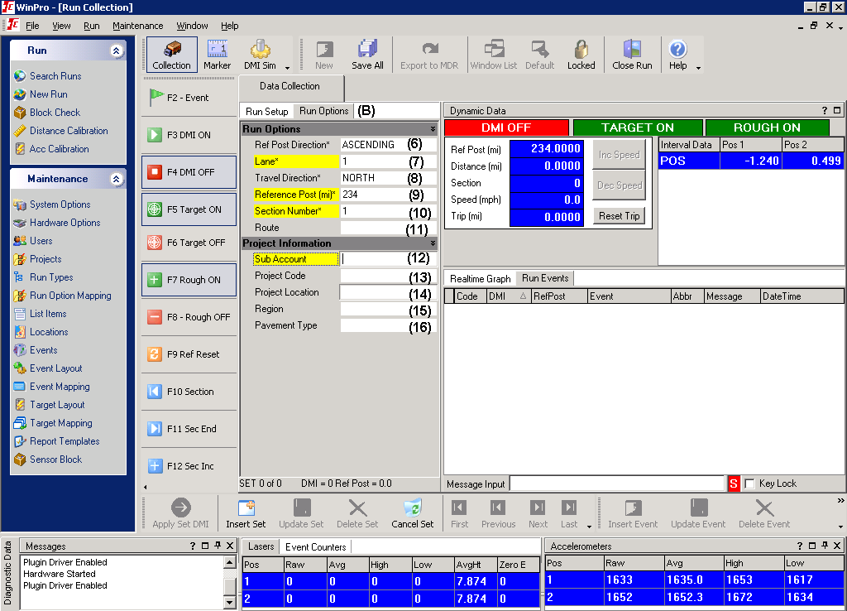

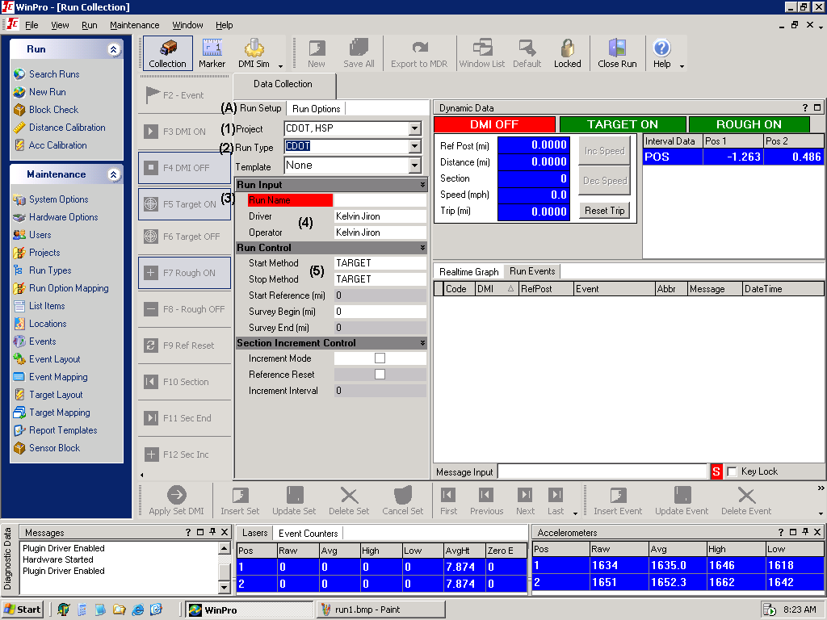
Figure 74-2
A2.9 When the vehicle has reached the testing speed press the F3 DMI ON button. This button starts data collection.

A2.10 Maintain a constant speed and position the profiler in the center of the lane.

A2.11 As you pass each of the triggers (cone with reflective tape or reflective tape) check the event screen to make sure that the profiler detected the trigger.

A2.12 After passing the final trigger allow the profiler to run for at least an additional 20 ft, and then press the F4 DMI OFF button. This button stops data collection.

A2.13 Bring the vehicle to a stop. Press the Export to MDR button. A screen will popup asking you where to store the data. Select the correct directory and hit OK. Record the name of the run in the Profiler Log along with any comments about the run.

NOTE 5: The profiler exports three files with the same name. The File name will be the same as the Run Name entered in Section A2.6. The files extensions are .P$$, .V$$ & .E$$. Each successive run will increase the number of the extension. For example the 1st run will have extensions of .P01, .V01 & .E01. The 2nd run will be .P02, .V02 & .E02.

A2.14 Repeat procedures A2.8 to A2.13 until all lanes have been profiled three times.

A2.15 Transfer the files of each run to the Engineer for analysis.

A3. DATA ANALYSIS

Segment Report

A3.1 Open the WINRP90L program and use the following inputs (Figure 3):

(1) Select "Interval Report"
(2) Select "General"
(3) Select "Miles"
(4) Check "IRI" & "Speed"
Select "Half Car" in the Avg/HCS box
Set the scale to "in/mi"
(5) Check "Filter Options";
Set Moving Avg to "1"
Set Wavelength to "300.00"
(6) Check "Section Control"
Check "Roughness Control"
Check "Interval Control"
Check "Interval Reset"
Check "Use Speed File"
Set the Interval to "0.100" for in/mi projects or “0.050” for %I projects
Set Spd Limit to "15.00"

A3.2 Click "Process Input File(s)". A window will open asking what files to open. Go to the directory and select the files that need to be processed. After the files are processed a results text file will be created. The results text file will have the same name as the profile file but it will have a .A$$ extension. The text file that is created can be opened in any text editor such as MS Word or Notepad. The results files can also be imported into MS Excel for analysis.

A3.3 From the output file you can determine where excluded areas are. The Results file will place a (S) on the next line to indicate a new section caused by a trigger. (See Example 2)

Localized Roughness

A3.4 To find areas of localized roughness, the ICC files must be converted into a file format that can be read by ProVAL. The ERD file format is what will be used

NOTE 6: On percent improvement project, localized roughness is not used.

A3.5 To convert the ICC file format to the ERD Format, open the WINRP90L program and use the following inputs (Figure 74-3):

(1) Select "ERD (ft or m)"
(2) Select "General"
(3) Select "Miles"
(5) Check "Filter Options";
Set Moving Avg to "1"
Set Wavelength to "300.00"
(6) Check "Section Control"
Check "Roughness Control"
Check "Interval Control"
Check "Interval Reset"
Check "Use Speed File"
Set Interval to "0.100"
Set Spd Limit to "15.00"

A3.6 Click "Process Input File(s)". A window will open asking what files to open. Go to the directory and select the files that need to be processed. After the files are processed a new file will be created. The new file will have the same name as the profile file but it will have a _$$.ERD extension. The _$$ will indicate the run number.
NOTE 7: The third run of each lane will be used for the localized roughness analysis.

A3.7 Open the ProVAL program. Verify that the version installed on your computer is version 2.60.009 or later. To check the version of ProVAL, click Help, and then click About…. A new window will popup showing the version. (Figure 74-4)

A3.8 Open a run by clicking the open button and locating your file.

A3.9 Click on the Analysis tool bar and select “Ride Stats Continuous” This will pull up the module that will be used to locate areas of localized roughness.

A3.10 Enter the following information into the inputs (Figure 74-5):
Analysis pull down “HRI”
IRI Threshold “Value from Table 105-6”
Sliding Base Length “25” feet
Check the Left Elevation and Right Elevation for the profile in the upper left hand corner
Check the Apply 250mm Filter

A3.11 Press the “Analyze” button. A continuous report graph will be produced. A table will also be produced showing the areas of the profile that exceed the localized roughness criteria.

A3.12 Press the “CSV Export” button to save the results. The file that is saved will be in the same directory as the profile, and share the same file name as the profile, but will have a CSV file extension instead of ERD.

A4. REPORT

A4.1 Compile each of the data files into a summary sheet showing: lane number, travel direction, start and stop locations, distance, HRI values for the three runs, average HRI of the three runs, lane width, area, locations of localized roughness, pay factor and pay adjustment. (See Example 2)

Figure 74-3

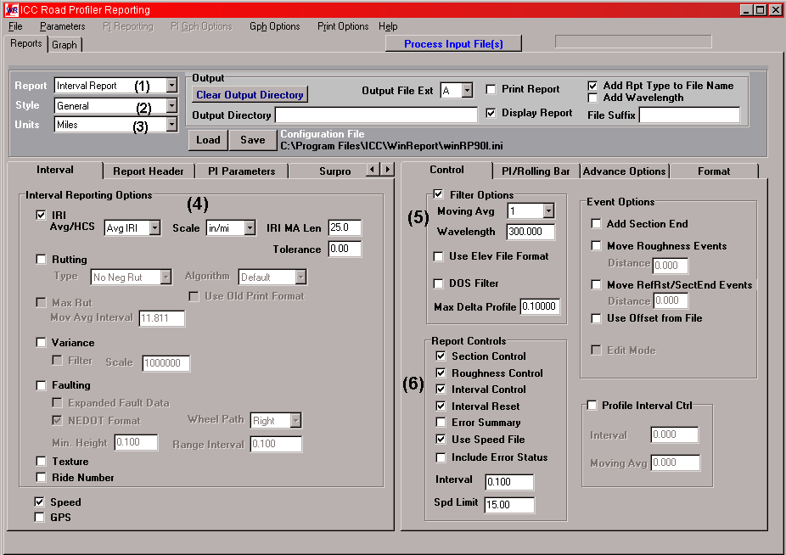

Figure 74-4

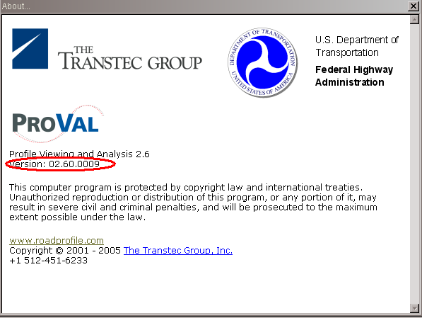

Figure 74-5

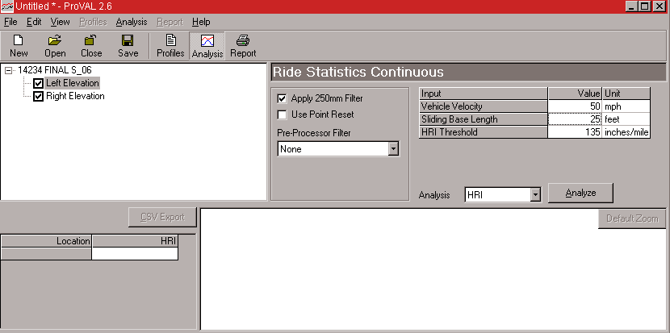
Example 2

An interstate project in Region 2 has been recently completed. The project is approximately 2.5 miles in length. Construction consisted of a 2” milling and a 2” SMA overlay, so the pavement smoothness category is Half-Car Roughness Index (HRI) Category I (Inches/mile). The project has a bridge approximately ¾ of mile into the project. The bridge’s asphalt overlay was not replaced by this project so the whole bridge is excluded from the profile.

Creating a Segment Report

The following is a report produced by the ICC WinReport program for one run following Procedures A3.1 thru A3.2:

DATE COLLECTED: 7/09/2006 TIME: 13:03:31
FILE NAME: C:\FINAL.P06
OPERATOR: Kelvin Jiron ROUTE: I-25
WAVELENGTH-LONG: 300 ft IRI SCALE: in/mi
START METHOD: TARGET STOP METHOD: TARGET
LANE: 1 DIRECTION: South(+)
SUB ACCOUNT: 25554
PROJECT CODE: IM 0250-100
PROJECT LOCATION: I-25
MILE POST: 0.0 to 2.5
REGION: 2
PAVEMENT TYPE: HMA
MILES IN/MI MPH
ROUGH HCS
FROM TO DIST IRI 1 IRI 2 IRI SPEED
------------ ------------ ------- ------ ------ ------ -----
0.0000 0.1000 0.1000 60.4 68.8 53.3 58.3(R)(S)
0.1000 0.2000 0.1000 52.5 57.2 44.7 58.3
0.2000 0.3000 0.1000 45.9 51.9 37.3 58.3
0.3000 0.4000 0.1000 79.8 66.2 56.3 58.3
0.4000 0.5000 0.1000 65.4 72.2 54.3 58.3
0.5000 0.6000 0.1000 60.1 67.4 51.4 58.3
0.6000 0.7000 0.1000 64.8 64.4 52.8 58.3
0.7000 0.7491 0.0491 55.9 48.7 37.7 58.3
0.7491 0.8005 0.0514 74.3 75.6 64.3 58.3(S)
0.8005 0.9005 0.1000 75.1 72.9 57.5 58.3(S)
0.9005 1.0005 0.1000 74.0 75.2 58.2 58.3
1.0005 1.1005 0.1000 65.7 61.0 53.4 58.3
1.1005 1.2005 0.1000 75.8 60.5 55.5 58.3
1.2005 1.3005 0.1000 66.2 64.6 52.1 58.3
1.3005 1.4005 0.1000 59.5 65.3 49.7 58.3
1.4005 1.5005 0.1000 65.8 52.4 45.9 58.3
1.5005 1.6005 0.1000 62.5 56.0 44.7 58.3
1.6005 1.7005 0.1000 77.6 67.1 54.8 58.3
1.7005 1.8005 0.1000 65.4 66.8 50.1 58.3
1.8005 1.9005 0.1000 59.6 58.3 47.7 58.3
1.9005 2.0005 0.1000 77.1 77.5 63.2 58.3
2.0005 2.1005 0.1000 82.6 77.6 63.9 58.3
2.1005 2.2005 0.1000 72.9 63.8 52.9 58.3
2.2005 2.3005 0.1000 58.1 60.8 45.2 58.3
2.3005 2.4005 0.1000 66.5 65.1 52.9 58.3
2.4005 2.4740 0.0735 67.1 67.7 53.6 58.3
============ ============ ======= ====== ====== ====== =====
0.0000 2.4740 2.4740 66.6 64.9 52.1 58.3

The ICC reports can be opened with MS Notepad, MS Word, and MS Excel or any text editor.

In this report, the (R) at the end of the 1st segment shows that the reference point was set to zero indicating the beginning of a run. The (S) at the end of a segment, shows that a section was started. In this report there are three section marks. The 1st is at the beginning of the lane. The 2nd indicates where the beginning of the bridge is. The third indicates the end of the bridge. In this case the bridge is located at 0.7491 to 0.8005 miles. The location is always miles from the beginning of the lane and has no correlation to mile posts or stationing. These section marks are inserted into the profile when the profiler passes the cones with reflective tape. At the beginning of each section, the 0.1 mile increment is started over so you could have numerous short segments if you have multiple leave out areas.

In this example Excel will be used to create the summary report. To open an ICC report in Excel, follow the following steps:

- Click File
- Click Open
- In the Open window, locate the file you want to open and click open. You will have to tell Excel to show all files
- The Text Import Wizard will pop-up. For text type pick Fixed Width then click next
- The Text Import Wizard will now show you a data preview where you can select the column widths. Change the columns to 18, 21, 33, 44, 49, 59 and 61 and click finish.

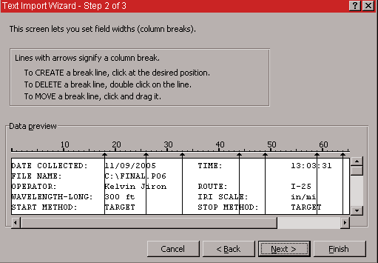

These steps will convert the ICC report into a usable Excel format allowing you to cut and paste columns of data for analysis.

The flowing is the ICC file converted to an Excel format:

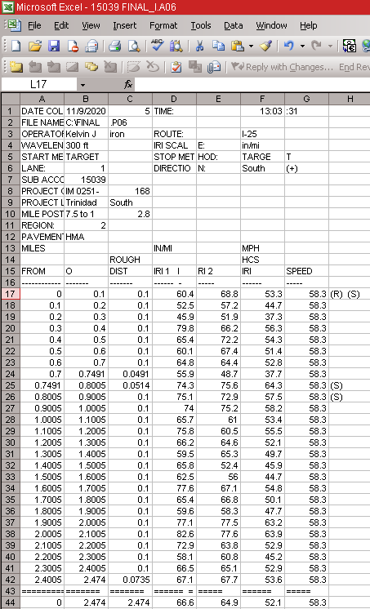

With this format you can now cut and paste the data to create a summary report similar to the following for each lane:

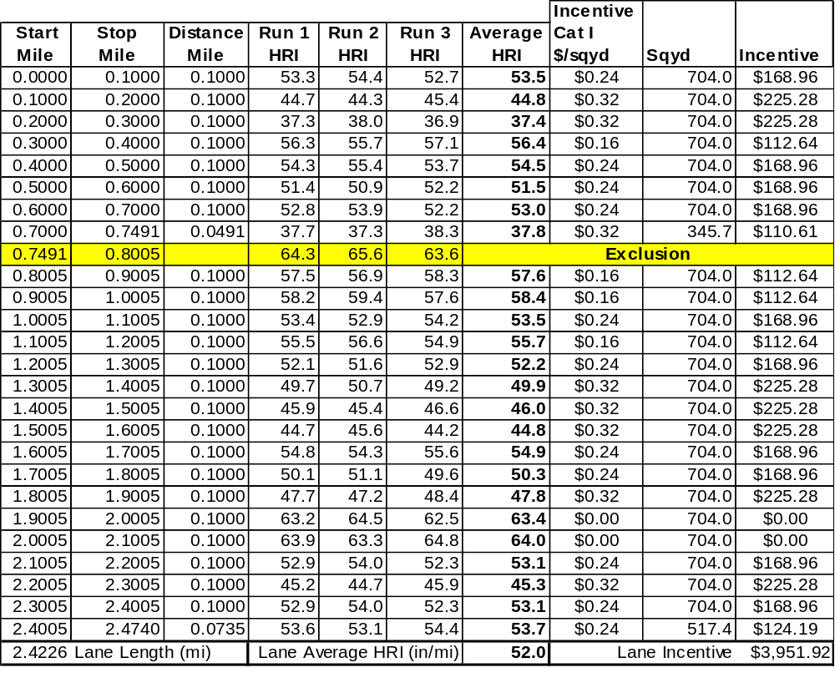
Creating a Localized Roughness Report

The following is a report produced by ProVAL for one run following Procedures A3.4 thru A3.12:

Location (miles),HRI (inches/mile)
0.0025 to 0.0030,140.67
1.2913 to 1.2930,146.87
1.9623 to 1.9624,135.52
2.0868 to 2.0877,145.54
2.0891 to 2.0892,135.38
2.0900 to 2.0901,135.13

The report lists the beginning and ending distance where the localized roughness occurs. These distances are from the beginning of the lane. The 3rd number is the HRI at the midpoint of the localized roughness. Cross reference the exclusion areas and delete areas of localized roughness that fall within the exclusion areas.

The following is a screenshot of ProVAL’s Ride Statistics Continuous module:

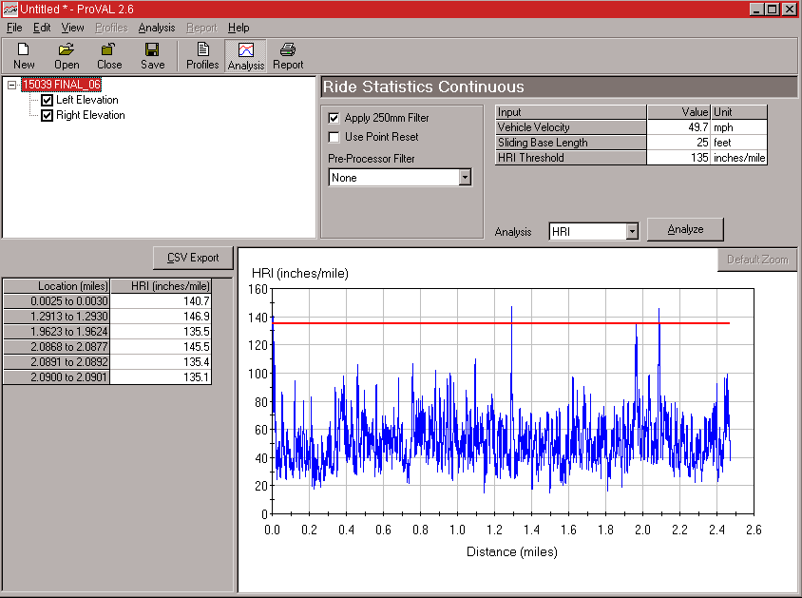

Colorado Procedure 78-08a

Standard Practice for

Certification of High Speed Profilers

1. SCOPE

1.1 This test method describes the procedures for certifying high speed profilers for use on CDOT projects.

2. REFERENCED DOCUMENTS

2.1 International Cybernetics Corp. SurPRO 2000 User’s Manual.

2.2 ASTM Standards:

E 1926 Computing International Roughness Measurements Index of Roads from Longitudinal Profile Measurements

2.3 AASHTO Standards:

MP 11-03 Standard Equipment Specification for Inertial Profiler

3. EQUIPMENT

3.1 International Cybernetics Corporation’s SurPRO 2000.

3.2 High Speed Profiler

3.2.1 The High Speed Profiler (HSP) shall meet the specifications of AASHTO MP 11

3.2.2 The HSP shall use the following operation parameters:

3.2.2.1 The height sensor spacing shall be 70 +/- 1 inch.

3.2.2.2 The sample interval at which relative profile elevations are reported shall be less than or equal to two inches.

3.2.2.3 The algorithm for filtering the profile data shall use a cutoff wavelength of 300 feet.

3.2.2.4 The HSP shall be capable of using automated triggering to start and stop data collection.

4. OPERATOR REQUIREMENTS

  - The Operator shall have a current LabCAT Level S Certification

5. REFERENCE SITE SELECTION

5.1 The Colorado Department of Transportation will select a site to perform the HSP Certification with the following requirements:

5.1.1 Shall be a relatively strait and level.

5.1.2 Shall have a sufficient distance for five consecutive 0.1mile sections and sufficient distance to safely start and stop with a 300 foot lead-in.

5.1.3 Two of the five 0.1 mile sections should have an average IRI value between 30 and 90 in/mile.

5.1.4 Shall be on a surface where surface texture will have a minimal impact on data collection.

5.1.5 Shall be free of cracks in the traveled wheel paths.

5.1.6 Shall be on a relatively stable base with minimal traffic.

6. REFERENCE VALUE DETERMINATION

6.1 The device for determining the reference values shall be an ICC SurPRO 2000.

6.2 The reference site will be painted with a dot every 10 feet in the wheel paths.

6.3 The reference device will perform ten data collection runs for each wheel path in the intended direction of travel.

6.4 The IRI for each 0.1 mile section in each wheel path will be determined for each run.

6.5 A standard deviation of the ten runs will be determined for each 0.1 mile section for each wheel path.

6.6 The standard deviations for each 0.1 mile section for each wheel path shall not exceed 3.0 in/mile. If the standard deviation of one or more 0.1 mile sections exceed 3.0 in/mile, the ten runs shall be repeated.

6.7 The average IRI of the ten runs for each 0.1 mile section for each wheel path will be used as the reference values for the HSP certification. These values will not be shared with the participants.

7. CERTIFICATION PROCEDURE

7.1 Prior to the HSP collecting certification data, the HSP’s distance measuring instrument shall be calibrated following the manufacturer’s procedures.

7.2 The HSP operator shall perform ten runs in the intended direction of travel.

7.3 The HSP operator shall generate printed reports for each run indicating the left and right wheel path IRIs for each 0.1 mile section. The reports shall be submitted to the Department for evaluation immediately after the completion of the ten runs.

7.4 Data files for the ten runs shall be submitted to the Department on electronic media, such as a thumb drive or compact disk immediately after the completion of the ten runs. The media will not be returned to the operator.

7.5 The data files will be analyzed by the Department.

8. ACCEPTANCE DETERMINATION

8.1 An average and standard deviation of the ten runs will be determined for each 0.1 mile section for each wheel path.

8.2 The HSP will be considered acceptable when:
- The standard deviation for each 0.1 mile section does not exceed 3.0 in/mile
- The average IRI for each 0.1 mile section does not vary from the reference IRI values by more than 6.0 in/mile.
- The results reported by the profiler operator match the results determined by the Department within 0.1 in/mile for each 0.1 mile segment.

9. CERTIFICATION

9.1 After a HSP is determined to be acceptable, a Certificate will be issued listing:
- HSP serial number
- HSP VIN number
- HSP Make and Model
- Height sensor serial numbers
- Accelerometer serial numbers
- Certification Date
- Expiration Date

9.2 The certification will expire after one year.

9.3 A list of certified profiler will posted on CDOT’s website at:
http://www.dot.state.co.us/DesignSupport/

10. SUSPENSION OF CERTIFICATION

NOTE 1: This section is used when a Contractor’s profiler fails to meet the Smoothness Verification Testing acceptance criteria.

10.1 The Contractor’s profiler shall make three repeat runs at a site chosen by the Department. The site will meet the requirements of Section 5.

10.2 CDOT’s profiler will make three runs of the site.

10.3 The data files for the three runs shall be submitted to the Department on electronic media, such as a thumb drive or compact disk. The media will not be returned to the Contractor.

10.4 The Department will determine an average IRI for each 0.1 mile section using the Department’s profiler’s results.

10.5 The Contractor’s Profiler’s results will be compared to the Department’s results.

10.6 The Contractor’s Profiler will retain its certification if the average IRI for each 0.1 mile section does not vary from the Department’s IRI values by more than 6.0 in/mile.

10.7 If the Contractor’s profiler fails to meet the criteria in Section 10.6, the Contractor’s profiler will be allowed to make three additional runs and be re-evaluated.

10.8 If the Contractor’s profiler fails to meet the criteria in Section 10.6 a second time, the Contractor’s profiler’s Certification will be suspended.

10.9 The Contractor’s profiler shall be repaired and/or adjusted/calibrated by the manufacturer.

  - If the Contractor wants to have his profiler recertified after repairs have been made prior to the next annual certification, all costs associated with recertification shall be borne by the Contractor.

