MEMORANDUM

DEPARTMENT OF TRANSPORTATION
Project Development Branch, Standards and Specifications Unit

4201 East Arkansas Avenue
Denver, Colorado 80222
(303)757-9474
FAX (303)757-9820
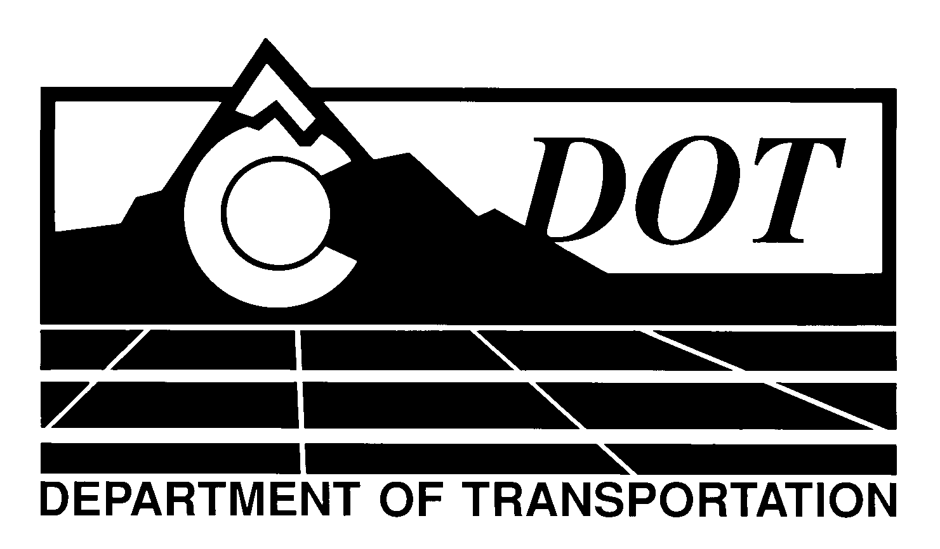

DATE: January 6, 2012

TO: All Holders of Special Provisions

FROM: Larry Brinck, Standards and Specifications Engineer

SUBJECT: Revision of Section 109, Measurement of Water

Effective this date, our unit is issuing a new standard special provision, Revision of Section 109, Measurement of Water. This new standard special provision is 1 page long. Use this standard special provision in all projects, beginning with projects advertised on or after February 2, 2012. Please feel free, however to use it in projects advertised before this date.

This new standard special provision corrects a typographical error in subsection 109.01 by changing the accuracy of water meters from 63 percent to ± 3 percent.

Those of you who keep books of standard special provision should add this new standard special to your file.

For your convenience, this and other special provisions that are being issued effective this date can be found at:

http://www.coloradodot.info/business/designsupport/construction-specifications/2011-Specs

We are also enclosing a new Index of Standard Special Provisions, effective this same date.

If you have any questions or comments, please contact this office.

LB/mrs

Attachments

Distribution: Per distribution list

