MEMORANDUM

DEPARTMENT OF TRANSPORTATION
Project Development Branch

4201 East Arkansas Avenue
Denver, Colorado 80222
(303)757-9040
FAX (303)757-9868
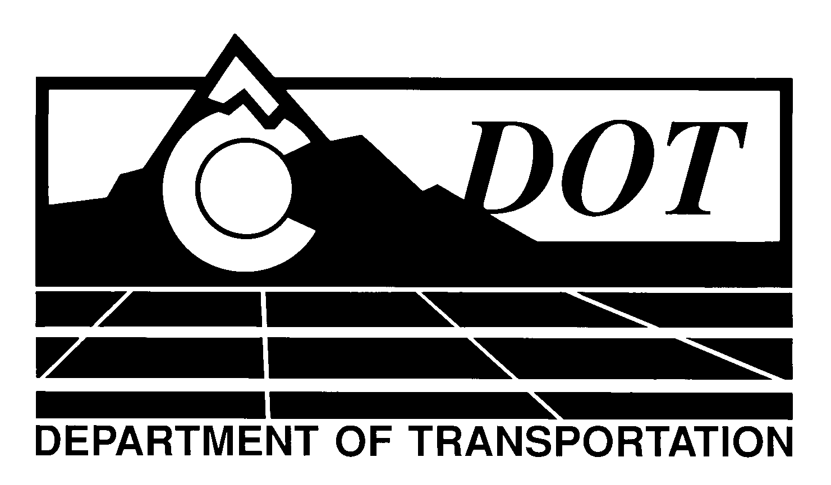

DATE: April 26, 2012

TO: All Holders of Standard Special Provisions

FROM: Larry Brinck, Standards and Specifications Engineer

SUBJECT: Revision of Sections 105, 106, 412, and 601, Conformity To The Contract Of Portland Cement Concrete Pavement And Dowel Bars For Transverse Weakened Plane Joints

Effective this date, our unit is issuing a revised version of the standard special provision, Revision of Sections 105, 106, 412, and 601, Conformity To The Contract Of Portland Cement Concrete Pavement And Dowel Bars For Transverse Weakened Plane Joints. This revised standard special is 13 pages long. It replaces and makes obsolete the standard special provision having the same name, dated June 16, 2011. It should be used in project having portland cement concrete pavement (PCCP), beginning with projects advertised on or after May 24, 2012. Please feel free, however, to include it projects advertised before this date.

This revision deletes a sentence in 106.06 (c) which erroneously references Table 106-2 for CDOT testing. Table 106-2 is only for the Contractor’s use. CDOT’s testing process is defined in the Field Materials Manual.

Those of you who keep books of Standard Special Provisions should replace the now obsolete version of this special provision with this revised one. For your convenience, we are attaching a new Index of Standard Special Provisions, effective this same date. In addition, you will find this and other special provisions that are being issued this date in one place in the CDOT Construction Specifications web site:

http://www.coloradodot.info/business/designsupport/construction-specifications/2011-Specs

Please click on the hyperlink titled “Specification Changes Under Consideration”.

LB/mrs

Attachments

Distribution: Per distribution list

