MEMORANDUM

DEPARTMENT OF TRANSPORTATION
Project Development Branch

4201 East Arkansas Avenue
Denver, Colorado 80222
(303)757-9040
FAX (303)757-9868
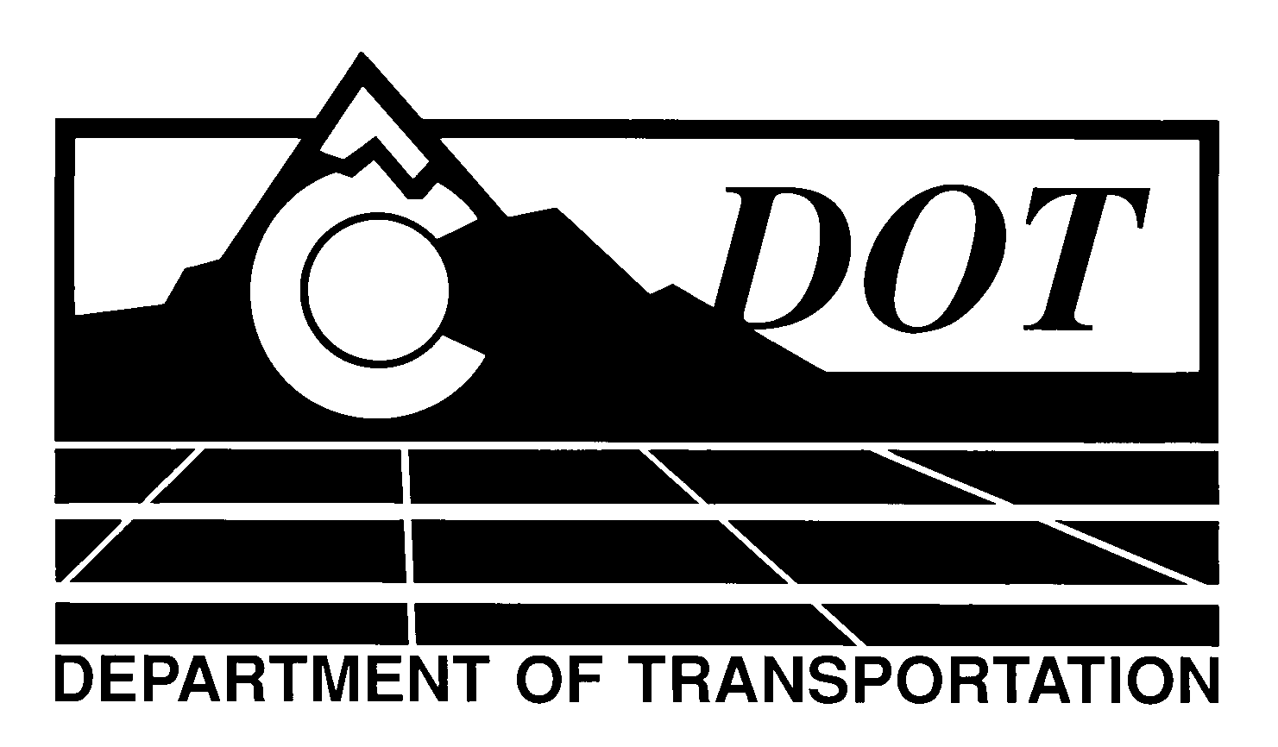

DATE: April 26, 2012

TO: All Holders of Standard Special Provisions

FROM: Larry Brinck, Standards and Specifications Engineer

SUBJECT: Revision of Sections 603, 624 and 705, Drainage Pipe

Effective this date, our unit is issuing a revised version of the standard special provision, Revision of Sections 603,624 and 705, Drainage Pipe. This revised standard special provision is 2 pages long, and replaces the current standard special provision, Revision of 624, Culvert and Sewer Pipe dated February 3, 2011. It should be used in projects having any type of culvert pipe, beginning with projects advertised on or after May 24, 2012. Please feel free, however, to include it projects advertised before this date.

This revision allows PVC to be used for storm drains. This revision requires that joint systems for siphons, irrigation systems, and storm drains be watertight. It also references ASTM D3212 for watertight plastic pipe systems. Please note that the title of this standard special provision has also changed.

Those of you who keep books of Standard Special Provisions should replace the now obsolete special provision with this one. For your convenience, we are attaching a new Index of Standard Special Provisions, effective this same date. In addition, you will find this and other special provisions that are being issued this date in one place in the CDOT Construction Specifications web site:

http://www.coloradodot.info/business/designsupport/construction-specifications/2011-Specs

Please click on the hyperlink titled “Specification Changes Under Consideration”.

LB/mrs

Attachments

Distribution: Per distribution list

