MEMORANDUM

DEPARTMENT OF TRANSPORTATION
Project Development Branch, Standards and Specifications Unit

4201 East Arkansas Avenue
Denver, Colorado 80222
(303)757-9474
FAX (303)757-9820
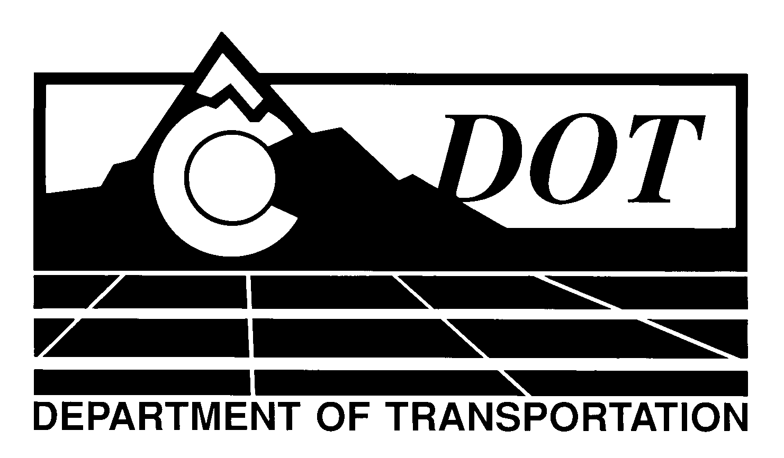

DATE: May 2, 2013

TO: All Holders of Standard Special Provisions

FROM: Larry Brinck, Standards and Specifications Engineer

SUBJECT: FASTER Monthly Employment Report

The attached document is a revised version of the standard special provision, FASTER Monthly Employment Report. This revised standard special is 1 page long. It replaces a now obsolete standard special provision of the same title, dated February 3, 2011. It should be used in projects that are partly or wholly funded by the Funding Advancements for Surface Transportation and Economic Recovery (FASTER) legislation. The use of this special provision becomes mandatory on May 30, 2013. You may use it before this date.

The modifications in this revision upgrades the e-mail address to which a completed Form 1405 should be sent. It also upgrades the location of this special provision to its current location on the 2011 Construction Specifications web page.

Those of you who keep books of Standard Special Provisions should replace the now obsolete this standard special provision in your file with this revised version your file. The CDOT Construction Specifications web site has been updated to reflect the issuance of this and other special provisions.

For your convenience, however, you will find this new standard special provision and other special provisions that have been issued effective this date in one place on the web site:

http://www.coloradodot.info/business/designsupport/construction-specifications/2011-Specs/recently-issued-special-provisions

If you have any questions or comments, please contact this office.

LB/ms

Attachments

Distribution: Per distribution list

