MEMORANDUM

DEPARTMENT OF TRANSPORTATION
Project Development Branch, Standards and Specifications Unit

4201 East Arkansas Avenue
Denver, Colorado 80222
(303)757-9474
FAX (303)757-9820
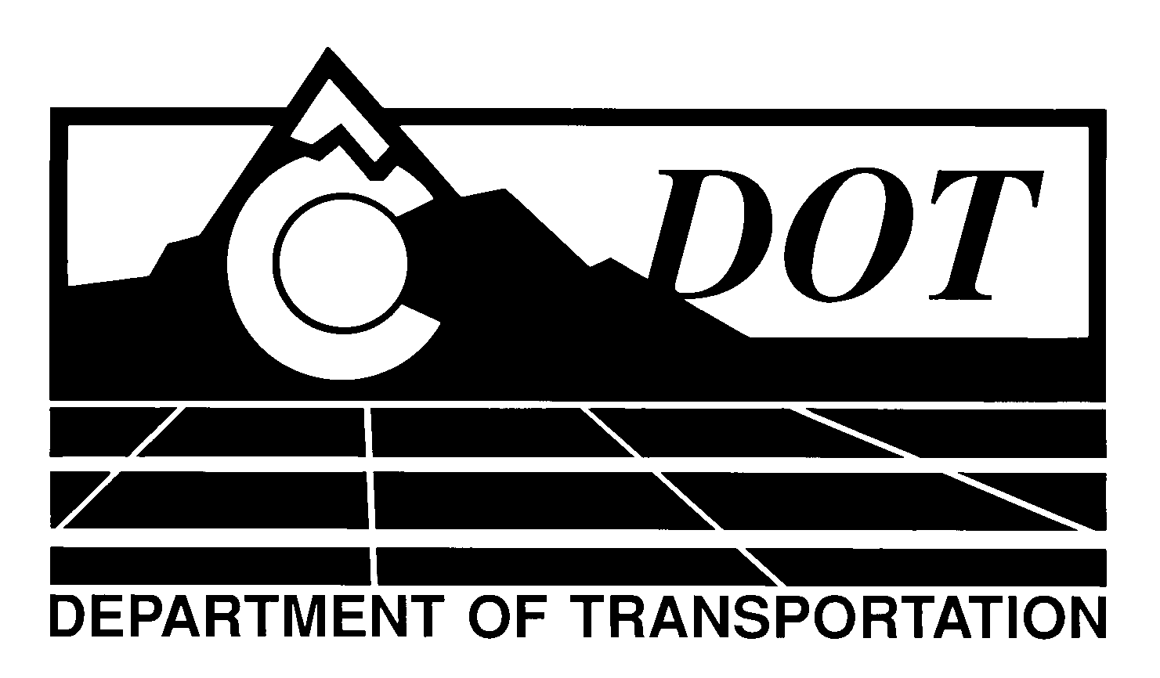

DATE: October 31, 2013

TO: All Holders of Standard Special Provisions

FROM: Larry Brinck, Standards and Specifications Engineer

SUBJECT: Revision of Section 518, Bridge Expansion Device

Effective this date, our unit is issuing a new standard special provision, Revision of Section 518, Bridge Expansion Device. This new standard special provision is 1 page long, and should be used in projects having bridge expansion devices, beginning with projects advertised on or after November 28, 2013.

This new standard special provision requires that structural steel elements of a bridge expansion device be galvanized to reduce corrosion.

Those of you who keep books of Standard Special Provisions should add this new special provision to your file. The CDOT Construction Specifications web site has been updated to reflect the issuance of this and other special provisions.

For your convenience, however, you will find this new standard special provision and other special provisions that have been issued effective this date in one place on the web site:

http://www.coloradodot.info/business/designsupport/construction-specifications/2011-Specs/recently-issued-special-provisions

If you have any questions or comments, please contact this office.

LB/ms

Attachments

Distribution: Per distribution list

