MEMORANDUM

DEPARTMENT OF TRANSPORTATION
Project Development Branch, Standards and Specifications Unit

4201 East Arkansas Avenue
Denver, Colorado 80222
(303)757-9474
FAX (303)757-9820
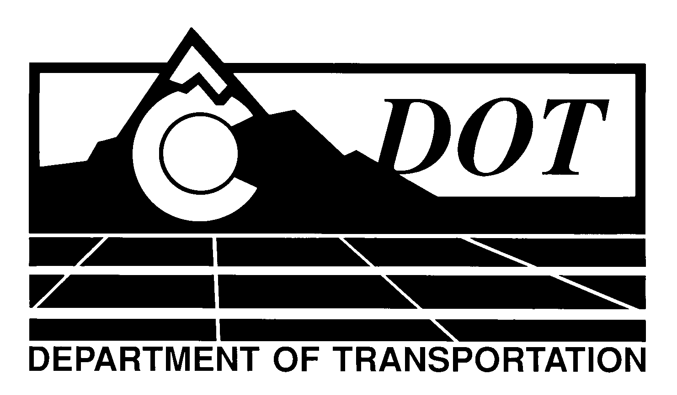

DATE: October 23, 2013

TO: All Holders of Standard Special Provisions

FROM: Larry Brinck, Standards and Specifications Engineer

SUBJECT: Deletion of Revision of Sections 603, 624, and 705, Drainage Pipe

Effective this date, our unit is deleting the Standard Special Provision, Revision of Sections 603, 624, and 705, Drainage Pipe, dated April 26, 2012 .

The contents of this now obsolete Standard Special Provision are being incorporated into a new Sample Project Special Provision, Revision of Sections 603, 624, 705 and 712, Drainage Pipe.

Those of you who keep books of Standard Special Provisions should remove this now obsolete Standard Special from your file. The CDOT Construction Specifications web site and the Index of Standard Special Provisions have been updated to reflect this deletion.

For your convenience, however, you will find the new sample project special provision on the web site by visiting:

http://www.coloradodot.info/business/designsupport/construction-specifications/2011-Specs/recently-issued-special-provisions

If you have any questions or comments, please contact this office.

LB/ms

Attachments

Distribution: Per distribution list

