MEMORANDUM

DEPARTMENT OF TRANSPORTATION
Project Development Branch, Standards and Specifications Unit

4201 East Arkansas Avenue
Denver, Colorado 80222
(303)757-9474
FAX (303)757-9820
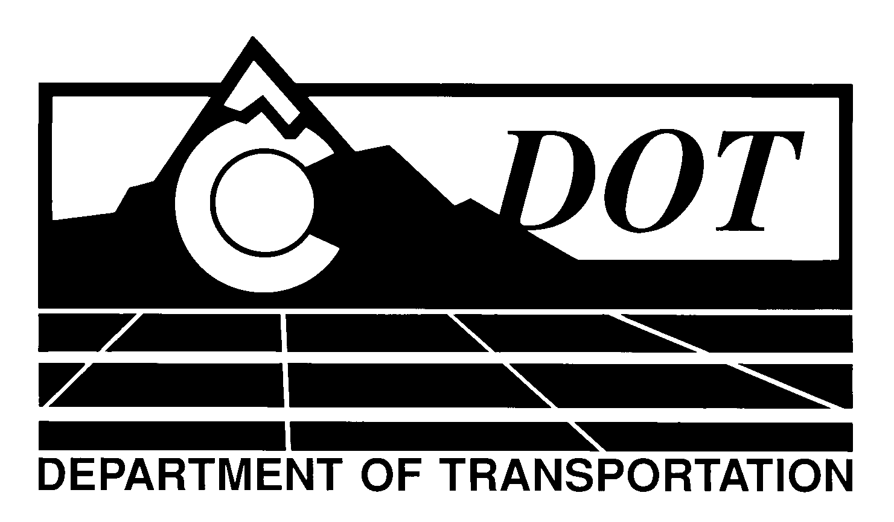

DATE: January 30, 2014

TO: All Holders of Standard Special Provisions

FROM: Larry Brinck, Standards and Specifications Engineer

SUBJECT: Revision of Section 105, Disputes and Claims for Contract Adjustments

Effective this date, our unit is issuing a revised version of the Standard Special Provision, Revision of Section 105, Disputes and Claims for Contract Adjustments. This revised standard special is 31 pages long, and replaces the standard special provision of the same title dated January 31, 2013. It should be used in all Design-Bid-Build projects and Modified Design/Build projects. Use in Design/Build projects unless a modified version of this standard special provision is approved by the Standards & Specifications Unit. Use of this revised Standard Special Provision is mandatory on projects advertised on or after February 27, 2014. You are free, however, to use it in projects advertised before this date.

The modifications in this revision correct an inadvertent error in subsection 105.22(b) by changing references to subsections 108.07 (a) and 108.07 (d) to 108.08 (a) and 108.08 (d).

Those of you who keep books of Standard Special Provisions should replace the now obsolete standard special provision with this revised version. The CDOT Construction Specifications web site has been updated to reflect the issuance of this and other special provisions.

For your convenience, however, you will find this standard special provision and other special provisions that have been issued effective this date in one place on the web site:

http://www.coloradodot.info/business/designsupport/construction-specifications/2011-Specs/recently-issued-special-provisions

If you have any questions or comments, please contact this office.

LB/ms

Attachments

Distribution: Per distribution list

