MEMORANDUM

DEPARTMENT OF TRANSPORTATION
Project Development Branch, Standards and Specifications Unit

4201 East Arkansas Avenue
Denver, Colorado 80222
(303)757-9474
FAX (303)757-9820
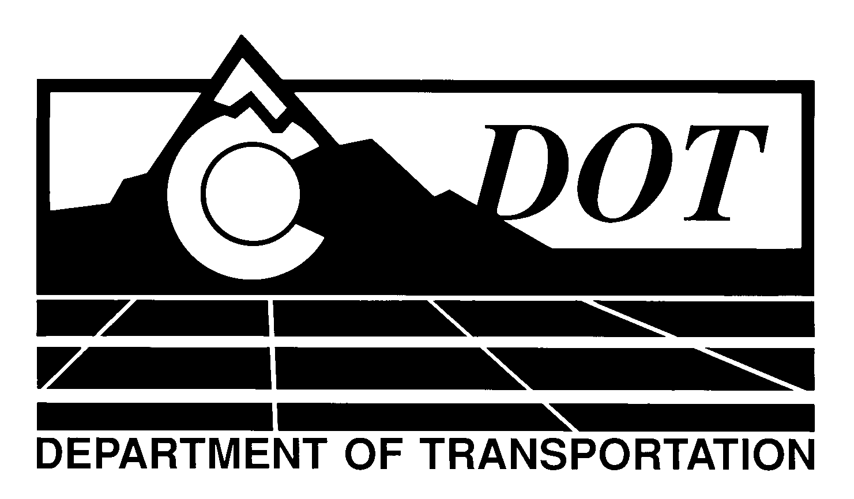

DATE: January 30, 2014

TO: All Holders of Standard Special Provisions

FROM: Larry Brinck, Standards and Specifications Engineer

SUBJECT: Revision of Section 107, Warning Lights for Work Vehicles and Equipment

Effective this date, our unit is issuing a new Standard Special Provision, Revision of Section 107, Warning Lights for Work Vehicles and Equipment. This new standard special is 1 page long, and should be used in all projects, beginning with those advertised on or after February 27, 2014. You are free, however, to use it in projects advertised before this date.

This new standard special defines the requirements and uses of warning lights on construction vehicles and equipment.

Those of you who keep books of Standard Special Provisions should add this new standard special provision to your file. The CDOT Construction Specifications web site has been updated to reflect the issuance of this and other special provisions.

For your convenience, a new Index of Standard Special Provisions, effective this same date, has been attached. In addition, you will find this new standard special provision and other special provisions that have been issued effective this date in one place on the web site:

http://www.coloradodot.info/business/designsupport/construction-specifications/2011-Specs/recently-issued-special-provisions

If you have any questions or comments, please contact this office.

LB/ms

Attachments

Distribution: Per distribution list

