MEMORANDUM

DEPARTMENT OF TRANSPORTATION
Project Development Branch, Standards and Specifications Unit

4201 East Arkansas Avenue
Denver, Colorado 80222
(303)757-9474
FAX (303)757-9820
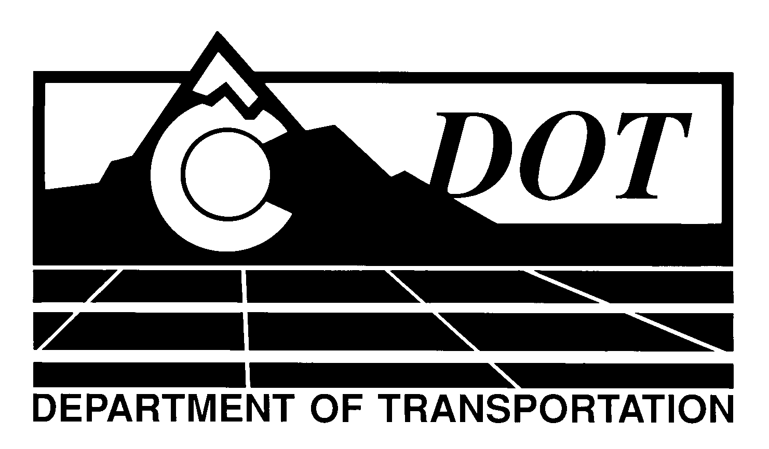

DATE: January 30, 2014

TO: All Holders of Standard Special Provisions

FROM: Larry Brinck, Standards and Specifications Engineer

SUBJECT: Revision of Section 216, Soil Retention Covering

Effective this date, our unit is issuing a new standard special provision, Revision of Section 216, Soil Retention Covering. This new standard special is 6 pages long, and should be used in projects having soil retention blanket or turf reinforcement mat.

Use of this revised Standard Special Provision is mandatory on projects advertised on or after February 27, 2014. You are free, however, to use it in projects advertised before this date.

This new standard special upgrades soil retention covering requirements to the industry accepted standards, and provides details on the installation of these coverings.

Those of you who keep books of Standard Special Provisions should add the new Standard Special Provision to your file. The CDOT Construction Specifications web site has been updated to reflect the issuance of this and other special provisions.

For your convenience, however, you will find this new standard special provision and other special provisions that have been issued effective this date in one place on the web site:

http://www.coloradodot.info/business/designsupport/construction-specifications/2011-Specs/recently-issued-special-provisions

If you have any questions or comments, please contact this office.

LB/ms

Attachments

Distribution: Per distribution list

