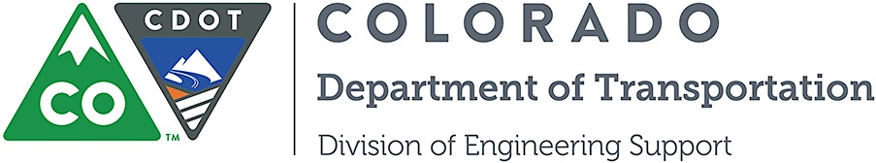

Memorandum

DATE: May 8, 2014

TO: All holders of Standard Special Provisions

FROM: Larry Brinck, Standards and Specifications Engineer

SUBJECT: Revision of Section 105, Portland Cement Concrete Pavement Smoothness

Effective this date, our unit is issuing a revised version of the Standard Special Provision, Revision of Section 105 Portland Cement Concrete Pavement Smoothness. This revised standard special is 1 page long. It replaces the now obsolete standard special provision having the same title dated April 26, 2012.

This revised standard special should be used Use on all projects having PCCP pavement. The designer will specify the roadway pavement smoothness category in the General Notes if it is not HRI Category II. Please note this specification requires a Force Account item for incentive payment.

Use of this revised Standard Special Provision is mandatory on projects advertised on or after June 5, 2014. You are free, however, to use it in projects advertised before this date.

The modifications in this revision upgrade the pavement smoothness requirements for PCCP pavement. They add temperature requirements for testing, and require full lane grinding for corrective work.

Those of you who keep books of Standard Special Provisions should replace the now obsolete standard special provision with this revised version. The CDOT Construction Specifications web site has been updated to reflect the issuance of this and other special provisions.

For your convenience, however, you will find this standard special provision and other special provisions that have been issued effective this date in one place on the web site:

http://www.coloradodot.info/business/designsupport/construction-specifications/2011-Specs/recently-issued-special-provisions

If you have any questions or comments, please contact this office.

Attachments

Distribution: Per distribution list

