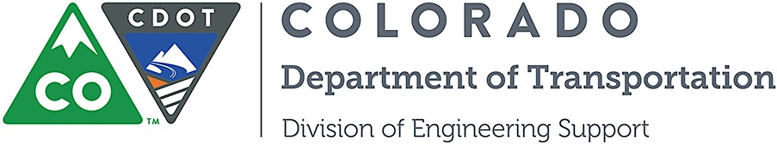

Project Development Branch
Standards and Specifications Unit

Memorandum

DATE: November 28, 2014

TO: All holders of Standard Special Provisions

FROM: Larry Brinck, Standards and Specifications Engineer

SUBJECT: The Minimum Wages on Federal Aid Projects

Effective this date, our unit is issuing a revised Minimum Wages, Colorado, U.S. Department of Labor General Decision Number CO140018, MOD 3 standard special provision. This revised standard special is 6 pages long, and dated November 28, 2014. It is to be included in all federal aid projects beginning with projects that have bid openings on December 8, 2014 or later. Use this standard special provision on all federal-aid projects with contracts exceeding $2000, except for non-ARRA projects on roadways classified as local roads or rural minor collectors, which are exempt. Projects on local roads, rural minor collectors, and enhancement projects funded with ARRA funds are not exempt.

MOD 3 changed the wage and fringe benefits for Electricians in Pueblo county.

If you have any questions or comments, please contact this office.

