Sample project special: 614wim
02-03-11
1
REVISION OF SECTION 614
WEIGH-IN-MOTION STATION

Section 614 of the Standard Specifications is hereby revised for this project to include the following:

Subsection 614.01 shall include the following:

This work includes the installation of a weigh-in-motion station (WIM) at locations as shown on the plans.

Add subsection 614.071, immediately following subsection 614.07, which shall include the following:

614.06 Weigh In Motion (WIM) Station. The WIM station electronics shall be supplied by Electronic Control Measurement (ECM), with the following specifications. Each WIM station shall be a completely functioning data collection unit. The accuracy of the WIM station shall be in conformance with the following requirements:

Axle Load ± 30%
Axle-Group Load ± 20%
Gross-vehicle Weight ± 15%
Speed ± 1 mph
Axle-Spacing ± 0.5 ft.

The operation of the station supplied under these specifications shall be compatible with the data format requirements from the latest edition of FHWA’s Traffic Monitoring Guide (TMG).

- Each WIM station shall consist of the following components:

- Class 1 piezoelectric axle sensors (two per lane).
- A data storage device with all cables and wiring needed to make all connections including battery chargers, communications (modems) and printer cabling.
- Modems that will transmit data at a minimum rate of 56 K.
- Traffic detection loops with lightning arrestors (two per lane).

(b) Materials for the WIM station components shall conform to the following:

- Sensors:
Loops – 6-foot by 6-foot square (2 per lane)
Cables - Class I piezoelectric

- Piezoelectric Interface:
2 piezoelectric sensors per lane
2 inductive loops per lane
Unit shall collect WIM traffic data in __ lanes expandable to 12 lanes.
- Surge and lightning protection: Each system shall be adequately surge and lighting protected. The electronics must be conductive for proper earth grounding.

- Data Collection Computer: The WIM computer shall be a permanent rack mounted system designed where circuit boards are easily accessible and changeable from the unit. The unit will contain all necessary boards to interface axle sensors, loops, and power sources to the CPU. The unit must be able to provide protection against extremes in temperature. The computer shall be capable of storing data for at least two weeks and for a minimum of 60,000 five-axle vehicles. The stored data shall include time, date of vehicle passage, weight, axle spacing, GVW, length, classification, validation, and speed.

2
REVISION OF SECTION 614
WEIGH-IN-MOTION STATION

- The Contractor shall supply the following number of manuals and software with each WIM station:

  - Three sets of operators’ manuals for each piece of equipment.
  - One maintenance manual. The maintenance manual shall include a plan view of the as-constructed layout of the station with dimensions, schematics, circuit diagrams, parts list, a current price list for parts, parts list with cross-reference of all components by manufacturers, and instructions suitable for CDOT technicians to perform programming, data analysis, services and repairs.
  - Software. All software used with the station must be clearly documented and provided at no additional cost. Enough software shall be supplied to run on three separate computers. Two software manuals, including documentation shall be provided at no additional cost for each permanent unit delivered. Polling, data retrieval, processing and reporting software shall be in a readily usable form along with supporting documentation, specifications, training and application support. All software must operate on an IBM compatible computer running under Windows NT or Windows 2000 operating system. All software and hardware shall be certified in writing by the manufacturer to be Windows NT or 2000 compliant.

Add subsection 614.121, immediately following subsection 614.12, which shall include the following:

614.121 WIM Station Installation.

The WIM station shall be installed at locations close to what is shown on the plans. A minimum of 10 days prior to the start of the installation, the Contractor shall meet with the Engineer and a representative of the Traffic Data Collection Unit of CDOT’s Division of Transportation Development (DTD) to determine exact site location and configuration. The DTD representative will be on site throughout the installation of the WIM station to ensure that the installation and operation is in accordance with CDOT requirements.

The layout of the WIM station shall be in accordance with manufacturer’s recommendations and as directed by the Engineer. Figures 614-1 and 614-2 are provided for information only, but may be utilized by the Contractor as an example of a typical layout.

Prior to start of work, the Contractor shall provide a detailed schedule of installation activities including alternative scheduling to the Engineer for information only.

The Contractor shall arrange for a representative of the manufacturer or supplier to be present to oversee the installation of the WIM station.

Upon completion of the WIM Installation, the Contractor shall meet with the Engineer and the DTD representative for inspection and acceptance of the WIM station. Acceptance of each site will be based on the results of this inspection. All additional labor, materials, and equipment necessary to bring the WIM to a fully functional level in order to meet acceptance requirements shall be at the Contractor’s expense.

- Piezoelectric Axle Sensors or Equivalent. In this multi-lane system the piezo cables shall be located directly adjacent in the adjoining lanes. Software shall be provided to prevent double counting of straddling vehicles.

The piezo sensors shall operate within specification in both asphalt and Portland cement concrete pavements, constructed on all commonly encountered sub-base materials and soil types.

The piezo sensors shall function within specification at temperatures from -20° to 160° Fahrenheit and be able to withstand temperatures from -40 to +160 °F and up to 95 percent relative humidity without suffering permanent damage or significant deterioration.

3
REVISION OF SECTION 614
WEIGH-IN-MOTION STATION

The piezo sensors shall achieve a minimum operating life of three years so long as the pavement integrity is maintained.

Minimum piezo lengths shall be 11'- 6" for use in each of the lanes.

Feeder lengths shall reach the roadside electronics without joints in the feeders. Feeder cables shall be protected by PVC sleeves where they cross joints in or adjacent to the pavement.

Piezo cables, electronics and sensor resin components shall be permanently installed under the supervision of the manufacturer’s or supplier’s representative. The sensor output shall be compatible with the station’s electronics without modification. The installation grout must be set and ready for traffic within 60 minutes after mixing at an ambient temperature of 32 °F or higher.

- Data Collection and Storage Device. The data collection device shall be capable of monitoring signals from two piezo sensors and at least one traffic loop per lane up to a four-lane facility (8 piezo sensors and 8 traffic loops).

Provisions shall be made for input of all the station's operating parameters on-site or by telephone.

User programmable factors shall include parameters required for setting up the station such as site identification, mode of operation, parameters for data processing, time and date, sensor configuration, etc.

Diagnostic checks of the station's operation and performance shall include, as a minimum: monitoring storage remaining in the station's memory; checking for low battery power, axle sensor failure, and telemetry errors; loop diagnostics; and condition of module data.

All data output shall be ASCII and RS232-C compatible. External data transmission rates shall include at a minimum 56K baud. Protocols and handshaking shall be provided for communication to modems, terminals and IBM compatible microcomputers.

In the continuous mode of operation, individual vehicle data for all vehicles shall be stored in memory and output to a remote computer or printer, including vehicle number, time, lane, speed, class, and axle spacings.

In the selection mode, individual vehicle data as above shall be output or stored in memory for all trucks and buses, or for any selected vehicle class.

Provisions shall be made for portable data retrieval from the site by means of take away memory, portable memory modules, downloading to a portable microcomputer, or a similar system to be clearly defined and demonstrated by the manufacturer’s representative.

Whatever data retrieval system is utilized, the external data output format shall be as specified in the TMG.

The station's electronics shall be designed for continuous operation. It shall be capable of operating on 110-120 VAC, and backup batteries, or both. Battery backup shall be provided for 10 hours of continuous operation during power supply failures, brownouts, or other supply fluctuations.

All of the data input parameters shall be capable of being monitored and reset via a telephone system.

All electric components shall be solid state design with high noise immunity. Logic and data storage components shall be mounted on replaceable plug-in circuit boards. All components shall be firmly mounted and housed so that they will not be damaged by jolts and vibrations encountered in transportation and use.

4
REVISION OF SECTION 614
WEIGH-IN-MOTION STATION

Electronic components shall be fully protected against overloads, power surges and transients. All components shall be capable of operating within a temperature range of -25 °F to 70 °F.

The equipment shall contain standard manufactured products, so that prompt and continuing service and delivery of spare parts may be assured.

- Communications (Modems). Modems shall be capable of transmitting data at a minimum of 56 K baud.

All modems shall have an auto-answer feature.

Modems shall be capable of operating on 110-120 VAC, or batteries.

Modems shall be capable of operating within a temperature range of 40 °F to 100 °F.

Modems shall be accessible by all IBM compatible microcomputer communications software.

- Traffic Detector Loops. All traffic detector loops shall have 4 wraps of 14 gauge XLP/RHH or RHW stranded wire. Lightning arrestors and surge protectors shall be attached to all traffic detector loops.

- All Weather Control Cabinets and Pull Boxes. Data collection devices shall be housed in a sealed and lockable roadside cabinet containing power mains, telephone connections, and modems. The cabinet model shall be in accordance with the manufacturer’s recommendations.

Pull boxes shall shall conform to the requirements of Standard Plan S-614-40, unless otherwise directed by the Engineer. Pull boxes shall be placed off the shoulder or as shown in the plans, and shall contain all loops and piezo cable lead wire connections.

- Power Source. The power supply shall be 110-120 VAC to the cabinet from a nearby source. All electrical devices shall be protected from lightning and power surges.

- Telephone Service. Regular land line telephone service shall be provided. The regular telephone line to the control cabinet shall be fully protected against overloads, power surges and transients.

- Approaches to WIM Station. The Contractor shall construct the finished roadway surface 165 feet in advance of and beyond the WIM sensors. Each lane of the finished roadway surface shall not have a high spot or a low spot greater than ⅛ inch, extending greater than 6 inches in width. Measurements to confirm that this roadway surface finish has been achieved shall be taken at locations selected by the Engineer within the 165 feet, using an approved straightedge furnished by the Contractor. All work required to complete this finishing will not be measured and paid for separately but shall be included in the work. All subsequent corrective work required to achieve this finished surface shall be as directed by the Engineer, and shall be at the Contractor’s expense.

- Station On-site Calibration and Acceptance. After final inspection and acceptance, the station shall be calibrated using a vehicle supplied by the Contractor and in the presence of the Engineer and the DTD representative. The vehicle shall be a 5-axle tractor-trailer loaded to at least 65,000 pounds GVW, unless otherwise directed by the Engineer. The vehicle shall make a sufficient number of runs over each lane of the station at various speeds for a proper calibration of the station, in accordance with ASTM E 1318 section 7.5.

5
REVISION OF SECTION 614
WEIGH-IN-MOTION STATION

- Performance Requirements. Following successful completion of the on-site calibration, the 5-axle truck shall make subsequent runs over each lane to verify the repeatability of the station in accordance with ASTM E 1318 section 7.5. After verification of the station calibration, the Contractor shall ensure that the station is able to operate accurately for continuous period of 30 days under normal operating conditions. All labor, materials and equipment required to maintain proper station performance during this period will not be measured and paid for separately, but shall be included in the work.

Subsection 614.13 shall include the following:

WIM stations will be measured by the actual number of stations installed, accepted, and maintained.

Subsection 614.14 shall include the following:

Pay Item Pay Unit

Weigh-In-Motion Station (Type II) Each

All labor, materials and equipment required to complete the work, including, excavation, backfill, concrete sawing, concrete removal, trenching, conduits, pull boxes, sensors, wiring, 5-axle tractor trailer, and straightedge, will not be measured and paid for separately, but shall be included in the work.

Electrical and telephone service from the source to the control cabinet will be paid by force account in accordance with subsection 109.04.

6
REVISION OF SECTION 614

WEIGH-IN-MOTION STATION

Figure 614-1: Weigh-in-Motion Station typical two-lane layout

(For Information Only)
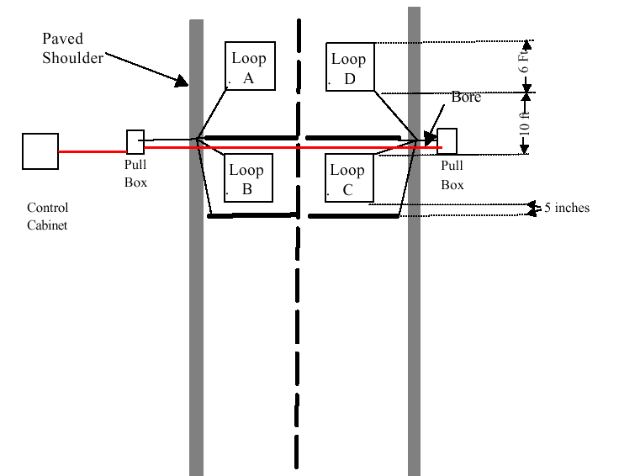

Equipment Requirement (each site)
4 – Class 1 Piezo Cables
1 – Control Cabinet
2 – Pull Boxes
4 – Inductive Loops 6-ft. x 6-ft.
Notes:
- WIM sites will be as indicated in the plans or located as directed. Sites should be located on a tangent section of roadway. Control cabinets should be placed in an accessible location, protected where possible by placing behind existing guardrail, or locating as far from the travel lanes as possible outside the clear zone, near the ROW fence.

- Cables from the median pull box shall be run in 1.5 inch conduit to the Control Cabinet, installed under new pavemnet or bored under the exisiting roadway. Open cutting of the roadway will not be permitted.

- All cabling runs from the loops to the pull boxes, and from the pull boxes to the Control Cabinet shall be placed in 1.5 inch conduit.

- Dimensions shown between piezos and loops are symmetric for each direction of travel.

7
REVISION OF SECTION 614

WEIGH-IN-MOTION STATION

Figure 614-2: Weigh-in-Motion Station typical four-lane layout

(For Information Only)

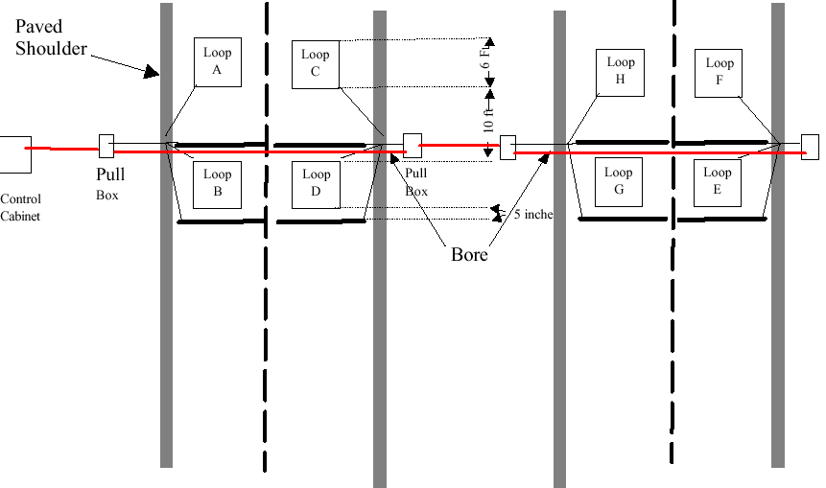

Equipment Requirement (each site)
8– Class 1 Piezo Cables
1 – Control Cabinet
4 – Pull Boxes
8 – Inductive Loops 6-ft. x 6-ft.

Notes:
- WIM sites will be as indicated in the plans or located as directed. Sites should be located on a tangent section of roadway. Control cabinets should be placed in an accessible location, protected where possible by placing behind existing guardrail, or locating as far from the travel lanes as possible outside the clear zone, near the ROW fence.

- Cables from the median pull box shall be run in 1.5 inch conduit to the Control Cabinet, installed under new pavemnet or bored under the exisiting roadway. Open cutting of the roadway will not be permitted.

- All cabling runs from the loops to the pull boxes, and from the pull boxes to the Control Cabinet shall be placed in 1.5 inch conduit.

- Dimensions shown between piezos and loops are symmetric for each direction of travel.

________________________________ __________________________
INSTRUCTIONS TO DESIGNERS (delete instructions and symbols from final draft):
Use this project special provision on projects that do not involve short-term HBP warranties.

Prior to including this special provision in the plans and specifications for a project, the designer should coordinate with Region and HQ Materials, and the Traffic Data Collection Unit of CDOT’s Division of Transportation Development (DTD) to evaluate the need for a WIM station within the limits of the project, and where necessary, to establish the exact location and configuration of this station.

