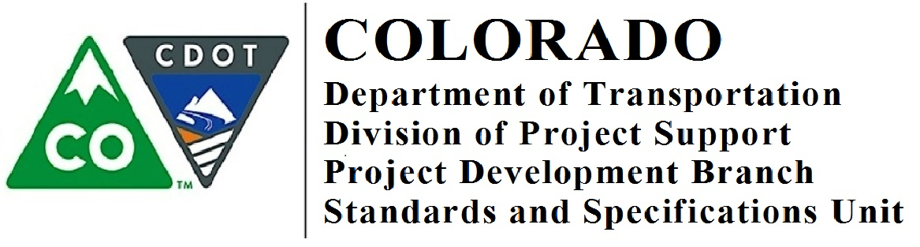

Memorandum

DATE: August 28, 2018

TO: All Holders of Standard Special Provisions

FROM: Shawn Yu, Standards and Specifications Engineer

SUBJECT: New On the Job Training standard special provision

Effective this date, our unit is issuing a new standard special provision:
- On the Job Training – Local Agency Projects not Using LCPtracker for Reporting (3 pages).
Please use On the Job Training –Local Agency Projects not Using LCPtracker for Reporting special provision on all Federal-aid local agency projects where the local agency will not use LCPtracker for reporting.
Use this standard special provision on all federal aid projects beginning with projects advertised after September 6, 2018.
Those of you who keep a book of Standard Special Provisions, you may add these standard special provisions to your file. For your convenience, you can find these and all other special provisions in one place at our Construction Specifications web page:

https://www.codot.gov/business/designsupport/cdot-construction-specifications/2017-construction-standard-specs, or only past issued special provisions with this “Recently Issued Special Provisions” link.

If you have any questions or comments, please contact this office.

