July 3, 2017
REVISION OF SECTIONS 412 AND 705
PREFORMED COMPRESSION SEALS

NOTICE

This is a standard special provision that revises or modifies CDOT’s Standard Specifications for Road and Bridge Construction. It has gone through a formal review and approval process and has been issued by CDOT’s Project Development Branch with formal instructions for its use on CDOT construction projects. It is to be used as written without change. Do not use modified versions of this special provision on CDOT construction projects, and do not use this special provision on CDOT projects in a manner other than that specified in the instructions unless such use is first approved by the Standards and Specifications Unit of the Project Development Branch. The instructions for use on CDOT construction projects appear below.

Other agencies which use the Standard Specifications for Road and Bridge Construction to administer construction projects may use this special provision as appropriate and at their own risk.

Instructions for use on CDOT construction projects:

Use this standard special provision on projects where it is necessary to use preformed compression seals in lieu of silicone sealant in concrete pavement joints, such as projects with fast track concrete.

July 3, 2017

1
REVISION OF SECTIONS 412 AND 705
PREFORMED COMPRESSION SEALS

Sections 412 and 705 of the Standard Specifications are hereby revised for this project as follows:
Subsection 412.13 shall include the following:
Transverse and untied longitudinal joints shall be sawed and sealed as shown in the following diagram for preformed compression seals. Installation shall conform to subsection 412.18, as revised for this project, and the compression seal and lubricant materials shall conform to subsection 705.01, as revised for this project.
Subsection 412.18 shall include the following:
Before installation of the preformed compression seal the following shall be completed:
(1) Repair of defective pavement slabs and repair and proper curing of cracks or spalls in accordance with subsection 412.16.
(2) Corrective work for texturing.
(3) Corrective work for smoothness in accordance with subsection 105.08.
Air temperature at the time of installation shall be from 40 to 80 °F or as recommended by the manufacturer. The joint shall be air cleaned with oil free air at 100 psi minimum just before seal installation. The preformed compression seal shall have an uncompressed width of ¹¹⁄₁₆ inch. Installation shall be in conformance with the following diagram and shall follow the manufacturers recommendations. A machine shall be used for installation which results in proper depth of the seal without damage or twisting of the seal. Elongation during installation shall not exceed 5 percent.
Subsection 705.01 shall include the following:
(c) Preformed Compression Seals. Preformed compression seals shall conform to AASHTO M 220. The lubricant adhesive used for installation of the preformed compression seal shall conform to ASTM D 2835. The Contractor shall provide the Engineer with certified test reports that indicate conformance of the preformed compression seals and lubricant adhesive with these specifications before installation begins.

July 3, 2017

2
REVISION OF SECTIONS 412 AND 705
PREFORMED COMPRESSION SEALS

JOINT SHAPE AND JOINT FILLER DETAILS FOR
TRANSVERSE SAWED CONTRACTION JOINT AND
UNTIED LONGITUDINAL CONTRACTION JOINT

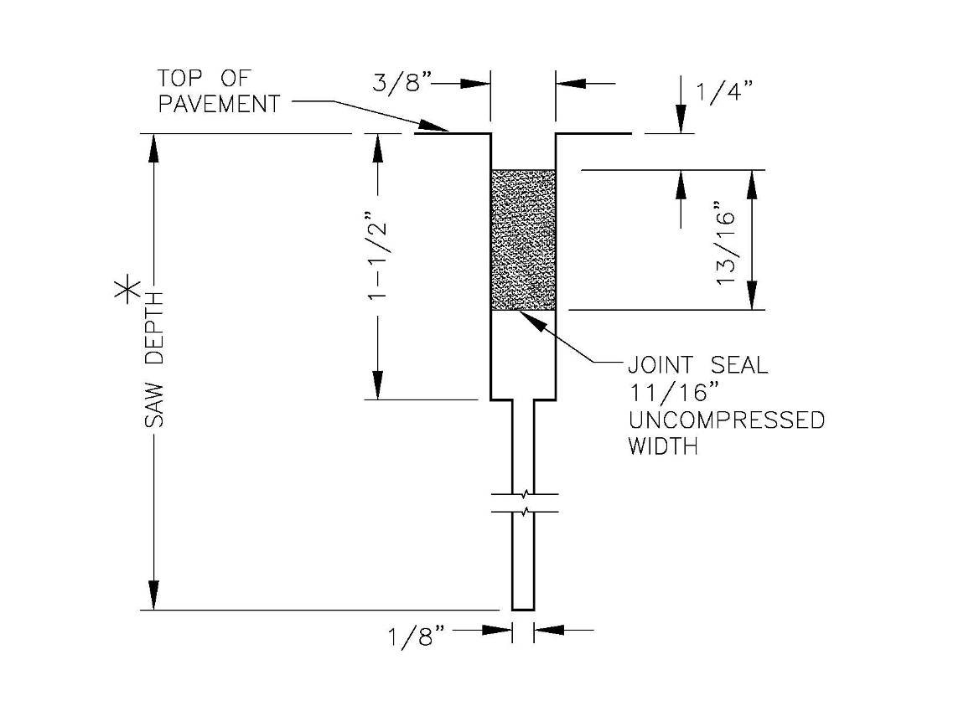
*Saw Depth
T/4 for transverse sawed contraction joint
T/3 for untied longitudinal contraction joint
Where:
T = pavement thickness

Tolerances of all joint width dimensions: 0 to +¹/₁₆ inch

Installation of preformed compression joint seals shall be in accordance with manufacturer’s recommendations.

The joint locations, spacing, and general notes on the standard for concrete pavement joints for this project shall apply.

All materials and installation required for compression joint seals will be included in the work.

All other joints shall be constructed in accordance with standard specifications.

