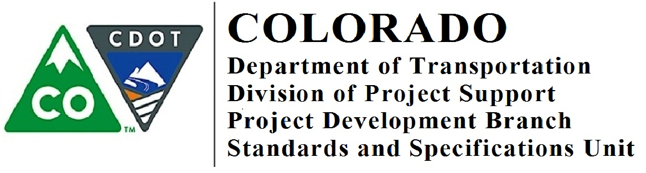

Memorandum

DATE: November 8, 2018

TO: All Holders of Standard Special Provisions

FROM: Shawn Yu, Standards and Specifications Engineer

SUBJECT: Revision of Section 601 – Class G Concrete
Effective this date, our unit is issuing a new standard special provision, Revision of Section 601 – Class G Concrete. This new standard special provision is 1 page long.

Please use this new standard special provision in all projects where Class G concrete shall be used to replace Class D concrete on all elements of new bridge structures that required Class D concrete for the metro areas of Denver, Loveland, Fort Collins, Colorado Springs, Pueblo, Silverthorne, Glenwood Springs, Grand Junction, Montrose, Durango and Alamosa. Do not substitute Class BZ or S concrete with Class G concrete. Notes on the plan sheets calling out Class D for bridge concrete will need to be changed to Class G, or the project needs to create a project special stating that all Class D concrete on Structure(s) XX shall be Class G. If you have a question whether or not the location of your project should use Class G, please contact the Concrete Unit within the Materials and Geotechnical Branch at DOT_ConcreteMixDesigns@state.co.us.

This specification must be used on projects advertised on or after December 8, 2018. You are free to use this in projects advertised before this date.

For those of you who keep a book of Standard Special Provisions, please add this new standard special provision to your file. For your convenience, you can find this and others special provisions on our Construction Specifications website or you may visit our Recently Issued Special Provisions website.

If you have any questions or comments, please contact this office.

