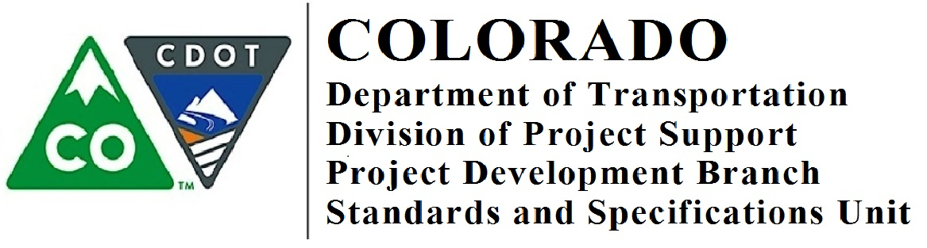

Memorandum

DATE: November 8, 2018

TO: All Holders of Standard Special Provisions

FROM: Shawn Yu, Standards and Specifications Engineer

SUBJECT: Revision of Sections 601, 701 and 711 – Structural Concrete
Effective this date, our unit is issuing a new standard special provision, Revision of Sections 601, 701 and 711 – Structural Concrete. This new standard special provision is 3 pages long.

Please use this new standard special provision in all projects that have structural concrete and that will be advertised on or after December 8, 2018. You are free to use this standard special provision in projects advertised before this date.

For those of you who keep a book of Standard Special Provisions, please add this new standard special provision to your file. For your convenience, you can find this and others special provisions on our Construction Specifications website or you may visit our Recently Issued Special Provisions website.

If you have any questions or comments, please contact this office.

