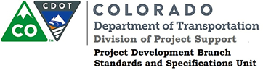

Memorandum

DATE: May 10, 2019

TO: All holders of Standard Special Provisions

FROM: Shawn Yu, Standards and Specifications Unit Manager

SUBJECT: The Minimum Wages on Federal Aid Projects

Effective this date, our unit is issuing the revised Minimum Wages, Colorado, U.S. Department of Labor, General Decision Number CO190014, MOD 1 standard special provision. This revised standard special is 7 pages long, and is dated May 10, 2019. It is to be included in all federal aid projects beginning with projects that have bid openings on May 20, 2019 or later. Use this standard special provision on all federal-aid projects with contracts exceeding $2000, except for non-ARRA projects on roadways classified as local roads or rural minor collectors, which are exempt. Projects on local roads, rural minor collectors, and enhancement projects funded with ARRA funds are not exempt.

MOD 1 changed the wages and fringe benefits for Drill Rig Caisson and Oiler (in Weld county only) Power Equipment Operators.
If you have any questions or comments, please contact this office.

