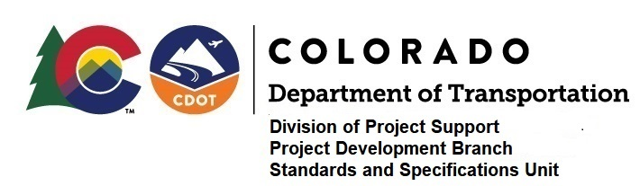

Memorandum

DATE: January 3, 2020

TO: All holders of Standard Special Provisions

FROM: Shawn Yu, Standards and Specifications Unit Manager

SUBJECT: The Minimum Wages on Federal Aid Projects

Effective this date, our unit is issuing the revised Minimum Wages, Colorado, U.S. Department of Labor, General Decision Number CO20200010 standard special provision. This revised standard special is 5 pages long, and is dated January 3, 2020. It is to be included in all federal aid projects beginning with projects that have bid openings on January 13, 2020 or later. Use this standard special provision on all federal-aid projects with contracts exceeding $2000, except for non-ARRA projects on roadways classified as local roads or rural minor collectors, which are exempt. Projects on local roads, rural minor collectors, and enhancement projects funded with ARRA funds are not exempt.

This new decision did not change any wages or fringe benefits for any job classifications. It just changed the General Decision Number from CO190010 to CO20200010.

If you have any questions or comments, please contact this office.

