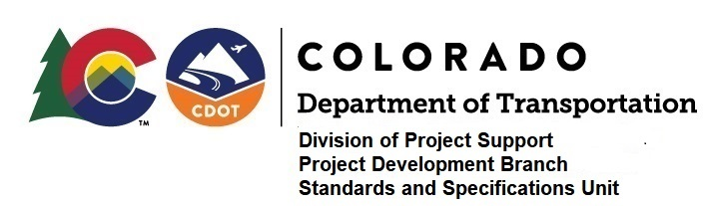

MEMORANDUM

DATE: August 28, 2020

TO: All holders of Standard Special Provisions

FROM: Shawn Yu, Standards and Specifications Unit Manager

SUBJECT: The Minimum Wages on Federal Aid Projects

Effective this date, our unit is issuing the revised Minimum Wages, Colorado, U.S. Department of Labor, General Decision Number CO20200006, MOD 1 standard special provision. This revised standard special is 10 pages long, and is dated August 28, 2020. It is to be included in all federal aid projects beginning with projects that have bid openings on September 7, 2020 or later. Use this standard special provision on all federal-aid projects with contracts exceeding $2000, except for non-ARRA projects on roadways classified as local roads or rural minor collectors, which are exempt. Projects on local roads, rural minor collectors, and enhancement projects funded with ARRA funds are not exempt.

MOD 1 changes the wages and fringe benefits for Drill Rig Caisson, Crane, and Scraper power equipment operators.

If you have any questions or comments, please contact this office.

