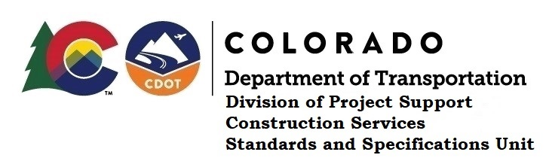

MEMORANDUM

DATE: October 19, 2020

TO: All holders of Standard Special Provisions

FROM: Shawn Yu, Standards and Specifications Unit Manager

SUBJECT: New standard special provision: Revision of Section 412 – Dowel Bars for Joints

Effective this date, our unit has issued the new standard special provision, Revision of Section 412 – Dowel Bars for Joints, with 3 pages, and dated October 19, 2020.

Use this standard special provision on all projects with concrete pavement advertised on or after November 19, 2020. Earlier use is acceptable.

This specification has revised the way dowel bars will be accepted as described in subsection 412.13 (b) 2. It removed the joint score criteria for dowel bars, the list of what is to be included in the MagnoProof report, plus minor editorial changes.

For those of you who keep a book of Standard Special Provisions, please include this new special provision. For your convenience, this specification and the latest SSP Index are attached. You can also find these in our Construction Specifications web page: Standard Special Provisions and the Recently Issued Special Provisions webpage.

If you have any questions or comments, please contact this office.

