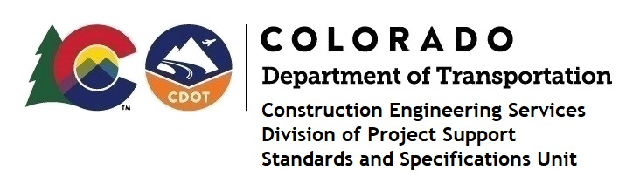

MEMORANDUM

DATE: March 30, 2021

TO: All holders of Standard Special Provisions

FROM: Shawn Yu, Standards and Specifications Unit Manager

SUBJECT: New standard special provision: Revision of Section 107 – Performance of Safety

Critical Work

Effective this date, our unit has issued the new standard special provision, Revision of Section 107 – Performance of Safety Critical Work, with 3 pages, and dated March 30, 2021.

This specification adds to subsection 107.06. Use this standard special provision on all projects with safety critical work including bridge removal and girder placement operations.

Please use this provision on all projects, beginning with projects advertised on or after April 29, 2021. Earlier use is acceptable.

For those of you who keep a book of Standard Special Provisions, please include this new special provision. For your convenience, this specification and the latest SSP Index are attached in the email. You can also find these in our Construction Specifications web pages: Standard Special Provisions and the Recently Issued Special Provisions.

If you have any questions or comments, please contact this office.

