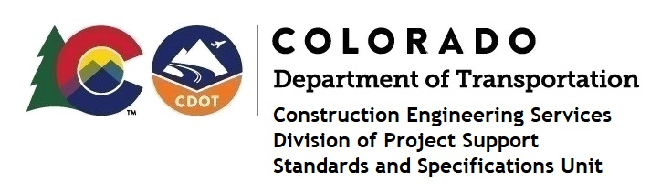

MEMORANDUM

DATE: June 2, 2021

TO: All holders of Standard Special Provisions

FROM: Shawn Yu, Standards and Specifications Unit Manager

SUBJECT: Revised standard special provision: Revision of Section 105 - Control of Work

Effective this date, our unit is issuing revised standard special provision, Revision of Section 105- Control of Work with 18 pages, and dated June 2, 2021. This standard replaces the previous two standards “Revision of Section 105 – Control of Work (105.22) and “Revision of Section 105 – Control of Work (Audit), both dated May 18, 2021.

This specification revised subsections 105.22, 105.23, and part of 105.24.

Please use these provisions on all projects, beginning with projects advertised on or after July 1, 2021. Earlier use is acceptable.

For those of you who keep a book of Standard Special Provisions, please include this revised special provision. For your convenience, this specification and the latest SSP Index are attached in the email. You can also find these in our Construction Specifications web pages: Standard Special Provisions and the Recently Issued Special Provisions.

If you have any questions or comments, please contact this office.

