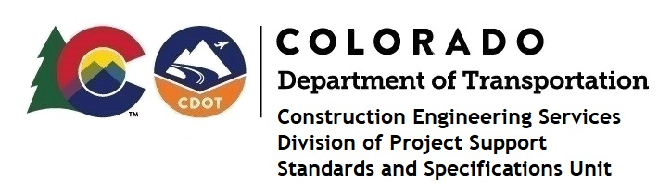

MEMORANDUM

DATE: June 18, 2021

TO: All holders of Standard Special Provisions

FROM: Shawn Yu, Standards and Specifications Unit Manager

SUBJECT: New standard special provision: Certified Payroll Requirements

for Construction Contracts

Effective this date, our unit has issued the new standard special provision, Certified Payroll Requirements for Construction Contracts, with 1 page, and dated June 18, 2021.

All applicable contractors subject to Davis-Bacon and Related Acts (DBRA) requirements shall submit all payrolls weekly (at least every seven days), related to Form FHWA 1273, Required Contract Provisions for Federal-Aid Construction Contracts, and the Colorado Senate Bill 19-196.

Use this standard special provision on:
- all federal-aid construction projects after July 1, 2021;
- all state-funded construction projects after July 1, 2021 (local agency projects are exempt from this requirement);
- select local agency federal-aid construction projects that elect to use the CDOT LCPtracker certified payroll system on projects advertised prior to January 1, 2022;
- all local agency federal-aid projects after January 1, 2022.

For those of you who keep a book of Standard Special Provisions, please include this new standard special provision. For your convenience, this specification and the latest SSP Index are attached in the email. You can also find these in our Construction Specifications web pages: Standard Special Provisions and the Recently Issued Special Provisions.

If you have any questions or comments, please contact this office.

