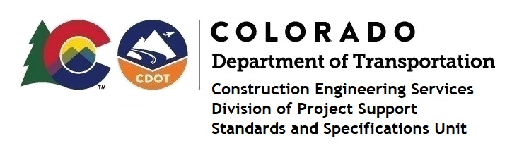

MEMORANDUM

DATE: June 18, 2021

TO: All holders of Standard Special Provisions

FROM: Shawn Yu, Standards and Specifications Unit Manager

SUBJECT: Revised standard special provision: Required Contract Provisions Federal-Aid

Construction Contracts

Effective this date, our unit has issued revised standard special provision, Required Contract Provisions Federal-Aid Construction Contracts, with 14 pages, and dated June 18, 2021.

This specification replaces the previous specification with the same name and dated July 30, 2020.

This revision deleted paragraphs 3 through 8 on page 1 of the previous specification. The new standard special provision, Certified Payroll Requirements for Construction Contracts (also issued today, June 18, 2021) refers to this revised specification.

This specification is effective on projects advertised on or after July 1, 2021. Earlier use of it is acceptable.

For those of you who keep a book of Standard Special Provisions, please include this revised standard special provision. For your convenience, this specification and the latest SSP Index are attached in the email. You can also find these in our Construction Specifications web pages: Standard Special Provisions and the Recently Issued Special Provisions.

If you have any questions or comments, please contact this office.

