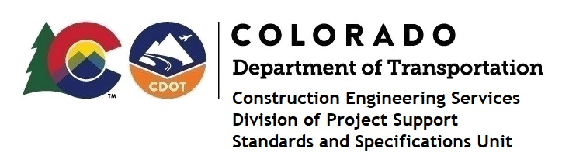

MEMORANDUM

DATE: June 28, 2021

TO: All holders of Standard Special Provisions

FROM: Shawn Yu, Standards and Specifications Unit Manager

SUBJECT: Revised standard special provision: Revision of Section 106 – Buy America

Requirements

Effective this date, our unit has issued revised standard special provision, Revision of Section 106 – Buy America Requirements, with 1 page, dated June 28, 2021, and to be used on all projects.

This provision specifically revised subsection 106.11(a) - Buy America Requirements.

This specification is effective on all projects advertised on or after July 22, 2021. Earlier use of it is acceptable.

For those of you who keep a book of Standard Special Provisions, please include this revised standard special provision. For your convenience, this specification and the latest SSP Index are attached in the email. You can also find these in our Construction Specifications web pages: Standard Special Provisions and the Recently Issued Special Provisions.

If you have any questions or comments, please contact this office.

