PROJECT SPECIFICATION ASSEMBLY TOOL

1. Click on the “PSAT Project Specification Assembly Tool” link. It will automatically download the newest version.
2. Save the PSAT to a file on your computer then open it from there.
3. Enable Micros if you have too.
4. If the yellow Protected View row appears, click the yellow “Enable Editing”, maybe twice.
5. The Project Special Provisions Entry Form window should appear on your screen.
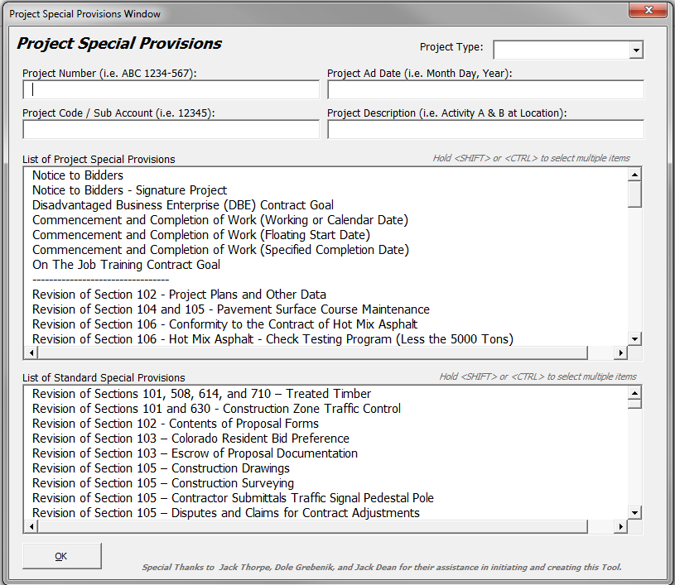
6. Fill in the Project Special Provisions Entry Form with your project information such as the Project Number, Project Code/Sub Account, Project Ad Date, and Project Description.
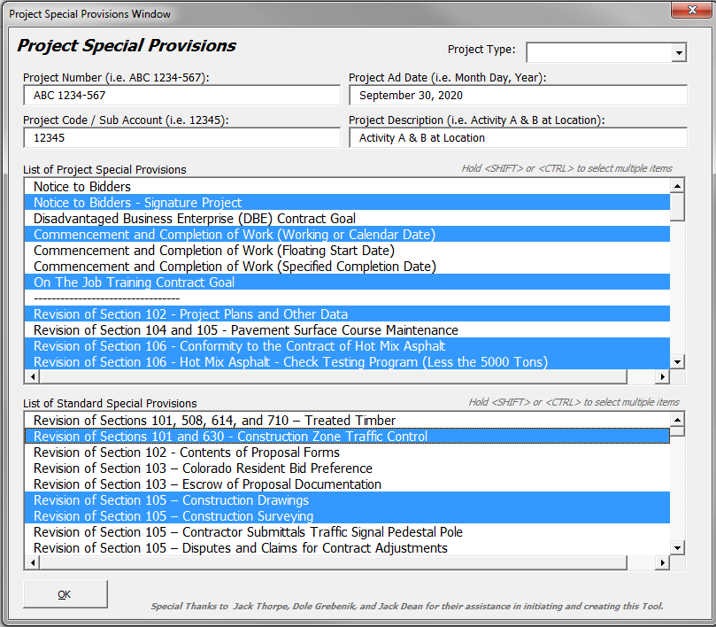
A). The “Project Type” dropdown list is optional. If an item from the dropdown list is selected, it will select the default specifications related to that project type. This can save you time. The “Pilot Specification” item selects no default specification in the case you do not at the moment know your Project’s type. NOTE: DO this sub-step first before you start manually selecting specifications because it will clear your selection to populate the selected item defaults.

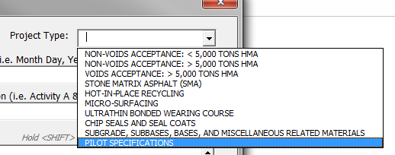
B) In the List of Project Special Provisions and the List of Standard Special Provisions scroll through each listing and hold the <SHIFT> or <CTRL> keys (similar to other Windows programs) and then click the multiple provisions and revisions that are applicable to your project so they are highlighted in blue (see example below).

7. Click the “OK” button at the bottom of the form window once all your project information and items are selected. The form will close and display all your input in the main document. Give the tool several seconds (to a max of 4 minutes if every spec is selected) and it will display all your input in the main document. To close the form window without entering any information, click the “X” in the top, right corner of the form.
8. Review your document to make sure all the selected revisions are present.
NOTE: The Project Code (PCN), Project Ad Date, Project Number (Project No.), and Project Description now populate the first page of the Specification Packet. The Project No., PCN, and Project Ad Date will appear in the Header of each following page of the assembly Specification Packet.
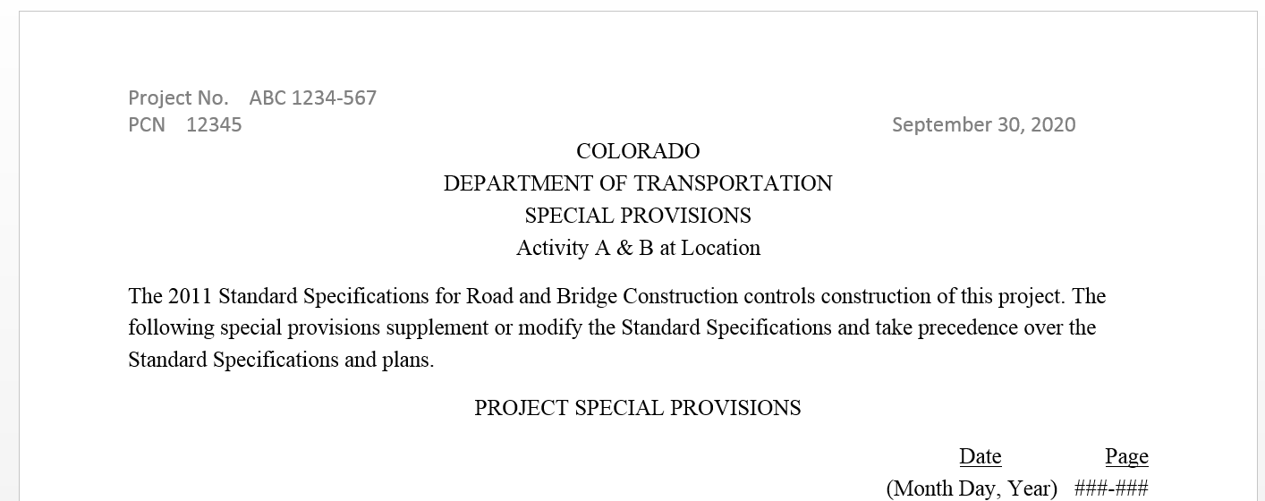

NOTE: The Project No., PCN, and Project Ad Date will appear in the Header of each following page of the assembly Specification Packet.
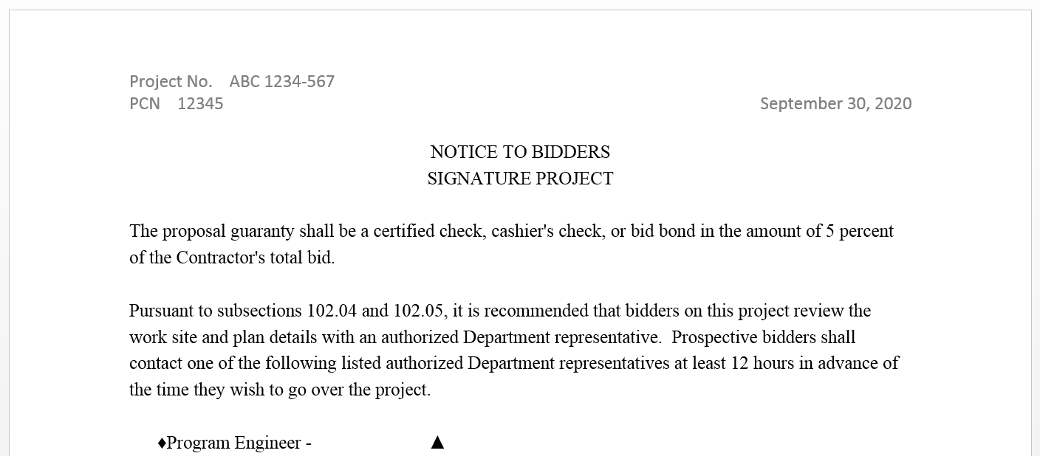

9. To properly save this document so the program will not appear again, click on the “File” tab, then click on the “Save As” button.

10. Clicking the “Save As” button will open a new menu. This menu will allow you to pick a destination for your file. For now, click “Desktop” to save the file there.

A) A pop-up window will appear (in this case after clicking the “Desktop” link)
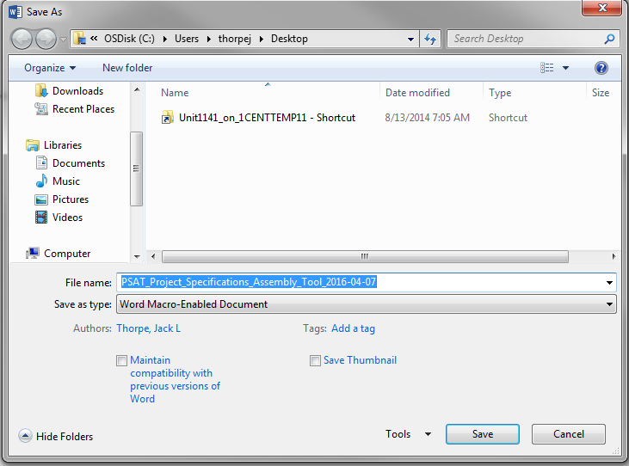
B) Click on the dropdown menu to the right of “Save as type:” and select the “Word Document type”. This will change the file to a regular Word document.
11. Type your desired document name into the space right of the “File name:” When you click in the space right of that text, the current text will be highlighted in blue and once you start typing that text will be replaced with your desired document/file name. The Project Code 5 digit number, a hyphen, and the Project Description is the suitable file name, i.e 12345 – Activity A & B at Location.
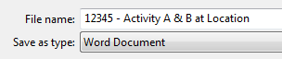
Before After 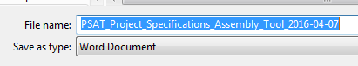

12. Click the “Save” button to save your newly named document into your specified location.
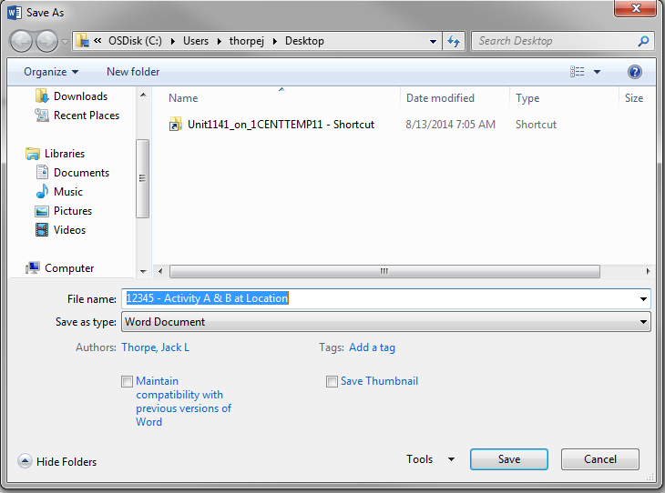
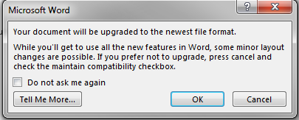
A) In the following “Microsoft Word” pop-up window. Click the “OK” button.

13. In the following pop-up window, click the “Yes” button. The purpose behind this selection is to save your custom document as the project specific file without the programming in the background.
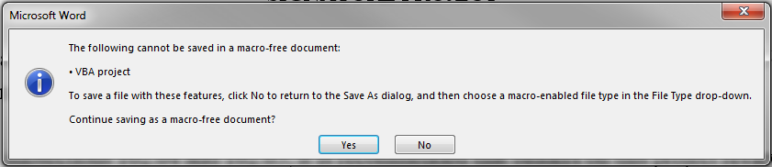

14. Congratulations, you now have the base Specifications Packet for your project. This base Packet document still requires your input and fine tuning for each of the individual specifications and worksheets for your project (i.e. review designer instructions and add specific project input were requested, delete designer instructions, and insure appropriate page breaks, etc.).
To exit the document, you can either click the “X” button in the upper right corner of the Microsoft Word window or you can go to “File” and click on the “Close” tab in the left pane.

