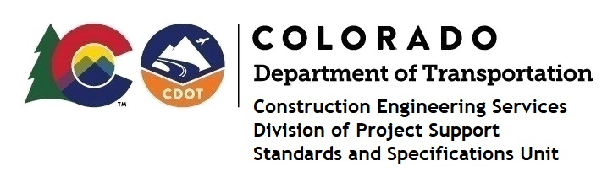

Memorandum

DATE: October 29, 2021

TO: All holders of Standard Special Provisions

FROM: Shawn Yu, Standards and Specifications Unit Manager

SUBJECT: The Minimum Wages on Federal Aid Projects

Effective this date, our unit is issuing the revised Minimum Wages, Colorado, U.S. Department of Labor, General Decision Number CO20210008, MOD 1 standard special provision. This revised standard special provision is to be included in all state-funded (except local agency projects), and all federal-aid projects, beginning with projects that have bid openings on November 8, 2021 or later with contracts exceeding $2000, except for non-ARRA projects on roadways classified as local roads or rural minor collectors, which are exempt. Projects on local roads, rural minor collectors, and enhancement projects funded with ARRA funds are not exempt.

MOD 1 changed the wages and fringe benefits for Electricians in El Paso and Teller counties.

If you have any questions or comments, please contact this office.

