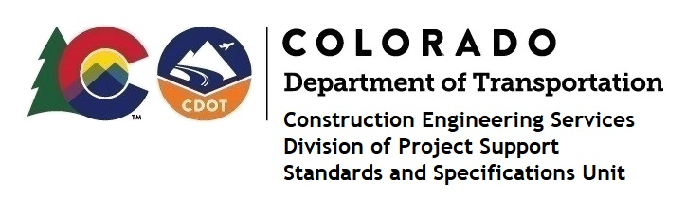

MEMORANDUM

DATE: June 23, 2021

TO: All holders of Standard Special Provisions

FROM: Shawn Yu, Standards and Specifications Unit Manager

SUBJECT: Revised standard special provision: Revision of Section - Disadvantaged Business

Enterprise (DBE) Requirements

Effective this date, our unit has issued revised standard special provision, Revision of Section - Disadvantaged Business Enterprise (DBE) Requirements with 1 page, and dated June 23, 2021.

This revision replaced subsection 7 (b) - Work Included in Commitment or Verified via Form.

This specification is effective on all Federal-Aid Design-Bid-Build projects, except Local Agency projects (see Notice page for more information) advertised on or after July 1, 2021. Earlier use of it is acceptable.

For those of you who keep a book of Standard Special Provisions, please include this revised standard special provision. For your convenience, this specification and the latest SSP Index are attached in the email. You can also find these in our Construction Specifications web pages: Standard Special Provisions and the Recently Issued Special Provisions.

If you have any questions or comments, please contact this office.

