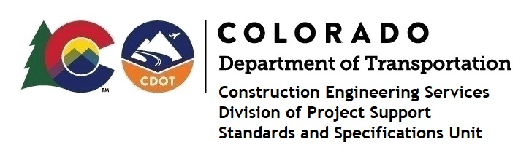

Memorandum

DATE: November 5, 2021

TO: All holders of Standard Special Provisions

FROM: Shawn Yu, Standards and Specifications Unit Manager

SUBJECT: The Minimum Wages on Federal Aid Projects

Effective this date, our unit is issuing the revised Minimum Wages, Colorado, U.S. Department of Labor, General Decision Number CO20210009, MOD 1 standard special provision. This revised standard special is 7 pages long, and is dated November 5, 2021. It is to be included in all federal aid projects beginning with projects that have bid openings on November 15, 2021 or later. Use this standard special provision on all federal-aid projects with contracts exceeding $2000, except for non-ARRA projects on roadways classified as local roads or rural minor collectors, which are exempt. Projects on local roads, rural minor collectors, and enhancement projects funded with ARRA funds are not exempt.

MOD 1 changed the wages and fringes benefits for Power Equipment Operators that reflect collectively bargained rates.

If you have any questions or comments, please contact this office.

