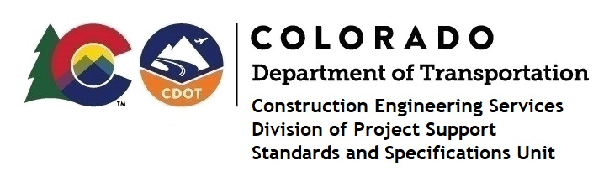

Memorandum

DATE: August 19, 2022

TO: All holders of Standard Special Provisions

FROM: Shawn Yu, Standards and Specifications Unit Manager

SUBJECT: The Minimum Wages on Federal Aid Projects

Effective today, August 19, 2022, our unit has issued the revised Minimum Wages, Colorado, U.S. Department of Labor, General Decision Number CO20220006 MOD 2 standard special provision. This revised standard special is 11 pages long, and is dated August 19, 2022. It is to be included immediately in all federal aid projects that had (or will have) bid openings on or after August 29, 2022. Use this standard special provision on all state-funded (except local agency projects) and all federal-aid projects with contracts exceeding $2000, except for non-ARRA projects on roadways classified as local roads or rural minor collectors, which are exempt. Projects on local roads, rural minor collectors, and enhancement projects funded with ARRA funds are not exempt.

MOD 2 changed the wages and fringe benefits for Electricians (Traffic Signalization) in Clear Creek county only.

Project Managers: Please check to see if your projects are affected and take appropriate action with a Revision Under Ad.

If you have any questions or comments, please contact this office.

