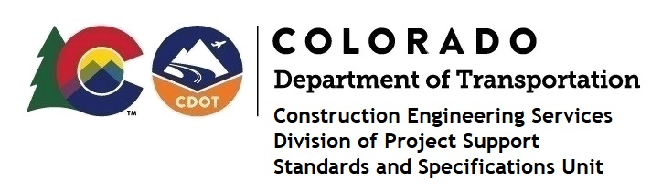

MEMORANDUM

DATE: August 31, 2022

TO: All holders of Standard Special Provisions

FROM: Shawn Yu, Standards and Specifications Unit Manager

SUBJECT: Revised standard special provision: Required Contract Provisions Federal-Aid

Construction Contracts

Effective today, August 31, 2022, our unit has issued revised standard special provision, Required Contract Provisions Federal-Aid Construction Contracts, with 14 pages, and dated August 31, 2022.

This specification replaces the previous specification with the same name and dated June 18, 2021.

This revision replaced the previous FHWA Form 1273 (dated May 1, 2012), with the revised FHWA Form 1273, dated July 5, 2022.

This specification is effective on all federal-aid construction projects advertised on or after September 6, 2022.

Further information about revised FHWA Form 1273 can be found here:
https://www.fhwa.dot.gov/construction/cqit/form1273.cfm

For those of you who keep a book of Standard Special Provisions, please include this revised standard special provision. For your convenience, this specification and the latest SSP Index are attached in the email. You can also find these in our Construction Specifications web pages: Standard Special Provisions and the Recently Issued Special Provisions.

If you have any questions or comments, please contact this office.

